OBSERVATOR
Weather Monitoring Portal — Sydney Metro M1

User Manual
How to use the portal, screen by screen

Signing in, reading the map and alerts, checking stations and pumps, finding and exporting data, keeping an eye on system health, and administering users, alert rules and sensors.

This manual describes the design prototype. All readings shown are demonstration data; no sensors are connected and no alerts, emails or pump commands are sent.
Design prototype · for review · 02 October 2026

Contents
1 Before you start
2 Signing in and out
3 Finding your way around
4 Map — the whole line at a glance
5 Alerts
6 Stations
7 Trends and Flood
8 History — finding and exporting data
9 Health — is the system working?
10 Administration
11 Your settings
12 Who can do what
13 Quick answers

Before you start
The portal shows the weather and flood monitoring for the Sydney Metro M1 line in one place: seven monitoring locations, the Marrickville flood pumps, every alert, and the health of the equipment. It works in any modern web browser — on a desktop, a laptop, a tablet or a phone — with nothing to install.
This is a design prototype. Every reading is demonstration data. No sensors are connected, and no emails, alerts or pump commands are sent. The screens are complete so the design can be reviewed; the working system is built after approval.
Colours mean the same thing everywhere:
Colour | Meaning
Red | Alert — a threshold has been crossed and action is needed
Amber | Warning — approaching a threshold, or something to check
Green | Normal / running / in service
Grey | Offline or no data
Blue | Information, or a pump command you can take

Every status also has a word and an icon beside the colour, so it can be read without colour.
Charts. A dashed red line on a chart is a threshold. Hover over (or tap) a chart to read exact values. The two small icons at the top right of every chart switch to a table view and download the data as CSV.

Signing in and out

Sign in
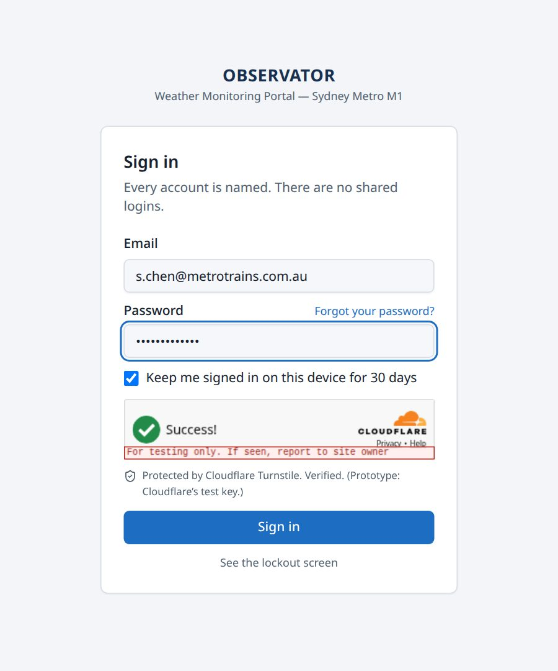
Figure 1 — The sign-in screen
- Open the portal link. Every page asks you to sign in first.
- Enter your email and password.
- Wait for the security check (Cloudflare) to show Success. It usually passes on its own; occasionally it asks you to tick a box.
- Leave Keep me signed in on this device for 30 days ticked on your own device. Untick it on a shared computer — you will then be signed out when the browser closes.
- Select Sign in. You go straight to the page you opened.
If the details are wrong you see That email and password do not match. Your email stays filled in; type the password again.

Forgotten your password
You reset it yourself — nobody at MTS needs to be involved.
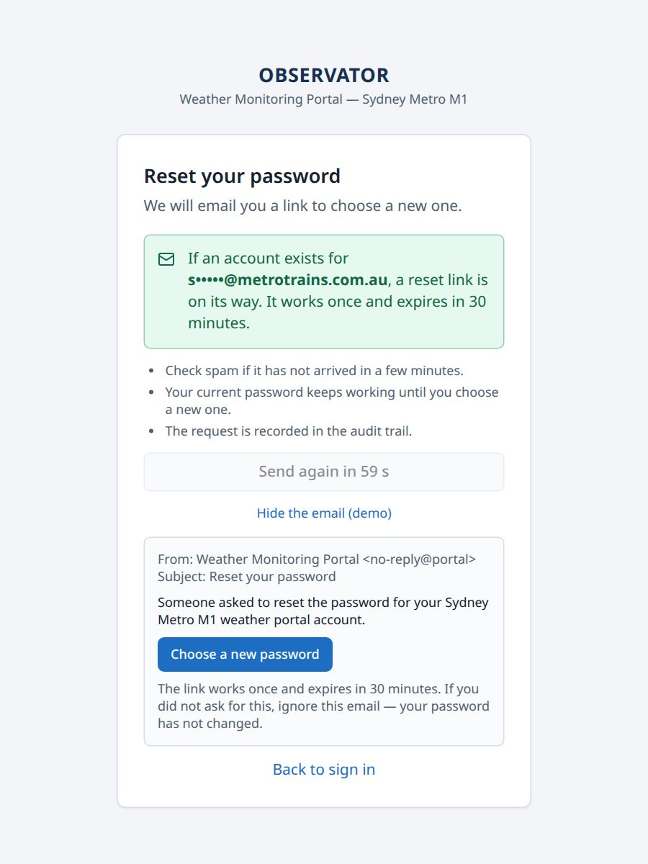
Figure 2 — After asking for a reset link
- On the sign-in screen select Forgot your password?
- Enter your work email, pass the security check and select Send the reset link.
- Open the email and select Choose a new password. The link works once and expires after 30 minutes. If it has expired, ask for a new one.
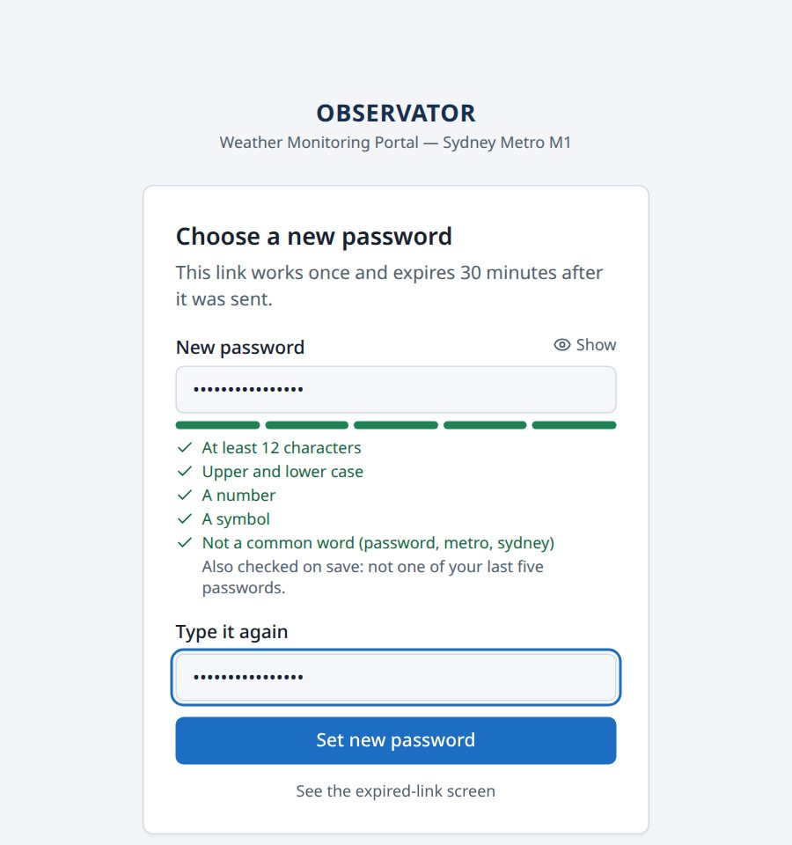
Figure 3 — Choosing a new password
- Type the new password twice. The rules turn green as they are met: at least 12 characters, upper and lower case, a number, a symbol, and not a common word.
- Select Set new password. You are signed out on every other device, and you receive a confirmation email.
The reset screen never says whether an email address has an account. That stops the page being used to find out who works at MTS.

Sign out
Select your initials (top right) and choose Sign out. On a phone, open the ☰ menu — Sign out is at the bottom. After signing out, every page asks for your email and password again.

Finding your way around
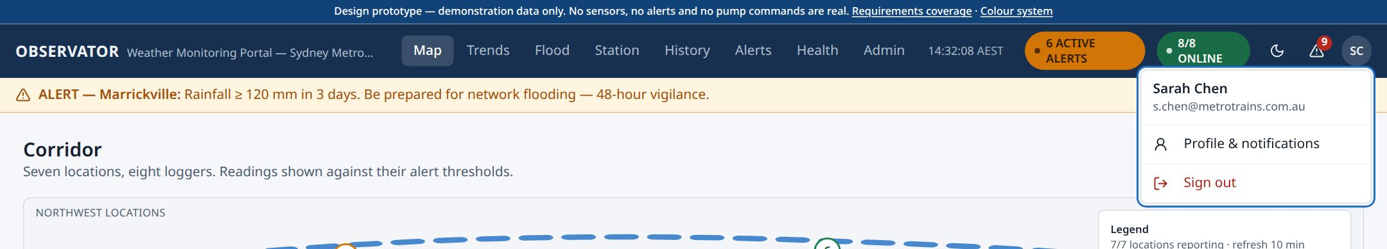
Figure 4 — The top of every page, with the account menu open
Along the top of every page:
- Menu — Map, Trends, Flood, Station, History, Alerts, Health and Admin. On a phone, it sits behind the ☰ button.
- Clock — Sydney time, marked AEST or AEDT.
- Active alerts (amber) — how many alerts are in force. Select it to open Alerts.
- Online (green) — how many monitoring loggers are reporting, for example 8/8 online.
- Moon / sun — switch between light and dark display.
- Bell — alerts not yet acknowledged.
- Your initials — your profile and notification settings, and Sign out.
Under the top bar, the alert banner repeats the most important alert in force, with Open to go to it. A blue strip announces any planned maintenance at least 48 hours ahead.

Map — the whole line at a glance
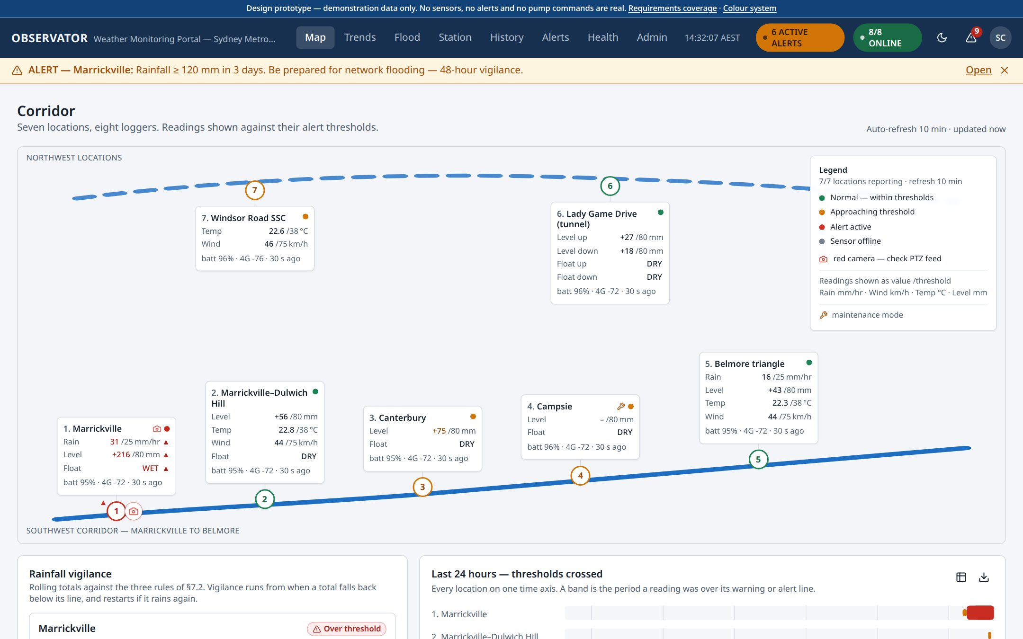
Figure 5 — Map — the corridor with every location
The map is the home page. It shows the line as a simple route, not a street map, with each of the seven locations on it.
- Each location card shows its readings beside their thresholds — for example Rain 31 / 25 mm/hr means 31 against a threshold of 25.
- The pin colour gives the location's status. A blinking red camera means standing water needs checking on the camera; a wrench means the location is in maintenance.
- Select a location to open its station page.
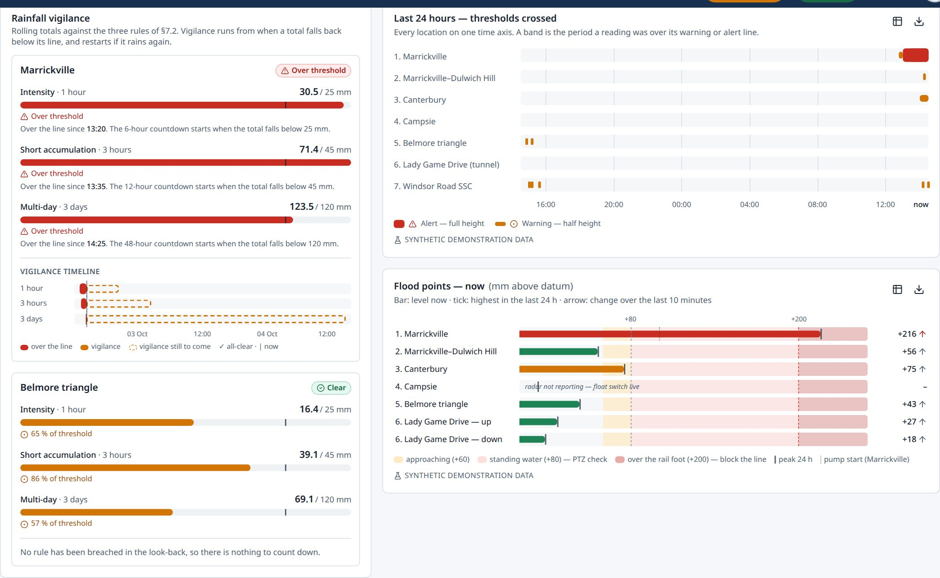
Figure 6 — Rainfall countdowns, the last 24 hours and the flood points
Further down the Map:
- Rainfall vigilance — for each rain gauge, the 1-hour, 3-hour and 3-day rainfall against the 25 mm, 45 mm and 120 mm rules. When a total falls back below its line, a countdown (6, 12 or 48 hours) runs before the all-clear. More heavy rain restarts it. The vigilance timeline draws this out.
- Last 24 hours — thresholds crossed — when each location was over its warning or alert line.
- Flood points — now — every water-level point on one scale against standing water and the rail foot, with the day's peak and whether the water is rising.
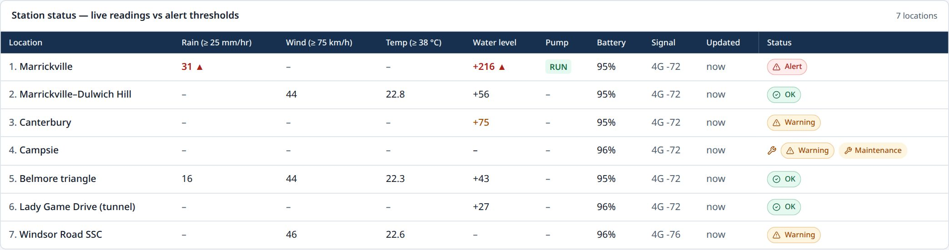
Figure 7 — Station status table
The station status table at the bottom lists every location's latest readings, battery, signal and status in one table.

Alerts
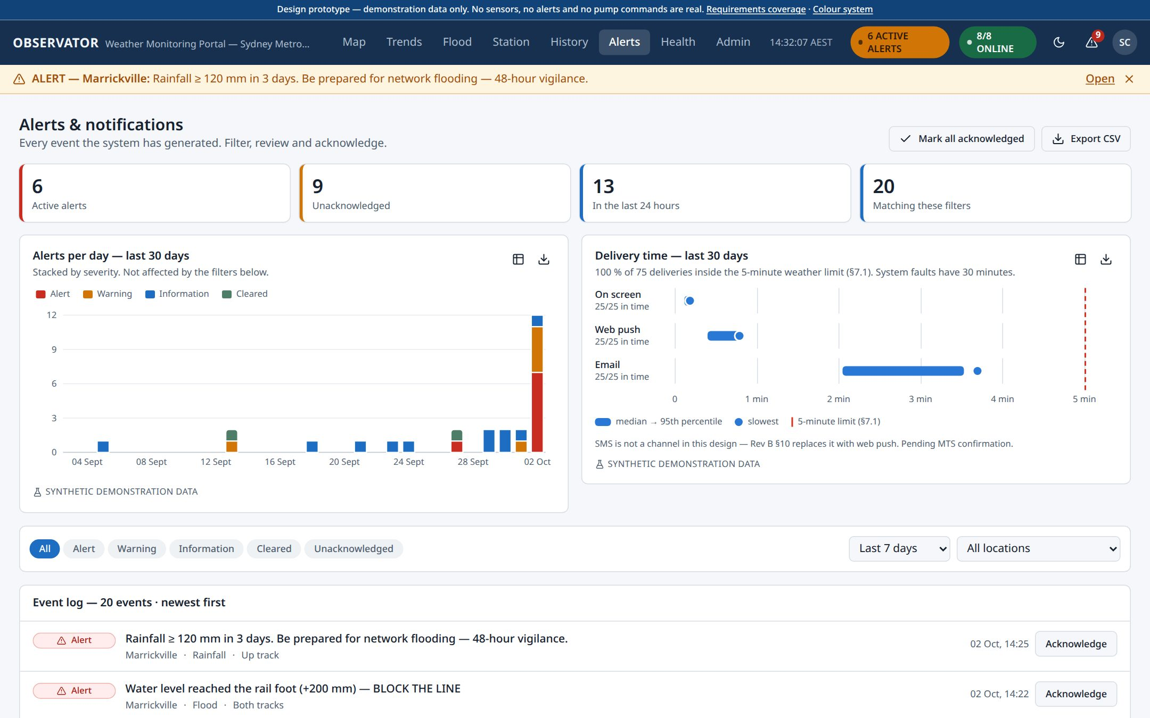
Figure 8 — Alerts and notifications
Alerts holds every alert the system has raised.
- The tiles at the top count active and unacknowledged alerts. The charts show alerts per day and how quickly each alert was delivered.
- Filter with the chips (Alert, Warning, Information, Cleared, Unacknowledged), the period and the location.
- Select Acknowledge on an alert to record that you have seen it. Your name and the time are saved. Mark all acknowledged does every alert in the list at once.
- Export CSV downloads the alerts in the list.
- Select an alert's text to open its own page.

Verifying standing water on the camera
When water reaches standing water level, a window opens by itself asking you to check the camera. The same window opens from the PTZ button on an alert, the red camera on the map, or Verify on PTZ camera on the station page.
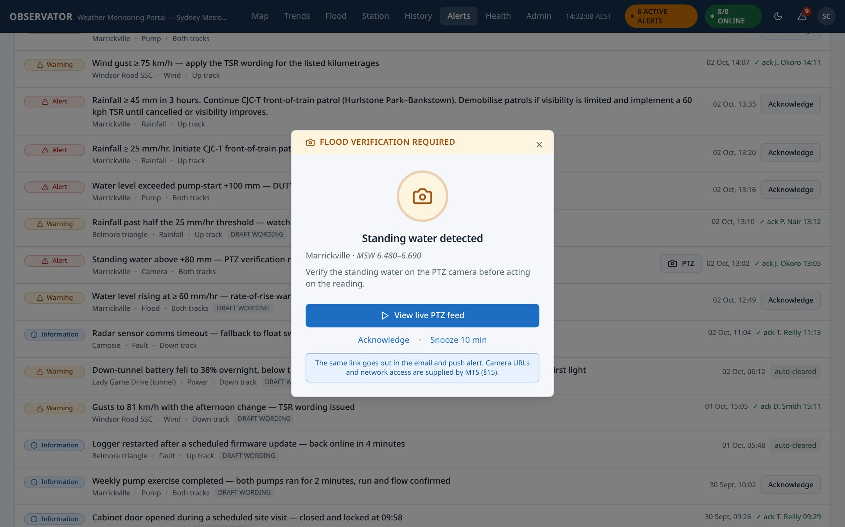
Figure 9 — The camera check
Choose View live PTZ feed, Acknowledge, or Snooze 10 min (it comes back if still unacknowledged).
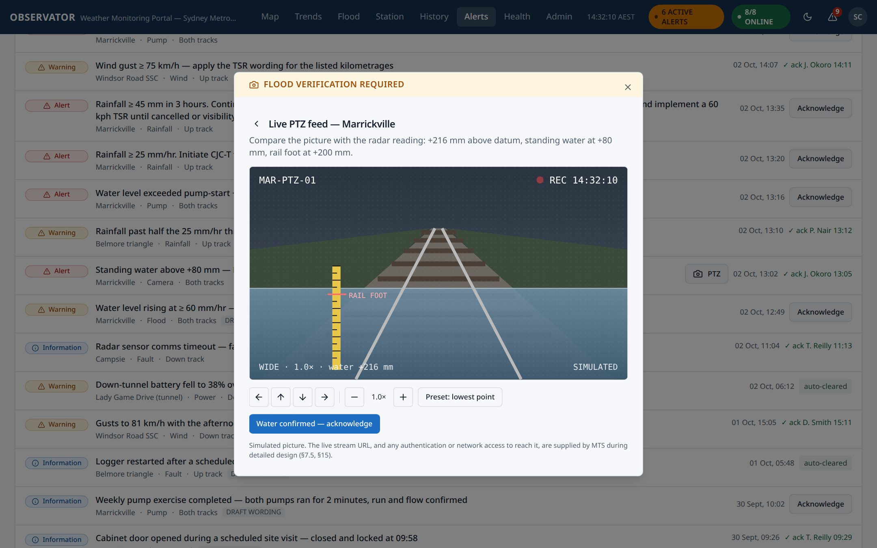
Figure 10 — The camera feed
Use the arrows and zoom to move the camera; Preset: lowest point points it at the gauge. When you can see the water, select Water confirmed — acknowledge.

An alert's own page
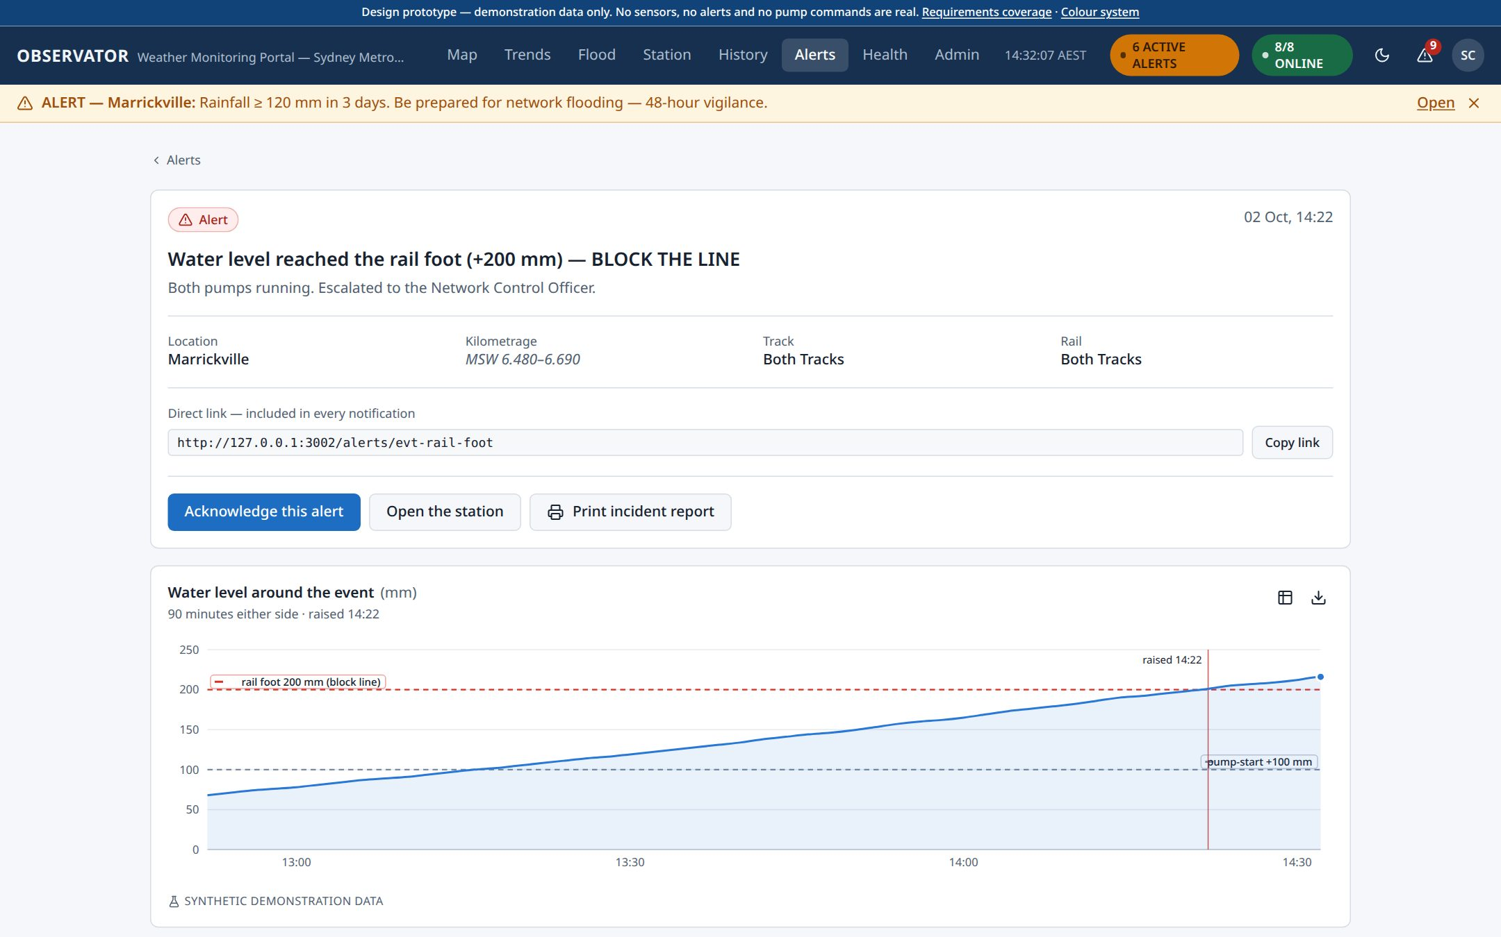
Figure 11 — An alert's page
Every alert email and notification links to this page. It shows where and when the alert happened (location, kilometrage, track and rail), the reading around that time with when it was raised and acknowledged, who it was sent to and when it arrived, and any notes added by the team. Use Copy link to share it, Open the station for the location, and Print incident report for a one-page record.

Stations
Open a station from the map, the status table, or Station in the menu. Each station has two tabs: Live and Installation.

Live
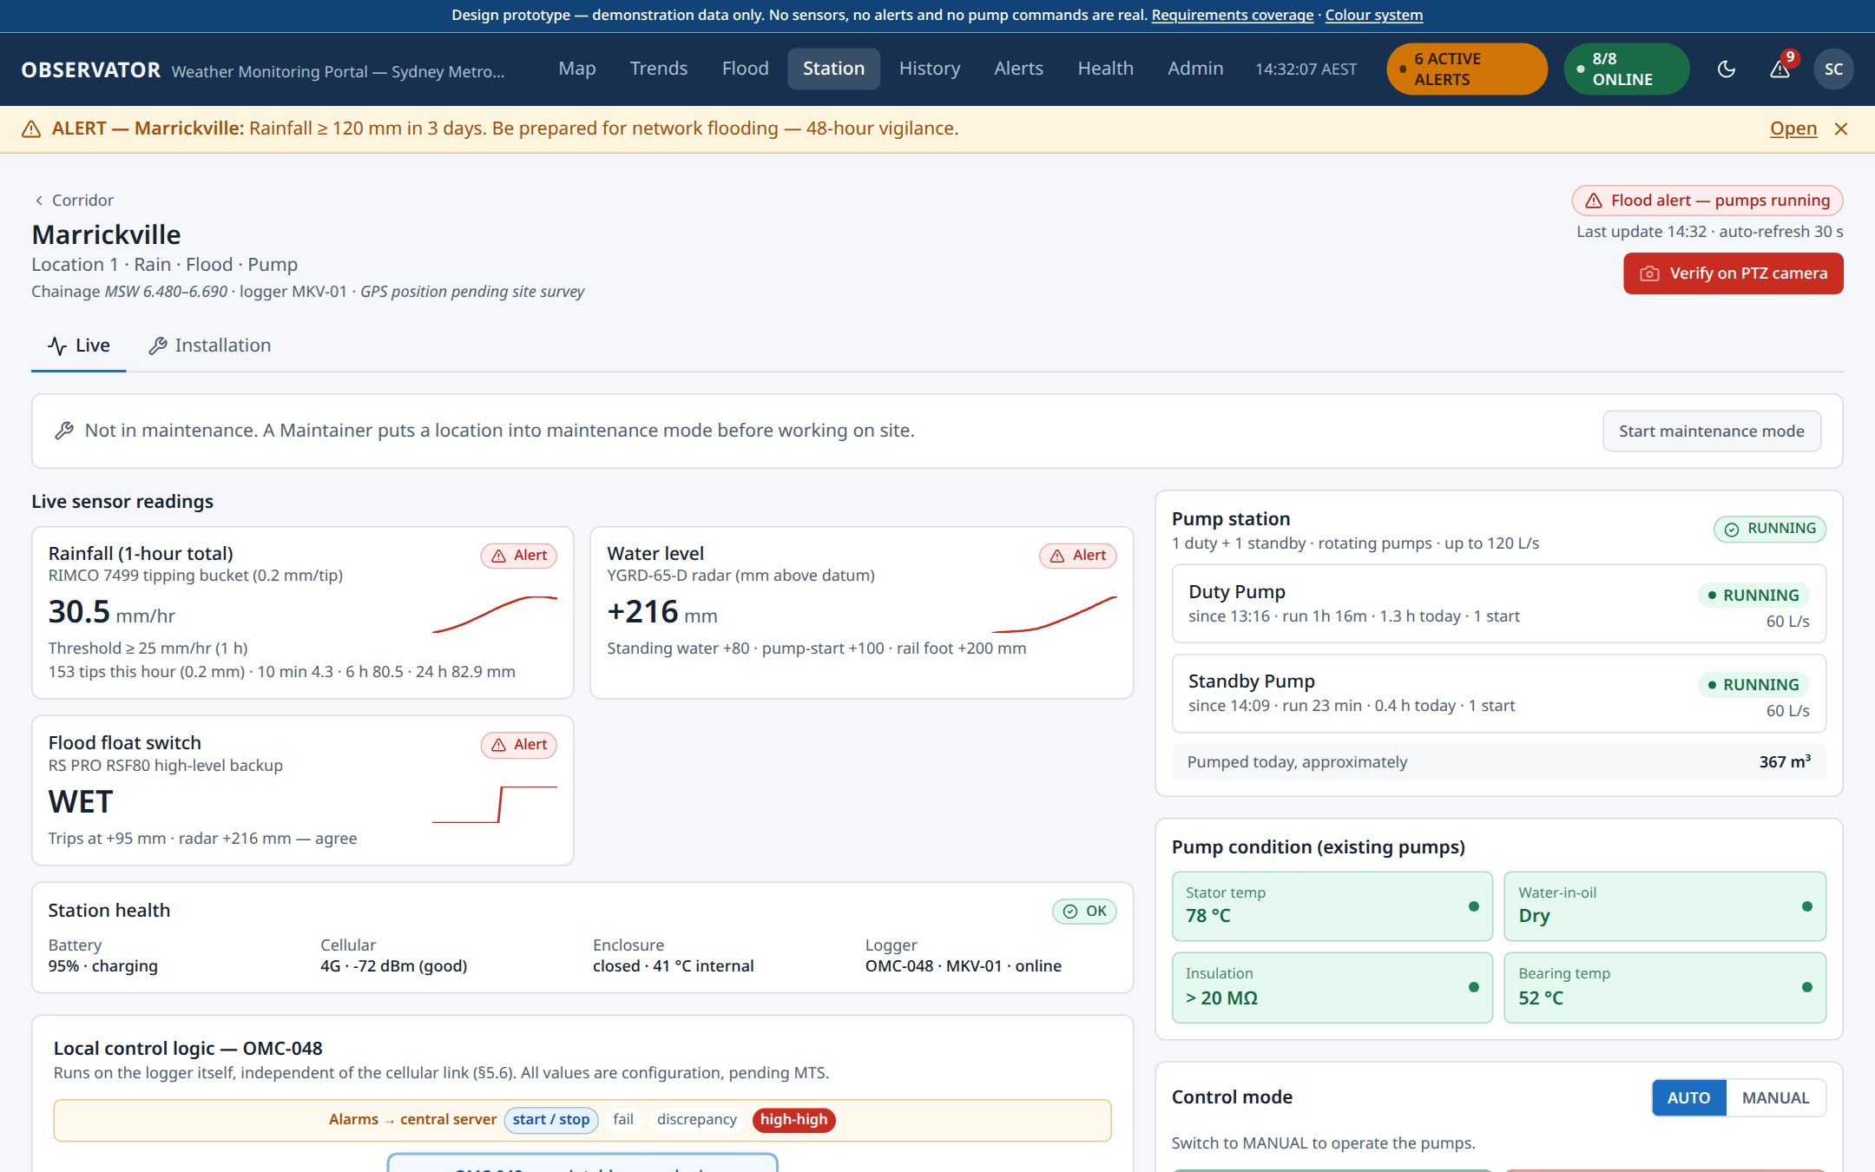
Figure 12 — Station — Live tab (Marrickville)
- Live sensor readings — one card per sensor, with its threshold and a small trend line.
- Station health — battery, mobile signal, cabinet and logger.
- Maintenance mode — a maintainer selects Start maintenance mode before working on site, so everyone can see why readings may be unusual. End maintenance mode when finished.
- Below the cards: the last 24 hours as charts, the battery and solar power for the last week, and how the station is reporting.

Pumps (Marrickville)
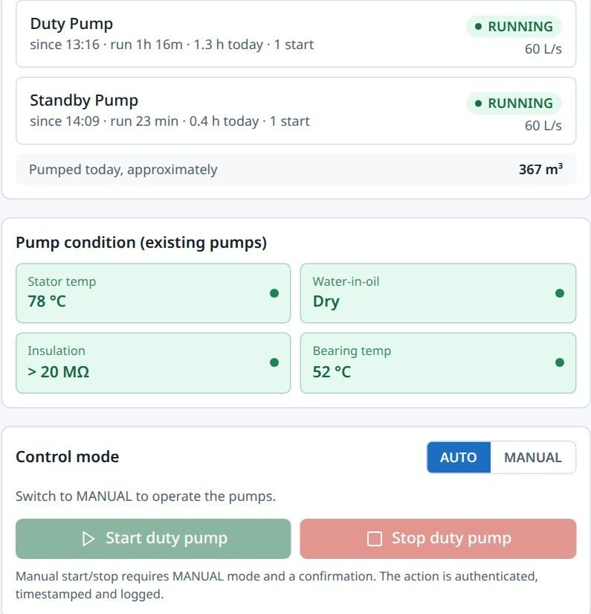
Figure 13 — Pump station and control
The pumps run themselves in AUTO: the duty pump starts at +100 mm, the standby pump joins at +180 mm, and both stop once the water is back down. The panel shows each pump, its run time, the pump-condition signals, and the control logic with each set point marked as met or not.
To run a pump by hand (Pump Controller role only):
- Switch Control mode to MANUAL.
- Select Start duty pump or Stop duty pump.
- Read the confirmation — what will happen, to which pump, and under your name — and confirm.
Every manual action is recorded with your name and the time. Switch back to AUTO when finished.

Installation
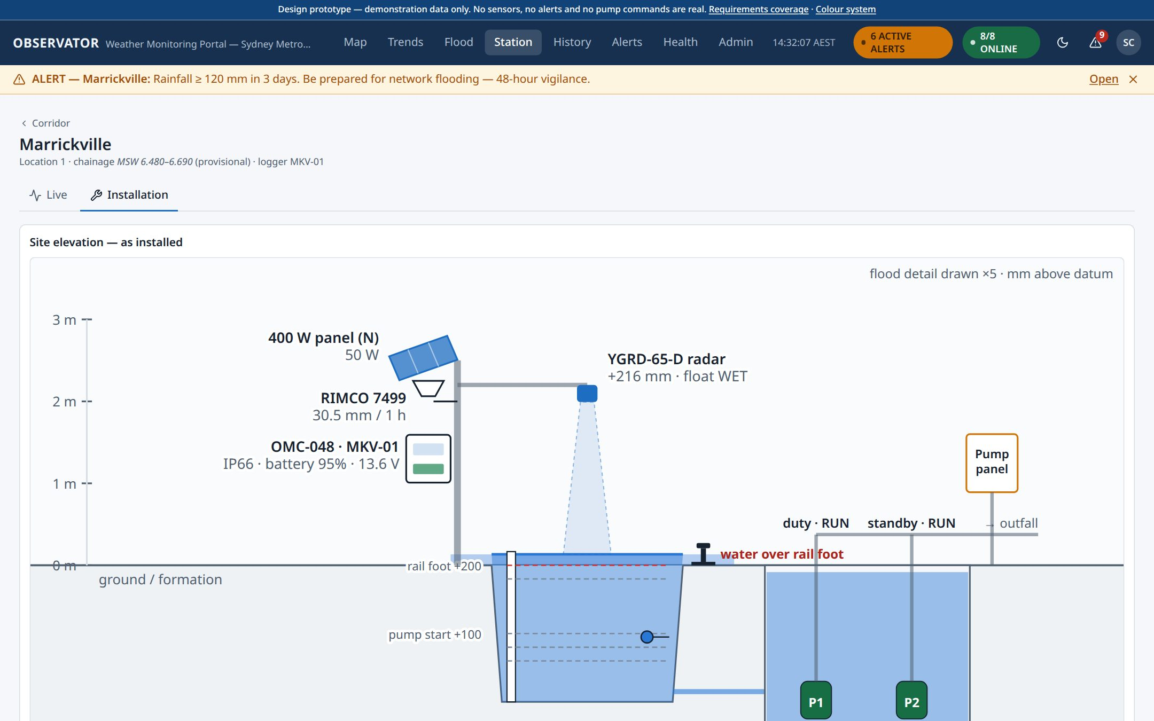
Figure 14 — Station — Installation tab
The Installation tab is for maintainers and engineers:
- Site elevation — a drawing of the station as installed, with live readings on it.
- Wiring and connectivity — each sensor on its logger connection, the power supply and the mobile link.
- Equipment at this location — the instruments fitted here, from the sensor register (see Administration → Sensors).
- Requirement vs provided — how each instrument meets the specification.

Trends and Flood

Trends
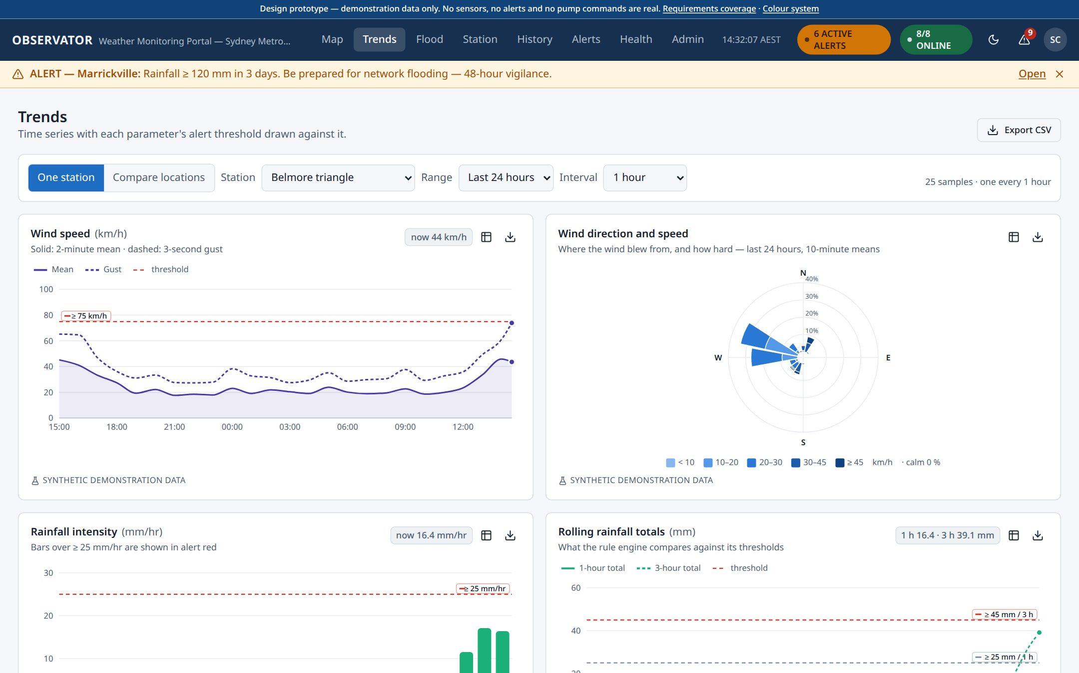
Figure 15 — Trends
- One station shows every measurement at one location: wind, wind direction, rainfall, temperature, humidity, water level and air pressure.
- Compare locations shows one measurement across all locations.
- Choose the station, the range (for example last 24 hours or 7 days) and the interval.
- Export CSV downloads what is on screen.

Flood
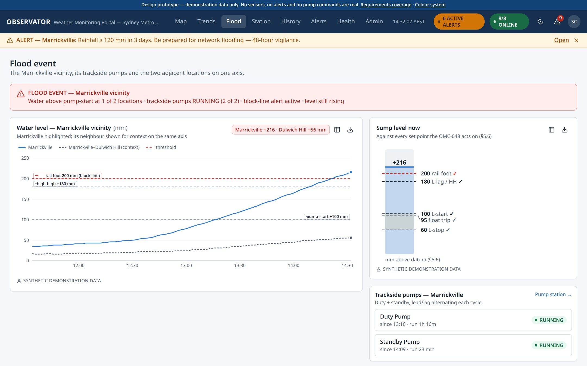
Figure 16 — Flood event
Flood brings everything about a flood at Marrickville onto one screen: the water level at the two nearby points, the pump sump gauge, the pumps, a strip map of the affected section, how fast the water is rising, the steps back to normal train speed after the line is blocked, and the event log.

History — finding and exporting data
- Choose one or more locations and measurements.
- Choose the period (last few days, or exact dates) and the interval (raw, 10 minutes, hourly or daily).
- Select Run query.
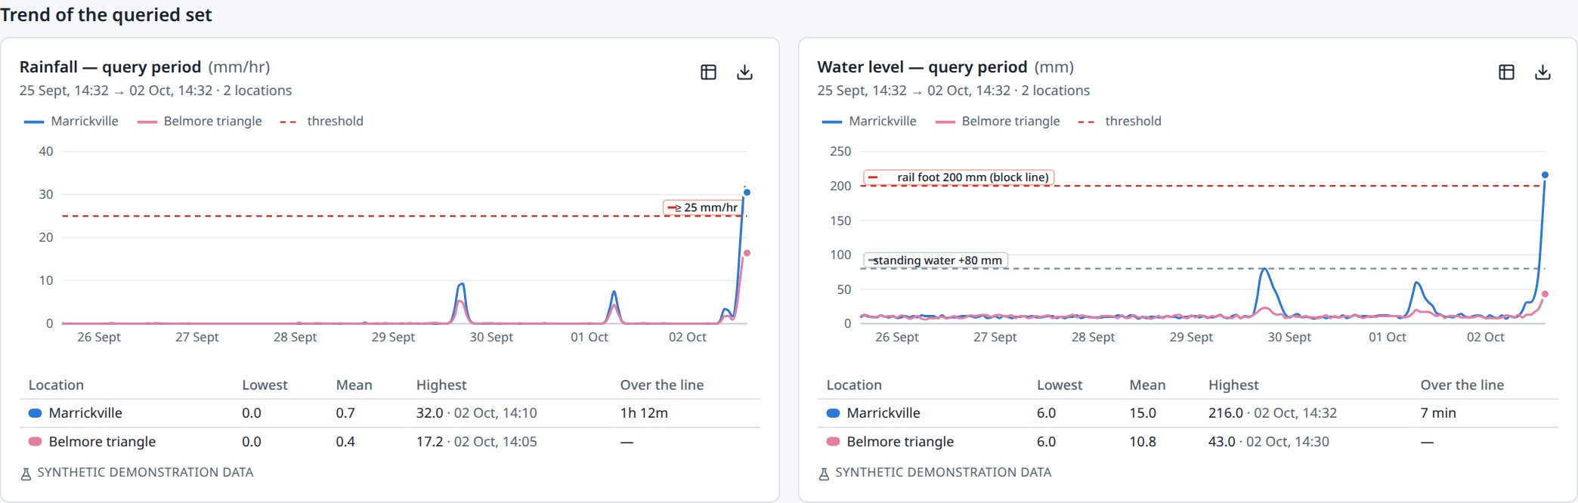
Figure 17 — History — charts of the query
The results open with a chart for each measurement, one line per location, and the lowest, average and highest values and the time spent over the threshold.
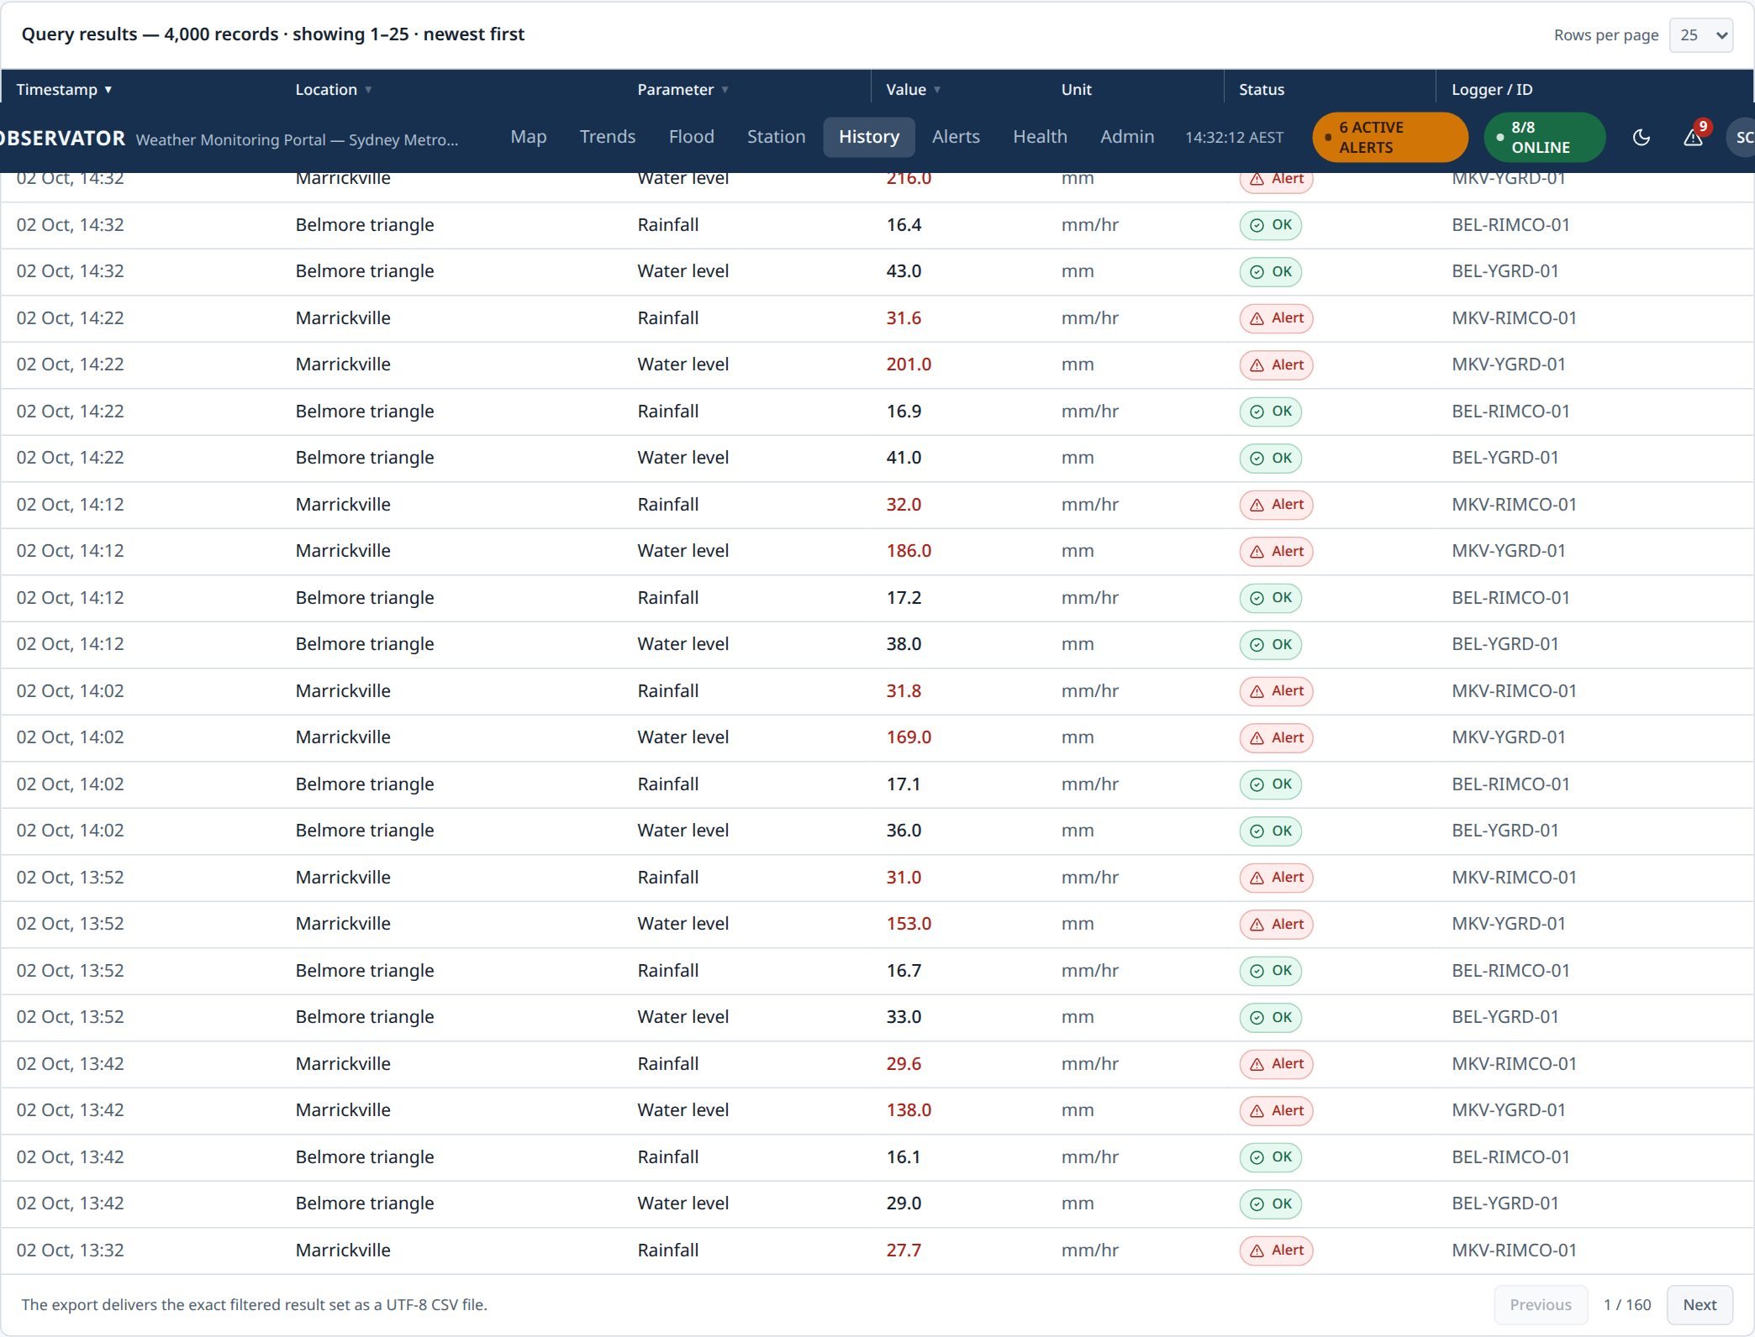
Figure 18 — History — the results table
Underneath is the full table. Select a column heading to sort, choose how many rows to show per page, and select Export CSV to download exactly the records you asked for. The rainfall charts at the top of the page show rain by hour for each gauge over the last two weeks.

Health — is the system working?
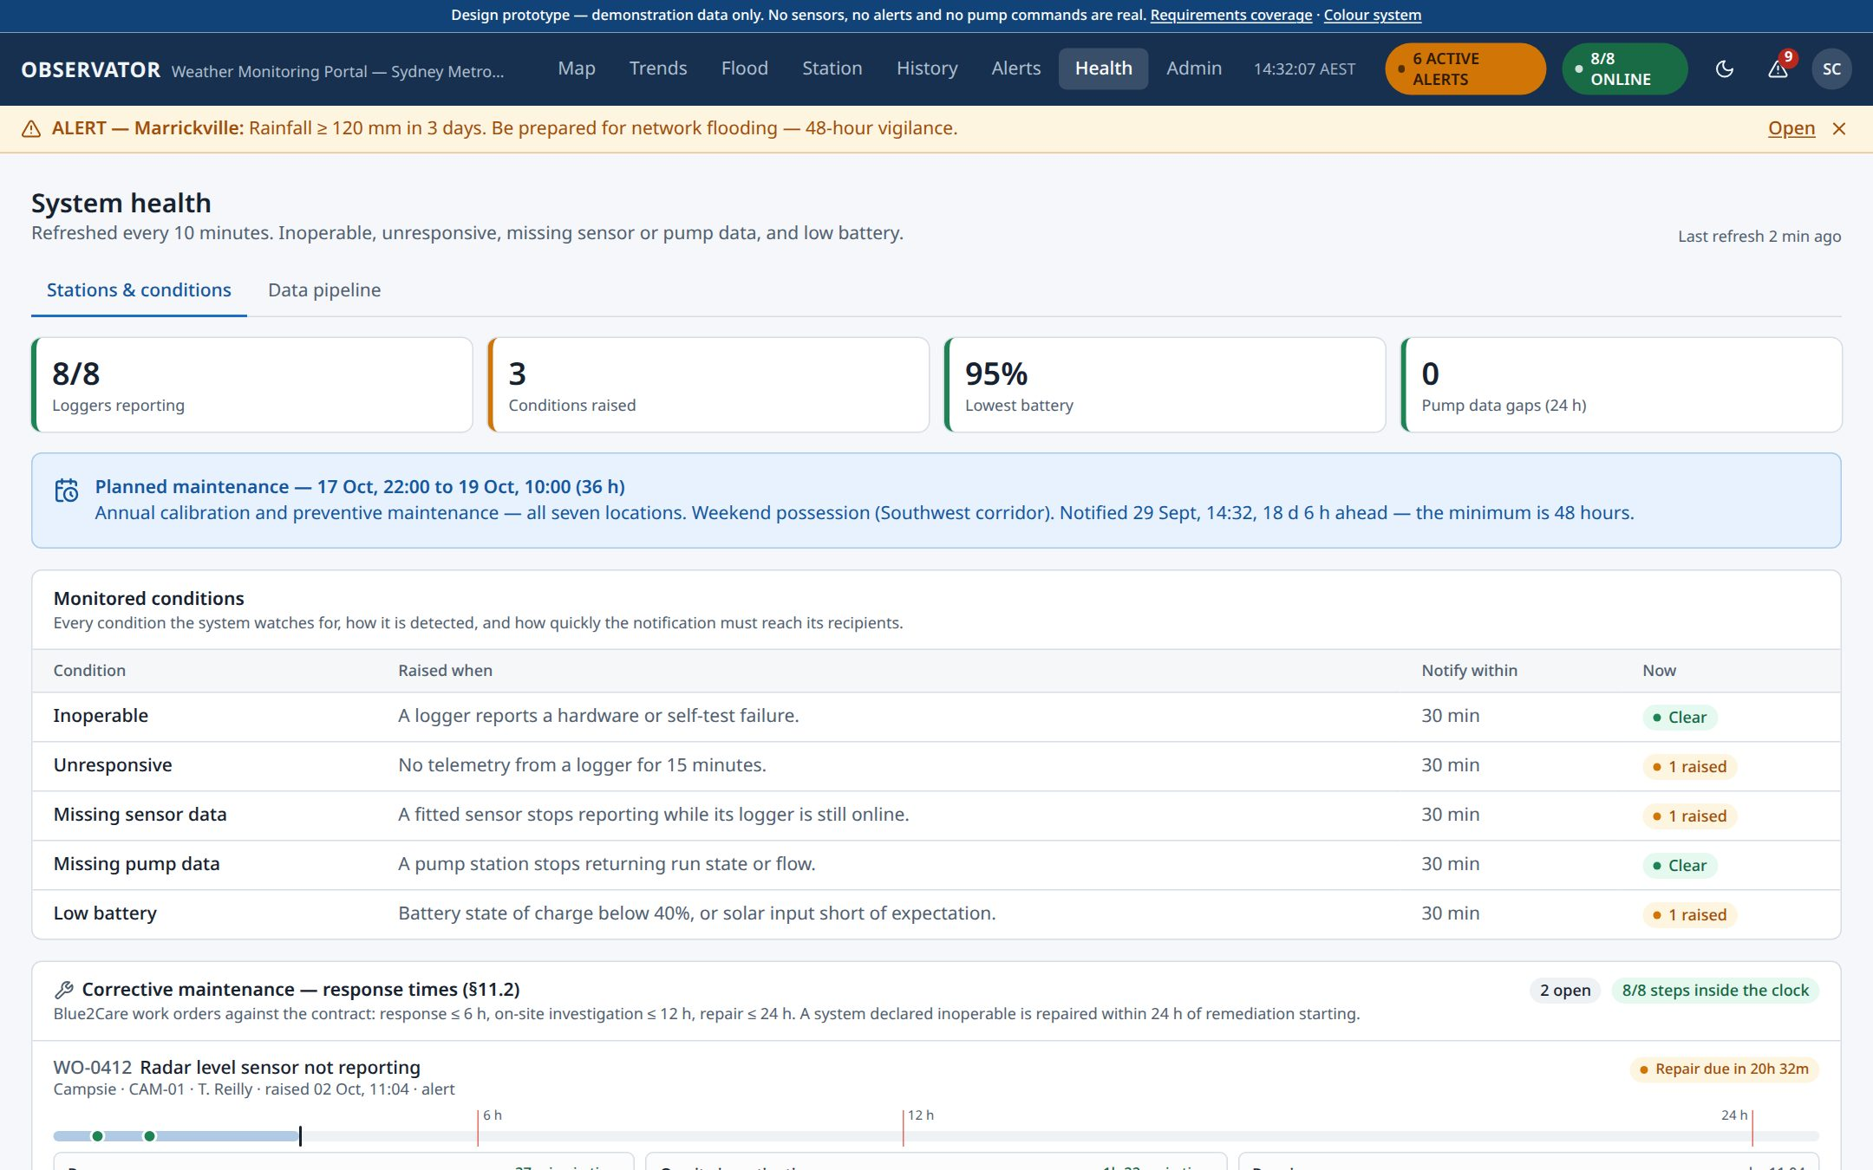
Figure 19 — System health
Health refreshes every 10 minutes and answers "is everything working?":
- Monitored conditions — inoperable, unresponsive, missing sensor data, missing pump data and low battery, each showing Clear or raised.
- Availability — a strip per logger for the last 24 hours. Green is reporting, amber is a sensor not reporting, grey is the logger silent. Hover a block for its time and cause.
- Redundancy — which backup source takes over if a sensor fails, and how the alert wording changes.
- Conditions raised, data quality (readings held back as suspect), calibration due dates, and power for every logger.
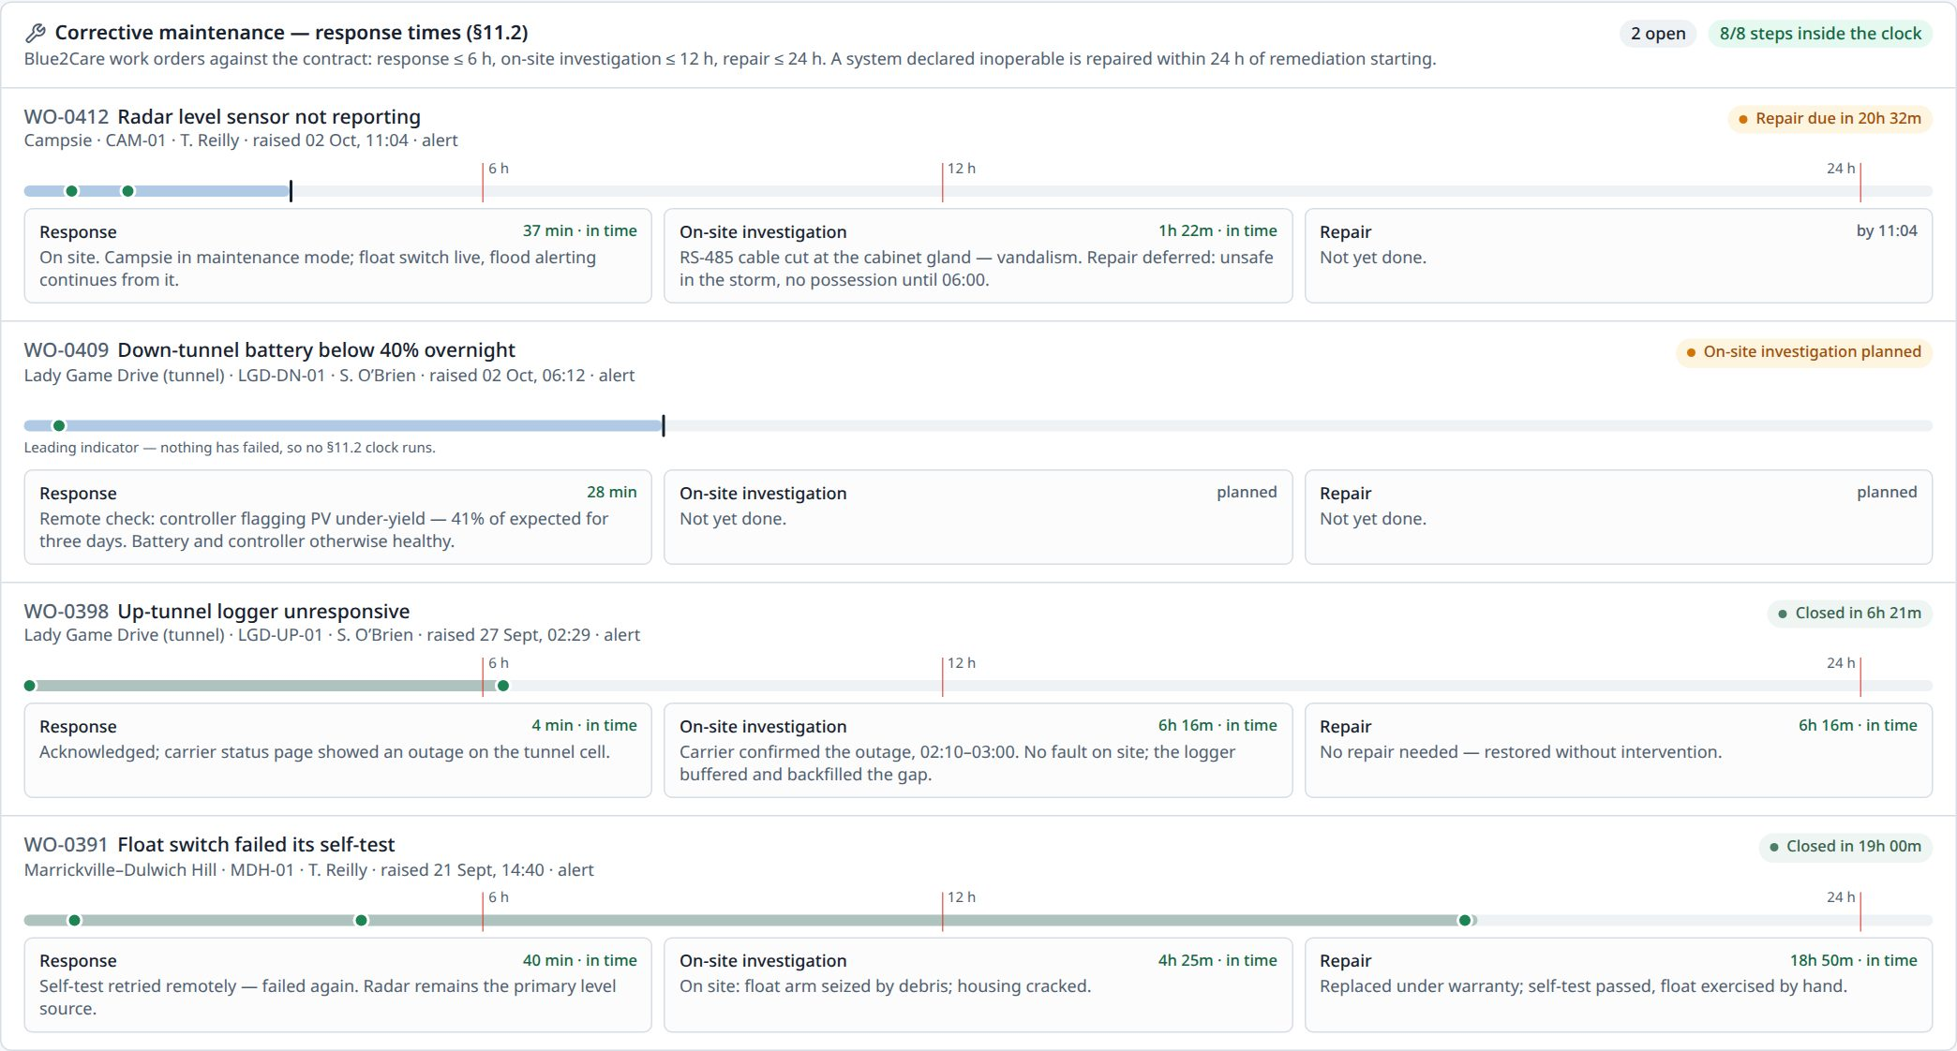
Figure 20 — Repairs against the response times
Corrective maintenance tracks each fault as a work order against the agreed response times — response within 6 hours, on-site investigation within 12, repair within 24 — with each step's time and notes.
The Data pipeline tab shows how data travels from the field to the portal, with today's counts.

Administration
Admin in the menu is for administrators. It has seven pages: Users, Roles, Alert rules, Sensors, Recipients, Audit trail, and System & contract.

Users
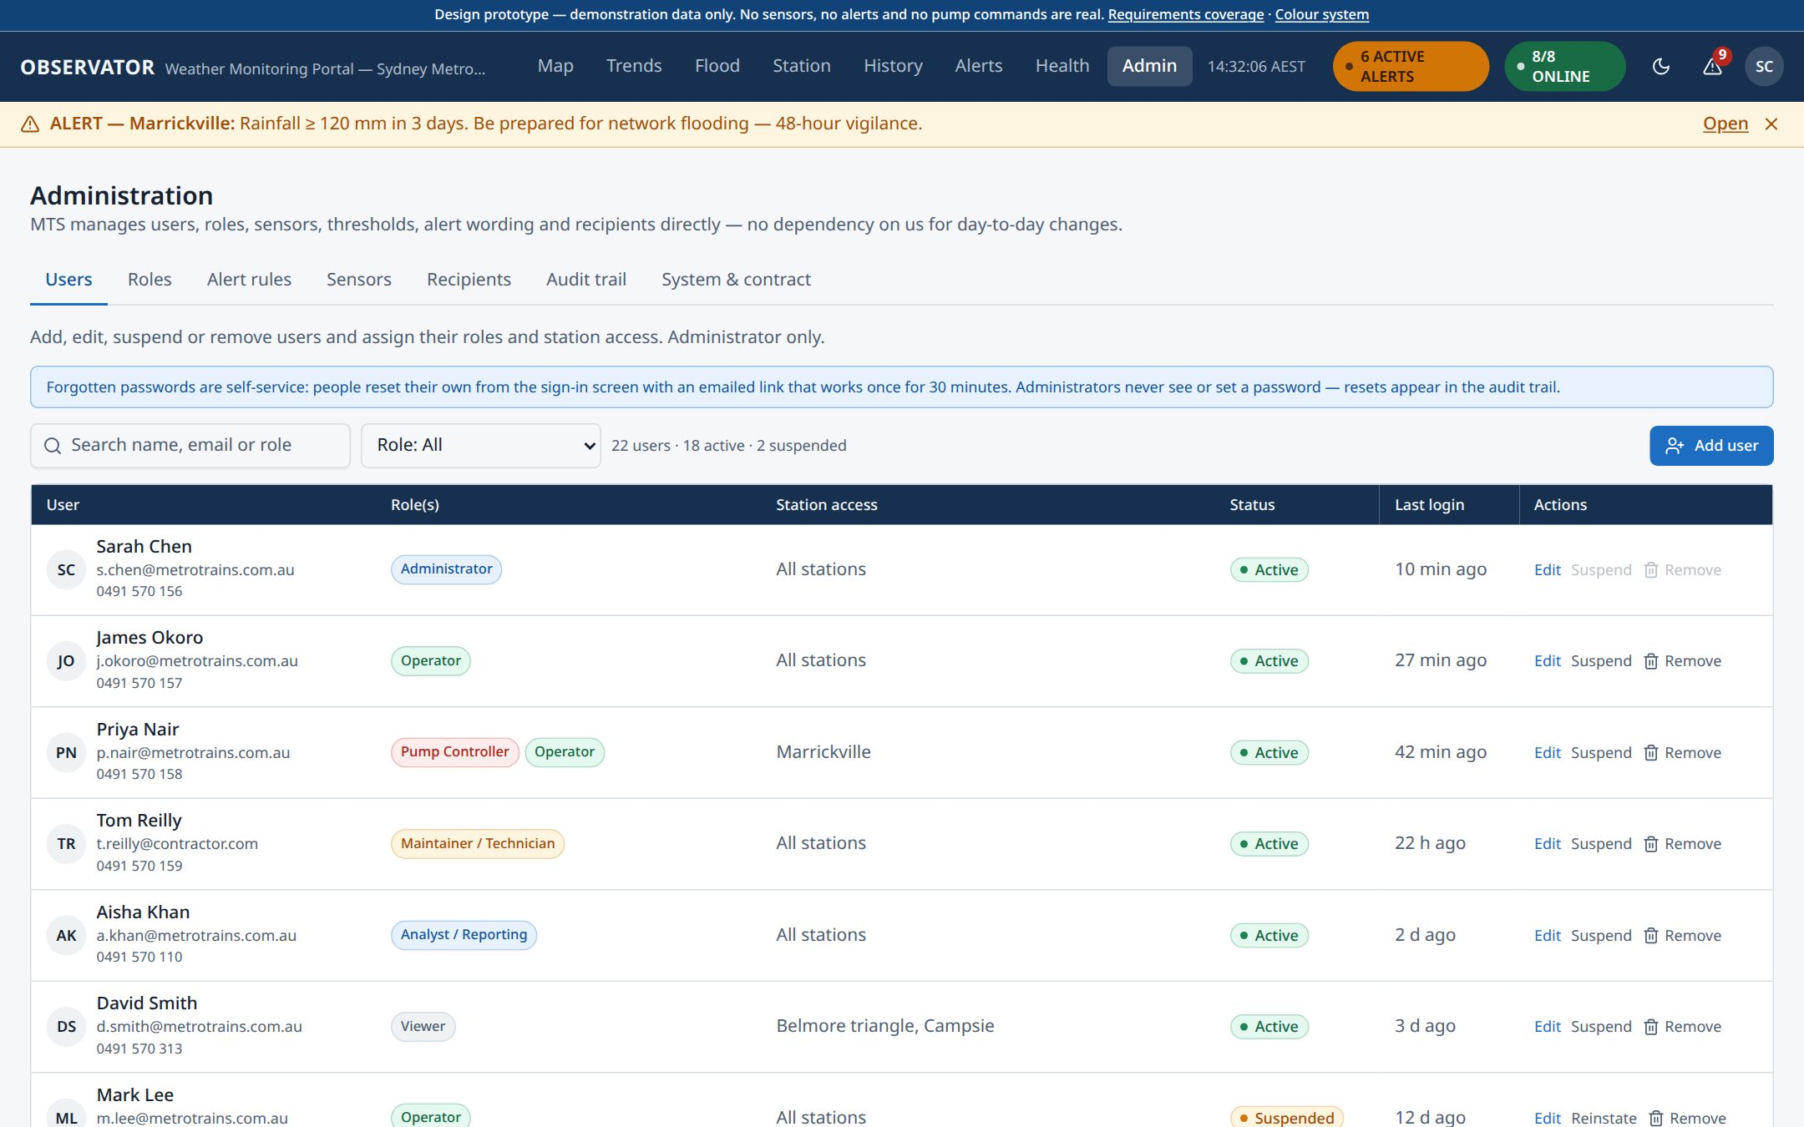
Figure 21 — Users
- Add user — enter the name, email and mobile number, choose one or more roles and which stations they can see. They receive an invitation and set their own password.
- Edit — change roles, station access or contact details. Changes apply at once.
- Suspend — block sign-in but keep the person's history. Reinstate reverses it.
- Remove — delete the account (its history stays in the audit trail).
Administrators never set or see passwords. People reset their own (see Forgotten your password).

Roles
Six standard roles are provided (see Who can do what). Select New role to create your own, choosing exactly which permissions it carries.

Alert rules
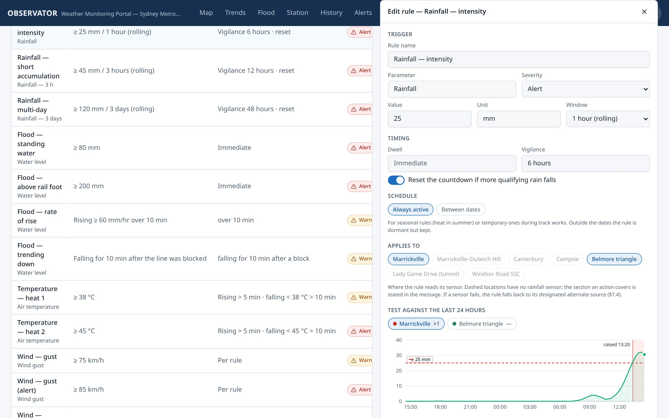
Figure 22 — Alert rules, with a rule open for editing
Every alert threshold, timer, message and recipient is a setting here — no software change is needed.
- Use the switch on a row to turn a rule on or off.
- Select Edit to change a rule: the threshold and time window, how long a reading must last before alerting, the countdown after it clears, dates it is active (for example summer only), the locations it covers, the message (with a preview of what people receive), and who gets it.
- Select New rule to add one.
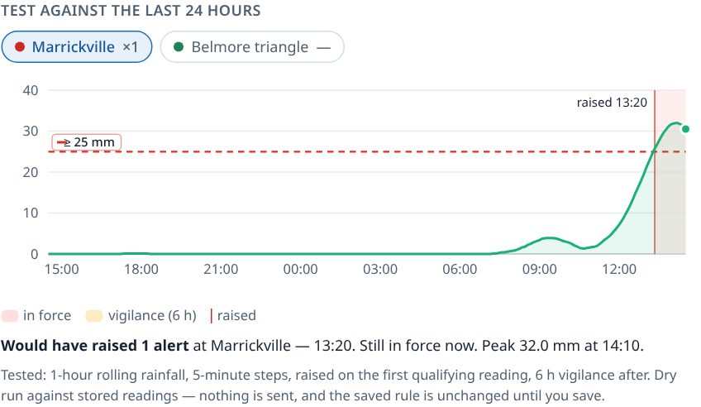
Figure 23 — Testing a rule before saving
Test against the last 24 hours shows, before you save, when your changed rule would have fired at each location. Use it to check a new threshold is right.
Every saved change creates a new version. Version history shows who changed what, and Restore brings back an earlier version.

Sensors
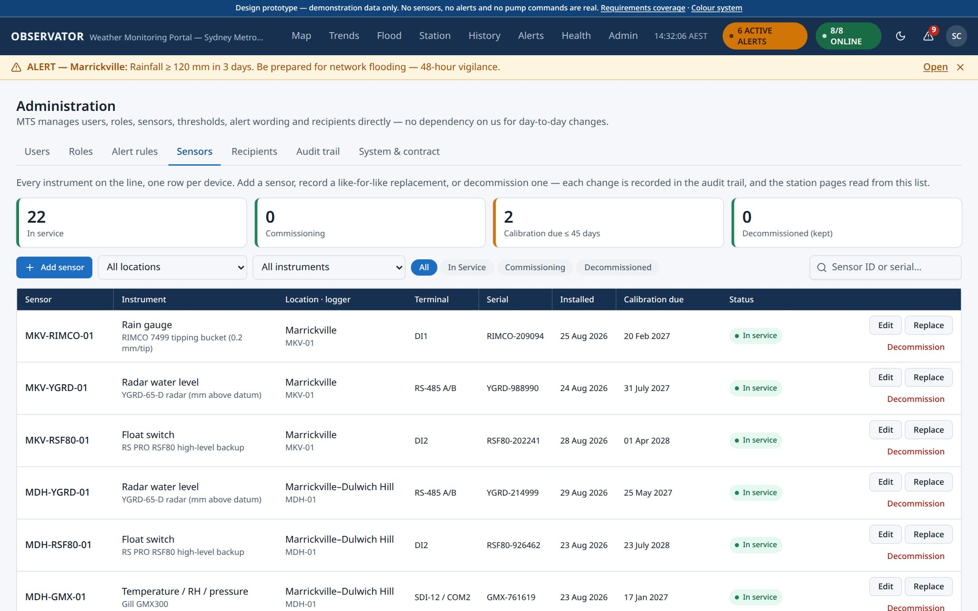
Figure 24 — The sensor register
Sensors lists every instrument on the line with its location, logger connection, serial number, install date, calibration due date and status.
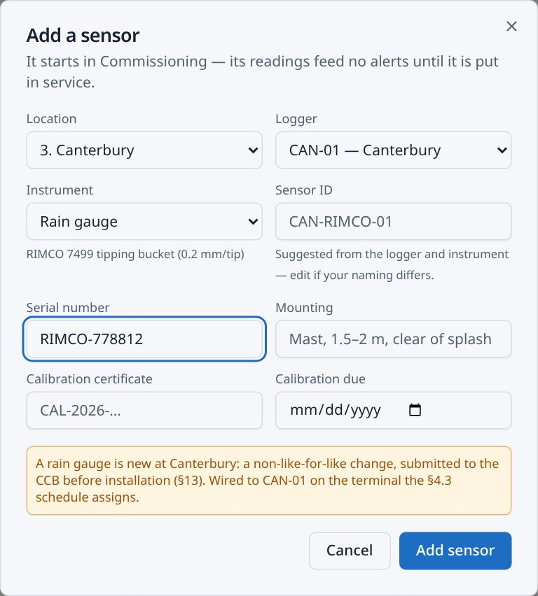
Figure 25 — Adding a sensor
- Add sensor — choose the location, logger and instrument type, then enter the serial number (and calibration certificate if you have it). A new sensor starts as Commissioning: it raises no alerts until you select Put in service.
- Edit — correct the details.
- Replace — record a like-for-like replacement with its new serial number. The sensor keeps its ID and history.
- Decommission — retire a sensor, with a reason. It stays on the list for its history.
Station pages read their equipment list from here.

Recipients
Who receives which alerts, and by which channel (on screen, email, web push), by group and by person.

Audit trail
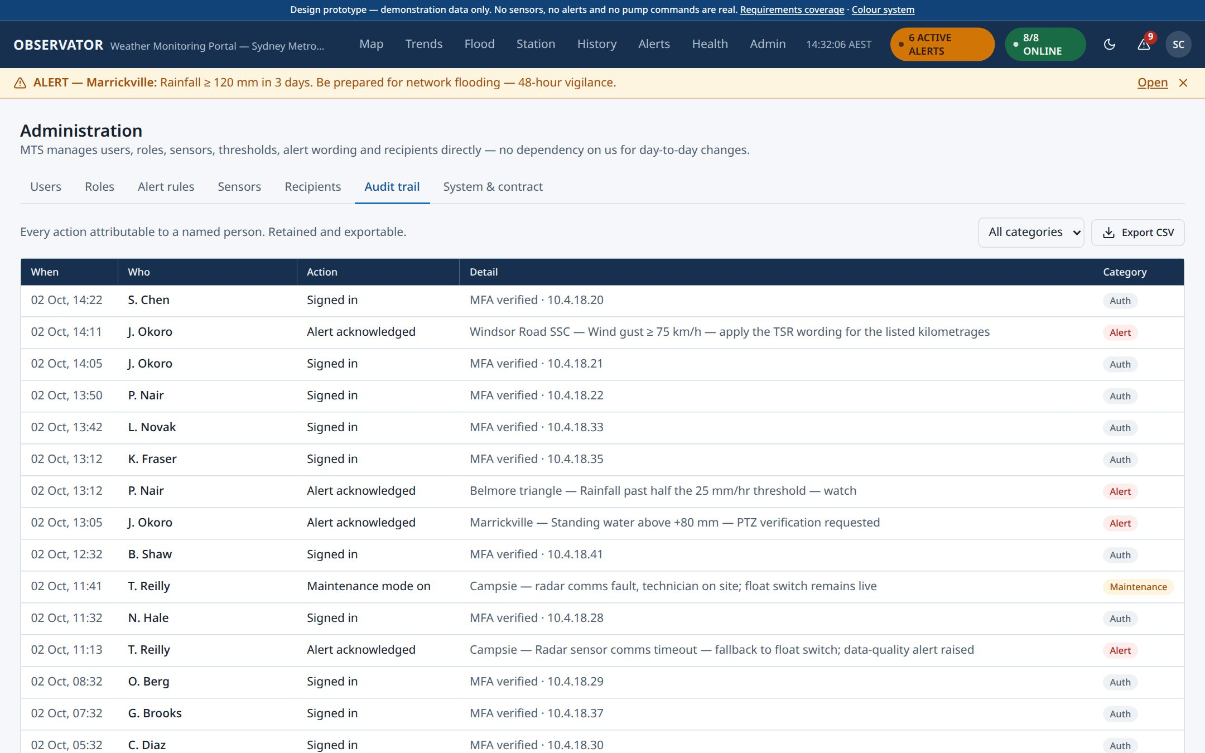
Figure 26 — Audit trail
A permanent record of who did what and when: sign-ins and password resets, users and roles changed, rule edits, sensor changes, alerts acknowledged, maintenance mode and every manual pump command. Filter by category and select Export CSV.

System & contract
A summary of the installed system: the sensors at each location, how the system was delivered, the maintenance and response commitments, and safety and governance.

Your settings
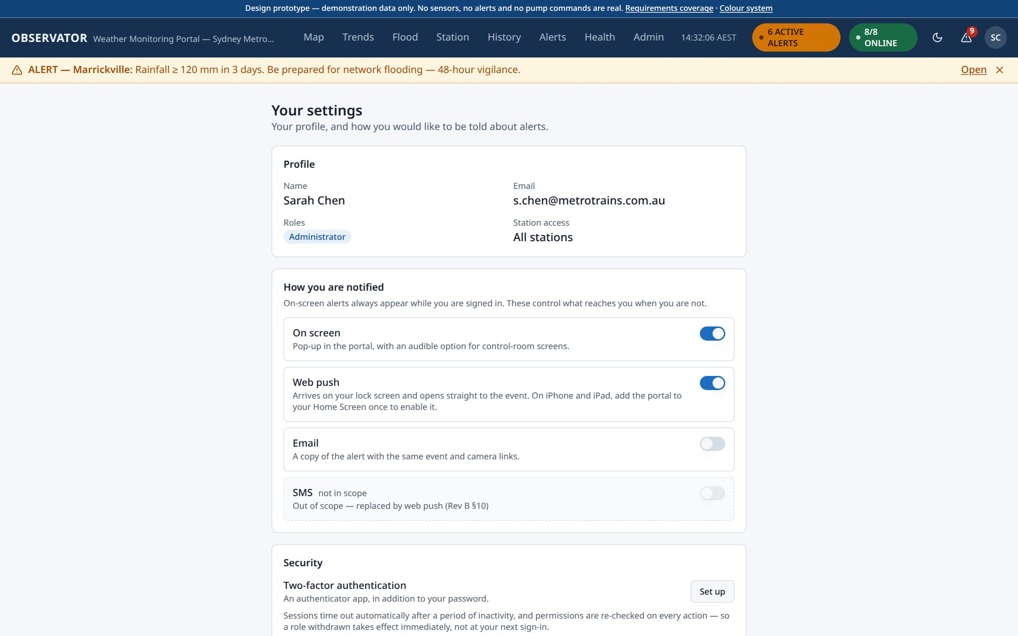
Figure 27 — Your settings
Open from your initials → Profile & notifications:
- Notification preferences — which alerts you receive, and how (on screen, email, web push).
- Security — set up two-factor authentication with an authenticator app.
- Display — how the portal uses colour. Light or dark is the moon / sun button in the top bar.
For your security, you are warned and then signed out after a period of inactivity.

Using a phone
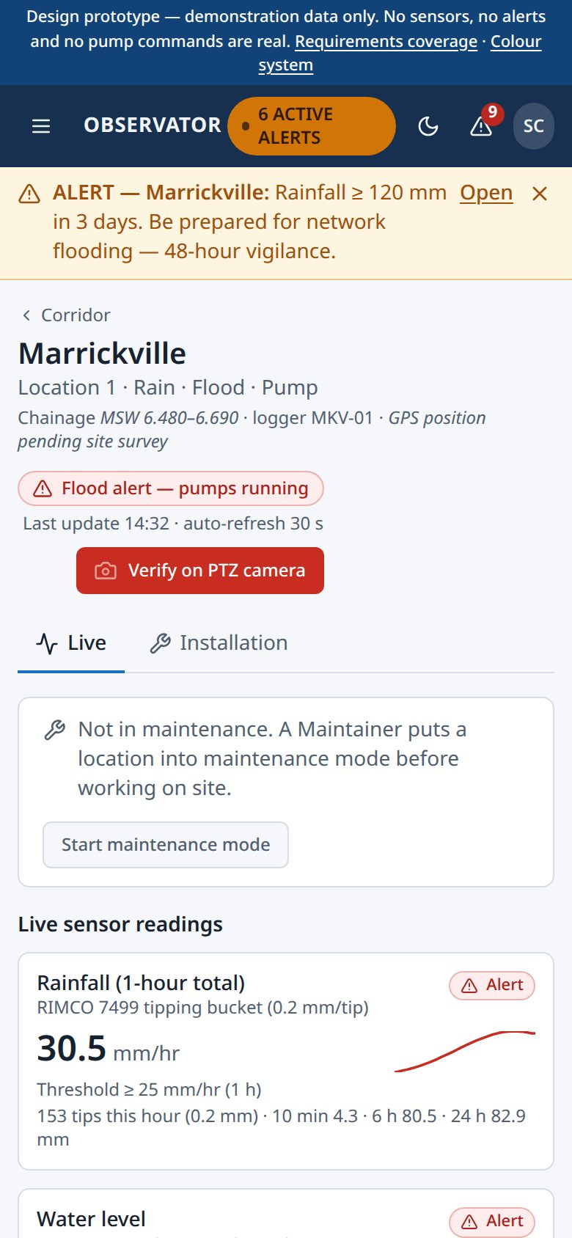
Figure 28 — The portal on a phone
Every page works on a phone. Pages reflow into a single column, tables scroll sideways, and the pump controls come straight after the readings so they are quick to reach.

Who can do what
Role | Typical user | Can
Administrator | System owner / IT | Everything: users, roles, alert rules, recipients, sensors, and all viewing and control
Operator | Operations control room | View everything, receive and acknowledge alerts, start operational responses
Pump Controller | Authorised operations staff | Everything an Operator can, plus manual pump start/stop at permitted stations
Maintainer / Technician | Field and maintenance | Equipment and power health, calibration, maintenance mode, maintenance alerts
Analyst / Reporting | Engineering and reporting | History, trends and CSV export; no control
Viewer | Stakeholders | View only — no actions or changes

A person can hold more than one role, and can be limited to particular stations.

Quick answers
I forgot my password. Select Forgot your password? on the sign-in screen. The link comes to your email and works once for 30 minutes.
I'm locked out after wrong passwords. Wait 15 minutes, or reset your password.
How do I stop a red alert showing as new? Open Alerts and select Acknowledge. Your name and the time are recorded.
The camera window keeps appearing. It is asking someone to confirm standing water. Check the feed and acknowledge, or snooze it for 10 minutes.
How do I get data into Excel? Use History, run your query and select Export CSV. Every chart's download icon also exports just that chart.
A station shows grey or "no data". The sensor or logger is not reporting. Health shows since when, and whether a work order is open.
How do I add a new sensor? Admin → Sensors → Add sensor. It starts in Commissioning; put it in service once it has been checked.
Who changed this rule? Admin → Alert rules → Version history, or the Audit trail.

Reviewing the prototype — demo time
Because the prototype uses demonstration data, it opens at 14:32 during a storm at Marrickville. The demo time button at the bottom right plays the storm forward (×10, ×60) or jumps straight to key moments — the pumps starting, the line blocked, the camera check, the water falling and the all-clear. Back to 14:32 starts again. This control exists only in the prototype.
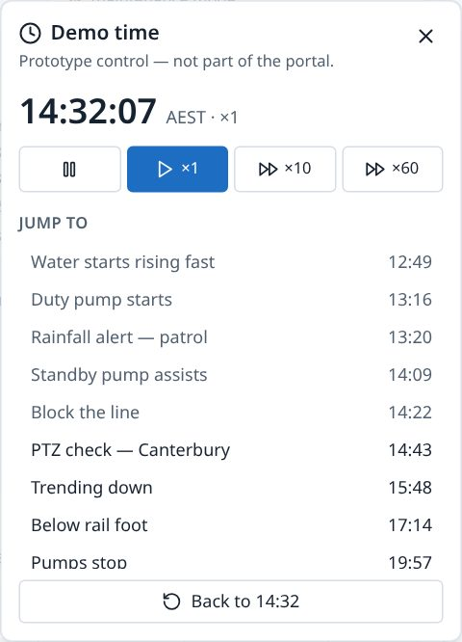
Figure 29 — Demo time

