**INFO 6205**

**Program Structures & Algorithms**

**Fall 2018**

**Assignment 4 – Test Cases and Outputs**

Parallel sorting algorithm screenshots for different thread values(ranging between 16-512 as power of two’s), and cutoff ranging from 4096 to 2097152.

**Output for Thread Value = 16**

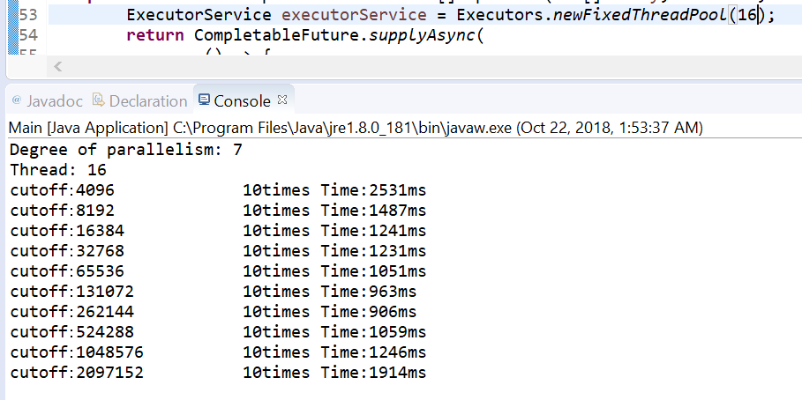

**Output for Thread Value = 32**

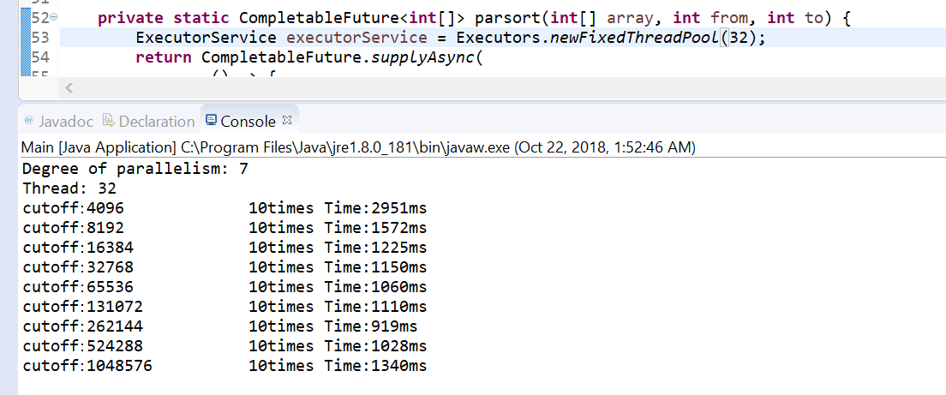

**Output for Thread Value = 64**

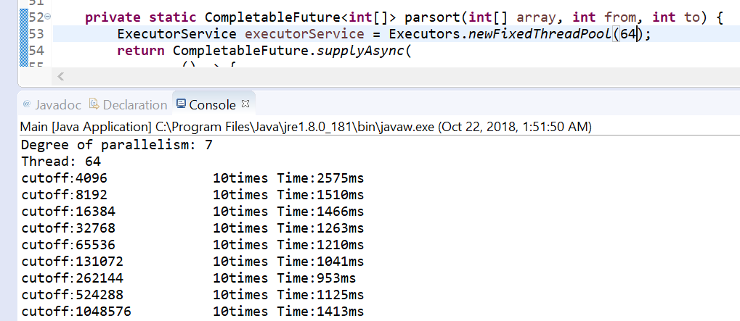

**Output for Thread Value = 128**

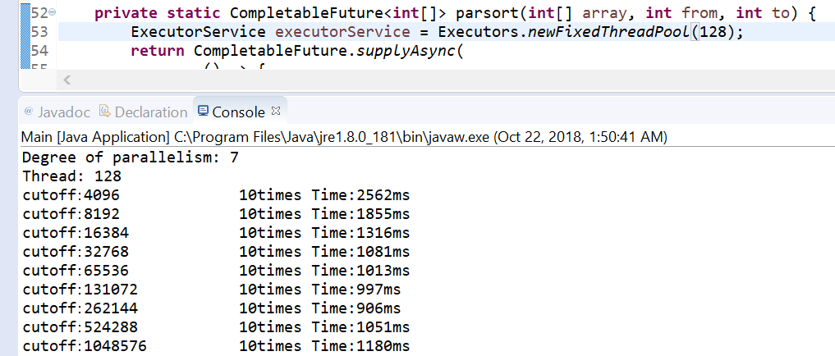

**Output for Thread Value = 256**

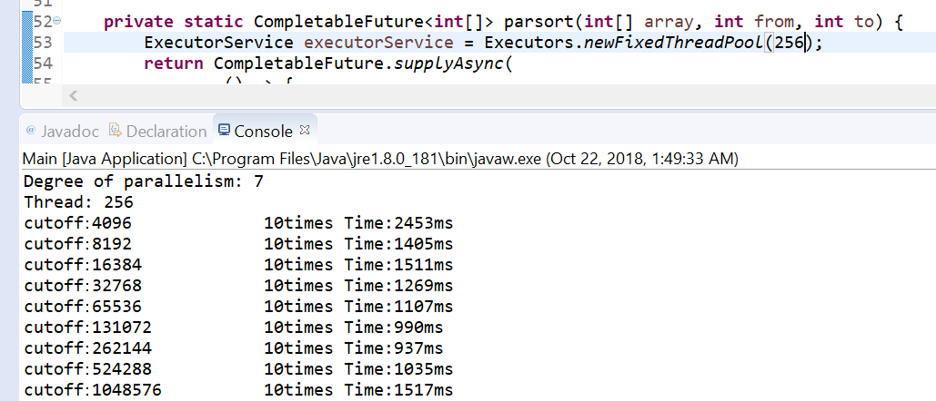

**Output for Thread Value = 512**

