<h3>THE LATEST BBQ TRENDS & TIPS FOR SUMMER 2017</h3>

<p>Over the last decade in the UK the average number of BBQ’s held per family each summer has risen dramatically from around 2.5 per year to 10. That’s pretty impressive considering our climate. Plus it clearly shows we Brits have embraced BBQ culture. And whilst we’re still playing catch up with our American cousins, a culture of grilling is most definitely on the rise in the UK.</p>

<p>There’s no denying, that on both sides of the Atlantic, BBQ food incites real passion, and in the US at least, some fierce competition. And much like the garden furniture industry, consumer demand is driving product innovation and development. </p>

<p>A burgeoning street food scene here in the UK is also driving us to try and recreate our favourite eats at home, to not be afraid to try new styles of cooking. So, with British summer officially in full swing, Garden Centre wanted to bring together a few of the latest grilling products and food related BBQ trends & tips. </p>

<h5>Korean BBQ</h5>

<p>We have a good friend who lives in Seoul, he’s been over there for a good 10 years or so, and since day one he’s raved about Korean BBQ. Big mistake! About 6 months or so back I went to Yijo in North London and it blew my mind. And the great thing is it can easily be replicated at home, well maybe not as good, but blooming close. And it is perfect for parties. We’ve had friends over a couple of times now, done them our take on a Korean style BBQ, and they’ve loved it. </p>

<p>Korean BBQ or Gogigui to give it the correct name (which simply translates as meat roast), is basically the Korean method of roasting beef, pork, chicken, or other types of meat. The key is that the food is usually prepared at the table on gas or charcoal grills, which in many of the Gogigui restaurants are built into the table itself. Just as a concept, this form of cooking works so well at home, really bringing friends and family together. </p>

<p>Your guests get to cook their own meat, which is best done on a BBQ table. We used a couple of Well Done Table Top Social BBQ Grill’s that we ordered online. You and your guests can then wrap the meat in a parcel of lettuce, throw in some rice and spicy condiments, and you’re good to go! Well, there’s a little more to it than that. However, the key to getting the authentic Korean BBQ taste is all down to the fermented and sweet-spice-umami. If you want to know more about getting the authentic Korean BBQ taste, then the YouTube video below from Angela Minji Kim is a great starting point: </p>

<h5>Electric Grills</h5>

<p>I think if I hadn’t only just purchased a new gas grill a year or so back, I’d be going electric. It's the ‘cleaner’ grilling of a gas BBQ taken a step further. Like gas, there’s no need for cleaning away dirty charcoal afterwards but with added convenience. No need for a gas bottle, just plug in and play. </p>

<p>I love my gas BBQ and well you get a good number of BBQ’s out of a large bottle, but I always find getting it swapped out for a full one when empty a bit of pain. Lugging them into the car. Plus you don’t have the fumes, it is cheaper to run and in some properties, it is simply not safe to have a gas BBQ. You need a fair bit of space, good ventilation. No gas or hot charcoal, the risk of fire is significantly reduced too, so much safer for those of us with small patios. Or you could even go as far as using an electric BBQ grill safely on an apartment balcony. So, if you fancy switching to electric, then take a look at the following grills: </p>

**<p>Fire Magic E250s Electric Grill</p>**

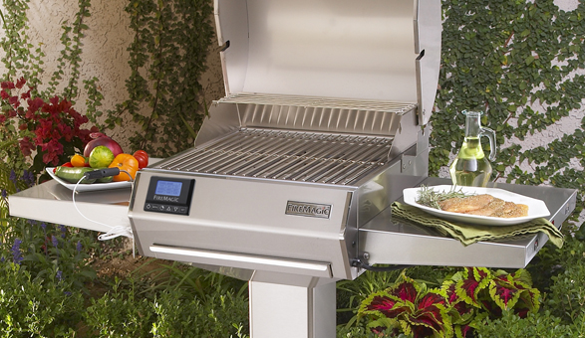

<p>The Fire Magic electric grill heats to more than 725 °F all wrapped up in a triple wall insulated body. It also features a double wall lid for maximum heat concentration, and a precision thermostatic control system so you know exactly when the grill is at the right temperature for whatever you’re cooking. For me this grill is spot on for apartment balconies or small back gardens, it looks stylish, but packs all the performance the home BBQ’er will ever need. </p>

**<p>Weber Q 1400 Portable Electric Grill</p>**

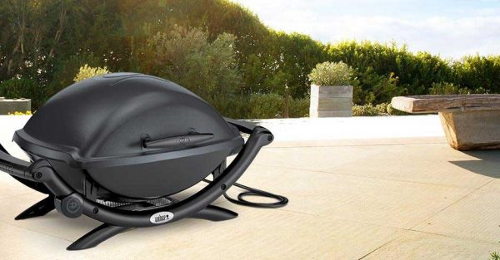

<p>The Weber Q 1400 Portable Electric Grill</p>

<p>The [Webber Q 1400](http://www.bbqguys.com/item_item_2876964.html), on the other hand, is a little more compact and portable so perfect for taking on a camping trip or to the caravan etc. Also great for that Korean BBQ table top experience too. It features an infinite control burner valve that allows you to choose the perfect temperature. Aluminium heat retention liners keep that heat from escaping, while removable trays etc. make cleaning-up a doddle. Just plug in the 6-foot cord and you’re good to go! </p>

<h5>Close to Home</h5>

<p>Locally sourced food is fast becoming one of the most important factors for many consumers. Not just for the BBQ, for all cooking. All of us have access to a local farmers market or shop, locally sourced products are even found in many of our supermarkets. And this is more than just the latest foodie fad, there are numerous real benefits to sourcing local foods. </p>

<p>Locally grown food is full of flavour. Crops are picked at their peak of ripeness versus being harvested early in order to be shipped and distributed to the supermarket. Many times produce at local markets has been picked within 24 hours of your purchase. You're also eating food seasonally, the right time to eat it. Nutrients in our fresh foods decrease over, and because the time between harvest and your table is significantly reduced, the nutrient value is higher. Food imported from other countries is older, has travelled and sat in a distribution centre before it even hits the supermarket shelf. </p>

<p>However, for me, the two main reasons to buy local is the support you're providing to your local economy and at the same time benefitting the environment. Money spent with local farmers etc. stays close to home, it is reinvested back into the local community. It helps to maintain farmland and green spaces in your community. And for those who like a little peace of mind, you know exactly where and how the food was grown. You can have confidence that animals have been raised free-range not in factories, and that crops are free from pesticides etc. </p>

<p>If you want to find out more about eating locally sourced food, then [BBC iWonder – Why should I buy and eat local?](http://www.bbc.co.uk/guides/zpg6sg8) is a great place to start. However, if you’re doing a BBQ for friends and/or family, then you want to use the best produce available, so locally sourced meat and veg is the best way to go! </p>

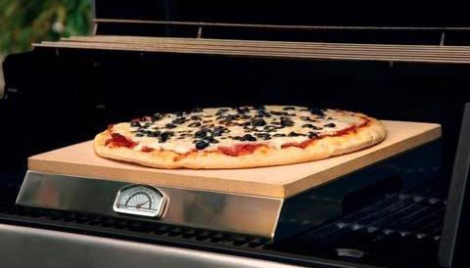

<p>The Bull PizzaQue Pizza Stone for BBQ Grills</p>

<p>I love this. I have, to be honest I don’t own one and I’ve not tried it, but the concept alone meant I had to include it in this post. I definitely want to get one. I’d love full-size pizza oven if I’m honest with you, but I just don’t simply have the room for one. This then is the next best thing. The Bull PizzaQue Pizza Stone features a steel base with built in thermometer, and it can be popped directly onto your BBQ grill to cook crisp, smoky, brick oven style pizza. It’s available to buy from our Garden Centre! </p>

<h5>BBQ Wing Rack</h5>

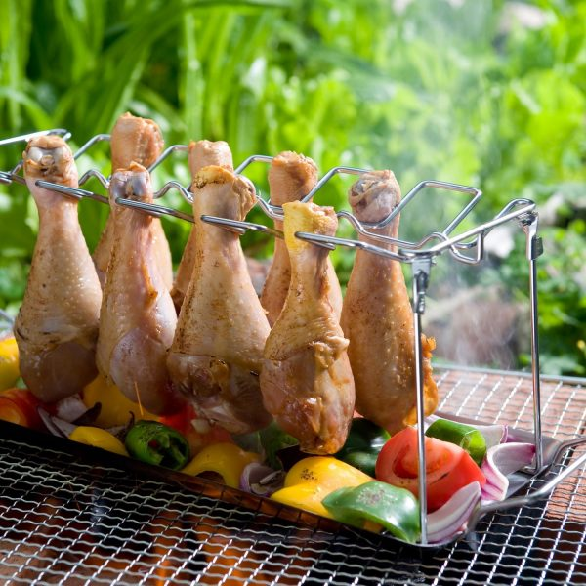

<p>Man-Law Stainless Steel BBQ Wing Rack</p>

<p>You can’t beat good (and spicy) BBQ chicken wings but they can be a pain to cook. Well not so much to cook, more the mess they make. Sauce burning to the grill plate, dripping everywhere. Tasty stuff but a pain to clean off afterwards. The solution is the Man-Law Stainless Steel BBQ Wing Rack from BBQGuys. </p>

<p>This clever little rack allows you to put BBQ wings and drumsticks without all the hassle of a mess, flip or adjust. The rack has a versatile, removable grill pan for cooking vegetables right along with your wings. It also folds flat when not in use which is good for saving on space. Heavy gauge stainless steel construction means this BBQ rack is built for toughness too. </p>

<h5>Himalayan Salt Plate</h5>

<p>This is another one I’ve not tried, but a good friend recommended it to me a few weeks back, so it just had to go on this list. He’s a retired chef, and BBQ fanatic too, so I trust him. Sounds like the point to include a bad pinch of a salt joke but I will refrain. Anyway, the Himalayan Salt Plate (pictured below) is basically an incredible way of getting flavour into your BBQ food and serving it. The light pink Himalayan rock can be slowly heated or chilled to extreme temperatures. The tight salt crystals that you find in the Himalayan salt blocks mean that they retain temperature for a long period of time. </p>

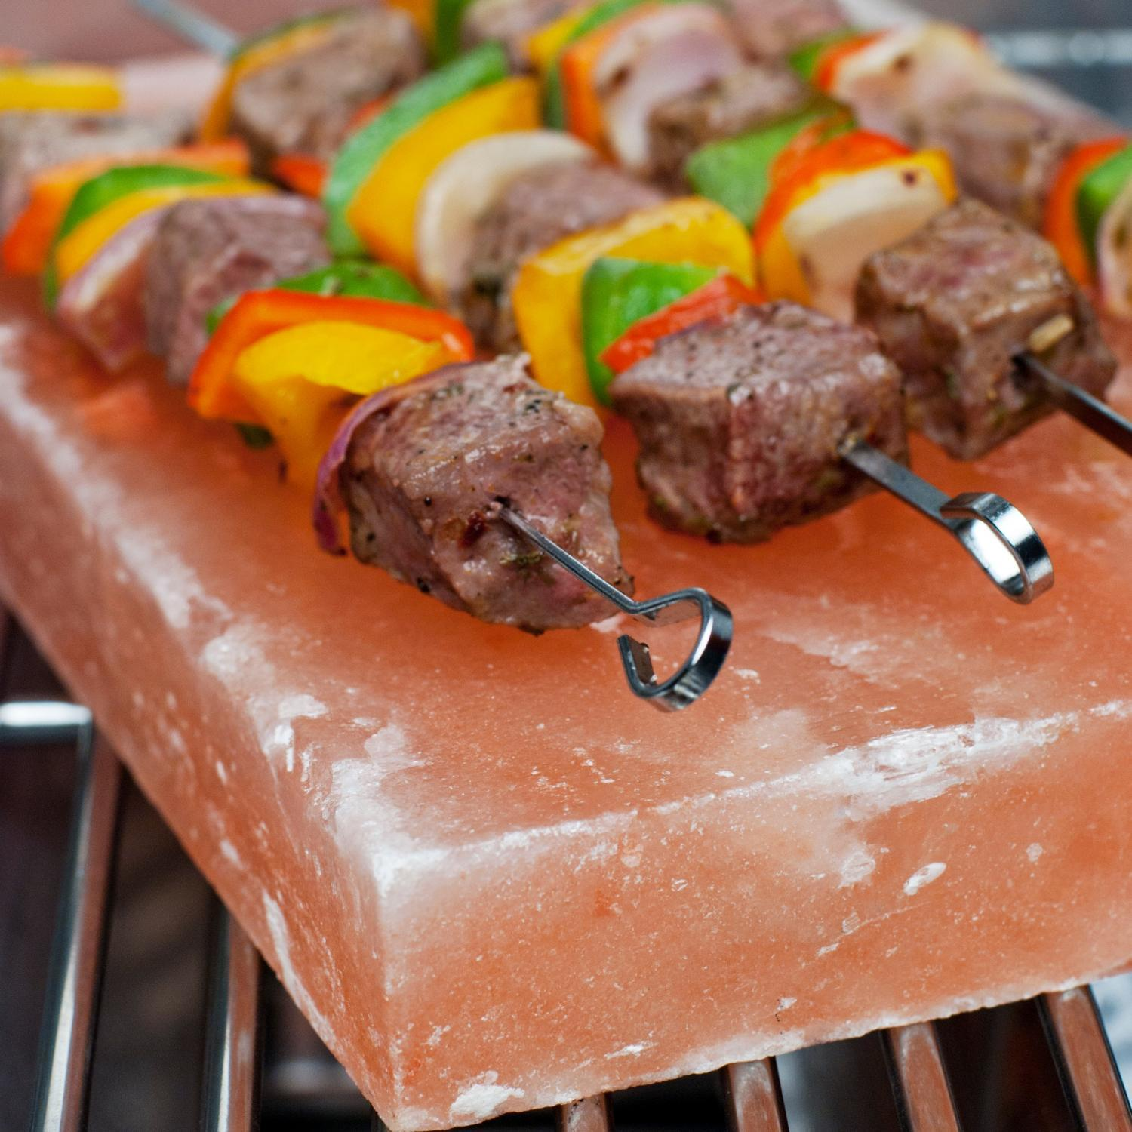

<p>Himalayan Salt Block on the BBQ</p>

<p>It can be heated up on the BBQ and then taken to the table and used to fry fish or meat. Or alternatively, it can be chilled in the fridge and then used to keep chilled food from warming up too quickly. The salt block is rich in mineral salts, which when used for will flavour any food that is cooked or served on it. </p>

<p>You can purchase a 30cm x 20cm x 2.5cm plate and a smaller 21cm x 10cm x 2.5cm plate in our shop. I also stumbled across a great article on [Natural Living Ideas](http://www.naturallivingideas.com/himalayan-salt-block/) whilst researching this post that gives you 10 reasons why we should all own a Himalayan Salt Block and how to use them. </p>

<p>Could smoking be the new grilling? </p>

<p>If you’ve ever had a slow cooked smoked brisket, ham, or pulled pork in a restaurant then this question is a no-brainer. Who wouldn’t want to try and cook some of that at home? Well, now you can do it on the BBQ with the [Stainless-Steel Smoker Box](http://www.williams-sonoma.com/products/stainless-steel-smoker-box/) from Williams Sonoma (pictured below). This a great way to get all that smoky BBQ flavour on a regular gas BBQ without any of the mess. </p>

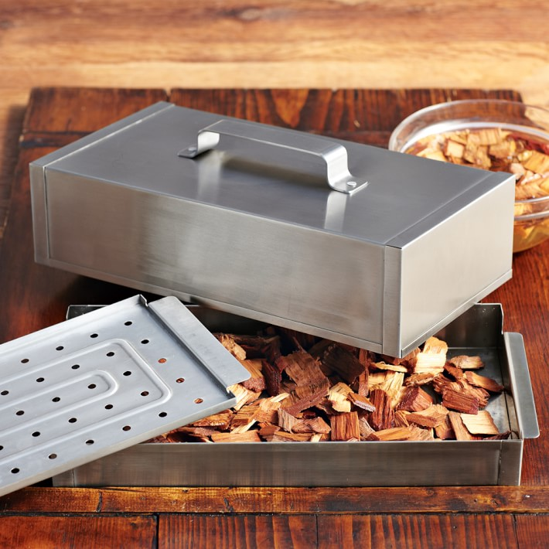

<p>The Stainless-Steel Smoker Box from Williams Sonoma</p>

<p>However, if you do want to take things to the next level of smokie-ness… Then it has to be the Char-Broil Digital Electric Smoker (pictured below), this is one bit of kit that really means business. It features what they’re termed SmartChef technology, which is basically built-in Wi-Fi that uses a mobile app to notify you when your food is smoked to perfection. You can get more info and purchase over on the Char-Broil website.</p>

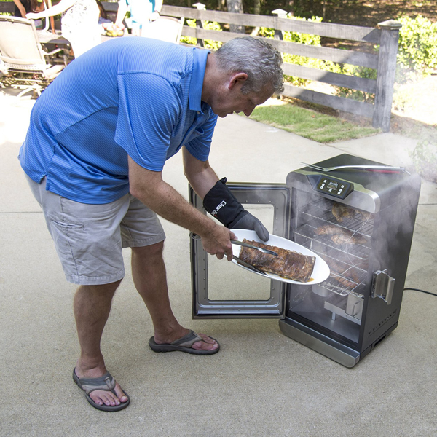

<p>The Char-Broil Digital Electric Smoker with WiFi SmartChef Technology</p>

<h5>Pellet Grills</h5>

<p>And last but not least, there is a new kid on the block. No longer is it just a choice between a gas or charcoal BBQ. Yes and we can now include electric into that equation too. But now there is also another option. Yes not new as such, but definitely new to the UK and quickly gaining popularity. Introducing the Pellet Grill. Providing you with that authentic pro BBQ taste, and helping you to take your wood-fired cooking skills to the next level, all in the comfort of your own back garden. A word of caution before we proceed though, a Pellet Grill is not cheap, however, they are by and far the best for taste, and to be honest they look damn cool too.</p>

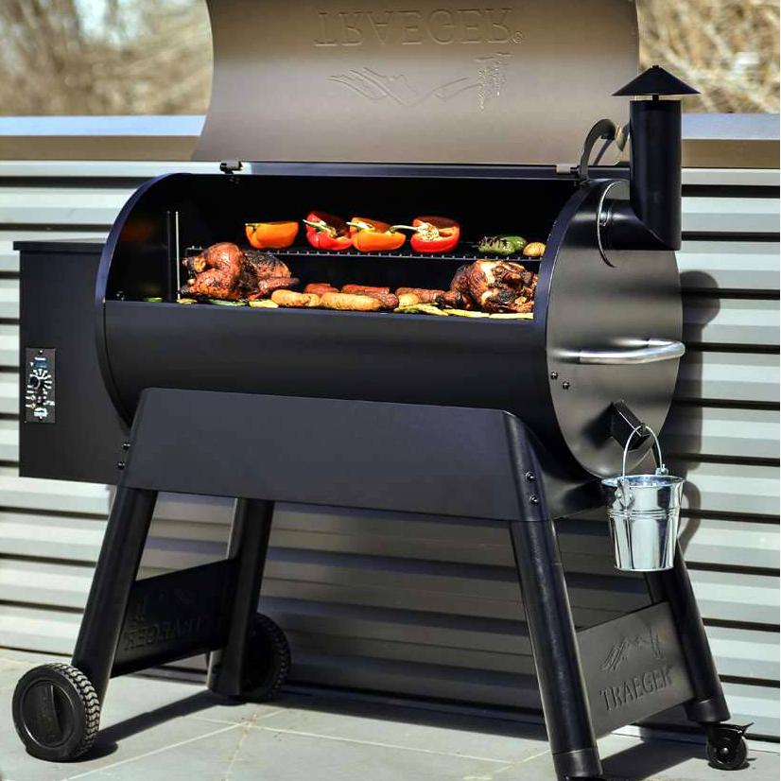

<p>Traeger Pro Series 34 Pellet BBQ Grill</p>

<p>Arguably the market leader when it comes to Pellet Grills is [Traeger](http://www.traegergrills.com/" \t "_blank), their name is synonymous with this type of grill, and they have an extensive range. The Pro Series 34 (pictured above) sits at the lower middle end of their offer but don’t let that put you off, this is a top bit of kit. And at close to £800, if you want that authentic taste, you have to pay a little bit more than our average gas grill.</p>

<p>However, as they say, themselves when your *“neighbours hear that you’ve bought a Pro Series 34, in all its colossal grillin’ glory, they might just crown you King of the Cul-de-sac”*! It features a digital pro controller with dual meat probes and an extra grill shelf. With 884 square inches of cooking surface, you’ve got the space to invite all your neighbours over for a BBQ too. Traeger also supplies a [wide range of hardwood pellets](http://www.traegergrills.com/shop/hardwood/), from Cherry to Mesquite, there’s something for all tastes.</p>

<p>So that’s all Lazy Susan’s BBQ trends & tips for summer 2017. If you’ve got any new BBQ gadgets you want to tell us about our any tips, please drop them in the comments box below. As always we’d love to hear from you. Happy grilling!</p>

Ref:

https://www.lazysusanfurniture.co.uk/blog/bbq/latest-bbq-trends-tips-summer-2016/