6 TIPS FOR CLEANING YOUR GARDEN IN SPRING

<p>There’s no denying our gardens and fields have been fooled by unseasonably warm weather this year across the whole of the UK. Daffodils were seen to bloom as far north as Yorkshire as December was one of the mildest on record in over 50 years.</p>

<p>As the weather continues to remain bipolar in its nature, the flowers that we associate with Easter have already started to blossom with temperatures reaching 10 degrees Celsius; above the seasonal average.</p>  
<p>So you may be asking, what difference does it make if our daffodils have blossomed early? Well, taking the time to spruce up your garden in early spring will no doubt pay off earlier than expected. Have you started dusting off your shovels, lawn mowers and gardening tool kits? Well, you may be noticing that the buds are breaking and the soggy grass we are so sick off trudging in has gradually turned into a calm shade of green. But when exactly is the best time to spring clean your garden? Now – is a pretty good time to do the dirty work; and by that we mean, tidying up the mess that winter offloads for three months of the year.</p>

<p>Here are 6 tips to spring cleaning your garden, so don’t think twice when you have a spare Sunday – it’s time to clean up while you can!</p>

<h5>Don’t let your garden own you, own it!</h5>

<p>Without a little TLC, your garden will soon become your arch enemy. Over winter, your garden has become a depositary for rubbish from last year’s shrubs and weeds. It’s time to grab some clean garden shears to cut away any dead weeds and flower heads frozen from winter. The way to do it is to cut them to the ground, so any new roots have the space to grow. Before you can begin planting a new lease of life into your garden, you must feel ready to attack last year’s perennials.</p>

<h5>Inject fresh soil</h5>

  
photo credit – shutterstock/ Singkham

<p>Once you have cleared your garden, early spring is the best time to take action against your weeds. You must be pro-active and the best time to do this is when the ground is still slightly damp as it’s easier to pull the young weeds out. If you are planning to add new plants to your garden, it may be worth testing your soil first; as if it’s been amended at any point during autumn/winter, it may be imbalanced. If you have rich, healthy soil, then all your ground needs is a little sprinkling of compost or an organic fertiliser.</p>

<h5>Divide and conquer</h5>

<p>Most of us like to grow perennials in our gardens as they last for around two years – a bargain keeper. However, due to their size, you may need to divide and transplant them somewhere else in your garden to avoid overcrowding. If done correctly, you will not damage the plant and of course, spring is the best time to move them.</p>

<h5>Organisation is key</h5>

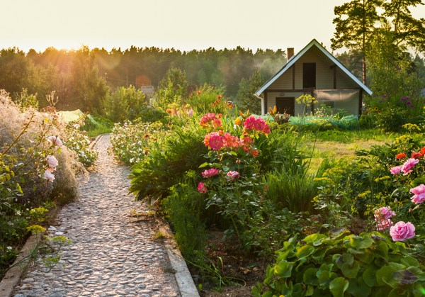  
(photo credit – shutterstock/ scorpp)

<p>Let’s take it back down to basics; without light, your plants will not bloom. So, when spring cleaning your garden, you must remember to observe the path of the sun throughout the day as what may look to be a perfect spot for your newly planted perennials, may become a hotspot for a shade under a canopy of foliage come summertime. </p>

<h5>Prepare a colour scheme</h5>



<p>Your garden is an opportunity to map your personality; your likes and your dislikes. If you enjoy an assortment of colours, you may choose to include a sharp contrast by choosing colours that are on the opposite side of the colour wheel. If vibrant shades are not your ideal garden theme, select several shades of the same hue. </p>

<h5>Plant away</h5>

  
(photo credit – shutterstock/wk1003mike)

<p>Once you have decided on your colour scheme and the variety of plants and perennials you would like to see blossom, it’s time for the fun to begin. Get your children involved as they love nothing more than getting mucky. Plant the tallest flowers at the back of your designated flower bed if it can only be viewed from one angle of the garden. If the flower bed can be seen from all different angles, then be sure to plant your tallest plants in the middle and remember the smallest plants should be planted in the foreground of the garden bed. </p>

<p>Your garden is now ready to soak up the sun (once it decides to grace us with its presence of course). But before you can do so, you may need to order brand new garden furniture to customise your garden design. If your table and chairs were damaged from last year's frost, it may be worth investing in a brand new set. Come spring, many gardening retailers will have some fantastic deals to snatch up. From BBQ, Homebase and teak garden furniture websites, there is an abundance to choose from. The best part, you can customise your furniture to your garden’s colour scheme; so match your cushions to your parasol. Whether you have a spacious lawn, or you have a patio area to accommodate your outdoor furniture, there are some fantastic ways to maximise your space. </p>

  
(photo credit – shutterstock/ zhu difeng)

Ref:

http://londoncleaningsystem.co.uk/6-tips-for-spring-cleaning-your-garden/