**Virtual Eye Doc**

**Human Eye:**

The human eye is a vital organ of human body, which reacts to light for several purposes. The eye as a conscious sense organ allows vision. The eyes are undoubtedly the delicate and most sensitive and amazing organs we possess. The human eye can distinguish about 10 million colours. They present us with the window through which we view the world, and are responsible for four fifths of all the information our brain receives – which is probably why we rely on our eyesight more than any other sense.

The human eye is the organ which

* Gives us the sense of sight
* Allows us to observe and learn about the surrounding world
* Are used in almost every activity we perform, whether reading, working, watching television, writing a letter, driving a car, and in countless other ways
* Processes light any object reflect or emit and allows us to see and interpret the shapes, colours, and dimensions of those objects

In absence of light eyes are not able to sense objects around. So taking care of our eyes is most important for all.

**Overview:**

Virtual Eye Doc is an android app based on Bengali language which can help people to measure their eye glass power considering their eye sight condition. They can also find the condition of their color blindness by checking some tests related to this problem. Also they can find here some special eye exercises and eye health tips, healthy foods which are good for keeping our eyes healthy. Most important thing is, this app is based on Bengali language to make sure that the people of all level in this society can use this app easily as many of them can hardly understand English and use that properly. So another goal of this app is to help general mass.

**Problem statement:**

Now a days using of eye glass is common. But there is no such way to know if it is necessary to consult an eye doctor or to know whether using glasses is necessary immediately. Also it is a problem to find eye health tips, eye exercises, healthy foods for eye etc many important information related to eye easily in one place in an organized way. Also as many people of our country specially in rural areas are still not used to use those apps made in English. So this app is made for them specially to help them to find their eye condition and take care of their eyes easily as this is made of Bengali language.

**Goal:**

It was our goal to help the general people by using eye power test feature, Color blindness feature, health tips, eye exercise movements, healthy foods etc in this app. As the main attraction of this app is, it is mainly based on Bengali language, the people of rural areas who can hardly understand English and can hardly use the apps made in English, they also can use this app easily and get benefits from this and also take care of their eyes. At beginning we had only the eye power test feature as our main feature, but later we added the color blindness feature also as there is no such app which combines both the feature in one place.

**Future Target:**

It is our future target to add the contact number and addresses of eye specialists in this app so that users of this app can easily contact with their desired specialists and take proper treatment. We have also planned to add more features related to eye tests here like various quiz games to check basic knowledge of user about eye and eye health.

**Target Group:**

* People of all level in this society
* People who are using glasses or want to use glasses or want to keep their eyes healthy
* People who want to know their eye sight condition
* People who can’t afford to do regular checkups and weak in English.

**Features:**

There are some features:-

**1. Eye Exam:**



**Fig-1: Power Test**

The eye exam feature decides the eye glass power of a user depending on the eye state. At first they will have to keep the screen away from their eye. Here they will be shown some letters, basing on their sight of those letters properly or not; result of their eye test will be decided approximately telling the eye glass power range.

**2. Color Blindness:**

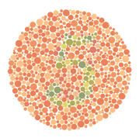

**Fig-2: Color Blindness**

The color blindness feature contains images which are used to check color blindness problem in our eyes. Here we used 15 images and in total 30 images. The first image contains a picture from which user has to find the hidden colored number and write it as input in that page. If they can find it correctly, then there will be a message. If they guess wrong number, there will be some information about their color blindness state and they will be known on which criteria of color blindness they belong. Finally the total number of correct guess will be shown when they complete all the levels of this test.

**3. Health Tips:**

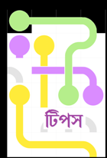

**Fig-3: Health Tips**

Eye health tips will help user to keep the eye healthy.

**4. Healthy Foods for eye:**



**Fig-4: Healthy Food**

Some healthy food for eye will let people know about the foods good for eye.

**5. Eye Exercises:**



**Fig-5(a): Eye Exercise**

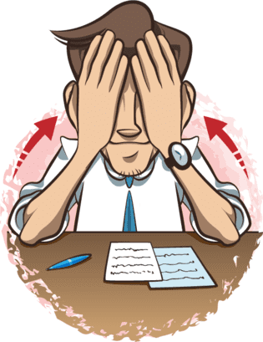

**Fig-5(b): Eye Exercise**

Eye exercise will help user to know about some easy and common eye movements.

**Functions:**

**Navigation header:**

For navigation header we used linear layout and also image view for adding image and text views.

**Drawer layout and navigation view:**

We used drawer layout and added navigation view to build up a navigation drawer.

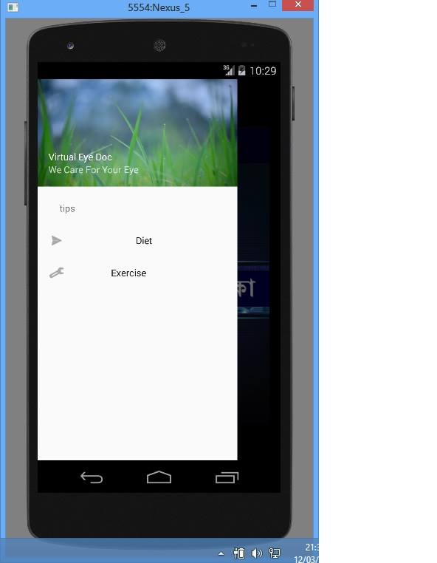

**Relative Layout:**

Relative Layout is a view group that displays child views in relative positions.

**Appbar Layout:**

Appbar is created to add to this lay out.

**Relative layout, Appbar Layout and text view:**

We used all these layouts to make this page for eye exam.

**Nested Scroll view, Appbar Layout and text view:**

**Coordinator layout and image view:**

Coordinator layout was used to coordinate and image view was used to add the image.

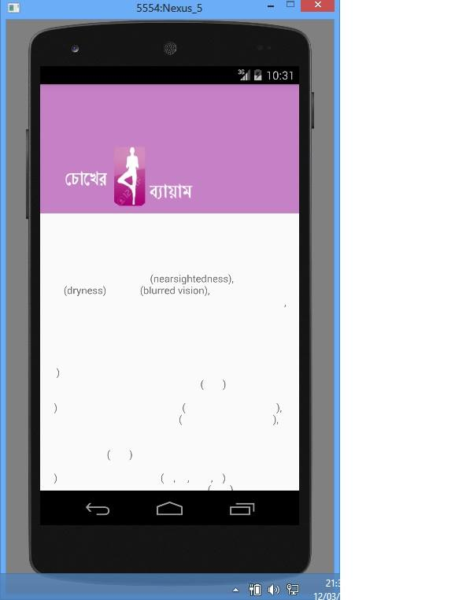 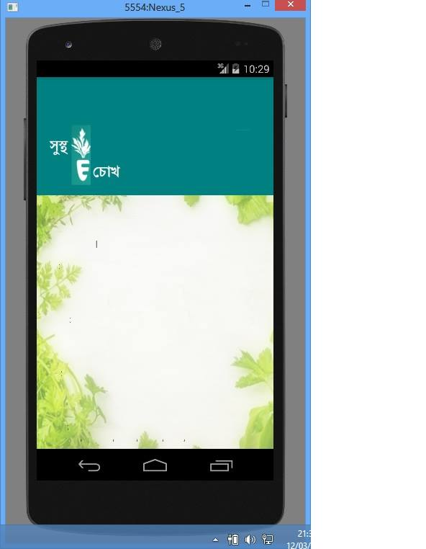

**Process:**

**Eye Power Test:**

 **<-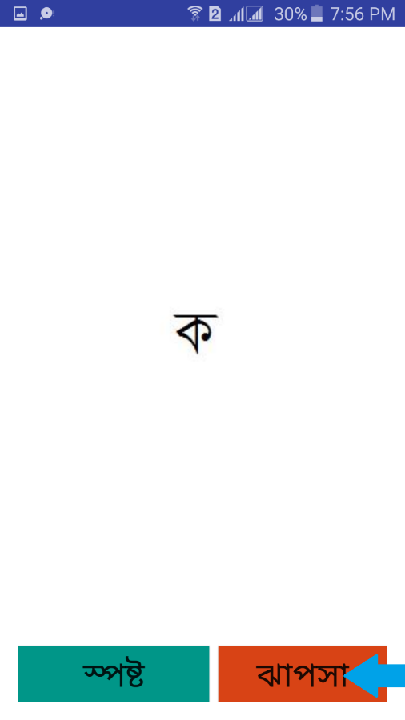 <- 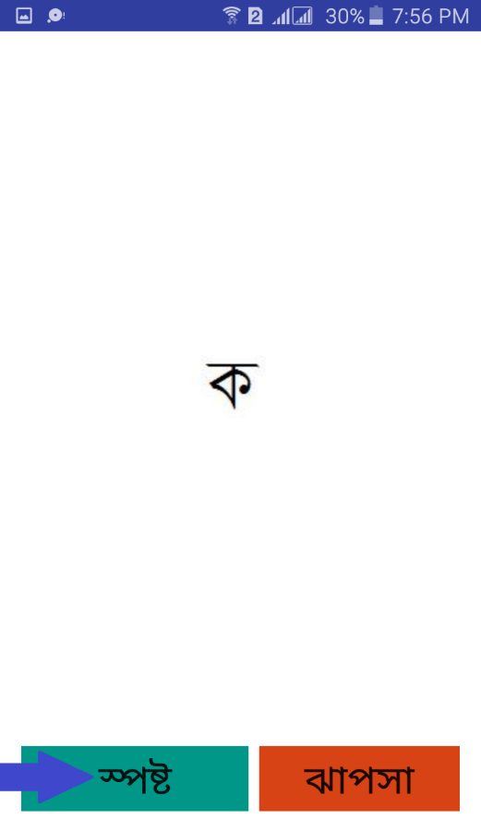<-**

**Fig-6(a): Eye Power Test Flow Chart**

**Color Blindness Test:**

**->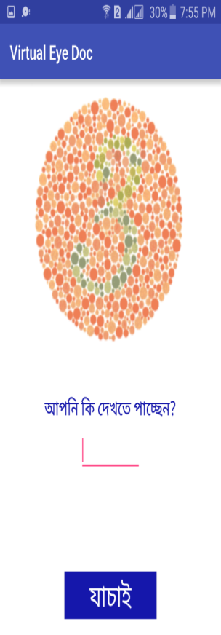->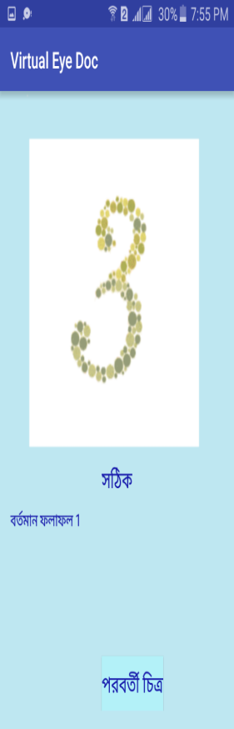->**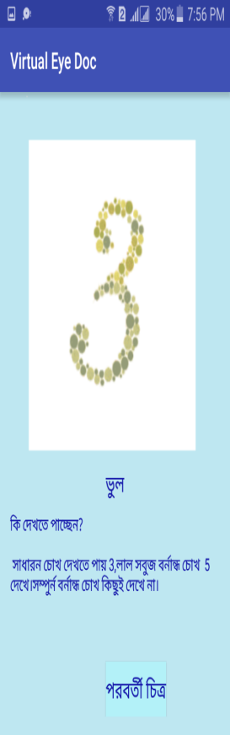

**Fig-6(b): Color Blindness Test Flow Chart**

**Overview of 10 android apps based on Virtual Eye Doc is developed:-**

**1. Application Name:** Eye exam

**Developers:**

[andrew.brusentsov@gmail.com](mailto:andrew.brusentsov@gmail.com)

Ul. Staronikitskaya, 10A, 79 Tula Tulskaya obl. Russia 300041

**Target Group:**

Those who have eye sight problems and also the normal user of Google apps store for normal eye check up.

**Feature Limitations:**

* This application is not intended to replace optician's regular full examination. They recommend getting a full eye test after using it.

**Features:**

* Several eye charts are available: Snellen chart, Landolt "C", Tumbling E, chart with pictures for little kids
* Objects are shown randomly
* Measurements statistics are available

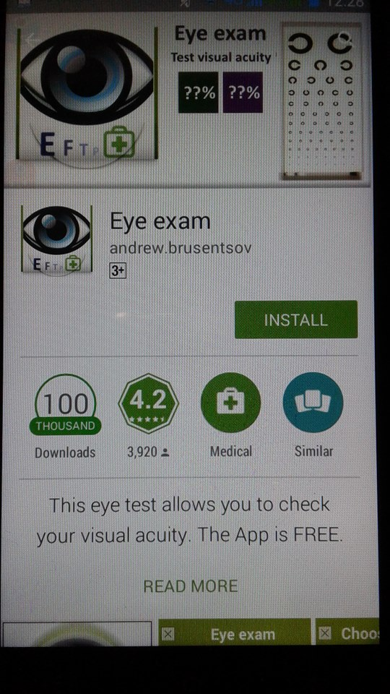 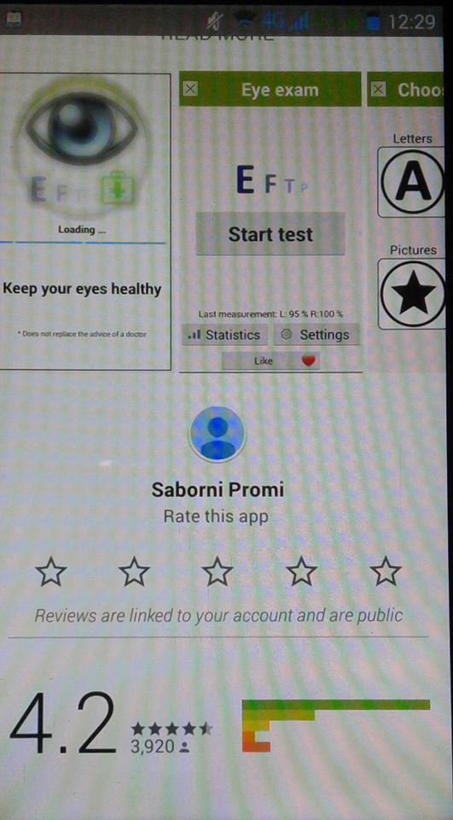

**2. Application Name:** Eye Test

**Developers:**

Balint Faragoapps

[b2creatived@gmail.com](mailto:b2creatived@gmail.com)

1023. Budapest Lajos utca 35 4/13

**Target Group:**

Those who have eye sight problems and also the normal user of Google apps store for normal eye check up.

**Limitations:**

* This application is not intended to replace optician's regular full examination. They recommend getting a full eye test after using it.

**Features:**

* Visual acuity tests (based on a Snellen chart, numbers and text, with black or white background)
* An Ishihara Colour Blindness test
* Spot The Odd! - A game that requires speed and good colour vision
* 4 Amsler grid tests
* An AMD test for macular degeneration
* A Glaucoma survey
* A Written test aka.

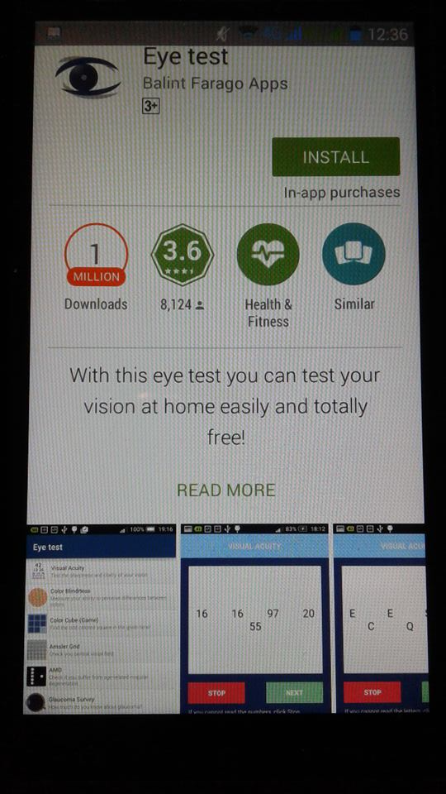

**3. Application Name:** Full Visual Test

**Developers:**

Gfsm

gfsmapp@gmail.com

**Target Group:**

Those who have eye sight problems and also the normal user of google apps store for normal eye check up.

**Feature Limitations:**

* This test can not in any case substitute a sight specialist examination.  
  Also note that colours of one’s screen device may alter the perception of the colours of the boards. Test may not be completely reliable.

**Features:**

* One can check the presence of any visual pathologies, such as:
* colour-blindness – Ishiara
* astigmatism
* myopia
* farsightedness

One can also measure your visual acuity.

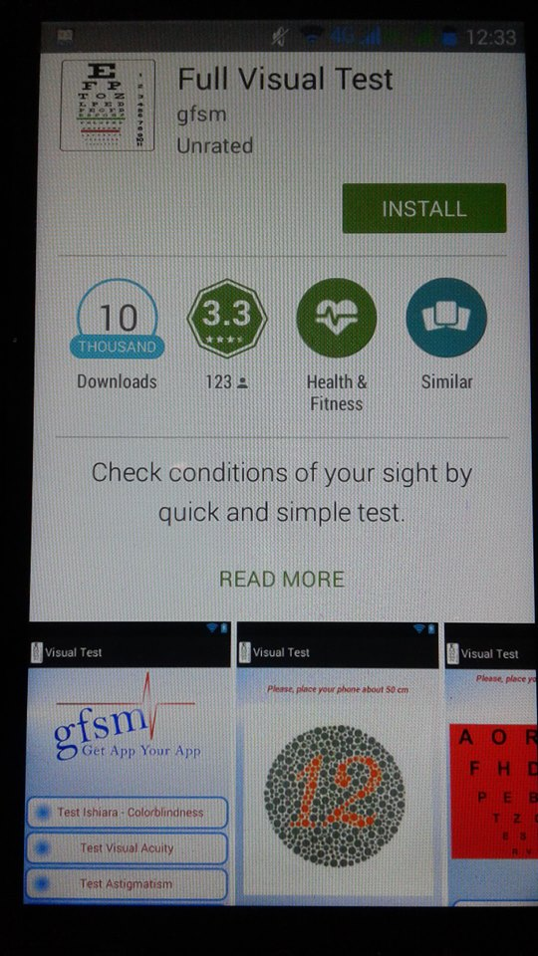

**4. Application Name:** Eye Exercise-Eye Care Plus

**Developers:**

healthcare4mobile

[healthcare4mobile@gmail.com](mailto:healthcare4mobile@gmail.com)

**Target Group:**

* Those who have eye sight problems and also the normal user of google apps store for normal eye check up.

**Feature Limitations:**

* This application is not intended to replace ophthalmologist's regular full examination.
* They recommend getting a full eye exam after using it.
* Eye exercises are not guaranteed to give perceptible/substantial results.

**Features:**

Vision therapy-

* Warm-up Eye Exercises
* Relaxation Eye Exercises
* Mind-Brain Exercises
* Eye Muscles and Focus Exercises

Eye Tests-

* personal vision screening to check vision improvement progress
* general eye screening to check if a doctor's visit is required
* household visits
* eye tests at universities, schools and kindergartens
* patients with macular degeneration who need to monitor their vision daily
* prevention of eye diseases
* Eye Health Information Field

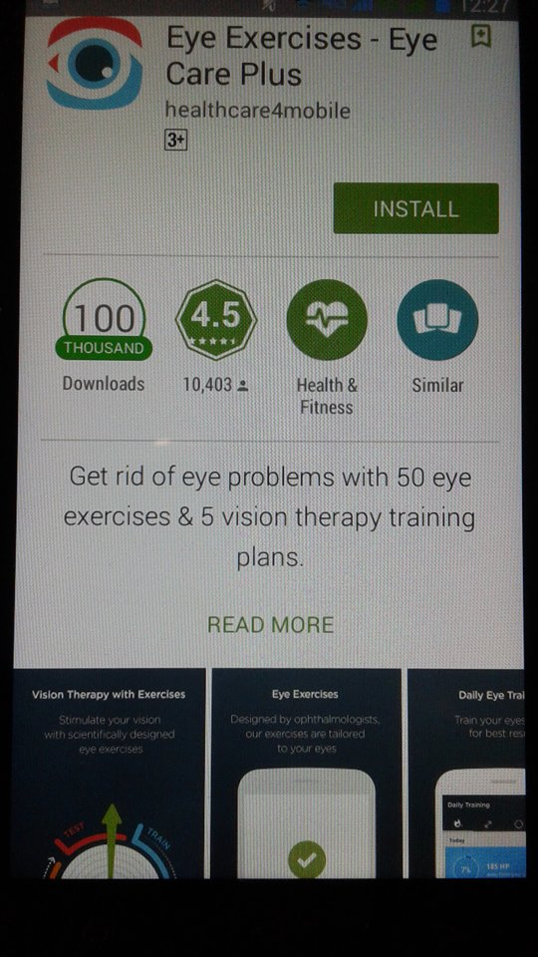 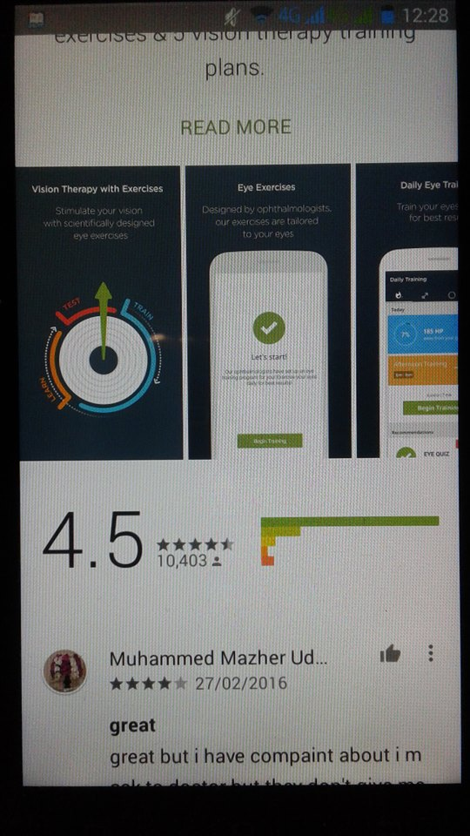

5. **Application Name**: Eye Test- Eye Exam

**Developers**:

healthcare4mobile

[healthcare4mobile@gmail.com](mailto:healthcare4mobile@gmail.com)

**Target Group:**

Those who have eye sight problems and also the normal user of google apps store for normal eye check up.

**Limitations:**

This application is not intended to replace ophthalmologist's regular full examination.  
They recommend to get a full eye exam after using it.

**Features:**

There are several types of eye tests in our Eye Exam app:

.Visual Acuity Test

.Snellen chart, LogMAR chart, Golovin–Sivtsev table, Landolt C / Japanese Vision

.Test, Tumbling E chart

. Astigmatism Test

. Accommodation Test

.Dry Eye Test

.Contrast Sensitivity Test

.Central Vision Test

.Cataracts Test

.Duochrome Acuity Test

.Red Desaturation Test

.Color Blindness Test

.Color Arrangement Test

. Hue Test (coming soon)

.Eye Health Quizzes

.Eye Quiz

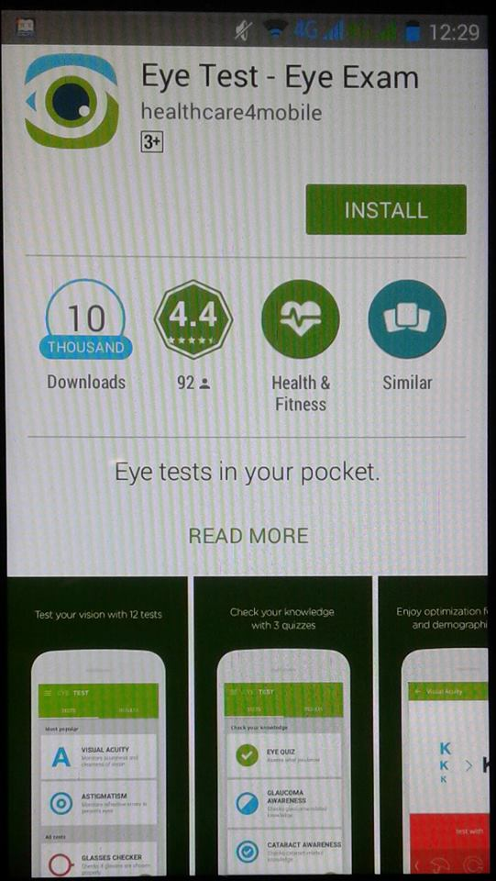

**6. Application name:** Vision Test.

**Developer Name:**  PC Mehanik

**Features:**

* Take a quick exam to test the vision
* Test results are shown for both the eye

**Feature Limitation:**

* Even though the result is based on international vision test using eye chart, it is not fully correct.
* Developers suggest seeing the specialists.
* The result is not 100% correct.

**Target group:**

* People having eye problems.
* Android users.
* Busy people

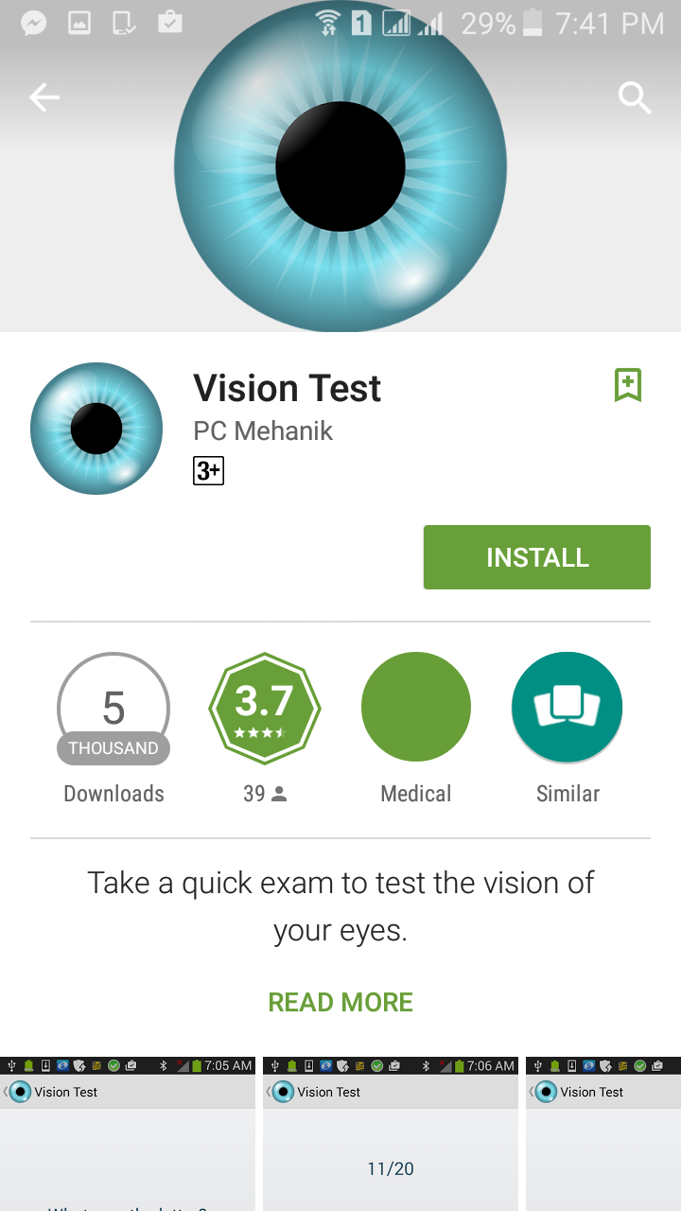

**7. Application name:** Eye Exam

**Developer Name:** Buzzard

**Features:**

* Allows to check visual acuity
* Using this app, vision can be tested at home

**Feature Limitation:**

* It can’t replace doctor advice
* The result is not 100% correct.

**Target group:**

* People having eye problems.
* Android users.
* Google play store users.

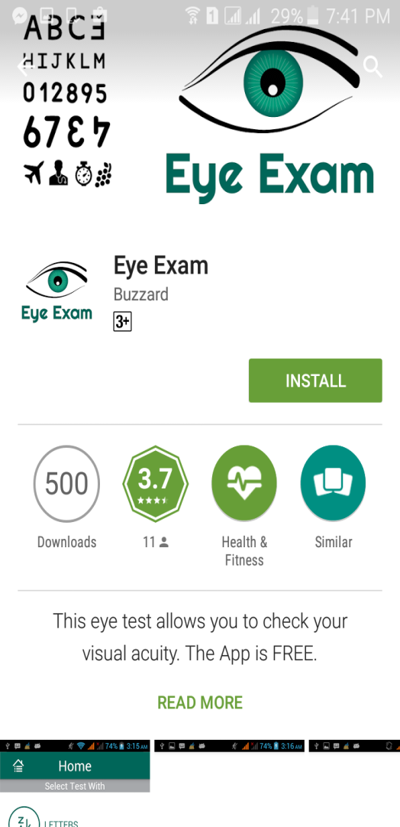

**8. Application name:** Visual Acuity test

**Developer Name:**  healthcare4mobile

**Features:**

* Visual acuity
* Tumbling E chart
* Astigmatism test
* Glasses check

**Feature Limitation:**

* It can’t replace doctor advice
* The result is not 100% correct.
* It doesn’t have colour blindness test

**Target group:**

* People having eye problems.
* Android users.
* Google play store users.

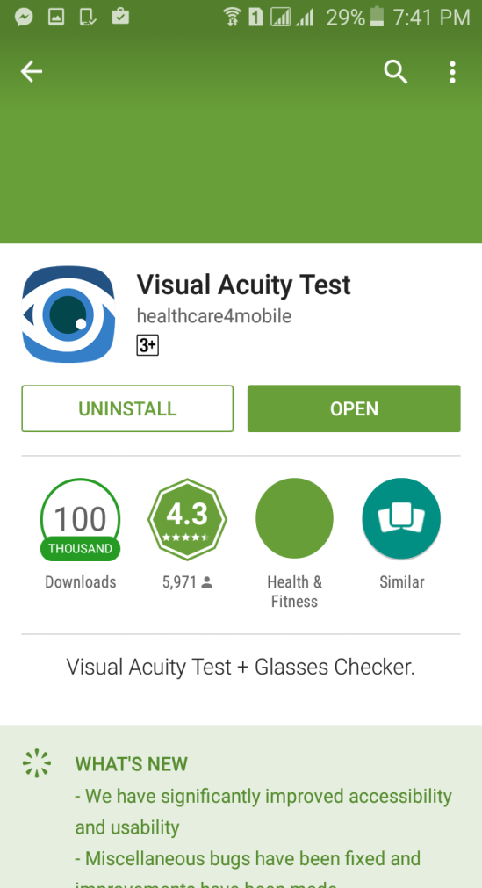

**9. Application name:** Central Vision Test

**Developer Name:**  healthcare4mobile

**Features:**

* Random test charts to eliminate boring and repeating experiences
* Voice controls to help you navigate easier
* Smooth and intuitive interface with animations

**Feature Limitation:**

* It can’t replace doctor advice
* The result is not 100% correct.
* One must get eye checkups and doesn’t tell eye power range

**Target group:**

* People having eye problems and Google play store users.

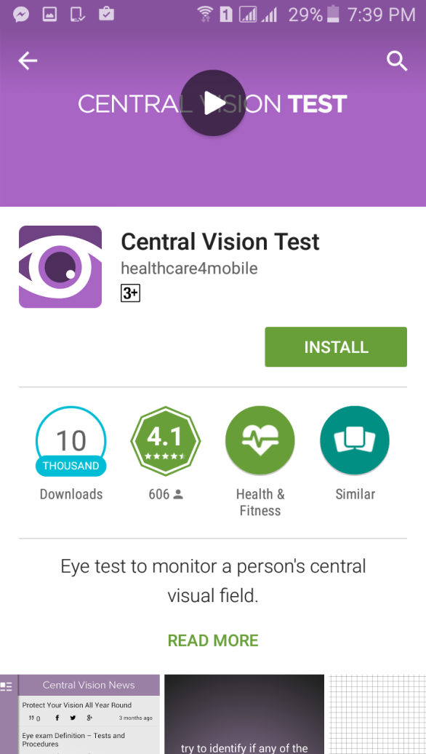

**10. Application name:** Eye Exam

**Developer Name:**  WoogaShow

**Features:**

* Easy to use.
* Three different icons

**Feature Limitation:**

* It can’t replace doctor advice.
* One must get eye checkups and doesn’t tell eye power range.

**Target group:**

* People having eye problems.
* Android users
* Normal people

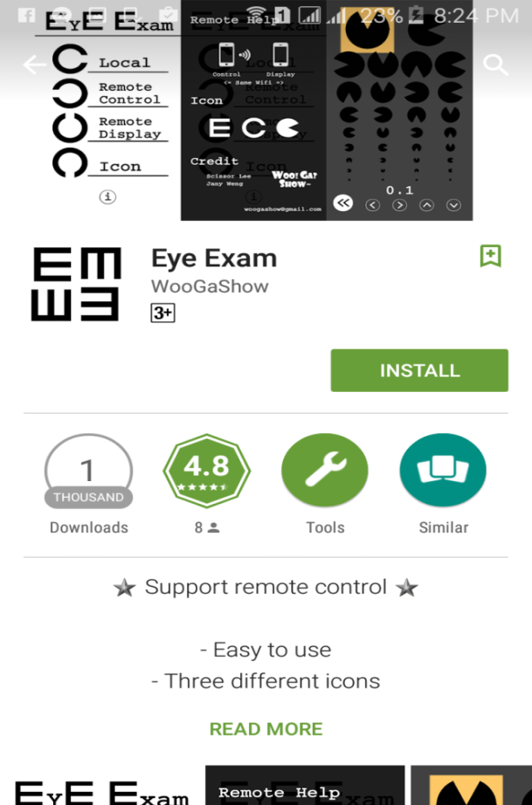 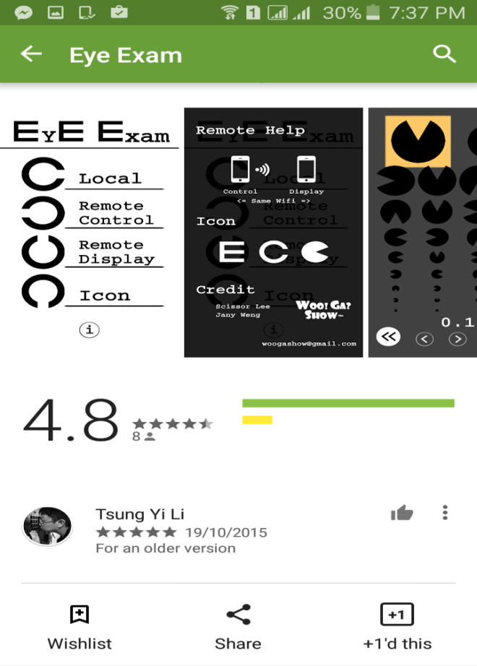

**Conclusion:**

Still now there is no such app which can measure the approximate eye glass power considering the eye sight condition. Also containing the information of eye health tips, exercises and healthy food for eye in one app is rare. So this app can help people. No app can replace the role of a doctor. All that it can do is to give approximate signal whether visit to a doctor is needed or not. Eyes are very sensitive part of human body and also one of the most essential organs. So proper care is needed to keep eyes fit and healthy.

**Acknowledgement:**

CSE department, MIST.

**Supervisor:**

1. Dr. Khondaker A.A. Mamun

2. Lec. Wali Mohammad Abdullah

3. Lec. Fariba Khan

4. Capt. Nazmul Hasan,Sigs

5. Lec. Nipi Paul

**Reference:**

* Eye Test App
* Snellen chart
* Various eye apps in google play store