Faster, Not Different
A Quarter-Century Baseline for AI’s Place in Consumer Technology Research
Sabou Rani Stocker¹
Emanuel de Bellis¹
Anne-Kathrin Klesse²
Ana Valenzuela³
¹ University of St. Gallen
² Erasmus University Rotterdam
³ ESADE Business School
Final order of authorship is to be determined

Abstract
Marketing has repeatedly reorganized its research agenda around emerging consumer technologies, and artificial intelligence (AI) is widely described as a break in that sequence rather than its latest instance. Evaluating this claim requires a baseline against which the response to AI can be placed. We construct one by screening all $10,196$ articles published in seven leading marketing and consumer-behavior journals between 2000 and June 2026, resolving $1,583$ technology mentions from $1,102$ empirical articles into $901$ canonical technologies grouped into 16 semantic clusters, and benchmarking academic attention against U.S. national news coverage of the same technologies. AI reproduces the field’s established pattern of novelty tracking at unprecedented rate and scale, but it is the only technology domain for which the temporal gap between public and academic attention is absent: the two rise concurrently rather than in sequence. We attribute this to the simultaneity of consumer and researcher adoption and to AI’s dual status as instrument and object of research, and derive implications for cumulative theorizing on consumer technology.
Keywords: artificial intelligence, consumer technology, research agenda, attention allocation, bibliometric mapping

1. Introduction
Consumer technologies have repeatedly reorganized the research agenda in marketing and consumer research, both in general [1] and for specific technologies as they became substantive parts of consumers’ experience [2,3]. AI is now widely described as a break in this sequence, disrupting nearly every aspect of consumers’ experience [4,5] as well as the research process itself [e.g., 6,7].
Academic attention is finite. Every technology that becomes a research object does so at the expense of others, so the distribution of attention across consumer technologies is a substantive outcome rather than a neutral by-product of individual interests. Because consumer technologies reach large populations quickly and are contested publicly before they are examined empirically, the evidence available at the moment of contestation is largely the evidence the field has chosen to produce [8,9]. Both considerations bind more tightly for AI than for any technology preceding it: it is general-purpose rather than confined to a single consumption context, so it can be attached to almost any existing research question and what it displaces is a share of everything else the field might study; and it became publicly contested within months rather than years of release, compressing the window in which evidence can be produced before positions harden.
Existing reviews of consumer technologies are organized around individual technologies or bounded domains [2,3], so the response to AI cannot easily be placed against the response to the technologies that preceded it. We therefore ask in which respects the field’s response to AI departs from its response to the other consumer-technology domains it has studied since 2000, and how the academic allocation of attention to AI compares with the visibility AI attained in public discourse.
We propose three mechanisms governing how the field allocates attention across consumer technologies. Novelty tracking describes the focus on technologies that have recently emerged: attention concentrates on the newest arrival at the expense of incumbents. The temporal gap describes why that arrival is nonetheless late. Studying consumer responses requires consumer data, which requires adoption, and review times in high-quality outlets are long [10,11], so diffusion precedes academic discourse [12]. We proxy public attention by news coverage, an established indicator of prominence in public awareness [13–15]. What is new to the field is therefore already familiar to consumers. Technology normalization describes the other end of the trajectory: technologies do not lose relevance once their use becomes habitual, but they do become harder to see as research objects, so academic attention declines while public exposure persists. Consumer AI has only been on the market since late 2022 [16], so we cannot observe normalization directly and infer it from earlier waves instead.
Together the three describe a window in which a technology is diffused enough to study and not yet ordinary enough to be overlooked. AI is presumably the first consumer technology for which the front edge of that window moves: consumers and researchers adopted generative AI simultaneously and through the same public interfaces, no firm partnership is required to study it, and the technology lowers the cost of producing research about itself.
Each mechanism is comparative and cannot be assessed from a literature examining a single technology. We therefore contribute the corpus such an assessment requires: a map of the consumer technologies the field has studied since 2000, identified without a predefined vocabulary of what counts as relevant and expressed on a common scale that places AI alongside its predecessors. Against this baseline, we show that the field’s response to AI reproduces the established mechanisms in kind while differing in rate, and that the gap closes only for AI.

2. Method
We screened all $10,196$ articles published between January 2000 and June 2026 in JCR, JM, JMR, JAMS, JCP, Marketing Science, and IJRM using a two-stage large-language-model procedure (GPT-4.1-mini, $T=0$, JSON-schema outputs) that identified technology discussions and then evaluated each mention for consumer-facing status and empirical design; human coding of a random 20% agreed with the model in 91% of cases. This yielded $1,583$ mentions from $1,102$ articles. A conventional keyword-based review of the same journals and period, reported in the supplementary materials, recovers $182$ articles, of which $176$ appear in the bottom-up corpus; the two approaches agree on the shape of the field’s growth but differ substantially in the breadth of technologies they recover. Screening every article therefore removes the circularity by which the technologies to be discovered must already be known in order to be found. We standardized the extracted labels, merged near-identical variants using sentence embeddings [17,18], and retained $901$ canonical technologies, reduced with UMAP [19] and grouped into 16 clusters using $k$-means [20].
For the external benchmark we queried the Media Cloud United States–National collection (247 sources) for each canonical technology over the same period [21,22], retrieving $4,714,445$ mentions across $4,074,851$ unique articles. We converted both corpora into annual attention shares on two bases and estimated cross-correlations across lags of $−5$ to $+5$ years, using circular-shift permutation tests to account for autocorrelation and the search across lags. Because Media Cloud coverage is sparse before 2008, comparisons cover 2008–2026.

3. Results
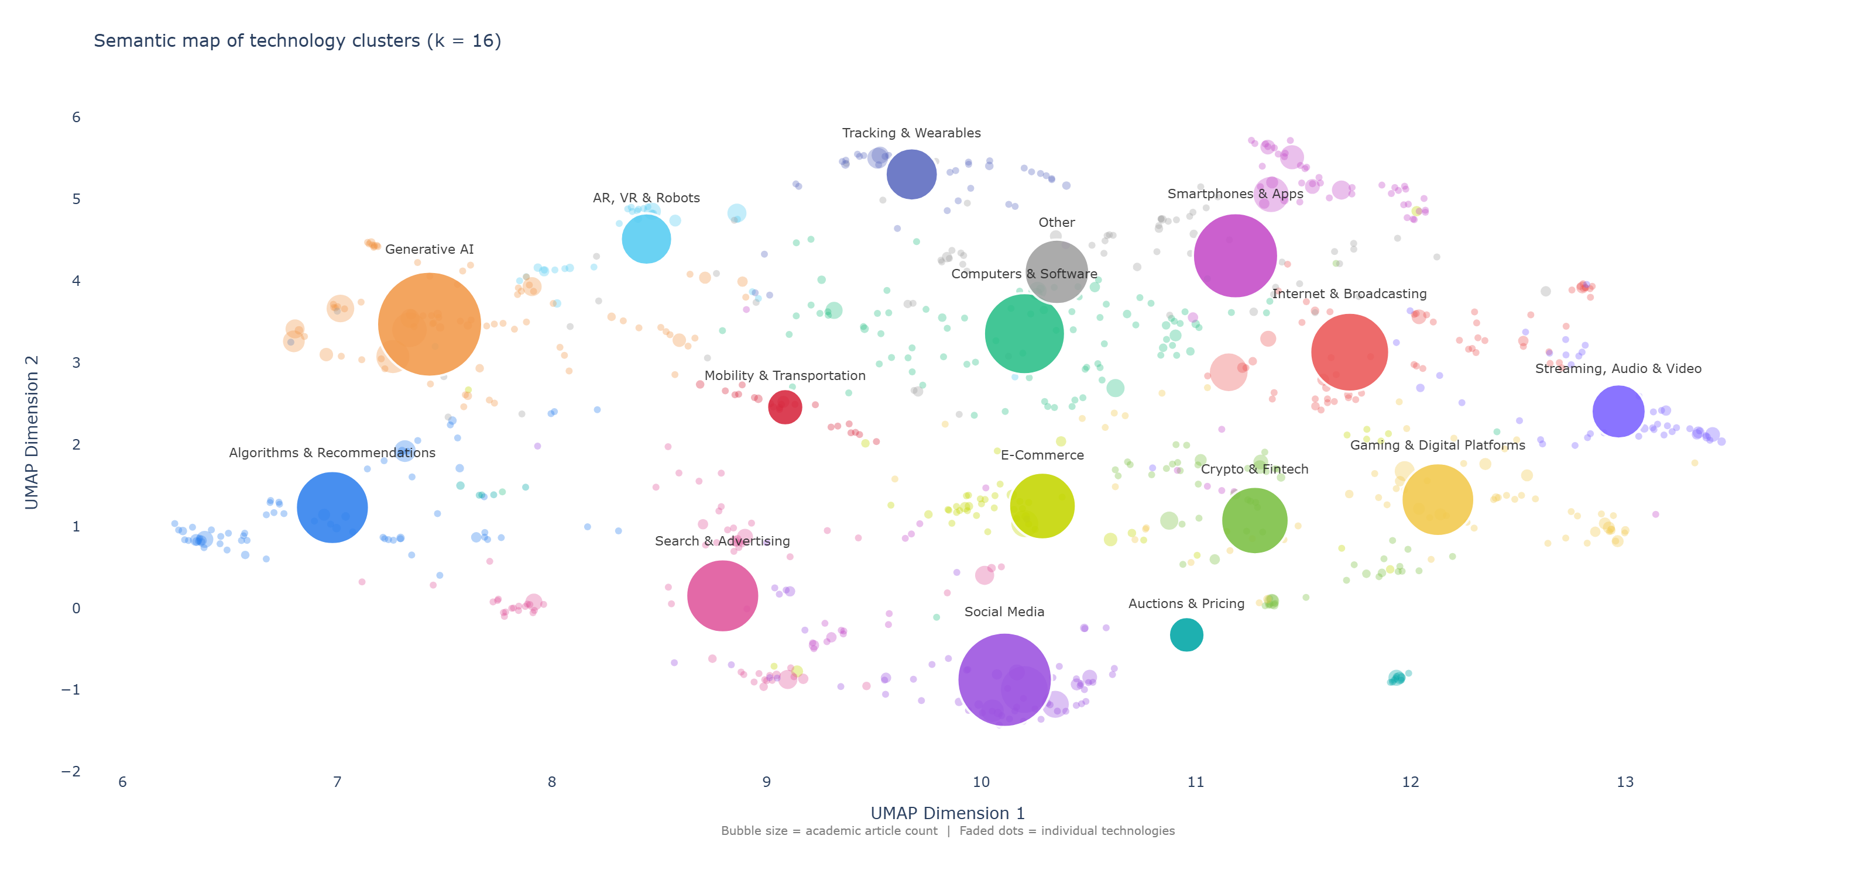
Figure 1: Semantic map of consumer-facing technology clusters. Faded points are individual canonical technologies, colors indicate cluster membership, labeled bubbles mark cluster centers, and bubble size corresponds to the number of academic articles per cluster.
Figure 1 summarizes the field as a semantic landscape rather than a taxonomy; because it is constructed from the vocabulary of the corpus itself, its regions reflect how the field has named its research objects rather than a classification imposed in advance. We manually labeled the resulting clusters. Clusters occupy recognizable thematic regions, but transitions between them are gradual, which matters directly for the case examined here: Generative AI does not occupy a previously empty region. It sits in a densely populated area bordering Algorithms & Recommendations, Search & Advertising, and AR, VR & Robots, and already comprises $82$ canonical labels — second only to Computers & Software ($93$), a cluster spanning the full 26 years. AI thus enters the field not as new territory but as the fastest-expanding part of one the discipline was already working in.
Generative AI is the most frequently studied cluster in the corpus ($n=225$ mentions), ahead of Social Media ($n=182$) and Smartphones & Apps ($n=148$), and reached that position within roughly three years of the public release of ChatGPT. It accounts for 22.5% of articles published in 2023–2024 and 25.8% of those published in the first half of 2026; in those six months alone the cluster recorded more articles ($26$) than any other cluster recorded in any complete year since 2000 (maximum $22$), whereas Social Media, the largest earlier wave, required approximately a decade to reach a double-digit annual count. The sequence of focal technologies — Computers & Software and Internet & Broadcasting until 2012, Social Media from 2013, Generative AI after 2022 — and the displacement of each incumbent’s share are consistent with novelty tracking rather than with a break in it.
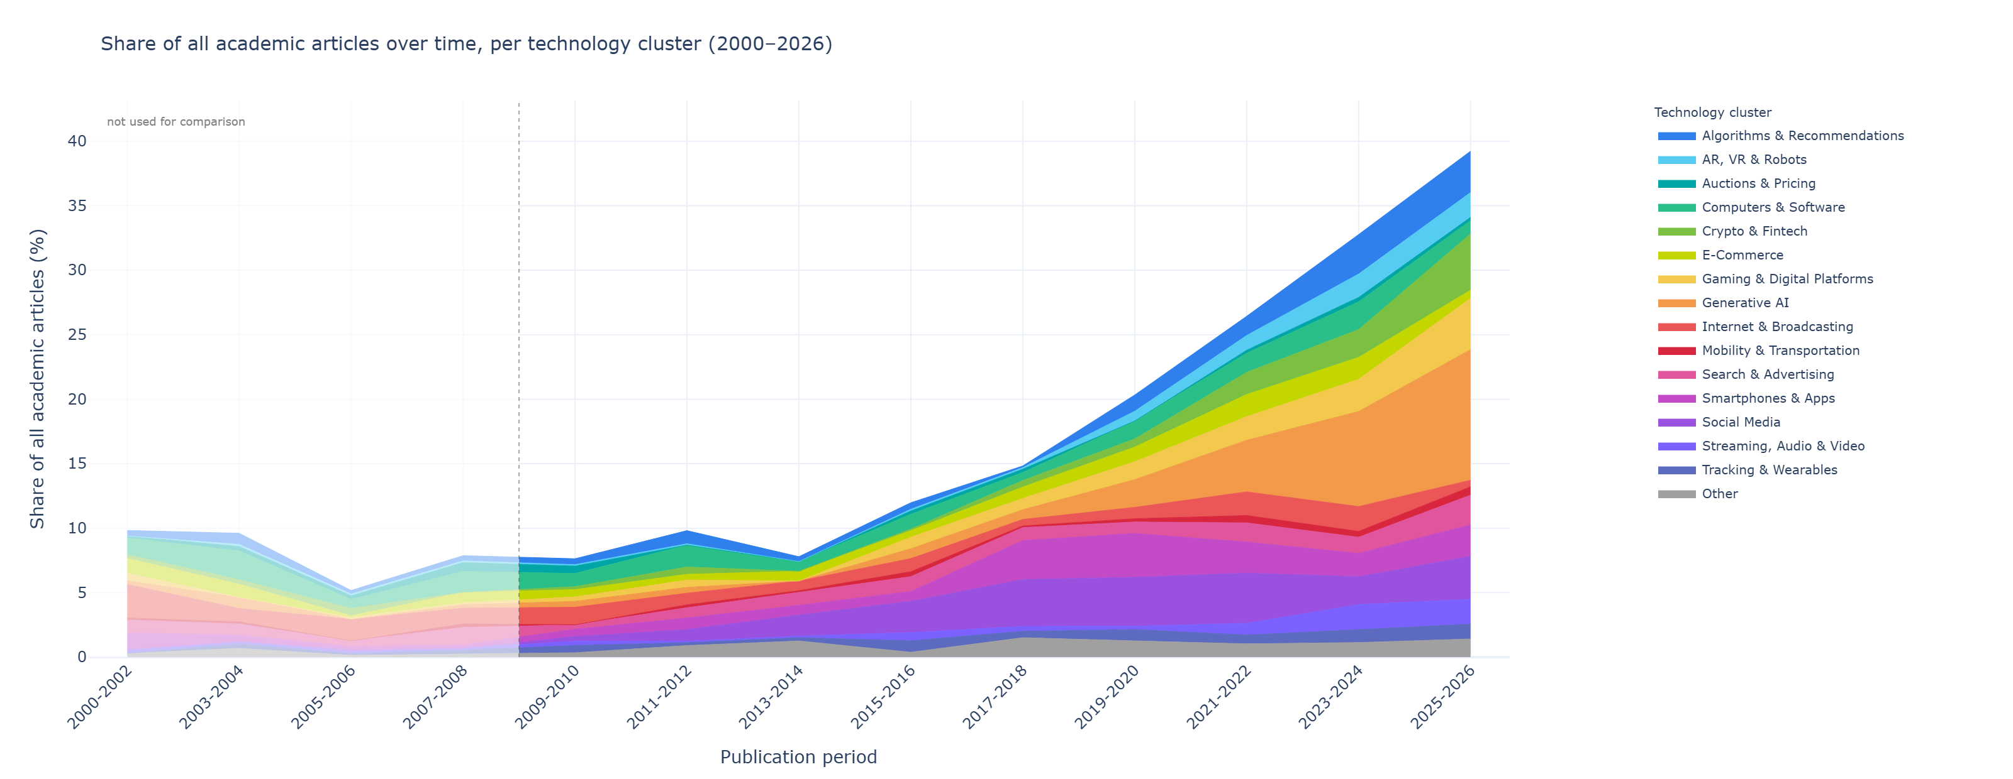
(a)

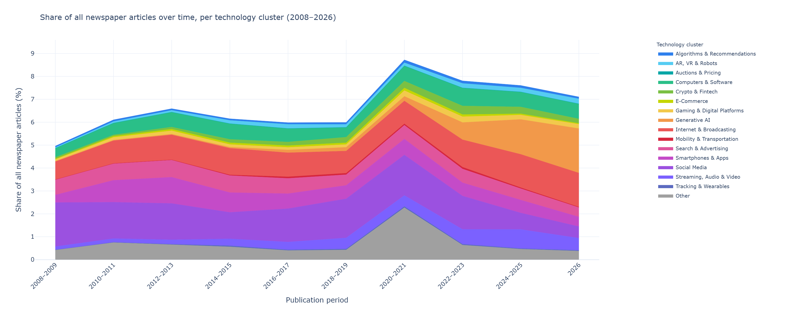
(b)

Figure 2: Panel A: share of all academic articles per technology cluster (2000–2026), binned in two-year intervals; periods before the comparison window are shown at reduced saturation and excluded from analysis. Panel B: share of all Media Cloud articles per cluster (2008–2026), same clusters. Because technology terms are queried separately, bands in Panel B are not mutually exclusive and stack height should be read as coverage intensity rather than as the share of distinct articles.
Read together, the panels locate the growth of consumer-technology research in the academic corpus rather than in the environment it studies: within the comparison window the share of academic articles addressing a consumer technology rises from under 10% in 2009–2010 to roughly 40% in 2025–2026, whereas newspaper coverage moves between approximately 5% and 9%. Two features qualify the displacement. First, growth is cumulative rather than substitutive: earlier clusters do not contract in absolute terms as Generative AI expands, so displacement operates on each cluster’s share of technology-related attention rather than on its output. Second, Generative AI becomes the largest band within two publication periods of its first appearance, while the corresponding media band appears at the same time but remains one among several.
Across the 16 clusters, academic and public attention are largely decoupled or follow the hypothesized lag pattern, and where a clear temporal relationship exists it takes the predicted form of a delay (Table 1). Generative AI is the exception on both bases: its concurrent correlation is the highest of any cluster ($r=.87$ relative, $r=.94$ absolute) and correlations remain high across neighboring lags. For the first time in the observed period, the field is producing evidence on a consumer technology while that technology is publicly contested rather than several years afterward.
Table 1: Mean annual academic and media attention shares and lagged correspondence by technology cluster, relative basis (share of technology-related mentions only). The gap equals academic share minus media share; positive values indicate a larger academic share. Positive lags indicate that media attention precedes academic attention. Asterisks mark best-lag correlations significant at $p<.05$ under a circular-shift permutation test. The absolute-share basis is reported in the supplementary materials.
Technology Cluster | Academic Share | Media Share | Gap (pp) | r at Lag 0 | Best Lag (r)
Generative AI | 10.3% | 5.5% | +4.8 | 0.87 | +4 (0.91)*
Algorithms & Recommendations | 6.0% | 1.3% | +4.7 | 0.02 | +3 (0.59)
E-Commerce | 5.6% | 1.0% | +4.6 | 0.05 | -3 (0.35)
Tracking & Wearables | 4.0% | 0.5% | +3.6 | 0.29 | -5 (0.47)
Gaming & Digital Platforms | 5.8% | 2.3% | +3.5 | 0.29 | +4 (0.59)
Auctions & Pricing | 1.7% | 0.0% | +1.7 | -0.04 | +4 (0.36)
Crypto & Fintech | 4.2% | 2.8% | +1.4 | 0.26 | +3 (0.73)
Mobility & Transportation | 1.9% | 0.6% | +1.3 | -0.21 | -3 (0.20)
AR, VR & Robots | 2.8% | 1.9% | +0.8 | 0.12 | +4 (0.73)*
Computers & Software | 8.7% | 8.9% | -0.2 | 0.04 | -2 (0.38)
Smartphones & Apps | 9.7% | 10.5% | -0.8 | 0.11 | +5 (0.56)
Search & Advertising | 8.2% | 9.7% | -1.5 | 0.60 | 0 (0.60)
Streaming, Audio & Video | 3.2% | 5.9% | -2.7 | 0.29 | +1 (0.36)
Other | 6.7% | 10.1% | -3.4 | -0.03 | -1 (0.15)
Social Media | 13.5% | 22.4% | -8.8 | 0.01 | +4 (0.22)
Internet & Broadcasting | 7.7% | 16.6% | -8.9 | -0.08 | +5 (0.33)

4. Discussion
AI is comparable in kind to previous waves of attention allocation, differing in rate and magnitude rather than in the mechanism through which attention is allocated. It differs in one respect: the interval respectively absence of a relationship between consumer adoption and academic study, which separates public from academic attention for every other domain in the corpus, is absent. We attribute this to the simultaneity of consumer and researcher adoption and to AI’s dual status as instrument and object of research.
The finding cuts in two directions. Concurrency is the condition editorials have long called for, and it means the evidence base is forming while the questions are live; it also means that a quarter of the field’s consumer-technology output is being produced without the corrective of replication and elapsed time. Proliferation at this speed makes construct fragmentation the binding constraint on cumulative theorizing: eighty-two labels in a few years, together with the adjacency of recommendation agents, algorithmic advice, and automated service agents in neighboring clusters, invites the treatment of each label as a separate domain. That adjacency also runs the other way. Because AI is general-purpose, neighboring technologies are being reconstituted as AI applications rather than remaining distinct objects, which will inflate the apparent growth of AI research while reducing the number of distinguishable research objects — and replicating established designs with an AI stimulus substituted for the original technology produces publishable increments without producing knowledge that would not otherwise have been available.
The comparison with media coverage bears on how far the current concentration can be expected to persist, because the two corpora differ in structure and not only in level. Academic attention is concentrated on technologies that can be instantiated as bounded interfaces or treatments — Generative AI, Algorithms & Recommendations, and E-Commerce head the ranking in Table 1 — whereas media attention is concentrated on the ambient environments consumers inhabit, with Social Media and Internet & Broadcasting showing the largest deficits in academic share. Generative AI clarifies rather than contradicts this pattern: it is the one cluster in which both corpora expand together, but even here it becomes the largest academic cluster within three years while remaining one media band among several. The concentration is therefore a property of the research agenda more than of the discourse it tracks, consistent with the tractability of AI as a research object contributing to its prominence alongside its consumer relevance. On the historical pattern, we hypothesize AI’s academic share will decline as it embeds into ordinary consumption, and that decline will not indicate that AI has ceased to matter.
Several limitations bound these conclusions. The corpus covers seven journals and empirical articles only, and technology labels are extracted from titles and abstracts, so technologies discussed without being named are underrepresented — precisely the direction that would understate normalization. News coverage indicates visibility rather than adoption or importance, and the lag estimates rest on short annual series and are interpreted as descriptive.

5. References
[1] D.L. Hoffman, C.P. Moreau, S. Stremersch, M. Wedel, The Rise of New Technologies in Marketing: A Framework and Outlook, Journal of Marketing 86 (2022) 1–6. https://doi.org/10.1177/00222429211061636.
[2] L. Stocchi, N. Pourazad, N. Michaelidou, A. Tanusondjaja, P. Harrigan, Marketing research on Mobile apps: Past, present and future, J. Of the Acad. Mark. Sci. 50 (2022) 195–225. https://doi.org/10.1007/s11747-021-00815-w.
[3] C. Lamberton, A.T. Stephen, A Thematic Exploration of Digital, Social Media, and Mobile Marketing: Research Evolution from 2000 to 2015 and an Agenda for Future Inquiry, Journal of Marketing 80 (2016) 146–172. https://doi.org/10.1509/jm.15.0415.
[4] S. Puntoni, R.W. Reczek, M. Giesler, S. Botti, Consumers and Artificial Intelligence: An Experiential Perspective, Journal of Marketing 85 (2021) 131–151. https://doi.org/10.1177/0022242920953847.
[5] M.-H. Huang, R.T. Rust, A Framework for Collaborative Artificial Intelligence in Marketing, Journal of Retailing 98 (2022) 209–223. https://doi.org/10.1016/j.jretai.2021.03.001.
[6] S. Feuerriegel, A. Maarouf, D. Bär, D. Geissler, J. Schweisthal, N. Pröllochs, C.E. Robertson, S. Rathje, J. Hartmann, S.M. Mohammad, O. Netzer, A.A. Siegel, B. Plank, J.J. Van Bavel, Using natural language processing to analyse text data in behavioural science, Nat Rev Psychol 4 (2025) 96–111. https://doi.org/10.1038/s44159-024-00392-z.
[7] M. Joerling, Integrating GenAI interactions in marketing studies: A methodological guide, International Journal of Research in Marketing 43 (2026) 28–47. https://doi.org/10.1016/j.ijresmar.2025.12.003.
[8] H.J. van Heerde, C. Moorman, C.P. Moreau, R.W. Palmatier, Reality check: Infusing ecological value into academic marketing research, Journal of Marketing 85 (2021) 1–13. https://doi.org/10.1177/0022242921992383.
[9] R.K. Chandy, G.V. Johar, C. Moorman, J.H. Roberts, Better marketing for a better world, Journal of Marketing 85 (2021) 1–9. https://doi.org/10.1177/00222429211003690.
[10] B.-C. Björk, D. Solomon, The publishing delay in scholarly peer-reviewed journals, Journal of Informetrics 7 (2013) 914–923. https://doi.org/10.1016/j.joi.2013.09.001.
[11] G. Ellison, The slowdown of the economics publishing process, Journal of Political Economy 110 (2002) 947–993. https://doi.org/10.1086/341868.
[12] E.M. Rogers, Diffusion of innovations, 3. ed, Free Press [u.a.], New York, NY, 1983.
[13] M.E. McCombs, D.L. Shaw, The agenda-setting function of mass media, Public Opinion Quarterly 36 (1972) 176–187. https://doi.org/10.1086/267990.
[14] A. Humphreys, R.J.-H. Wang, Automated text analysis for consumer research, Journal of Consumer Research 44 (2018) 1274–1306. https://doi.org/10.1093/jcr/ucx104.
[15] K. Jedidi, B.H. Schmitt, M. Ben Sliman, Y. Li, R2M index 1.0: Assessing the practical relevance of academic marketing articles, Journal of Marketing 85 (2021) 22–41. https://doi.org/10.1177/00222429211028145.
[16] OpenAI, Introducing ChatGPT, (2022). https://openai.com/index/chatgpt/ (accessed July 21, 2026).
[17] N. Reimers, I. Gurevych, Sentence-BERT: Sentence embeddings using siamese BERT-networks, in: Proceedings of the 2019 Conference on Empirical Methods in Natural Language Processing and the 9th International Joint Conference on Natural Language Processing, Association for Computational Linguistics, 2019: pp. 3982–3992. https://doi.org/10.18653/v1/D19-1410.
[18] D.U. Wulff, R. Mata, Escaping the Jingle-Jangle Jungle: Increasing Conceptual Clarity in Psychology Using Large Language Models, Curr Dir Psychol Sci 35 (2026) 59–65. https://doi.org/10.1177/09637214251382083.
[19] L. McInnes, J. Healy, N. Saul, L. Großberger, UMAP: Uniform Manifold Approximation and Projection, JOSS 3 (2018) 861. https://doi.org/10.21105/joss.00861.
[20] J. MacQueen, Some methods for classification and analysis of multivariate observations, in: L.M. Le Cam, J. Neyman (Eds.), Proceedings of the Fifth Berkeley Symposium on Mathematical Statistics and Probability, University of California Press, Berkeley, CA, 1967: pp. 281–297.
[21] H. Roberts, R. Bhargava, L. Valiukas, D. Jen, M.M. Malik, C.S. Bishop, E.B. Ndulue, A. Dave, J. Clark, B. Etling, others, Media cloud: Massive open source collection of global news on the open web, in: Proceedings of the International AAAI Conference on Web and Social Media, 2021: pp. 1034–1045. https://doi.org/10.1609/icwsm.v15i1.18127.
[22] F. Bermejo, R. Bhargava, P. Budne, P. Gulley, E. Leon, R. McGrady, E.B. Ndulue, E. Zuckerman, Media Cloud 2.0: An Updated Open Web News Archive, ICWSM 20 (2026) 2735–2746. https://doi.org/10.1609/icwsm.v20i1.42778.

