**NAME: SABRA IDRISSA MOHAMED**

**REG NO: BITAM/6/18/015/TZ**

**ASSIGNMENT NAME: SERVICE ORIENTED ARCHITECTURE.**

**COURSE INSTRUCTOR: MR. MASOUD HAMAD MMANGA**

**SERVICE ORIENTED ARCHITECTURE**

**INTRODUCTION**

Service Oriented Architecture (SOA) is an architectural style which allows interaction of diverse applications regardless of their platform, implementation languages and locations by utilizing generic and reliable services that can used as application building block.

Micro services is a self contained web service API, which performs a small subset of tasks needed for a larger application. For example, let’s say you need some type of document processor that converts text or word documents to a PDF. Now this needs to be shared across multiple applications. Then we can write a micro service to accomplish this for a specific number of applications which need it.

A macro service would also be a self contained web service API, where the needs would be across an enterprise. This would be a service which will encompass a whole company, and even serve clients for a particular need.

**HOW IT WORKS**

SOA with Web services are at the present gaining momentum, as with Web services there is fundamental improvement in SOA based application development.

It is required to follow new approaches and particular methodologies when building service based application structure, rather than tracking the traditional approaches to software development.

SOA needs unique development strategies, which replace the conventional approaches to building software architectures and promise the development of plug-and-play application structures and building modules capable of expressing definite business functionalities and problem domains.

SOA provides a strong architectural discipline and focus area centered on service creation, modeling and development, formation of process information, and service oriented integration approaches and strategies.

To implement a successful SOA in enterprise requires consideration of various concepts and implementation strategies, which formulate the essential characteristics of service oriented enterprise.

complete SOA implementation reflects on not only the deployment of services, but also the possibility of using them to

integrate diverse application logic, and building of composite applications.

**SOA COMPONENTS**

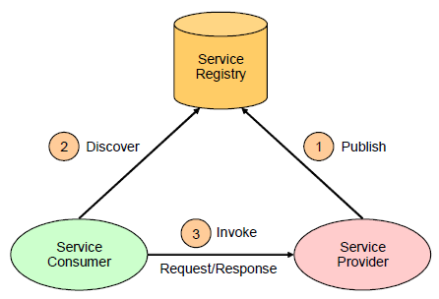

**CONCLUSION**

The term service-orientation implies a distinct set of concerns and activities to different audiences. For example, to software engineers it is all about functional requirements, components, integration techniques, messaging, tools, development environments, and middleware. To business people, it is all about implementing business strategies, enabling leaner IT departments, facilitating agile process models, and driving new service delivery processes.