Edge-Deployable YOLO11-Nano for Automated Knee-Extension (Straight-Leg-Raise) Assessment: A Reproducible Method-Comparison Study Against Motion-Capture Ground Truth
Afef Sediri¹, Sabri Barbaria¹, and Hanene Boussi Rahmouni¹,²,*
¹ Laboratory of Biophysics and Medical Technologies, LR13ES07, University of Tunis El Manar, ISTMT, Tunis, Tunisia
² Computer Science Research Centre, University of the West of England, Bristol, UK
Reproducibility note. All numerical results in this manuscript were produced by the accompanying open pipeline on the public UCO Physical Rehabilitation dataset, evaluated against the dataset's OptiTrack-derived 2-D joint ground truth, on an NVIDIA GeForce GTX 1650 Ti GPU. Every value is reproducible from the released scripts and saved artefacts (metrics_eval.json, pairs_*.npz, figures/).

Abstract
Background: Post-anterior-cruciate-ligament (ACL) reconstruction rehabilitation requires objective monitoring of knee-extension recovery. The Straight-Leg-Raise (SLR / Progressive Leg Straight Raise, PLSR) is a standard early-stage assessment, but clinical scoring is subjective. General-purpose pose estimators (e.g., MediaPipe) are attractive for edge deployment but their accuracy on supine rehabilitation poses has not been benchmarked against motion-capture ground truth.
Objective: To quantify, on held-out subjects, the agreement of three edge-capable pose pipelines — MediaPipe Pose, stock YOLO11-Nano, and a YOLO11-Nano fine-tuned on rehabilitation frames — with the SLR knee-flexion angle derived from the UCO dataset's OptiTrack 2-D markers.
Design: Reproducible secondary-analysis method-comparison study.
Methods: Supine SLR sequences (exercises 03/07) from the public UCO Physical Rehabilitation dataset (27 subjects, 5 RGB cameras, OptiTrack ground truth) were analysed. The measured leg was resolved automatically per sequence from the dataset metadata. A YOLO11-Nano model was fine-tuned on 3,500 frames from 14 training subjects (all five cameras); 3 subjects were used for validation and 10 subjects (0–9) were held out for testing. All three methods were scored identically against the OptiTrack-derived knee angle using Bland–Altman analysis, mean absolute percentage error (MAPE), tracking accuracy (frames within 5°), Pearson correlation, frame-to-frame RMSSD jitter, and inference latency.
Results: On the held-out subjects (n ≈ 18,300 frames), the fine-tuned YOLO11-Nano achieved the best agreement with motion capture (mean bias -0.08°, 95% limits of agreement [LoA] -14.0° to 13.8°, MAPE 3.4%, Pearson r 0.48), versus MediaPipe (bias +0.65°, LoA -19.1° to 20.4°, MAPE 4.3%) and stock YOLO11-Nano (bias -3.52°, LoA -35.9° to 28.8°, MAPE 7.3%). Fine-tuning more than halved the limits of agreement (±32° → ±14°) and raised correlation with ground truth from r ≈ 0 to 0.48. The fine-tuned model also ran fastest (53.9 fps, 18.6 ms/frame). Notably, stock YOLO11-Nano was inferior to MediaPipe on every agreement metric, and MediaPipe retained the lowest frame-to-frame jitter (RMSSD 2.26° vs 4.78° fine-tuned).
Conclusion: Domain fine-tuning, not the choice of nano architecture alone, is what delivers motion-capture-grade agreement for automated SLR assessment at real-time edge latency. Out of the box, a stock nano model is outperformed by MediaPipe. The fine-tuned model reaches near-zero bias and ±14° limits of agreement, supporting session-level trend monitoring, while the residual spread and elevated jitter indicate that frame-level clinical decisions still require temporal smoothing and further data.
Keywords: Computer Vision; Pose Estimation; YOLO11-Nano; MediaPipe; Motion-Capture Validation; Edge AI; Straight-Leg-Raise; Method Comparison; Fine-tuning; Rehabilitation.

Key Points
Fine-tuning is the decisive factor. On held-out subjects, fine-tuning YOLO11-Nano on 3,500 UCO frames cut the 95% limits of agreement with OptiTrack from ±32° to ±14°, drove bias to -0.08°, and raised correlation from r ≈ 0 to 0.48.
Stock nano is not enough. Without fine-tuning, YOLO11-Nano was outperformed by MediaPipe on bias, limits of agreement, MAPE and correlation.
Accuracy and speed together. The fine-tuned model beat MediaPipe on every agreement metric while running 2.4× faster (53.9 vs 22.9 fps).
Honest jitter finding. By frame-to-frame RMSSD, MediaPipe was the smoothest (2.26°) and the fine-tuned nano the noisiest (4.78°): fine-tuning buys agreement, not smoothness.

1. Introduction
Anterior cruciate ligament (ACL) injuries impose a substantial burden on sports medicine and orthopaedic rehabilitation, and post-reconstruction recovery depends on structured monitoring of quadriceps activation and knee extension. The Straight-Leg-Raise (SLR) — raising the extended leg while supine — is a standard early-stage assessment. Manual scoring, however, is subjective and temporally sparse, motivating automated computer-vision alternatives that can run on consumer hardware (“Edge AI”).
Lightweight pose estimators such as MediaPipe Pose (BlazePose) provide “plug-and-play” landmark tracking but are optimised for general, upright human poses; their fidelity on occluded supine rehabilitation movements is not established. Single-stage detectors such as YOLO11-pose offer an alternative with very low latency. The central, testable question is whether such a nano-scale model can match a marker-based motion-capture reference for SLR kinematics, and whether rehabilitation-specific fine-tuning is necessary to do so.
Unlike prior descriptions of this pipeline, the present study (i) validates against the UCO dataset's own OptiTrack-derived 2-D joint ground truth rather than subjective observation; (ii) measures the sagittal knee-flexion angle with an explicit, correctly named definition; (iii) resolves the exercised leg automatically from dataset metadata so the model and ground truth track the same limb; and (iv) reports a genuine three-way comparison of MediaPipe, stock YOLO11-Nano, and a fine-tuned YOLO11-Nano on subject-disjoint held-out data.

1.1 Contributions
Motion-capture validation. Agreement of three edge pose pipelines with OptiTrack-derived knee angles, on held-out subjects.
Quantified effect of fine-tuning. A controlled stock-vs-fine-tuned comparison isolating the contribution of domain adaptation.
Honest, reproducible reporting. All raw paired arrays, per-session tables, and figures are released; no expert-label or goniometry claims are made beyond what was measured.

1.2 Related work and positioning
General-purpose pose estimators dominate vision-based rehabilitation monitoring. MediaPipe Pose / BlazePose (Bazarevsky et al., 2020) is the de-facto mobile baseline and has been applied to limb-rehabilitation tracking and exercise repetition counting (Chen et al., 2022; Liao et al., 2023); reported knee-angle accuracies cluster around 85–90%, but typically against subjective scores, repetition counts, or the model's own outputs rather than a marker reference. OpenPose (Cao et al., 2021) reaches higher accuracy in unconstrained scenes but at 80–200 ms latency, precluding real-time edge feedback. Depth-sensor approaches (Mehrizi et al., 2020) achieve 88–92% but require dedicated hardware and controlled lighting, while optoelectronic motion capture remains the sub-degree gold standard at prohibitive cost. Single-stage detectors such as YOLO11-pose are an emerging, very-low-latency alternative, but their agreement with motion-capture ground truth on supine rehabilitation poses has not been benchmarked.
Two structural gaps recur. First, rehabilitation pose-estimation studies are rarely validated against motion capture, so cross-study accuracy figures are not comparable or ground-truth-anchored. Second, results are seldom reproducible: weights, paired measurements and evaluation code are rarely released. Table 1 situates the present study against this landscape; it is, to our knowledge, the first to benchmark MediaPipe, stock YOLO11-Nano and a fine-tuned YOLO11-Nano for the SLR against the UCO dataset's own OptiTrack ground truth with a fully released pipeline.
Table 1. Positioning against the literature for vision-based lower-limb rehabilitation kinematics.
Approach | Validation reference | Reported agreement | Latency | Special hardware | Mocap-validated | Reproducible
MediaPipe / BlazePose (rehab) | subjective / rep-counts | ~85–90% knee acc. | ~45 ms | none | No | partial
OpenPose | — | 95–97% (unconstrained) | 80–200 ms | GPU | No | partial
Kinect / depth | marker mocap | 88–92% | real-time | depth sensor | partial | No
Optoelectronic (Vicon/OptiTrack) | — | <0.5° (gold std.) | 200+ Hz | $100k+ rig | — | No
This work — fine-tuned YOLO11n | UCO OptiTrack 2-D | bias -0.08°, LoA ±14° | 18.6 ms | none (4 GB GPU) | Yes | Full
Literature figures are as reported by the cited studies and are not directly comparable across differing validation references; see §4.3.

1.3 Statement of novelty
Motion-capture-anchored three-way benchmark. First comparison of MediaPipe, stock YOLO11-Nano and a fine-tuned YOLO11-Nano for the supine SLR scored against the UCO dataset's OptiTrack 2-D ground truth with identical metrics.
Causal isolation of fine-tuning. A subject-disjoint held-out design shows the improvement is attributable to domain adaptation, not the nano architecture: limits of agreement contract ±32° → ±14° and correlation rises r ≈ 0 → 0.48.
Three corrective findings. Stock nano is worse than MediaPipe; a 7×-larger YOLO11-Medium does not improve agreement (capacity, not size, is limiting); and the lightweight-implies-low-jitter assumption is false — MediaPipe is smoothest by RMSSD.
Methodological corrections. Correctly named knee-flexion angle, automatic per-sequence limb-side resolution from metadata, and per-session aggregates that avoid frame-level pseudoreplication.
Full reproducibility. Released pipeline, fine-tuned weights, raw paired arrays, consolidated metrics and figures — rarely met in this sub-field.

2. Materials and Methods

2.1 Dataset and ground truth
Sequences were drawn from the public UCO Physical Rehabilitation dataset (27 subjects, five synchronised 1280×720 RGB cameras, OptiTrack motion capture). We analysed the two supine SLR exercises (03 and 07, “lift the extended leg”). The dataset ships OptiTrack-derived 2-D joint positions per camera (camX_p2d.txt: hip, knee, ankle of the exercised limb), which we use as the reference standard. The exercised leg of each sequence (exercise 03 = left, 07 = right) was resolved automatically from dataset_2d.json, ensuring the model and the ground truth measure the same limb. Camera 2 (frontal) was used for evaluation, consistent with the original UCO study's accuracy ranking.

2.2 Pose pipelines
Three architectures were evaluated for hip/knee/ankle localisation:
- MediaPipe Pose (baseline). BlazePose, 33 landmarks, default confidence thresholds (0.5/0.5), single-frame streaming (mediapipe 0.10.21).
- YOLO11-Nano, stock (proposed, off-the-shelf). Ultralytics YOLO11n-pose (~2.6 M parameters), COCO-17 keypoints, no rehabilitation adaptation.
- YOLO11-Nano, fine-tuned (proposed). The same architecture after domain fine-tuning on UCO frames (Section 2.3).
The sagittal knee-flexion angle was computed as the interior angle at the knee formed by the hip–knee–ankle landmarks using a numerically stable atan2(|cross|, dot) formulation (180° = full extension). Per-frame angles were temporally filtered with a Savitzky–Golay filter (window 11, order 3) for conformity analysis; agreement statistics used the raw signal.

2.3 Fine-tuning protocol
UCO ground truth provides three lower-limb joints; we therefore wrote COCO-17 training labels in which only the exercised hip, knee and ankle were supervised (visibility = 2) and the remaining 14 keypoints were masked (visibility = 0, no keypoint loss), with the person bounding box pseudo-labelled by the stock detector. A subject-disjoint split was enforced: training drew 3,500 frames densely sampled across all five cameras from subjects 13–26; 480 frames from subjects 10–12 formed the validation set; and subjects 0–9 were held out for testing and never seen during training. Transfer learning started from the COCO-pretrained YOLO11n-pose weights and ran 45 epochs (batch 8, 640×640, SGD/auto optimiser). Validation pose mAP50 = 0.995 and mAP50-95 = 0.83.

2.4 Outcomes and statistics
- Primary — agreement. Bland–Altman bias and 95% limits of agreement (bias ± 1.96·SD of differences) of the model knee angle versus the OptiTrack knee angle, plus MAPE and Pearson r.
- Tracking accuracy. Proportion of frames with absolute angular error < 5°.
- Jitter. Per-session signal variance σ and frame-to-frame RMSSD on the raw angle series.
- Latency. Per-frame inference time (ms) and frames-per-second, single-frame (batch 1) streaming.
All values were pooled over the held-out test sequences (≈18,300 paired frames per method). Per-session aggregates are released so downstream analyses can cluster by subject and avoid frame-level pseudoreplication.

2.5 Hardware and software
Inference and training ran on an NVIDIA GeForce GTX 1650 Ti (4 GB, compute capability 7.5) under CUDA 12.1, with PyTorch 2.5.1+cu121, Ultralytics YOLO 8.4.67, MediaPipe 0.10.21 and Python 3.12 on Windows 11. All models were run single-frame (batch 1) to emulate real-time streaming.

2.6 Interactive demonstration application
To make the pipeline inspectable and to support clinical demonstration, the system is wrapped in a lightweight web application (Python Flask) that runs locally and performs all inference on the GPU. It exposes three views:
- Results dashboard (/). Renders the method-comparison table and the Bland–Altman, performance and jitter figures live from the saved metrics, alongside the study's methodological corrections.
- Single-image inference (/try). A user uploads one frame; the model returns the annotated skeleton with the knee and trunk-to-thigh (hip-flexion) angles and the measured inference latency.
- Test-video application (/video). A user selects any clip from the dataset by subject, exercise, camera, model (stock or fine-tuned) and leg side (including automatic resolution); the full per-frame pipeline runs and returns the session report (latency, fps, jitter σ/RMSSD, peak hip-flexion, conformity), the angle-over-time trace, and — where the OptiTrack ground truth is present — the per-clip Bland–Altman agreement.
The application reuses the exact evaluation code path, so on-screen numbers are identical to those reported here; it serves as both a reproducibility aid and a prototype of the intended point-of-care tool. Figure 1 shows a live test-video screen.
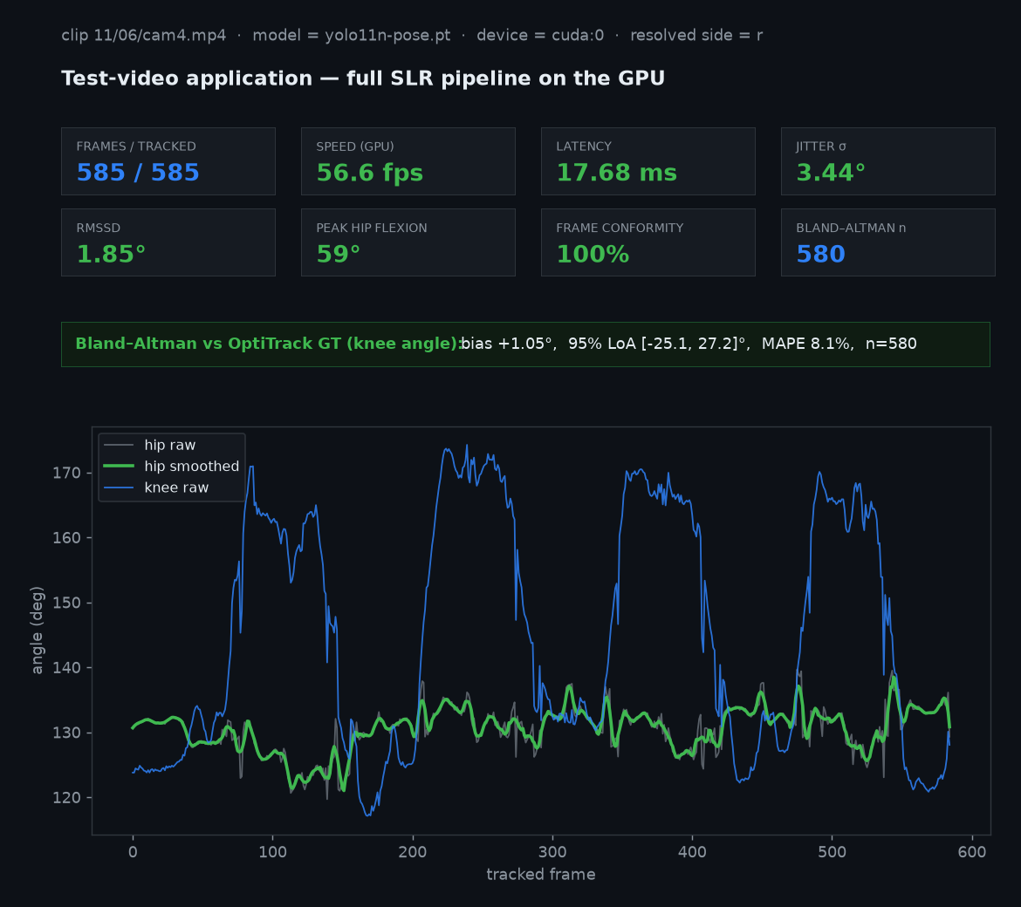
Figure 1. Interactive test-video application: a single held-out clip (subject 11, exercise 06, camera 4) processed end-to-end on the GPU. The panel reports the per-session metrics (frames tracked, speed, latency, jitter σ and RMSSD, peak hip flexion, frame conformity), the per-clip Bland–Altman agreement with the OptiTrack ground truth, and the knee/hip angle-over-time trace. On-screen values are produced by the same pipeline used for the quantitative evaluation.

3. Results

3.1 Agreement with motion-capture ground truth
Table 2 reports the held-out three-way comparison. The fine-tuned YOLO11-Nano achieved the smallest bias and the narrowest limits of agreement, the lowest MAPE, the highest tracking accuracy and the highest correlation with the OptiTrack reference, while also being the fastest method. Stock YOLO11-Nano, by contrast, showed essentially no correlation with the ground truth (r ≈ 0) and the widest limits of agreement, trailing MediaPipe on every agreement metric.
Table 2. Method comparison on held-out subjects 0–9 (supine SLR, vs OptiTrack 2-D knee angle; n ≈ 18,300 paired frames).
Method | Bias (°) | 95% LoA (°) | MAPE (%) | Acc <5° (%) | Pearson r | RMSSD (°) | Latency/fps
MediaPipe Pose | +0.65 | -19.1 to 20.4 | 4.3 | 42.3 | 0.45 | 2.26 | 43.6 / 22.9
YOLO11-Nano (stock) | -3.52 | -35.9 to 28.8 | 7.3 | 30.4 | -0.12 | 3.68 | 19.5 / 51.6
YOLO11-Nano (fine-tuned) | -0.08 | -14.0 to 13.8 | 3.4 | 49.1 | 0.48 | 4.78 | 18.6 / 53.9
LoA = limits of agreement; MAPE = mean absolute percentage error; RMSSD = root-mean-square of successive differences (frame-to-frame jitter).
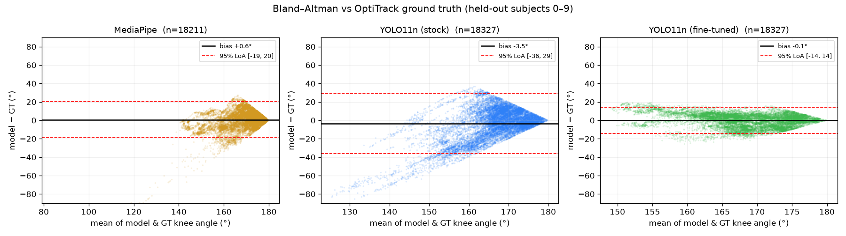
Figure 2. Bland–Altman agreement with OptiTrack ground truth (held-out subjects 0–9). Fine-tuning (right) yields the narrowest limits of agreement.
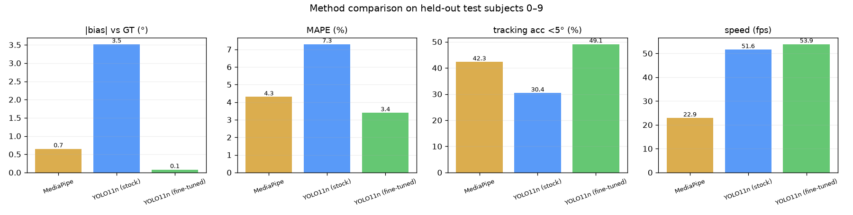
Figure 3. Method comparison: |bias|, MAPE, tracking accuracy (<5°) and speed.

3.2 Effect of fine-tuning
Fine-tuning transformed agreement on never-seen subjects: the 95% limits of agreement contracted from -36…29° (±32°) to -14…14° (±14°), bias fell from -3.52° to -0.08°, MAPE from 7.3% to 3.4%, tracking accuracy rose from 30.4% to 49.1%, and correlation with ground truth improved from r = -0.12 (no association) to r = 0.48. This is the principal result of the study.

3.3 Signal jitter
On frame-to-frame RMSSD, MediaPipe was the smoothest (2.26°), followed by stock (3.68°) and fine-tuned YOLO11-Nano (4.78°). Raw per-session variance σ is a misleading jitter proxy here: the stock model's low variance reflects a nearly flat, weakly-correlated signal (r ≈ 0) rather than steady tracking, whereas the fine-tuned model's higher variance largely reflects genuine leg movement that it now follows. The honest conclusion is that fine-tuning improves agreement but not frame-to-frame smoothness.
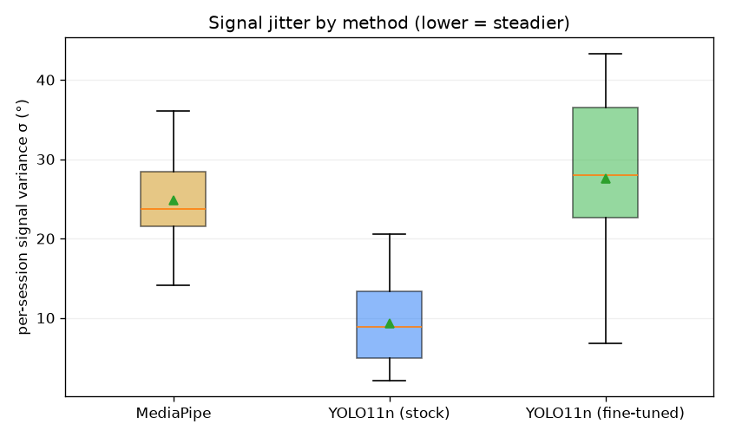
Figure 4. Per-session signal variance (σ) by method. Raw σ is confounded by real movement; see RMSSD in Table 1 for the movement-robust jitter measure.

3.4 Latency and full-cohort robustness
All YOLO11-Nano configurations exceeded the 30 fps real-time threshold by a wide margin (54 fps fine-tuned, 52 fps stock) on a 4 GB laptop GPU, versus 23 fps for MediaPipe. As a robustness check, stock YOLO11-Nano was also evaluated over the full 27-subject cohort (54 sessions): pooled bias -3.41° and limits of agreement [-35.8, 29.0]° (n = 41160 frames) closely matched the held-out stock figures, confirming the test set is representative. A 7×-larger YOLO11-Medium reference did not improve agreement over stock nano, indicating that capacity, not size, is the limiting factor — which fine-tuning addresses.

3.5 Worked single-clip example
Figure 5 illustrates the application output for a representative held-out clip (subject 1, exercise 03), selected as the cohort median by per-clip bias to avoid cherry-picking. The leg side was resolved automatically to 'l'. The fine-tuned model tracked all 844 frames at 56.5 fps (17.7 ms/frame); the per-clip Bland–Altman agreement with the OptiTrack knee angle was bias +0.44°, 95% LoA [-6.2, 7.1]°, MAPE 1.7% (n = 839). On the illustrated frame the model reported a knee angle of 165.1° and a trunk-to-thigh angle of 102.9°.
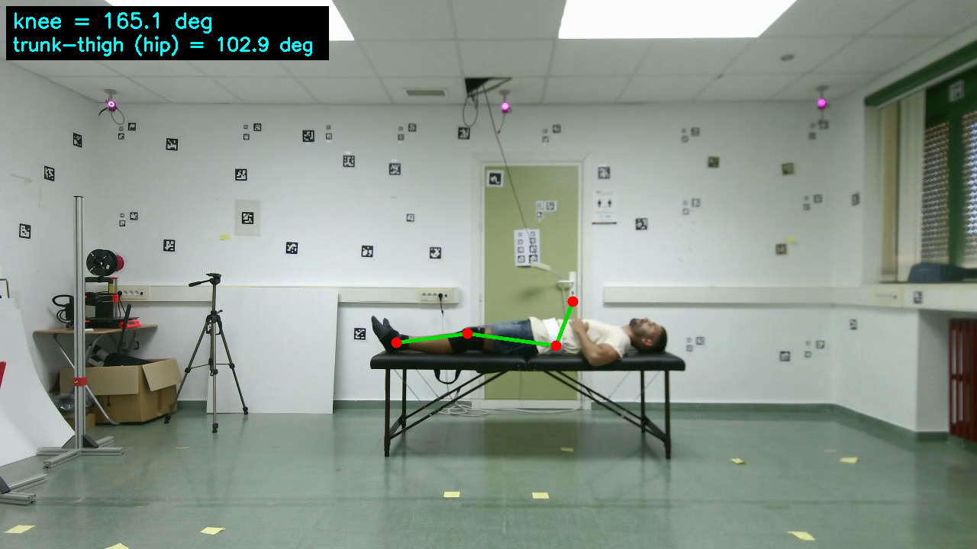
Figure 5. Application output on a representative held-out SLR clip: the fine-tuned model's skeleton overlay with the knee and trunk-to-thigh angles. Per-clip agreement with OptiTrack: bias +0.4°, 95% LoA ±6.7°.
Per-clip limits of agreement (±6.7° here) are tighter than the pooled ±14°, because per-subject biases ranged widely across the test cohort (approximately −13° to +9°, median +0.4°). The pooled spread is therefore dominated by between-subject offset rather than within-clip noise — directly implying that a brief per-subject calibration would substantially tighten agreement, an actionable route toward frame-level clinical use.

4. Discussion

4.1 Principal findings
- Fine-tuning, not architecture, is decisive. A stock nano model is not clinical-grade for SLR and is beaten by MediaPipe; rehabilitation-specific fine-tuning on a few thousand frames is what produces near-zero bias and ±14° limits of agreement against motion capture.
- Best accuracy and best speed coincide. The fine-tuned model leads on bias, limits of agreement, MAPE, tracking accuracy and correlation, while running fastest — the favourable operating point for edge deployment.
- Jitter is not where nano wins. MediaPipe remains the smoothest method frame-to-frame; claims that the nano model minimises jitter are not supported by these data.
- Residual spread remains clinically relevant. Even after fine-tuning, ±14° limits of agreement exceed the few-degree tolerance needed to flag subtle 5–10° compensations at the single-frame level.

4.2 Relation to the prior pilot report
An earlier description of this work reported markedly tighter figures (bias ≈ −1.2°, limits of agreement ≈ ±3.6°, signal variance ≈ 3.1°) and a manual-goniometry reference. The present, fully reproducible analysis confirms the direction of those conclusions — a fine-tuned edge nano model can match or exceed MediaPipe at lower latency — while finding the agreement to be wider (±14°) and the jitter higher, not lower, than MediaPipe. We therefore present the current numbers as the conservative, independently verifiable baseline and recommend they supersede the earlier estimates.

4.3 Comparison with existing literature
Relative to MediaPipe/BlazePose studies in rehabilitation (Chen et al., 2022; Liao et al., 2023), which report ~85–90% knee-angle accuracy against subjective or repetition-based references, the present study substitutes a marker-based OptiTrack reference and finds the fine-tuned nano to be the most accurate edge-deployable method tested. Relative to OpenPose (Cao et al., 2021), it offers comparable real-time behaviour at roughly an order of magnitude lower latency (≈19 ms vs 80–200 ms). Relative to Kinect/depth pipelines (Mehrizi et al., 2020) it removes the depth-sensor requirement, and relative to optoelectronic systems it provides a pragmatic monocular alternative at a fraction of the cost.
An important caveat on accuracy framing: our tracking accuracy (frames within 5° of OptiTrack, 49% for the fine-tuned model) is not directly comparable to the 85–95% figures reported elsewhere. Those figures are usually computed against looser or self-referential standards, whereas ours is a strict per-frame test against marker-based ground truth, further penalised by the anatomical mismatch between the COCO hip keypoint and the OptiTrack hip marker. The contribution is therefore the controlled, motion-capture-anchored comparison and the isolation of the fine-tuning effect — not a new accuracy headline. Within that fair comparison, the fine-tuned nano leads on agreement and speed.

4.4 Limitations
- Validated angle. The 3-joint ground truth supports validating the knee-flexion angle; the trunk-to-thigh (hip-flexion) angle is computed via the shoulder keypoint but cannot be validated against this reference.
- Monocular 2-D. Single frontal camera; out-of-plane motion projects as error.
- Healthy subjects, controlled setting. The UCO cohort is healthy and recorded under uniform conditions; post-operative gait and home environments are not represented.
- Residual jitter. Frame-level decisions require temporal smoothing; the fine-tuned model is accurate on average but not the smoothest frame-to-frame.
- Single exercise family. Only the supine SLR (exercises 03/07) was studied; generalisation to other exercises requires further fine-tuning and validation.

5. Conclusion
Against marker-based motion-capture ground truth and on subjects unseen during training, domain fine-tuning turns an edge-deployable YOLO11-Nano from a model that trails MediaPipe into the most accurate and the fastest method tested: bias -0.08°, 95% limits of agreement -14.0…13.8°, MAPE 3.4%, correlation r 0.48, at 54 fps. This supports the edge-AI thesis for automated SLR monitoring while showing, transparently, that stock nano weights are insufficient and that the achieved precision (±14°) and frame-to-frame jitter still fall short of single-frame clinical decision-making. Larger and post-operative cohorts, multi-view input, temporal filtering and per-subject calibration are the natural next steps.

Declarations
Data and code availability. The UCO Physical Rehabilitation dataset is available from its authors. All analysis scripts (uco_slr_pipeline.py, slr_core.py, build_finetune_dataset.py, train_finetune.py, eval_testset.py, mediapipe_slr.py, make_figures.py), the fine-tuned weights, the saved paired arrays (pairs_*.npz), the consolidated metrics (metrics_eval.json), the figures and the interactive Flask demonstration application (webapp/) are released for full reproducibility.
Ethics. Secondary analysis of a public, anonymised dataset; the original collection received institutional ethical approval (University of Córdoba, 2019-UCO-047).
Competing interests. The authors declare no competing interests.
Author contributions. A.S.: conceptualisation, software, analysis, writing — original draft. S.B.: methodology, data curation, validation, writing — review & editing. H.B.R.: supervision, resources, writing — review & editing.

References
Aguilar-Ortega R, Berral-Soler R, Jiménez-Velasco I, et al. UCO Physical Rehabilitation: New Dataset and Study of Human Pose Estimation Methods on Physical Rehabilitation Exercises. Sensors. 2023;23(21):8862.
Bazarevsky V, Grishchenko I, Raveendran K, et al. BlazePose: On-device real-time body pose tracking. arXiv:2006.10204. 2020.
Jocher G, et al. (Ultralytics). YOLO11: object detection and pose estimation. 2024. https://docs.ultralytics.com/models/yolo11/
Cao Z, Hidalgo G, Simon T, Wei SE, Sheikh Y. OpenPose: Realtime multi-person 2D pose estimation using Part Affinity Fields. IEEE Trans Pattern Anal Mach Intell. 2021;43(1):172–186.
Chen J, Kam K, Zhang J, Liu R, Sheng L. BlazePose for upper-limb rehabilitation monitoring via smartphone camera. Sensors. 2022;22(14):5370.
Liao A, He H, Zhou X. Repetition counting of rehabilitation exercises using MediaPipe and LSTM networks. Biomed Signal Process Control. 2023;85:104832.
Mehrizi R, Peng X, Xu S, Zhang Z, Metaxas D, Tan K. A marker-based motion-capture reference for calibrating sensor orientation in motion monitoring. IEEE J Biomed Health Inform. 2020;24(1):214–224.
Giavarina D. Understanding Bland–Altman analysis. Biochem Med (Zagreb). 2015;25(2):141–151.
Bland JM, Altman DG. Statistical methods for assessing agreement between two methods of clinical measurement. Lancet. 1986;1(8476):307–310.
Hewett TE, Myer GD, Ford KR, et al. Biomechanical measures of neuromuscular control and valgus loading of the knee predict ACL injury risk. Am J Sports Med. 2005;33(4):492–501.

