Supplementary Materials
Development of an autonomous artificial intelligence agent for training load monitoring: a closed-loop in silico trial against the acute-to-chronic workload ratio
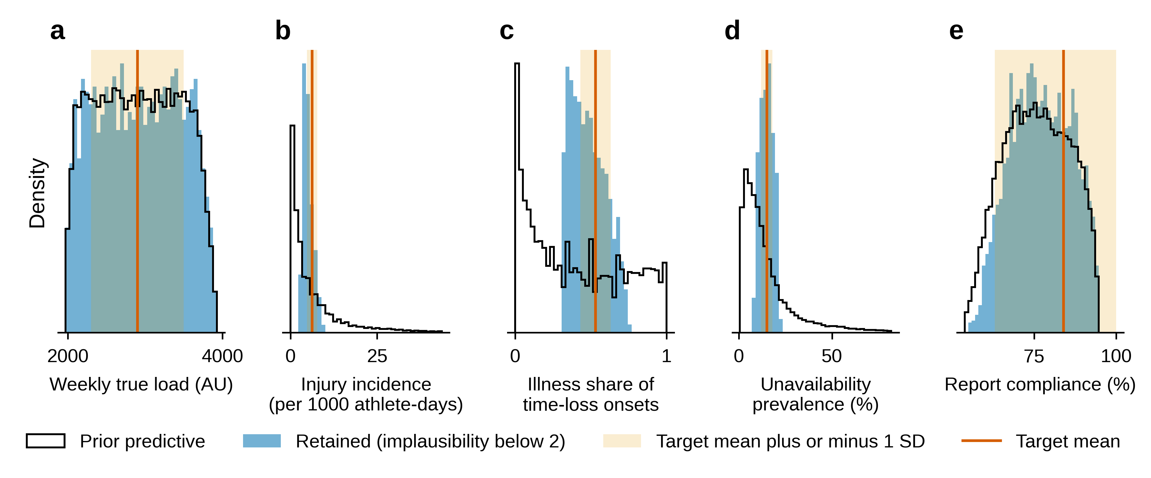
Figure S1. Calibration of the data-generating model. Distributions of the five calibration statistics across the 32,768 wave-2 parameter sets (prior predictive) and across the 3276 sets retained with a maximum implausibility below 2. Shaded bands show the target mean plus or minus one standard deviation, and vertical lines the target means. AU: arbitrary units; SD: standard deviation; sRPE: session rating of perceived exertion.
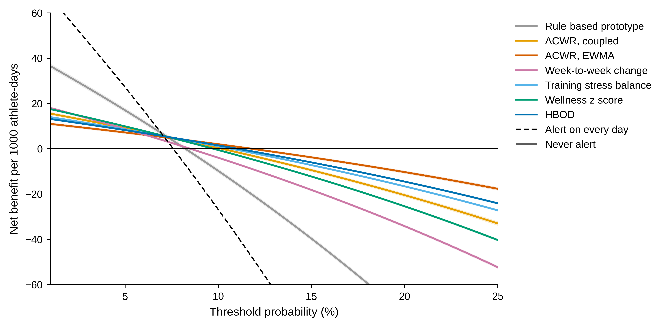
Figure S2. Net benefit per 1000 athlete-days at default thresholds across threshold probabilities, with 95% CI bands, across 1000 worlds, against alerting on every day and never alerting. Uncoupled ACWR and HBOD without wellness are omitted for legibility. Because default alert rules are not probability thresholds, the threshold probability acts as an exchange rate between true and false alerts. ACWR: acute-to-chronic workload ratio; CI: confidence interval; EWMA: exponentially weighted moving average; HBOD: Hooper-Borg-Oslo-Dergaa.
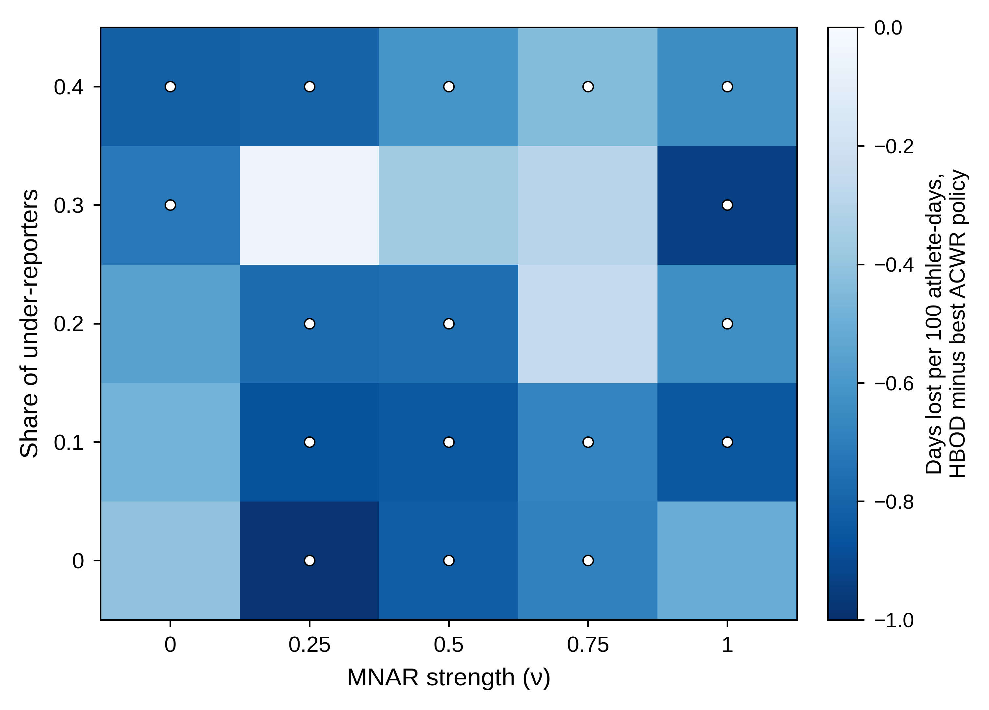
Figure S3. Robustness grid. Paired difference in days lost per 100 athlete-days between HBOD and the best ACWR policy in each cell of the five-by-five grid crossing the share of under-reporters with MNAR strength (40 worlds per cell). White dots mark cells whose 95% CI excludes zero. ACWR: acute-to-chronic workload ratio; CI: confidence interval; HBOD: Hooper-Borg-Oslo-Dergaa; MNAR: missing not at random.
Table S1. Frozen analysis plan.
The plan below was written after development runs on separate seeds and before any evaluation seed was simulated. It is reproduced as frozen, with only typographic changes (numbers in words, mathematical signs and symbols).
Engines frozen as in engines.py (v1, ra_coupled, ra_uncoupled, ewma, week_change, tsb, wellness, v2, v2_noW).
v2 hyperparameters frozen: kappa 1.0, q_g 0.005, q_h 0.03, q_s 0.30, rho_s 0.80, forgetting 0.99, imputation inflation 4, alert at posterior probability ≥ 0.80.
Evaluation worlds: 1000 parameter vectors drawn without replacement from the wave-2 non-implausible pool; simulation seeds 900000 onwards (never used in development or calibration).
Primary horizon: any time-loss onset (injury or illness) within the next seven days, healthy athlete-days from day 42.
Open-loop estimands (per world, then averaged over worlds; paired differences against v2 with 95% CI from the world-level t distribution; Benjamini-Hochberg across engines):
AUROC, average precision, event sensitivity, false alerts per athlete-month and PPV at default thresholds and at a matched 10% alert budget; net benefit across threshold probabilities 0.005 to 0.10; injury-only and illness-only AUROC.
Closed-loop estimands (common random numbers, matched 10% alert budget, deload 25% for two days):
days lost per 100 athlete-days (primary), injury and illness incidence per 1000 athlete-days, delivered load, season-end Banister performance; paired differences against a random-alert placebo with the same budget.
Robustness: five-by-five grid of under-reporter share (0, 0.1, 0.2, 0.3, 0.4) and MNAR strength (0, 0.25, 0.5, 0.75, 1), 40 worlds per cell.
Global sensitivity: Saltelli design (base N = 256) over the wave-1 non-implausible box with a dummy parameter; outputs AUROC of v2, AUROC difference v2 minus EWMA ACWR, closed-loop days lost difference v2 minus ACWR policy.
Pre-specified replacement rule. A candidate replaces the ACWR component of HBOD if all hold on evaluation seeds:
(1) closed-loop days lost lower than under the best ratio-based (ACWR) policy, BH q < 0.05;
(2) closed-loop days lost lower than under the random placebo, BH q < 0.05;
(3) open-loop AUROC non-inferior to the best ACWR variant, lower 95% limit of the difference above −0.02;
(4) the sign of (1) preserved in at least 20 of the 25 robustness cells.
If no candidate meets all four, the paper reports that no replacement is supported.
ACWR: acute-to-chronic workload ratio; AUROC: area under the receiver operating characteristic curve; BH: Benjamini-Hochberg; CI: confidence interval; EWMA: exponentially weighted moving average; MNAR: missing not at random; HBOD: Hooper-Borg-Oslo-Dergaa; PPV: positive predictive value. The wave-1 non-implausible box coincided with the prior box. The frozen term alert budget corresponds to the alert rate of the main text. In the frozen text, v1 denotes the rule-based prototype, v2 denotes HBOD, v2_noW denotes HBOD without wellness, and engines denotes the monitoring signals. In the frozen rule, HBOD denotes the deployed system, whose rule-based prototype contained the ACWR flag.
Table S2. Fixed constants of the data-generating model and settings of HBOD.
Component | Quantity | Value
Training plan | Weekly template, fraction of W0 and duration (min), days 1 to 7 | 0.08 and 45; rest; 0.22 and 85; 0.20 and 80; 0.15 and 70; 0.08 and 50; match, 0.27 and 95
Training plan | Congested weeks (15th to 17th) | Second match on day 4 (0.27 of W0, 95 min), then 0.08 of W0 for 45 min
Training plan | Camp block (when present) | Starts between the 9th and 27th week, lasts one or two weeks, load × 1.3 to 1.5
Training plan | Log-normal load noise (SD on the log scale) | Squad-week 0.05; squad-day 0.10; athlete multiplier 0.10; athlete-day 0.15
Training plan | Starters and non-starters | Starter with probability 0.6; non-starters 35% of match load and 12% of W0 the next day
Physiology | Fitness gain k1 | 0.001
Physiology | Fatigue-gain scale k3 | Set so that the steady-state fatigue gain equals the drawn gain ratio × k1 at the planned mean daily load W0/7
Physiology | Initial states | Fitness, fatigue and fatigue gain equal to zero on day 0
Physiology | Load spike zS | Log of (seven-day mean + 10)/(mean of the preceding 28 days + 10), standardised against the planned season
Events | Injury and illness frailties | Normal with SD 0.5 on the log-odds scale
Events | Life stress ℓ | Athlete-level first-order autoregressive process, coefficient 0.9, innovation SD √0.19 (unit variance)
Events | Incubation | Two to four days, counting the exposure day; onset one to three days after exposure
Events | Event duration | Log-normal around the drawn median, log-SD 0.9 for injury and 0.6 for illness, minimum one day
Events | Return to play | Seven days at 60% of the planned load; no new event during this phase
Reporting | Hooper item order | Sleep, stress, fatigue, soreness; 1 = best, 7 = worst
Reporting | Item loadings λj on fatigue | 0.4, 0.3, 0.8, 0.7
Reporting | Item effects ψj of yesterday's deviation from the plan | 0, 0, 0.3, 0.5
Reporting | Item effects γj of life stress | 0.5, 0.9, 0.3, 0
Reporting | Item prodrome loadings δj | 1.0, 0, 1.0, 0.3
Reporting | Item baselines μij and residuals | Baselines normal with mean −0.5 and SD 0.5; residuals standard normal
Reporting | Ordered-probit cut points ζ | −2.0, −1.2, −0.4, 0.4, 1.2, 2.0
Reporting | RPE noise | Gaussian SD 0.6, rounded to an integer and bounded between 0 and 10
Reporting | Reported sRPE during return to play | Scaled by 0.6 on top of the reduced true load (about 36% of the plan); used only by the rule-based prototype
Reporting | Compressors and careless responders | Compressors halve all deviations; careless responders answer uniformly from 1 to 7 on 30% of days
Reporting | Athlete missingness | logit mi = logit m0 + 0.8 × standard normal
HBOD | Transition matrix F | diag(e^(−1/42), e^(−1/7), 0.8)
HBOD | Process noise Q | diag(0.005², 0.03², 0.30²) in kAU², kAU² and item units²; G and H variances × 4 on imputed days
HBOD | Initial state and covariance | State zero; covariance diag(0.05, 0.05, 0.25)
HBOD | Initial observation coefficients (c0, ch, cg) | 3.5, 1.0, 0.3; RLS covariance diag(1, 4, 4); forgetting factor 0.99
HBOD | Coefficient bounds | ch between 0.1 and 5; cg between 0 and 5
HBOD | Observation variance R | Starts at 0.5; R ← max[0.95R + 0.05(e² − cPcᵀ), 0.05] after each measurement update (Equation 11, Section 2.5)
HBOD | Measurement update | From day 14, only on days with all four Hooper items
HBOD | Baselines and alert | From day 28, up to 42 previous days; κ = 1 SD; alert at p ≥ 0.80
All load signals | Missing and unavailable days | Missing sRPE replaced by the squad median of the day; unavailable athletes contribute zero load
HBOD: Hooper-Borg-Oslo-Dergaa; kAU: thousands of arbitrary units; RLS: recursive least squares; RPE: rating of perceived exertion; SD: standard deviation; sRPE: session rating of perceived exertion; W0: planned weekly load.
Table S3. Verification checks.
Check | Reference | Criterion | Result
Rule-based prototype, Python against JavaScript | Original JavaScript code of the rule-based prototype in the HBOD web application | Identical decrease decision on every athlete-day with an entry | 19,471 of 19,471 athlete-days identical
HBOD filter, vectorised against scalar | Independent line-by-line scalar implementation | Relative difference of daily scores | Maximum 5.9 × 10⁻⁸ (single-precision storage)
HBOD steady state | Discrete algebraic Riccati equation under constant inputs | Absolute difference of posterior covariance | Maximum 3.8 × 10⁻¹⁵
Fitness-fatigue recursions (standalone implementation) | Closed-form limits under constant load | Agreement of fitness and fatigue | At least 12 significant digits
HBOD: Hooper-Borg-Oslo-Dergaa.

Table S4. Results by reporting style.
Reporting style | Athlete-seasons (worlds) | AUROC, HBOD | AUROC, coupled ACWR | AUROC, EWMA ACWR | Days lost, HBOD | Days lost, EWMA ACWR | Days lost, random alerts | Days lost, HBOD minus EWMA ACWR
Honest | 16,262 (1000) | 0.552 (0.549 to 0.556) | 0.559 (0.554 to 0.563) | 0.548 (0.543 to 0.552) | 13.13 (12.79 to 13.47) | 13.57 (13.23 to 13.91) | 12.69 (12.34 to 13.04) | −0.44 (−0.57 to −0.32); q < 0.001
Under-reporter | 4917 (896) | 0.552 (0.545 to 0.560) | 0.546 (0.537 to 0.554) | 0.531 (0.524 to 0.538) | 12.96 (12.40 to 13.51) | 13.73 (13.16 to 14.31) | 12.54 (11.97 to 13.11) | −0.78 (−1.04 to −0.51); q < 0.001
Compressor | 2550 (825) | 0.555 (0.545 to 0.564) | 0.548 (0.538 to 0.558) | 0.530 (0.522 to 0.539) | 13.09 (12.39 to 13.79) | 13.91 (13.21 to 14.60) | 13.15 (12.41 to 13.89) | −0.81 (−1.12 to −0.50); q < 0.001
Careless responder | 1271 (644) | 0.566 (0.553 to 0.579) | 0.539 (0.526 to 0.553) | 0.522 (0.511 to 0.533) | 13.83 (12.91 to 14.75) | 13.48 (12.63 to 14.33) | 12.59 (11.62 to 13.56) | 0.35 (−0.07 to 0.77); q = 0.101
Post-hoc analysis of the 1000 evaluation worlds replayed under their original seeds. Values are means (95% CI) over the worlds that contained at least one athlete of each style; athlete-seasons count each athlete in each world once. Days lost are per 100 athlete-days in the closed loop at the 10% alert rate. Compare signals within a row only, because the worlds that contained each style differed in their other parameters. q: Benjamini-Hochberg adjusted probability across the four styles. ACWR: acute-to-chronic workload ratio; AUROC: area under the receiver operating characteristic curve; CI: confidence interval; EWMA: exponentially weighted moving average; HBOD: Hooper-Borg-Oslo-Dergaa.

File S1
File S1 is a compressed archive with the complete Python code. It holds the data-generating model (hbodsim.py) and the decision algorithms (engines.py), together with the performance measures (metrics.py) and the calibration scripts (calib.py, calib_summ.py). It also holds the experiments (experiments.py, run_main.py, run_robust.py, run_sobol.py, run_dose.py, run_lifeoff.py, run_style.py), the analyses (analyze*.py, including analyze_circ.py, analyze_sobol_cluster.py and analyze_style.py), the verification scripts and the figure scripts. The README file lists the random-number seeds used for development, calibration and evaluation.

