Description:

The **eight queens puzzle** is the problem of placing eight [chess](https://en.wikipedia.org/wiki/Chess) [queens](https://en.wikipedia.org/wiki/Queen_(chess)) on an 8×8 chessboard so that no two queens threaten each other. Thus, a solution requires that no two queens share the same row, column, or diagonal.

Input:

There is no input data

Process:

There are 64 choose 8 ways to place 8 queens on a chess board. Most such placements can be discarded, since they require that two or more queens would be placed on a single row or column, thus, disqualifying such placements as possible solutions. The heart of the solution lies in a recursive function, that provided the right starting arguments, creates a recursion tree that all of its leaves are placements of 8 queens, so that there is only one queen in each row and in each column. After that, it's just a matter of checking the diagonals for the presence of more than a single queen, and if the check passes - We can add that solution to a list of legal solutions, and print it if necessary.

Output:

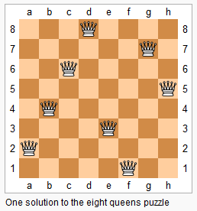

In how many ways can you place 8 queens on a board of chess, so that no two queens threaten each other? The answer: an 8×8 matrix so that no two queens=1 threaten each other. Thus, a solution requires that no two queens share the same row, column, or diagonal.