REPORT ON LEARNING PROCESS

February 13, 2020

Submitted to

Towhidul Islam

Head of Technology

SELISE Fintech

Submitted By

Sabrina Nusrat Ayvi

Software Engineering Shahjalal University of Science and Technology.

**ACKNOWLEDGEMENT**

Firstly, I am really thankful to the SWE and it’s Intern Program Office for arranging the wonderful internship program for me. I am also grateful to SELISE for recruiting me as an intern. I take this chance to express my significant appreciation and profound respects to Md. Towhidul Islam, Head of Technology of SELISE Fintech for his praiseworthy direction, observing and steady consolation during this time.

I also would like to thank Prof Mohammad Abdullah Al Mumin, Professor and Director of IICT, SUST for giving me the opportunity to take part in the internship such a renowned organization. I also make this chance to express a profound sense for gratitude to Md. Imrul Islam, Senior Software Engineer of SELISE and my supervisor for his friendly support, guidance.

**Executive Summary**

This document deals with the author experiences and learning process as a beginner and intern. It also represents the achievements and challenges during the learning process. The scope of this document is to identify and describe the analysis carried out, projects completed, experience gained and focuses on the achievements.

The Internship Program Office of IICT, SUST offers their bachelor’s student to take an internship during their 7th semester. The goal of offering and taking this internship is to provide students with the opportunity to get practical work experiences and applied software engineering practices in real life projects. It is a golden opportunity for the student to learn new things and getting familiar with the industry during their student life

Being a bachelor program student of IICT, I was offered to take an internship at Secure Link Service BD Ltd, a well-known, multinational software company in Bangladesh. I have joined SELISE as an intern. I was cordially welcomed by the SELISE family. However, after getting proper training, I started working as a frontend developer along with practicing various software engineering practices. I was treated as an employee and got all the facilities just like other employees. I have explored new technologies and practices, got familiar with industry people and faced new challenges. I feel really fortunate to have support and mentoring from all of my teammate and team leaders.

During my last six semesters, I have learned many software engineering practices. However, it all about to theoretical knowledge but in the internship, I found a practical implementation of that such as agile process of development, scrum, sprint etc. It really helps me to make the link between my theoretical knowledge’ s with the practical implementations.

Now I am currently working in a team for developing real life projects. The experience of working this project help me both develop my problem-solving skills and practicing the software engineering best practices. This internship program helps me to improve my skills, confidence and provide me an opportunity to be a professional Software Engineer.

**Table of Contents**

CHAPTER 1: INTRODUCTION ..........................................................................................5

CHAPTER 2: Learning CSS & SCSS .................................................................................6

2.1 Home page.........................................................................................................................6

2.2 Template ............................................................................................................................7

2.3 Personal Assistant Home Page................................................................................. 8

CHAPTER 3: Learning JavaScript & ES6 .....................................................................9

3.1 DicePigGame................................................................................................................... 9

3.2 Budget Application......................................................................................................10

CHAPTER 4: Learning Angular ........................................................................................11

4.1 To-do list ..........................................................................................................................12

4.2 Employee Management System..............................................................................13

**CHAPTER 1: INTRODUCTION**

Every Web Developer must have a basic understanding of HTML, CSS, and JavaScript. Responsive Web Design is used in all types of modern web development.

A front-end developer is someone who takes a client or design team’s website design and writes the code needed to implement it on the web. Before starting Angular, anyone need to know the basic idea of HTML, CSS and JavaScript.

So, we started our learning process with CSS. I made a simple home page website. Then I started to learn SCSS. I made a personal assistant home page with SCSS.

After finishing CSS and SCSS, I have started learning JavaScript. I did a simple dice game and budget application with JavaScript and employee management application with Angular 6.

Next chapter, I will describe the resources from where I’ve learnt those things.

➢ CSS

➢ SCSS

➢ JavaScript

➢ ES6

➢ Angular

**2.1** **Home page**

**Learning Materials:** Making website Home page with top nav-bar

**Duration:** 1 Day

**Resource Link:** w3school, many tutorials from Youtube.

**Github Link:** <https://github.com/sabrina-32/disney-princess-website-with-html-and-css>

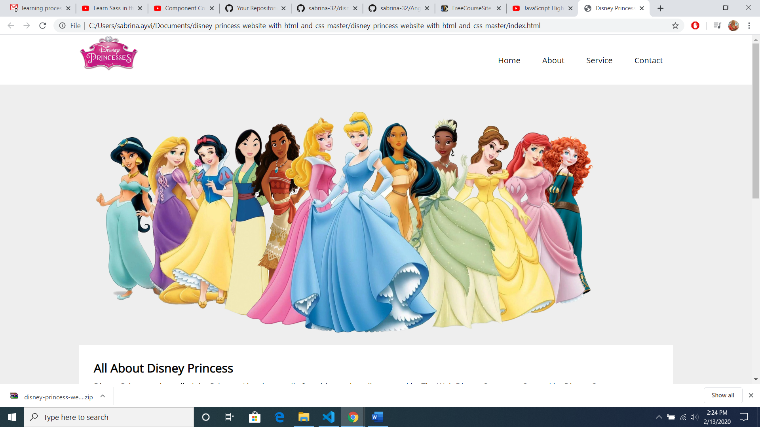

**2.2 Template**

**Learning Materials:** responsive website

**Duration:** 1.5 days

**Resourse Link:** w3school and youtube

**Github Link:** <https://github.com/sabrina-32/home-page-template>

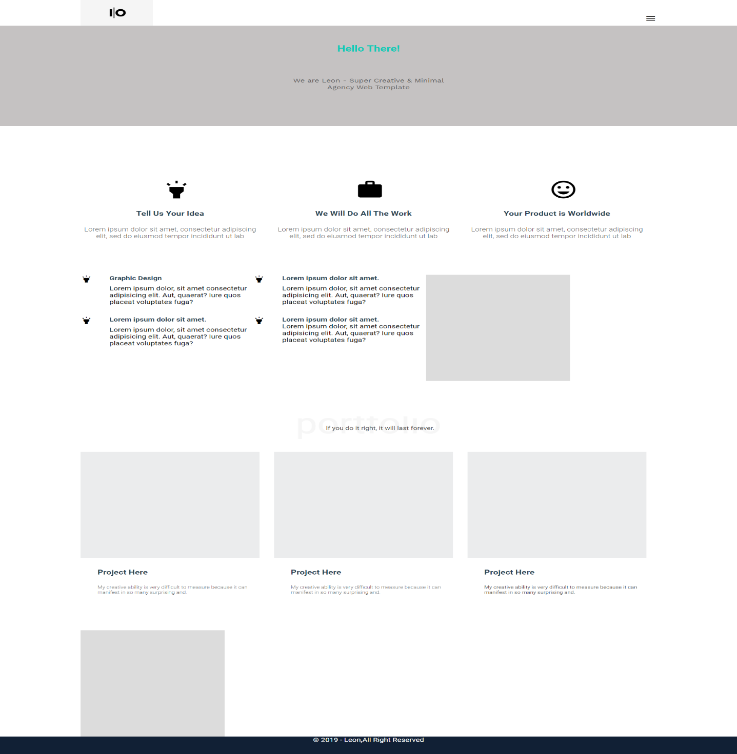

**2.3 Personal Assistant Home Page**

**Learning Materials:** SASS installation and properties, syntax

**Duration:** 1 day

**Resourse Link:**

* DesignCourse**:** <https://www.youtube.com/watch?v=roywYSEPSvc>
* egghead.io: <https://egghead.io/lessons/css-transpile-scss-to-css-using-node-sass>

**Github link:** <https://github.com/sabrina-32/SCSS-SASS>

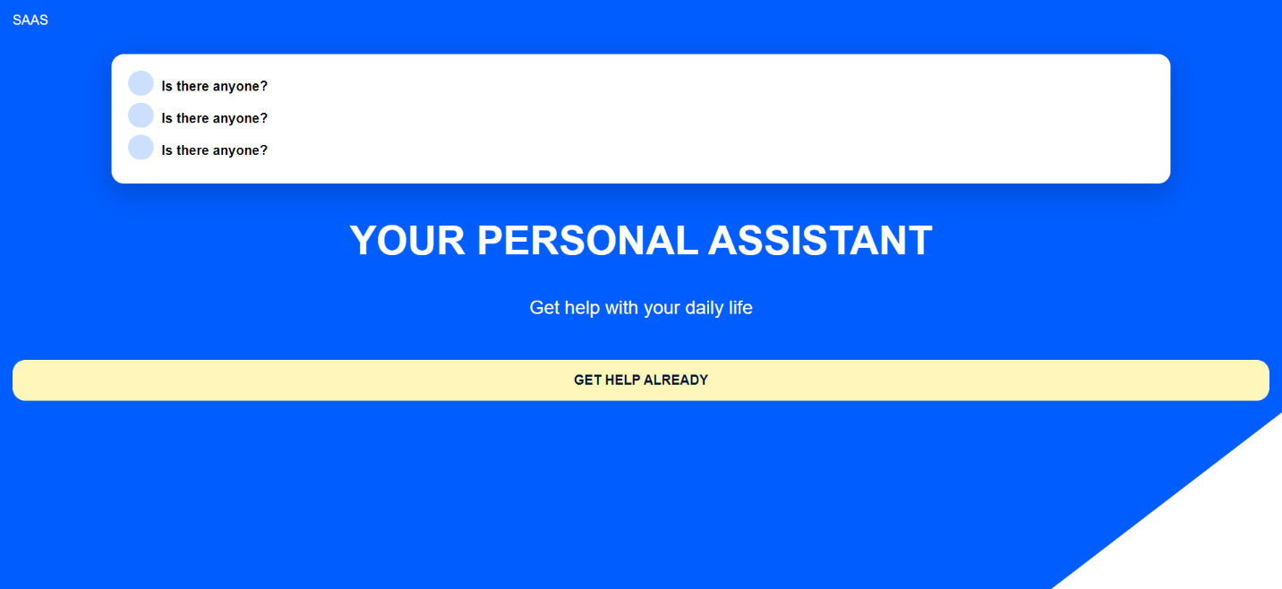

**CHAPTER 3: Learning JavaScript & ES6**

**Github link:**

### [**Learning-JS-ES6**](https://github.com/sabrina-32/Learning-JS-ES6)**:** <https://github.com/sabrina-32/Learning-JS-ES6>

### [**Asynchronous-JavaScript**](https://github.com/sabrina-32/Asynchronous-JavaScript)**:** <https://github.com/sabrina-32/Asynchronous-JavaScript>

### [**Fetch-AJAX-Promise**](https://github.com/sabrina-32/Fetch-AJAX-Promise)**:** <https://github.com/sabrina-32/Fetch-AJAX-Promise>

**3.1 Dice Pig Game**

**Learning Materials:** JS basics , DOM

**Duration:** 1 Day

**Resourse Link:** Complete JavaScript Course By Jonas Schmedtmann

**Github link:** https://github.com/jonasschmedtmann/complete-javascriptcourse

**Github Link:** <https://github.com/sabrina-32/Pig-Game>

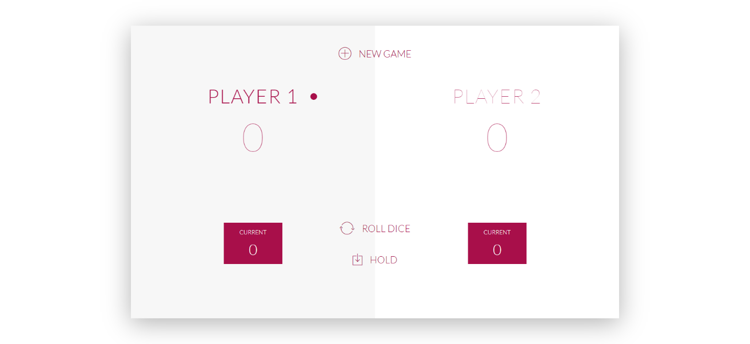

**3.3 Budget Application**

**Learning Materials:** Advanced-JS functions and properties

**Duration:** 2 days Resourse Link: Complete JavaScript Course By Jonas Schmedtmann ,

**Github link:** <https://github.com/jonasschmedtmann/complete-javascript-course>

**Github Link:** <https://github.com/sabrina-32/Budgetty>

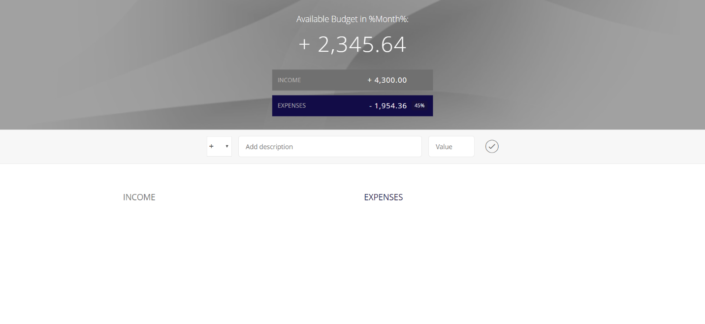

**CHAPTER 4: Learning Angular**

**4.1 To-do list**

**Learning Materials:** Angular set up and basics Duration: 1 day

**Resource Link:**

* **angular.io:** <https://angular.io/docs>
* **Codedamn:**<https://www.youtube.com/watch?v=UoVytwPk3iA&list=PLYxzS__5yYQlqCmHqDyW3yo5V79C7eaTe>
* **Traversy Media:** <https://www.youtube.com/watch?v=Fdf5aTYRW0E>

**Github Link:** <https://github.com/sabrina-32/AngularTodoApp>

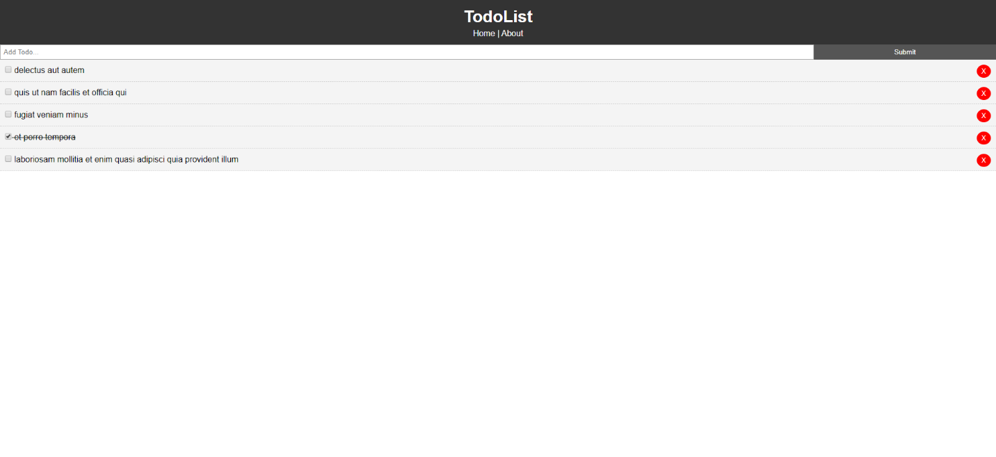

**4.2 Employee Management System**

**Learning Materials:** Angular forms

**Duration:** 1 week

**Resourse Link:**

**Kudvenkat:**<https://www.youtube.com/watch?v=CusfUmB6mkY&list=PL6n9fhu94yhWNJaDgh0mfae_9xoQ4E_Zj>

**Github Link:** <https://github.com/sabrina-32/Angular-Project>

