**Assignment on**

**Describing an Image or Scenery Chosen or Photographed by Me**

**Course Title: English for Academic Purposes I**

**Course code: EAP 101**

**Section: EB**

**Semester: Summer 2020**

**Date of Submission: 12, 2020**

**Prepared to:**

**Name: Md. Rasel Kabir**

**Designation: Assistant Professor**

**Department: English**

**Prepared By:**

**Name: Mariom Akter**

**ID No.: 201015049**

**Green University of Bangladesh**

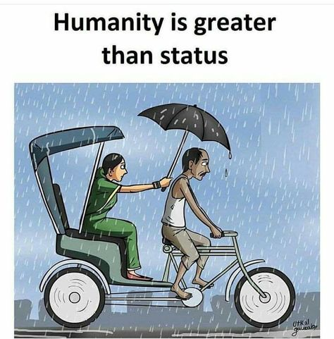

The picture passes a great message to all especially those who are privileged to be among the richest. We were all born equally regardless of our status. Being among the richest doesn't mean you were born differently, it's just the grace of our good God. It's obvious from the picture how the woman trying to prevent the poor man/driver from being drenched by rain with her umbrella. It's called humanity. Don't help people with an impression of being repaid. Help the less privilege people. Those who you are very sure won't be able to repay your good deed to them. Don't help people just because you needed others to see you doing it. We have seen some philanthropists helping others just to impress people.You are in that position today not to oppress but to assist. Humanity can be defined as quality of being human; the peculiar nature of man, by which he is distinguished from other beings. Being human does not mean that an individual possesses humanity. We live in a world that, although it has borders, it is limitless. People can travel anywhere, see anything, experience every feeling that ever existed, but we are not satisfied. We try to impose borders on ourselves, we fight today to be recognized as not belonging to “their community”, to be labeled as part of a smaller group. We fight today to impose limits to a world in which yesterday people have fought so that it didn`t have any. And we applauded them. Humanity is an important part of life which tells that to help others, try to understand other and realize the people problems with our own eyes and try to help them. For showing humanity you don't need to be a rich person, even a poor person can sow humanity by helping someone or sharing his or her food, etc. When you show humanity you have a feel click or a pinch from your inner soul which you cannot get from something else. Every religion tells us about humanity, peace and love that is why no religion is higher than humanity. Humanity is an important part of life which tells that to help others, try to understand other and realize the people problems with our own eyes and try to help them For showing humanity you don't need to be a rich person, even a poor person can sow humanity by helping someone or sharing his or her food, etc. When you show humanity you have a feel click or a pinch from your inner soul which you cannot get from something else. Every religion tells us about humanity, peace and love that is why no religion is higher than humanity.