The **event loop** is the secret behind JavaScript’s asynchronous programming. JS executes all operations on a single thread, but using a few smart data structures, it gives us the illusion of multi-threading.

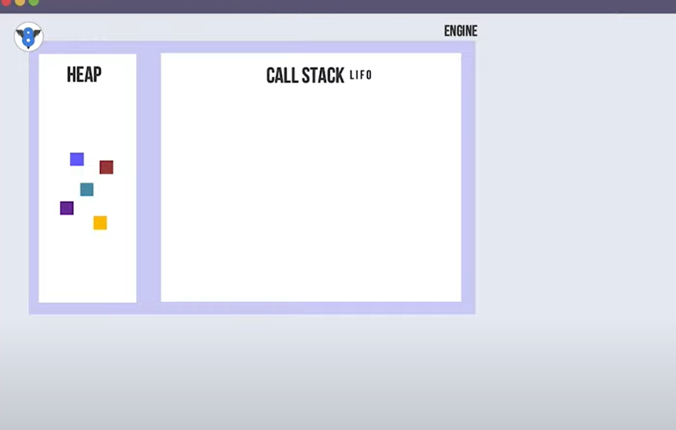

Heap works with memory allocation

Call stack works how to arrange function and maintains last in first out.

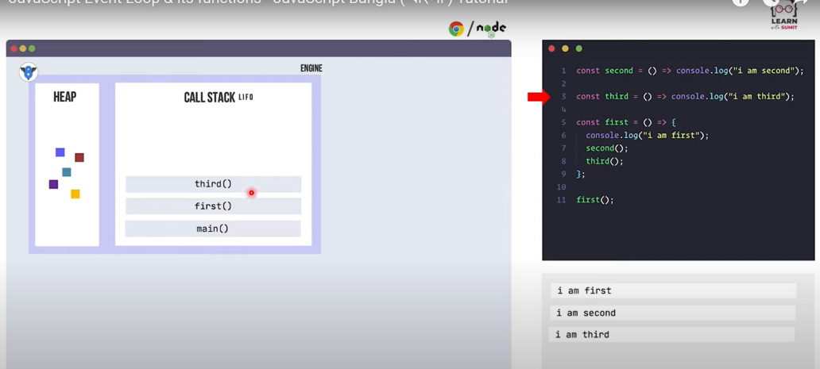

When set timeout() get call stack it will pass webapi.

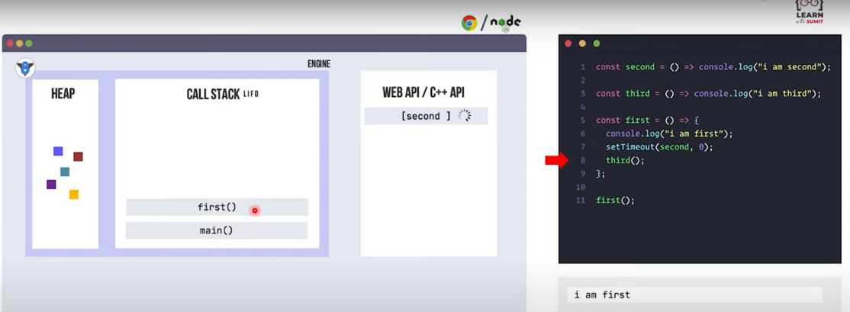

After setTimeOut time finished WEB API send to callback queue. We should take this second() to call Stack. But call stack know second() is in callback queue. Event loop is the guardians which contacts with call Stack.

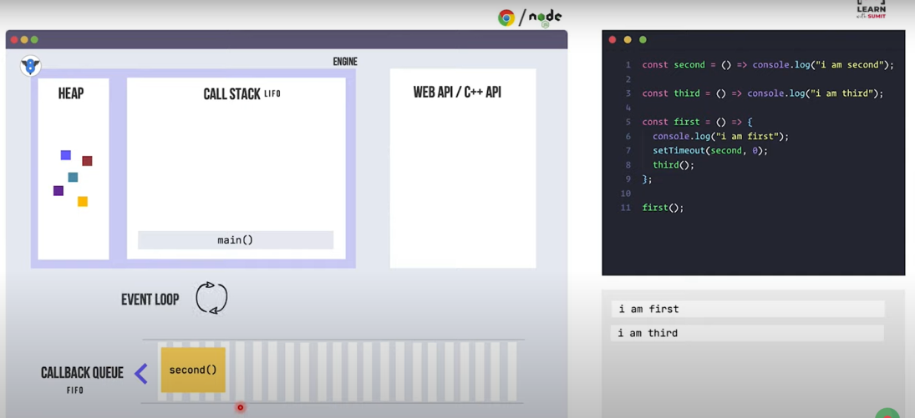

Promise goes to Microtask Queue. Event loop takes promise first in callStack then second()

