Object

What is object?

Object is the collection of key/value pairs which creates with curly brackets. Objects are variables too. But objects can contain many values.

It is a common practice to declare objects with the const keyword. If we declare with const which will not be modified later.

const car = {type:"Fiat", model:"500", color:"white"};

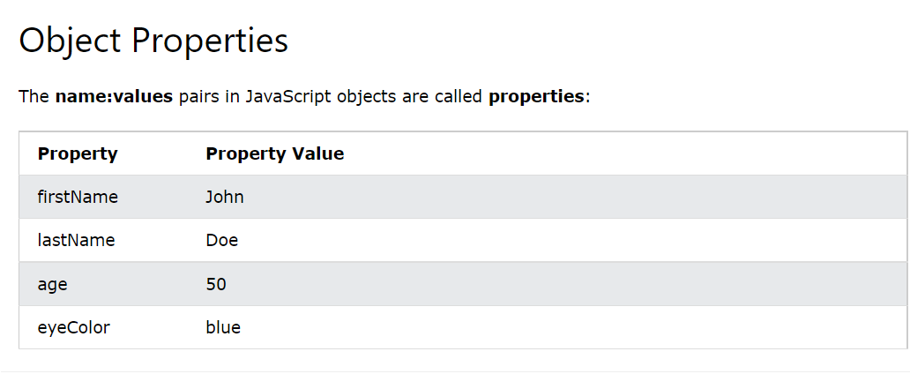

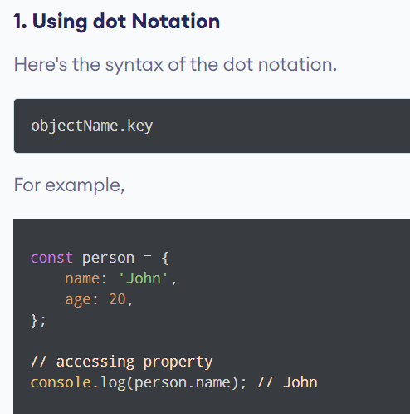

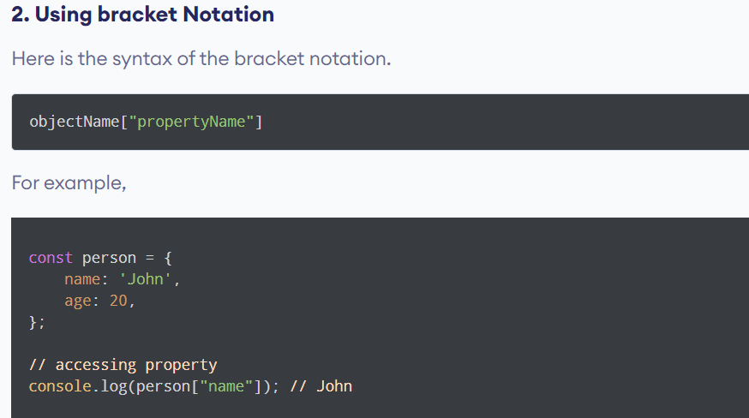

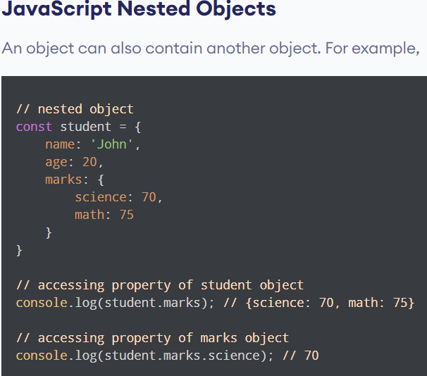

Object Methods

Objects can also have **methods**.

Methods are **actions** that can be performed on objects.

Methods are stored in properties as **function definitions**.

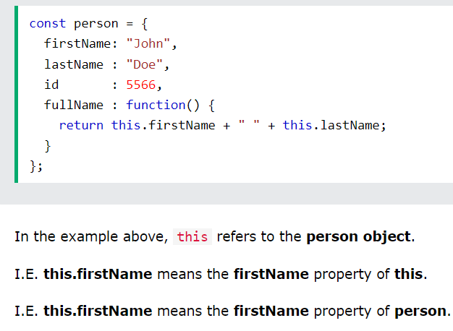

The **this** Keyword

this is not a variable. It is a keyword. You cannot change the value of this.

In the example above, this  is the **person object** that "owns" the fullName function.

In other words, this .firstName means the firstName property of this  **object**.

Arrow function does not work like normal function. If you put arrow function in this condition which refers to global window, it doesn’t bind with person object. Because of arrow function doesn’t have own this  keyword.

Object loop:

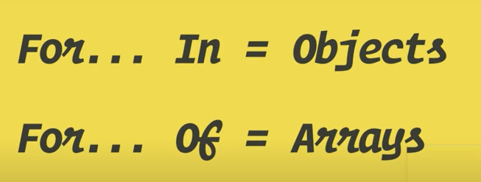

**How to loop through an object in JavaScript with object static methods**

We have three object static methods, which are:

* Object.keys()
* Object.values()
* Object.entries()

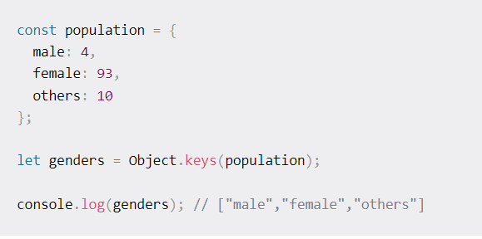

Now we can use array method

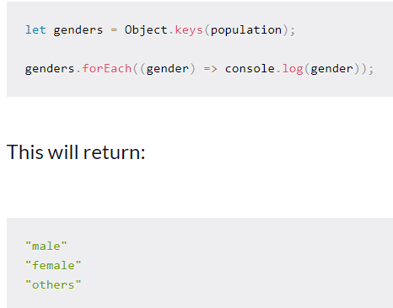

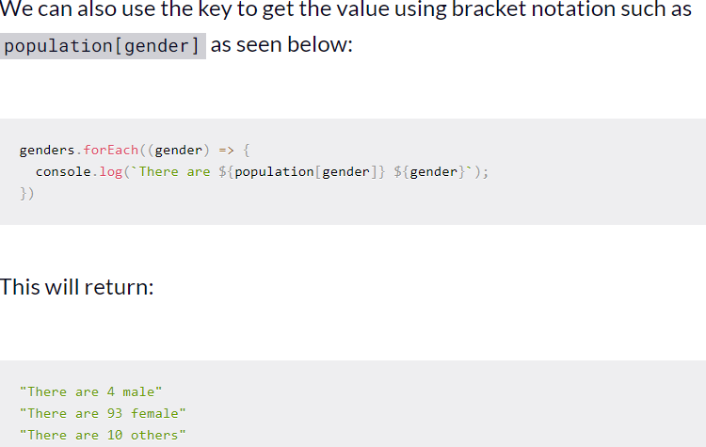

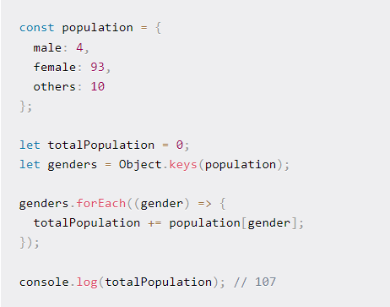

**How to loop through an object in JavaScript with the Object.values() method**

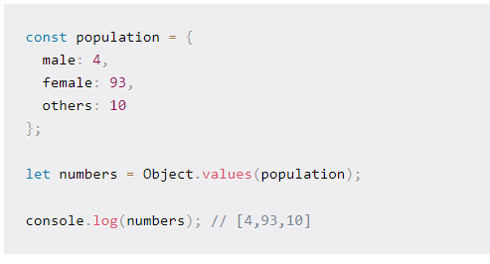

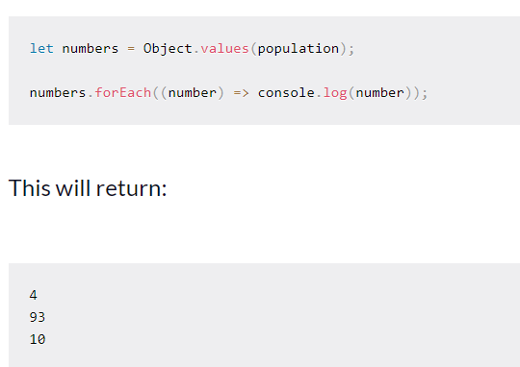

**How to loop through an object in JavaScript with the Object.entries() method**

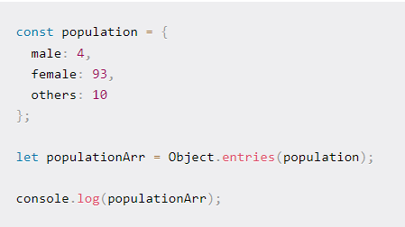

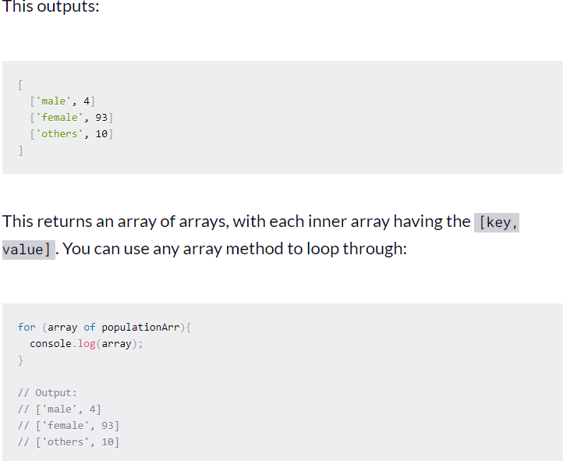

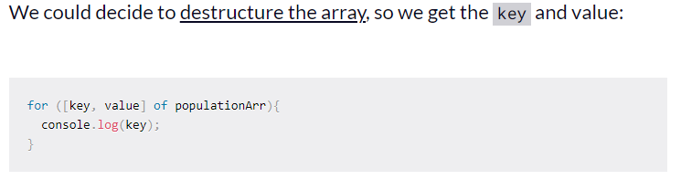

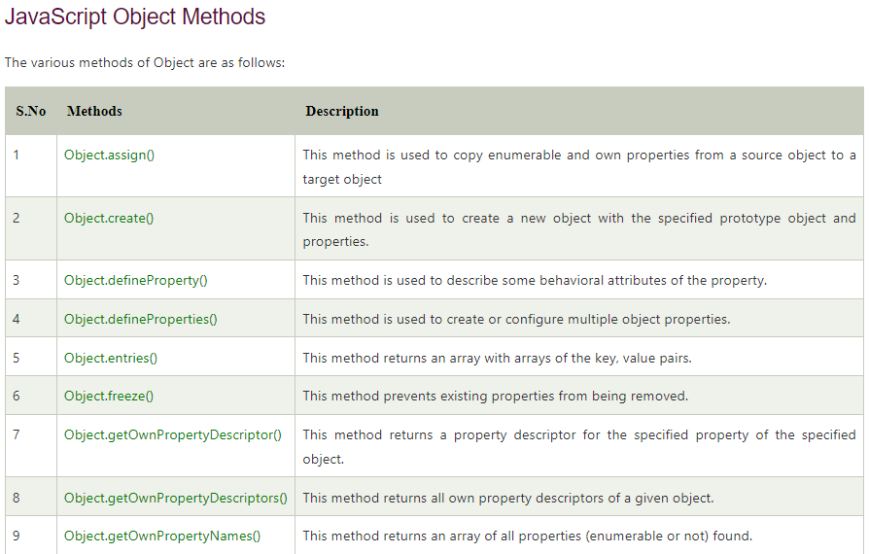

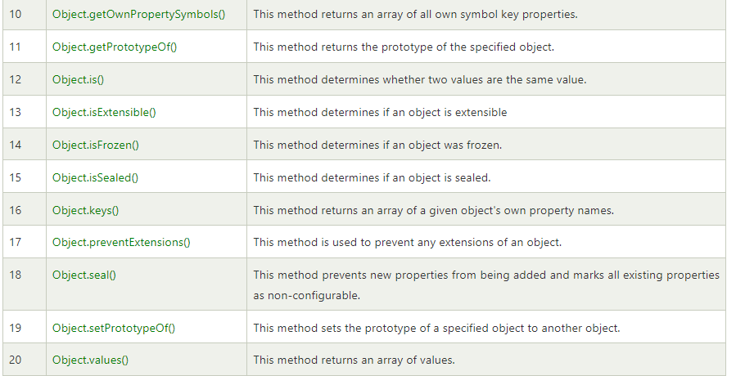

**Output based questions and answers**

**https://www.youtube.com/watch?v=XnFIX3c7xoI&ab_channel=RoadsideCoder**