**Assignment 6**

**The Employee Management System (Add Employee Popup)**

In the previous assignment you were tasked with creating the front-end ‘Add Employee’ web form for an Employee Management System. When you clicked the ‘Add Employee’ button, the data was collected from the form the results were displayed in the console window. In this assignment, you will modify how this form works. In this assignment, the ‘Add Employee’ form will now pop up in a new browser window. And this time, when the user clicks the ‘Add Employee’ button in the pop up, the pop up will close itself, and the values that user enters, will be displayed within an <output> tag in the parent window.

**General Considerations**

The majority of the UI has been built for you. You will be focusing primarily on the functionality. To complete this assignment, consider the following:

* When the user clicks the ‘Add Employee’ button on the index.html page, the add-employee.html page should open within a new popup window. It doesn’t matter what dimensions you specify here as they will be overwritten on the add-employee.html pop up. This UI is done and the main.js script is created for you. I’ve added comments into this .js file to guide you.
* Within the add-employee.html popup, the user should be able to add values into the form objects and then click the Add Employee button. At this point, the popup should close itself and the values of the form should be displayed within the <output> tag in the index.html page. Again, the add-employee.js script is created for you and I’ve added comments into this file to help guide you.

**Other Considerations**

Keep in mind that you will need to use the following window objects to successfully complete this assignment:

* Use window.open() to open the popup window.
* Use window.resizeTo() to resize the popup window.
* Use window.moveTo() to center the popup window within the web page.
* Use window.close() to close the popup when the user clicks the ‘Cancel’ button or when the user submits the form.
* Use window.opener to select the <output> tag from the main page in order to set the data with the values of the form elements entered into the ‘Add Employee’ form.

**Completed Example (Popup)**

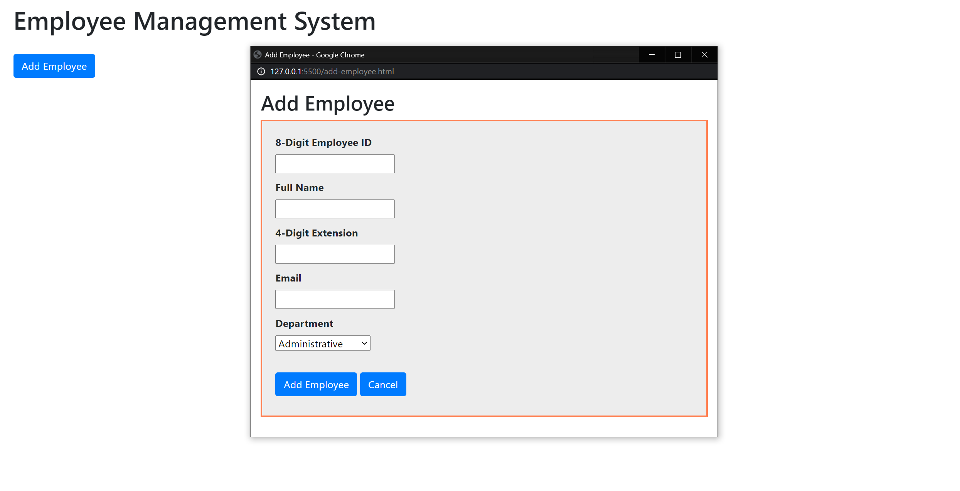

**Completed Example (After Form Submission)**

