Design Plan for **Greasemonkey University** Web Site

Sabrina Tochkov

October 3rd, 2022

## Description

Name: Greasmonkey University (GreasemonkeyU or GMU)

GMU is a car mechanic business bent on helping car owners or beginner mechanics fix and maintain their vehicles. The company offers regular services as well as lessons on how to perform simple repairs or general maintenance tasks. The client is taught how to do the repair themselves, so they won’t need to pay a professional in the future.

## Purpose

The website for GreasemonkeyU is a place where car owners can seek an auto mechanic/technician (a Greasemonkey) to diagnose and fix any issue their automobile may have. They may request to take a course (for simple repairs), which will be held on site (on campus).

## Pages

* **Home:** This is where the client will be able to gather information about the company. It will contain a video of a lesson being held, where a Greasemonkey is teaching students how to change their oil. It will also contain a section describing the origins of the university and its founders, the Tochkovs. At the bottom will be a few positive client reviews.
* **Greasemonkeys:** This is where the client will find the auto mechanics of the company (with a photo of each), their qualifications/experience and an “About Me” on how they came to work at GMU. This page is for those who want to contact a professional to diagnose and repair their vehicle.
* **Courses:** This page will contain a list of all the courses the client can apply for, along with prices and which professor will teach the course. The client can also request an online consultation (for questions). The lessons offered will be rather basic ones.
* **Campus:** This is where a table of GMU’s open hours will be displayed, along with a map that indicates where the university is located. There will be many photos of the campus here.
* **Contact us:** This is where the client can find contact information (for feedback/reviews).

## Target Audience

The website’s target audience is car owners, and those who are seeking to learn how to properly maintain their automobile (whether it’s out of curiosity or to save money for the future). These clients are interested in cars and/or fixing things themselves, like handymen. They are often concerned with being cost-efficient. The design of the website should take into consideration their straight-to-the-point view of life (so very little text, lots of images, clear instructions, reasonable prices, etc.).

## Company Logo



## Colour Palette

Here is the colour swatch that will be used to design the website:

*with whitesmoke, black and dark grey



## Banner

## Layout

Home GreaseMonkeys Courses Campus Contact Us



Reviews

Copyright (footer)

Pick a Course

Watch a Lecture  
  
*video

Founders  
  
*background story and photo of founders

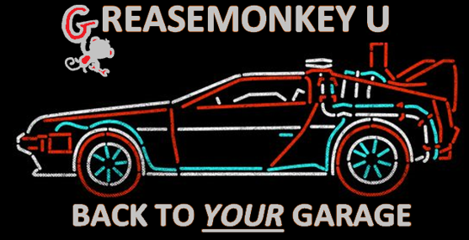

Founders

Watch a Lecture

Reviews

CONTACT US

CAMPUS

COURSES

GREASEMONKEYS

HOME