LINUX COMANDS
NAME=Sabrina Abdullahi Ali
ID=C6240239
Subject=LINUX
LINUX COMANDS
CHAPTER 1 INTORDUCTION LINUX

1.Whoami=displays the username of the user currently logged in.
PRACTICE SCREENSHOT
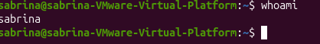
2.pwd=prints the full path of the current working directory
PRACTICE SCREENSHOT
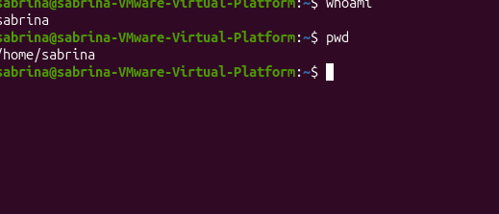
3.ls= lists the files and directories in the current directory.
PRACTICE SCREENSHOT
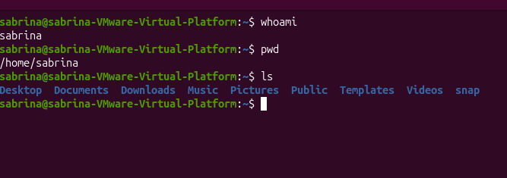
4.uname-r=displays the release/version of the Linux kernel currently running.
PRACTICE SCREENSHOT
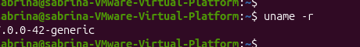
5.uname-s= displays the operating system kernel name .on macOS the slide shows thee output “Darwin”.
PRACTICE SCREENSHOT
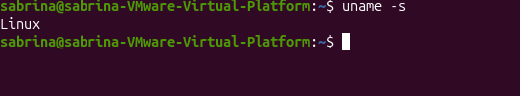

CHAPTER 2 LINUX SYSTEM ARCHITECTURE, COMMAND LINE, AND FILE
MANAGEMENT

6.cd=changes to the user s home directory when used without an argument
PRACTICE SCREENSHOT
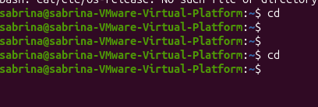
7.cd..=move one level up to the parent directory.
PRACTICE SCREENSHOT
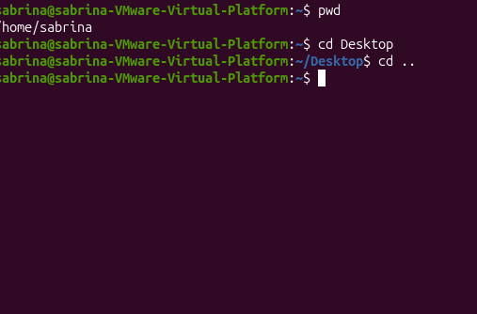
8.cd~=changes the user`s home directory.
PRACTICE SCREENSHOT

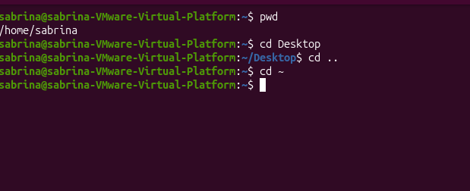
9.cd-=Returns to the previous working directory.
PRACTICE SCREENSHOT

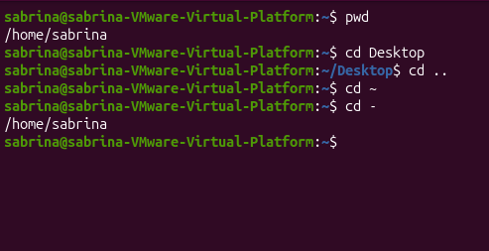
10.ls/=lists the contents of the root directory.
PRACTICE SCREENSHOT

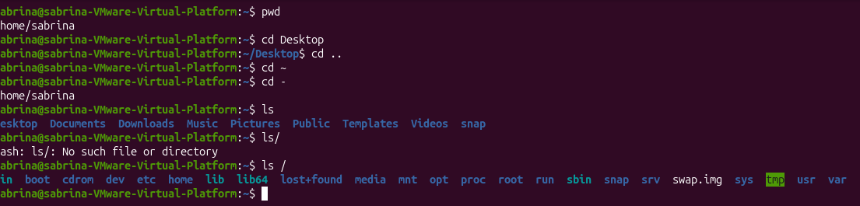
11.ls/home=lists the content of the /home directory.
PRACTICE SCREENSHOT

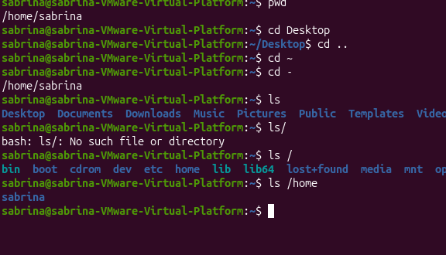
12.ls-a=lists the entries including hidden files and directory.
PRACTICE SCREENSHOT

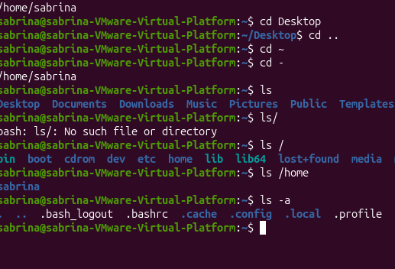
13.ls-l=Displays directory contents in a detailed long format.
PRACTICE SCREENSHOT

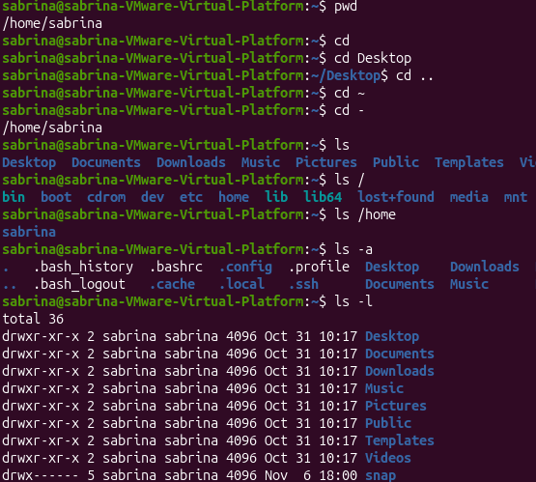
14.ls-h=Displays file sizes in a human-readable format when used with a size listing
PRACTICE SCREENSHOT
.
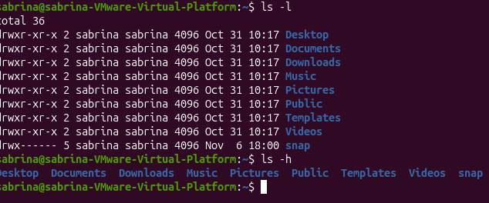
15.ls-lh=Displays a detailed listing with human-readable file sizes.
PRACTICE SCREENSHOT

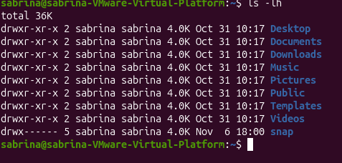
16.echo= Displays the path of the current user's login heellow
PRACTICE SCREENSHOT

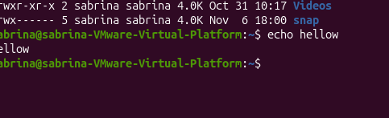
17.history= Displays the numbered list of commands entered in the current shell history.
PRACTICE SCREENSHOT

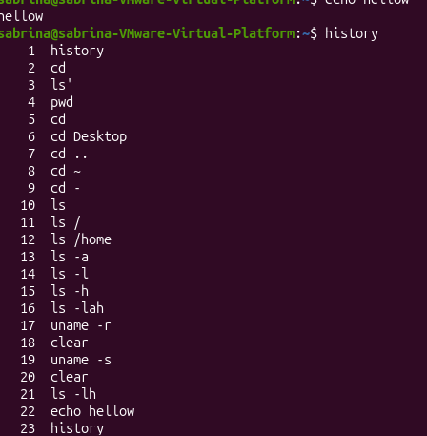
18.mkdir-help= Displays a short help summary and available options for mkdir.
PRACTICE SCREENSHOT

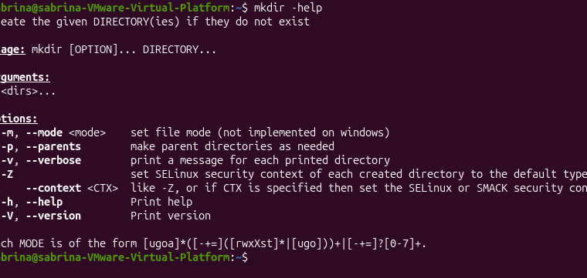
19.help cd= Displays Bash help for the built-in cd command.
PRACTICE SCREENSHOT

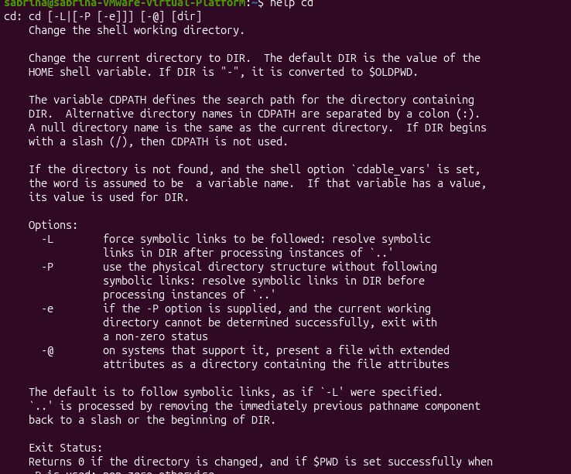
20.touch notes.txt= Creates an empty file named notes.txt or updates its timestamp if it exists.
PRACTICE SCREENSHOT

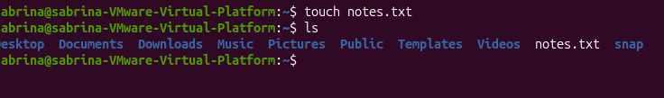
21.touch notes.txt file.md= Creates the two named empty files or updates their timestamps.
PRACTICE SCREENSHOT

22.mkdir week3=creates directory week3.
PRACTICE SCREENSHOT

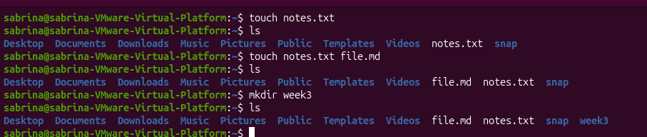
23.mkdir-p project/Linux= Creates the Linux directory and any missing parent directories.
PRACTICE SCREENSHOT

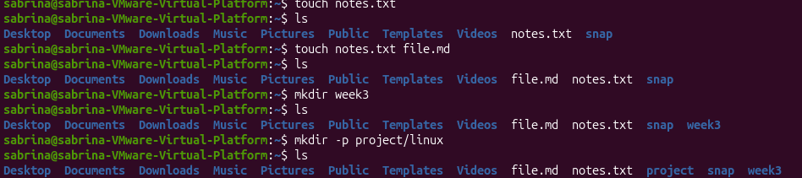
24.rmdir week3= Removes the week3 directory only if it is empty.
PRACTICE SCREENSHOT

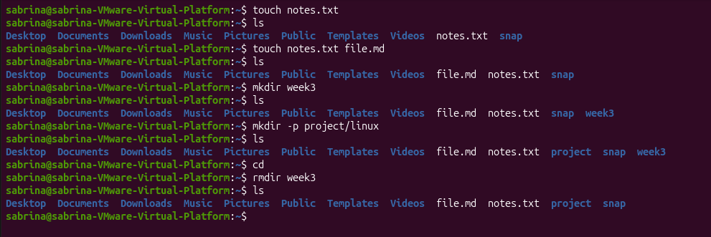
25.cp notes.txt notes.ba= Copies notes.txt to a new file named and keeps the original.
PRACTICE SCREENSHOT

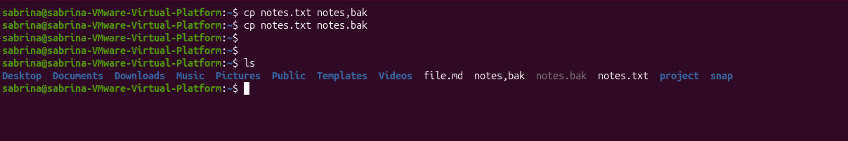
26.mv notes.txt old.txt= Renames notes.txt to old.txt or moves it to another location.
PRACTICE SCREENSHOT

27.rm -I notes.ba= Asks for confirmation before removing the specified file.
PRACTICE SCREENSHOT

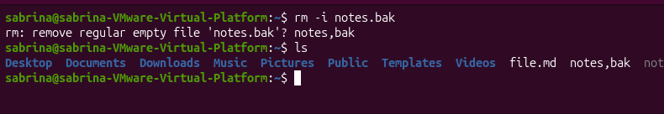
28 ls -a ~=Lists all entries, including hidden entries, in the user's home directory.
PRACTICE SCREENSHOT

29 cd document= Changes to the Documents directory if it exists in the current location.
PRACTICE SCREENSHOT

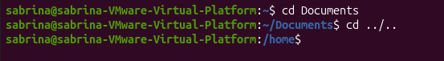
30.cd../..= Moves two directory levels up.
PRACTICE SCREENSHOT
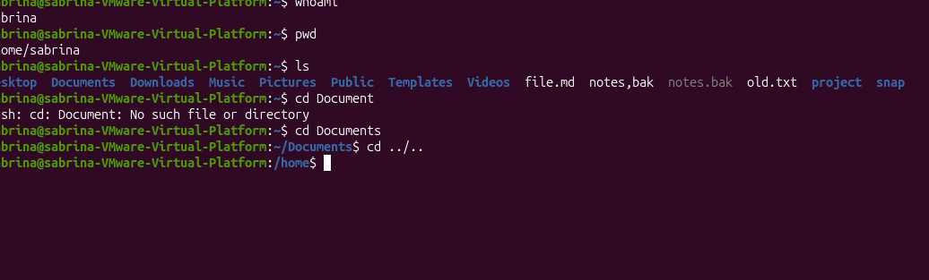
CHAPTER 3
Text Processing, Searching,
Archiving, and Editors
31.cat= Displays the contents of a file and combines multiple files.
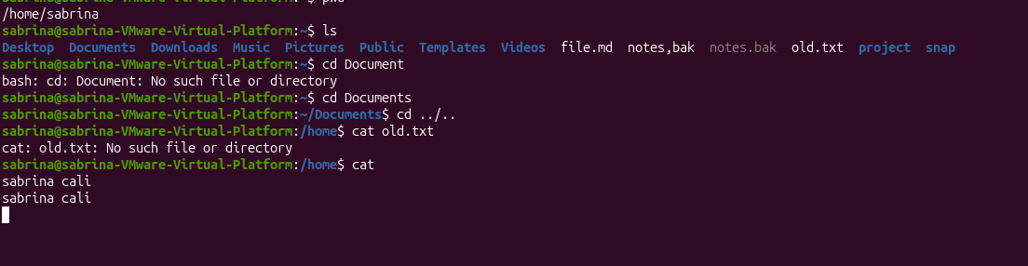
32.cat -n=Displays file contents with line numbers.
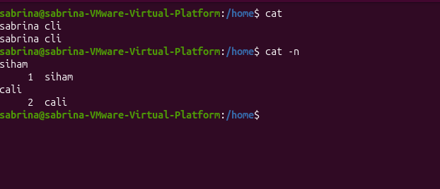

33.less=Views a long file one screen at a time. 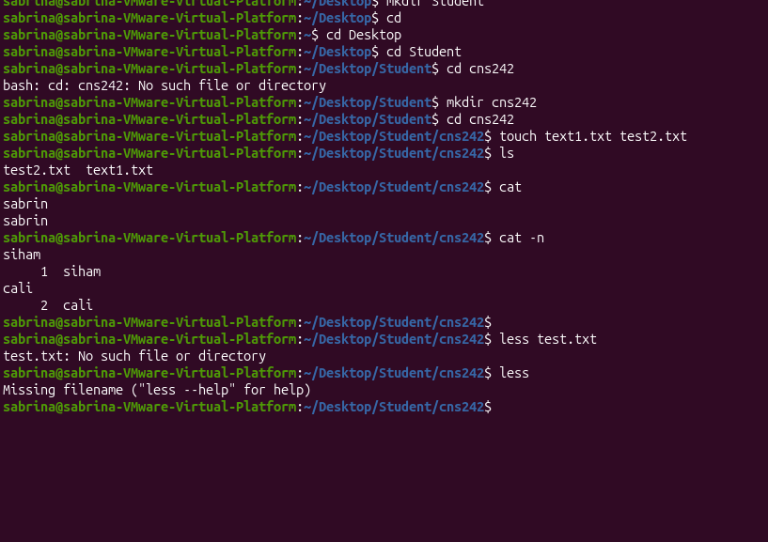
34.head=Displays the beginning of a file.
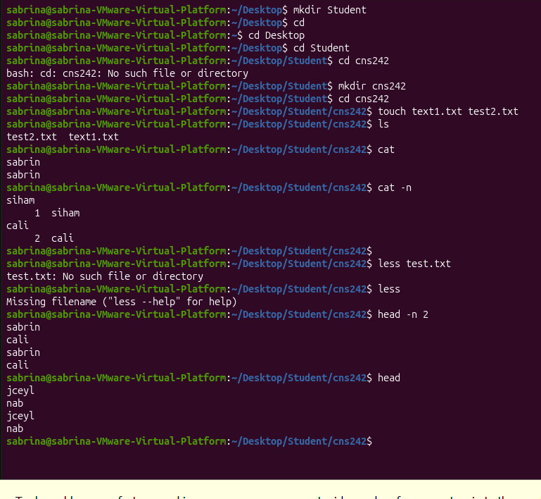
35.head-n2= Displays the first two lines of a file.

36.command -v=Shows how the shell resolves a command.
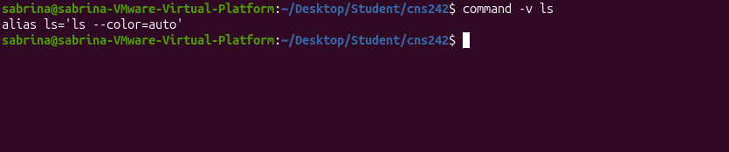
37. whereis=Locates a command's binary, source, and manual pages.
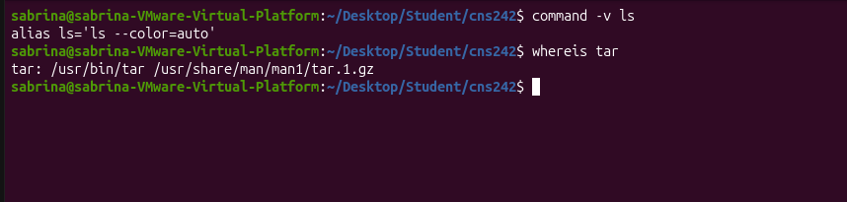

38. type=Identifies whether a command is a built-in, alias, function, or executable.
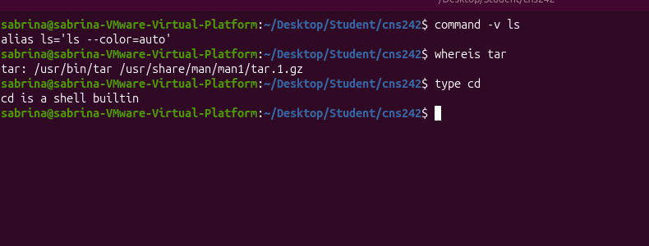
39.find=Searches for files and directories.
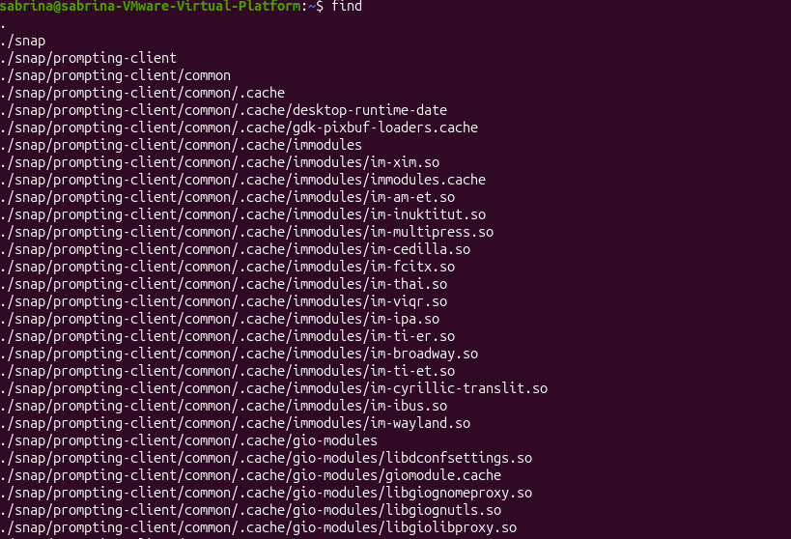
40.find -name=Searches for files by exact filename pattern.
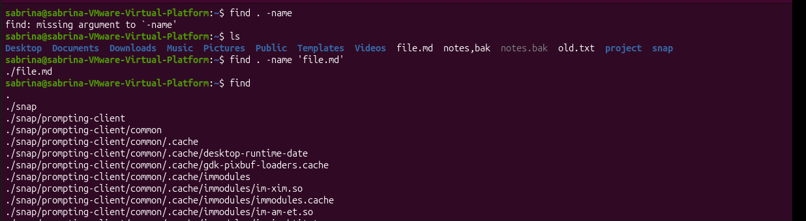
41.find -iname=Searches for filenames without case sensitivity.
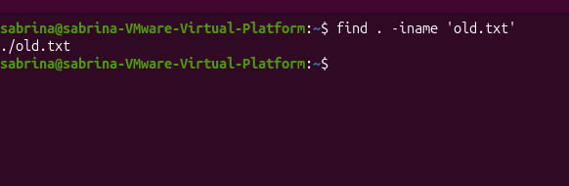
42.find -type f=Searches for regular files.
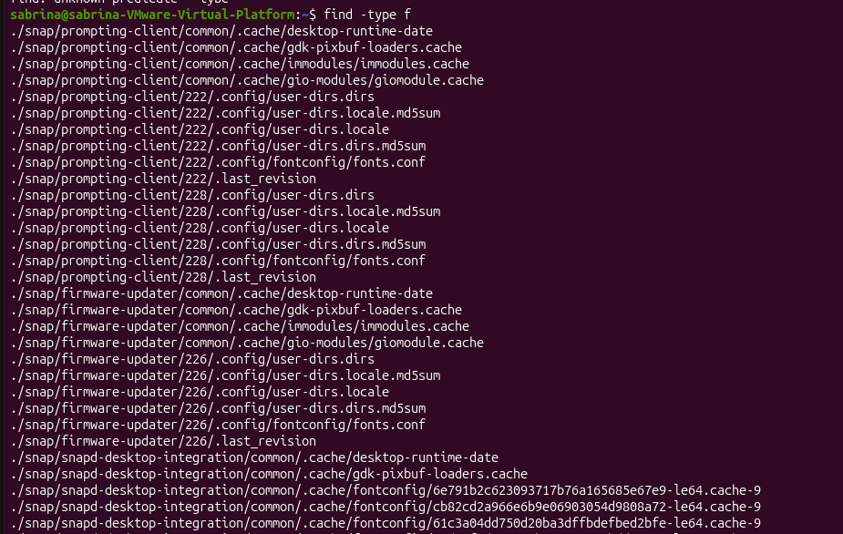
43.find -type d=Searches for directories.
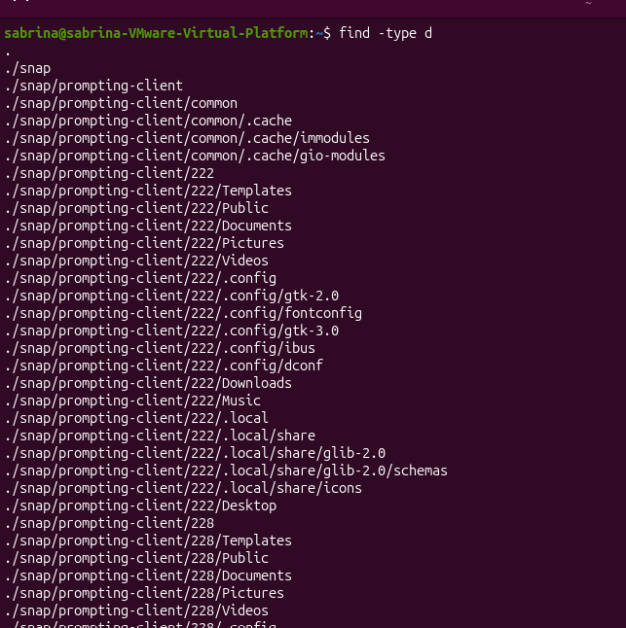
44.find -size=Searches for files based on size.
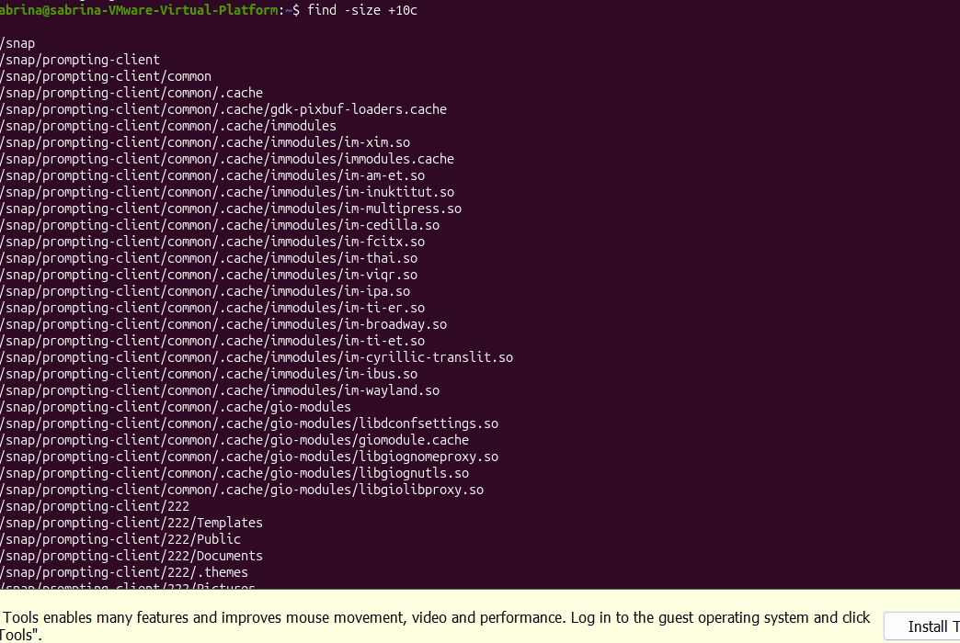
45.locate=Finds files using a prebuilt filename database.
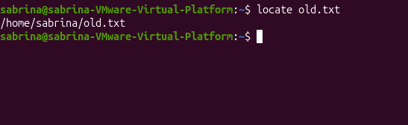
46.touch=Creates an empty file or updates its timestamps.
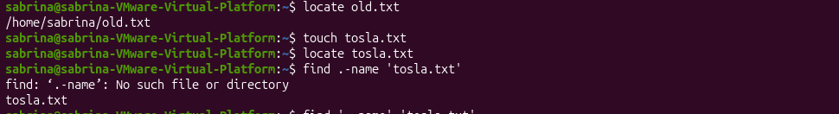
47.grep=Searches for specific text or patterns inside files.
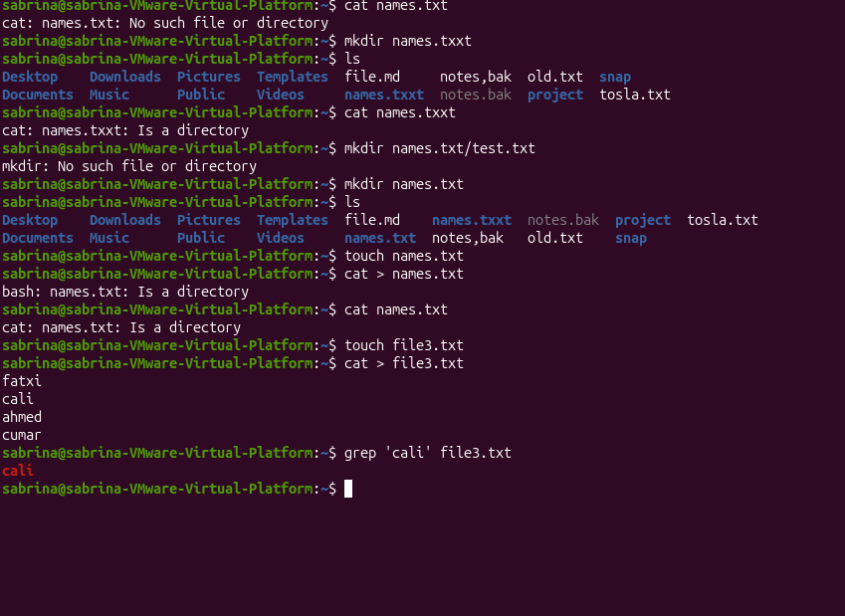
48.grep -n=Displays matching lines with line numbers.
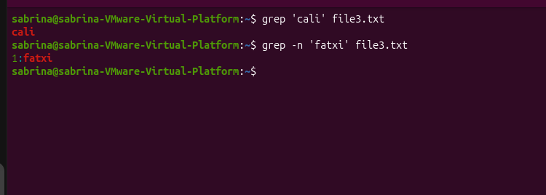
49.grep -i=Searches without distinguishing uppercase and lowercase letters.
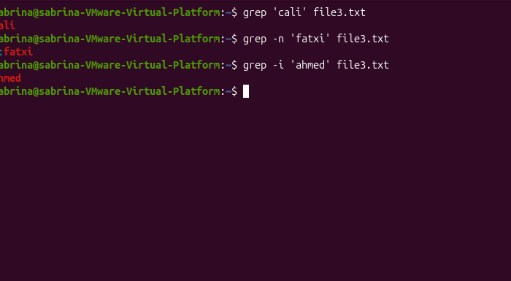

50.grep -v=Displays lines that do not match the search pattern.
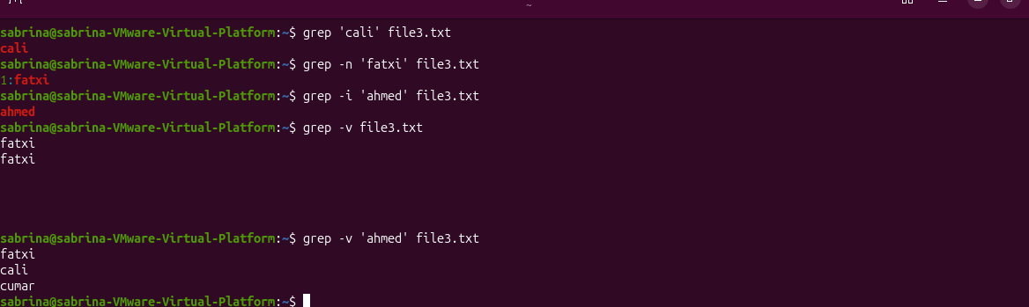
51.grep -rn=Searches recursively and displays line numbers.
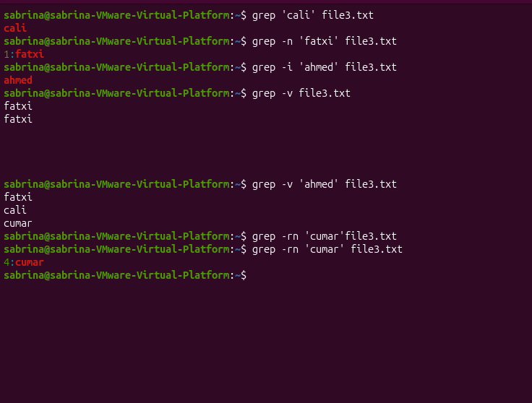
Regular Expression
Symbols Used with grep

. Matches any one character.
* Matches zero or more repetitions of the preceding character or expression.
^ Matches the beginning of a line.
$ Matches the end of a line.
[ ] Matches one character from a specified list or range.
[0-9] Matches any single digit from 0 to 9.
[ae] Matches either the letter a or e.
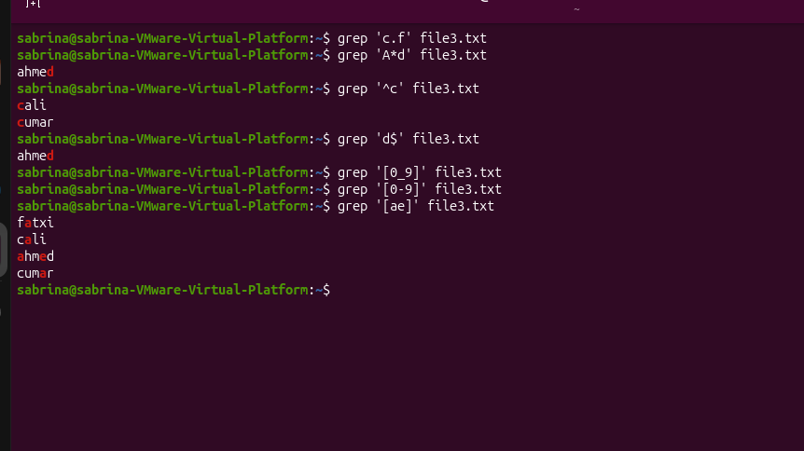
Redirection and Command Operators

| > | Redirects standard output to a file, creating or overwriting it. |
| >> | Appends standard output to the end of a file. |
| 2> | Redirects standard error to a file. |
| < | Reads input from a file instead of the keyboard. |
| | | Sends the output of one command to another command. |
| ; | Runs multiple commands one after another, regardless of success or failure. |
| && | Runs the next command only if the previous command succeeds. |
| || | Runs the next command only if the previous command fails. |
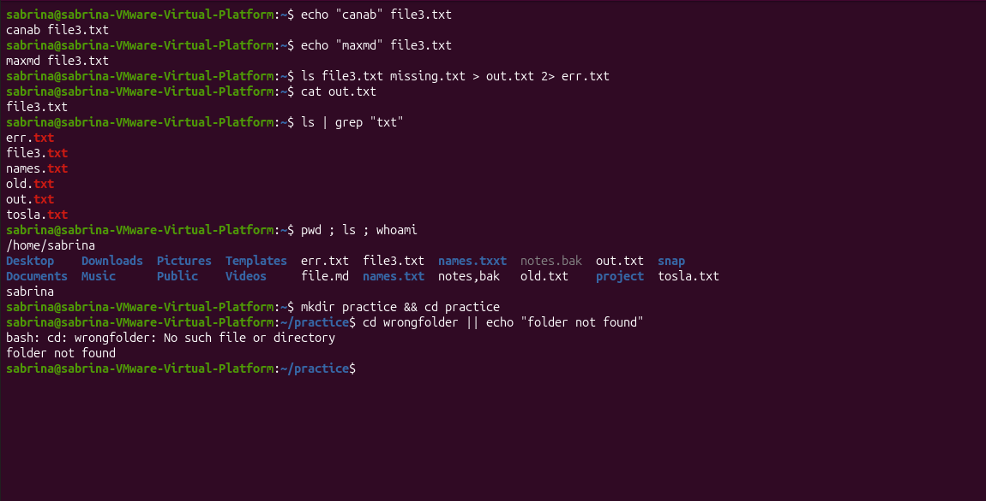
52.Wc=Counts lines, words, and bytes or characters.
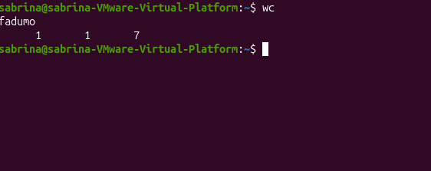
53.wc -l=Counts the number of lines.
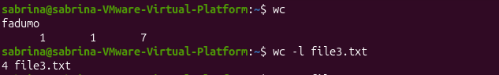
54.wc -w=Counts the number of words.
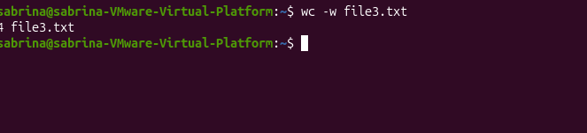
55.wc -c=Counts the number of bytes.
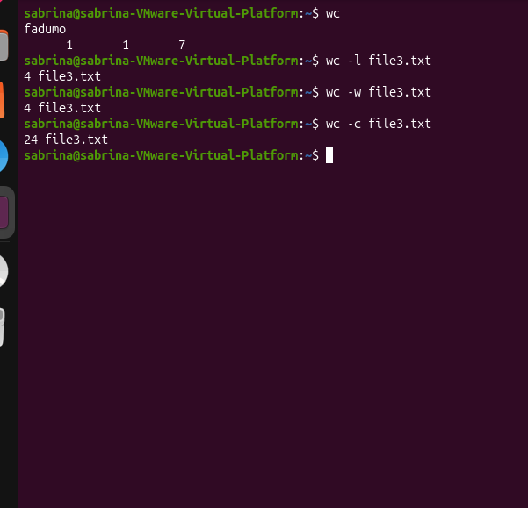
56. tr= reads stdin and writes transformed text to stdout.
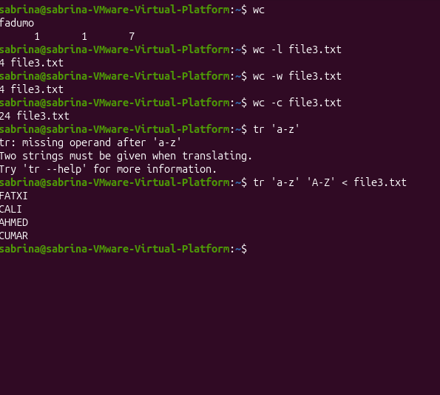

57.sort=Sorts lines of text alphabetically.
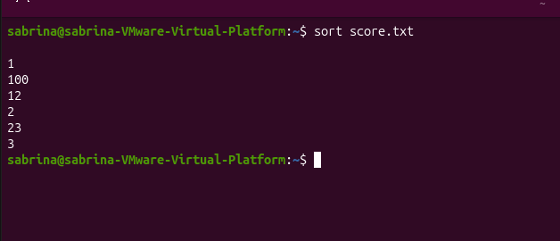
58.sort -n=Sorts numbers according to their numeric values.
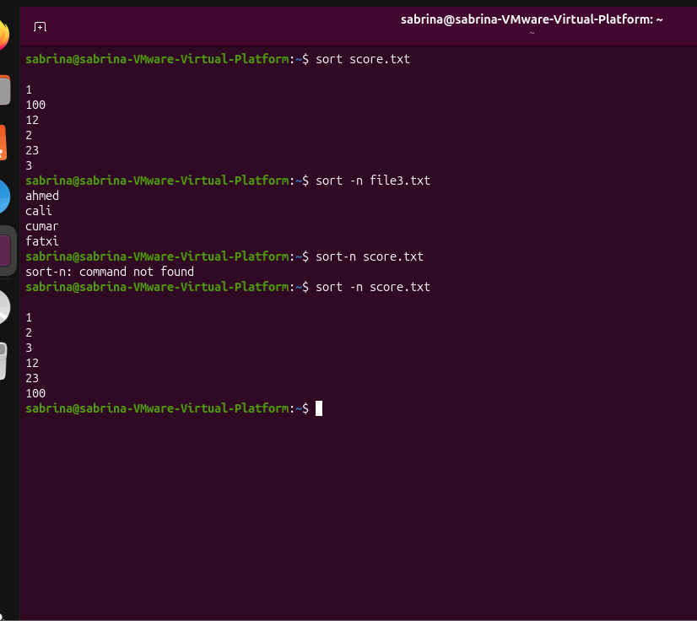
59.sort | uniq = Sort lines and remove duplicates.
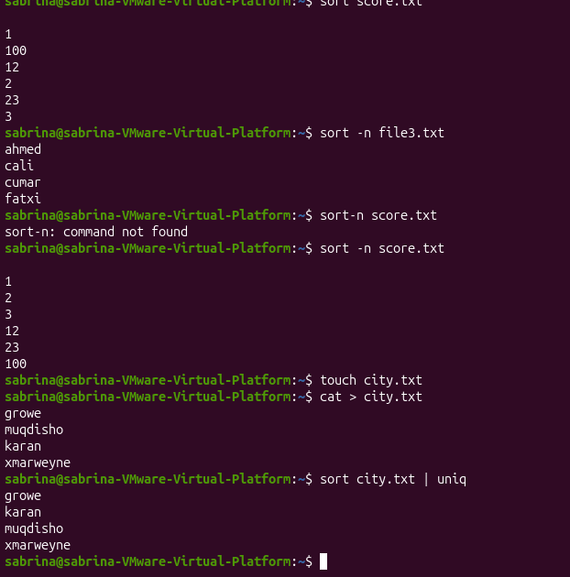
60.sort un-c=Counts how many times each name appears.
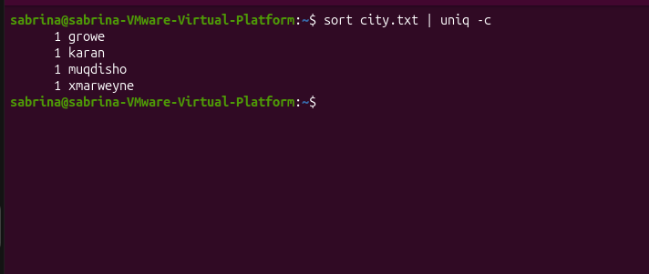
61.cut -d=Specifies the delimiter used to separate fields.
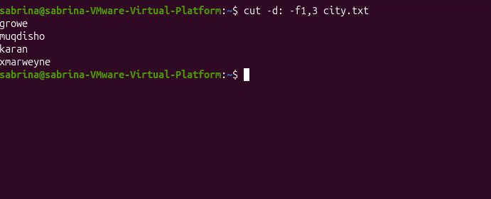
62.cut -f=Selects specific fields from each line.
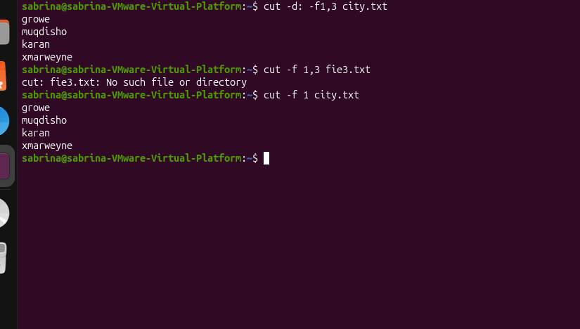
63.cut -c=Selects specific character positions.
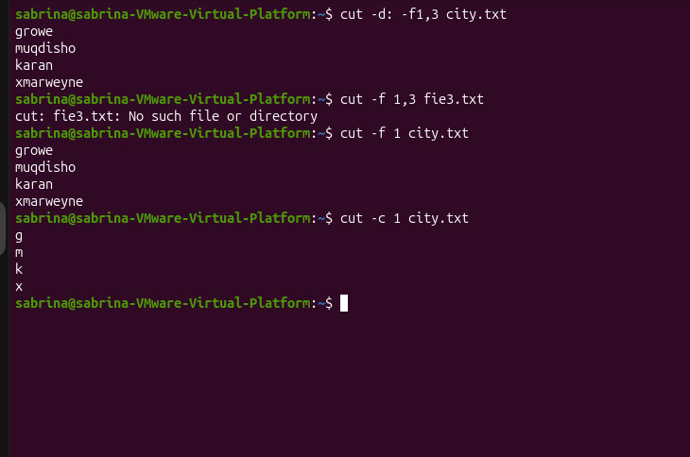
64.paste=Combines corresponding lines from two or more files.
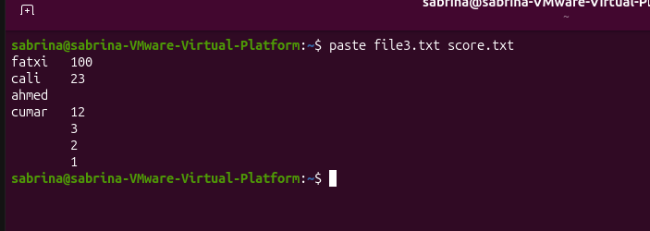
65.paste -d=Specifies the delimiter between combined fields.
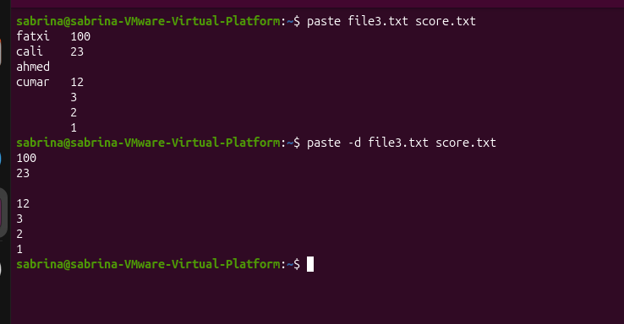
66.paste -s=Combines lines from one file serially into one row.
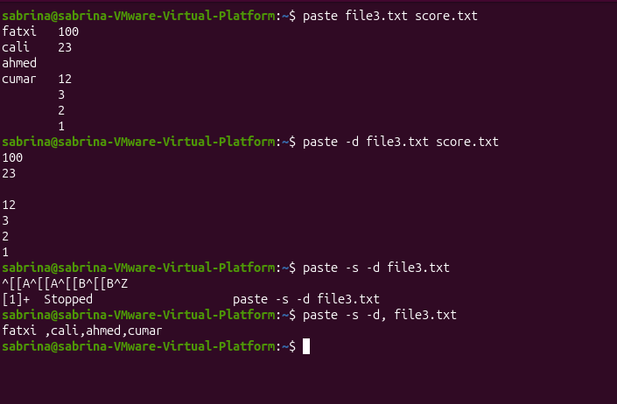
67.tr=Translates, replaces, or deletes characters.
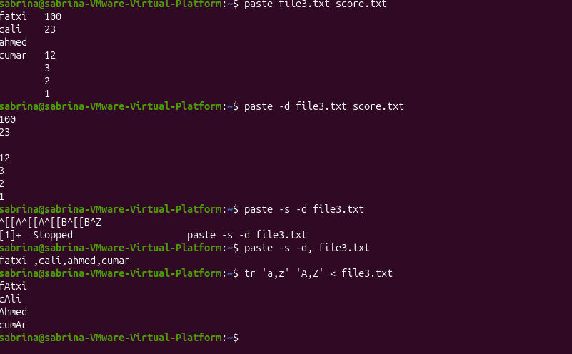
68.tr -d=Deletes specified characters.
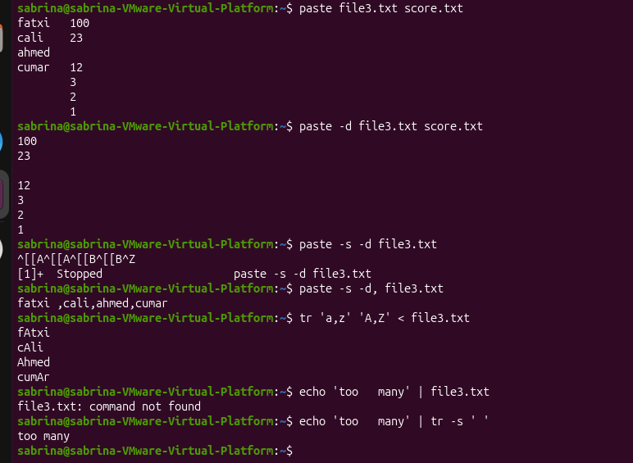
69.tr -s=Replaces repeated characters with a single occurrence.
69. tr -cs=The first tr splits on any nonletter character.
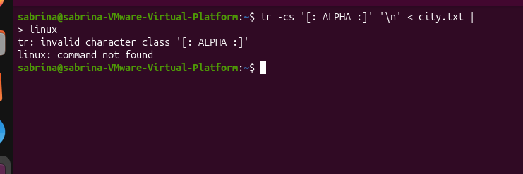
70.gzip =Compresses a file to reduce its size.
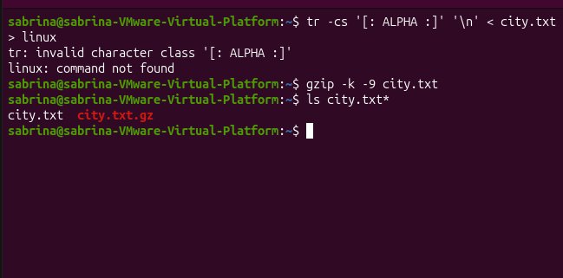
71.gunzip = Decompresses a GZ file to restore the original file.
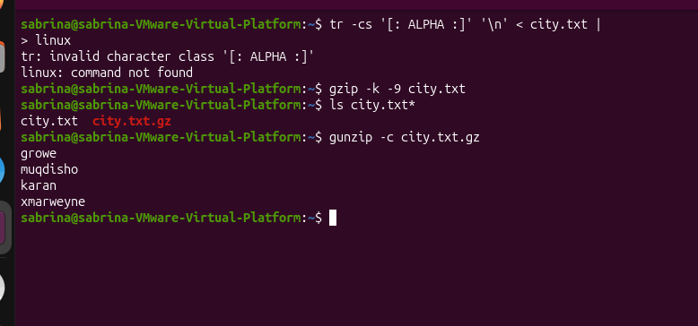
72. zip -r=Creates a ZIP archive recursively, including directories and their contents.
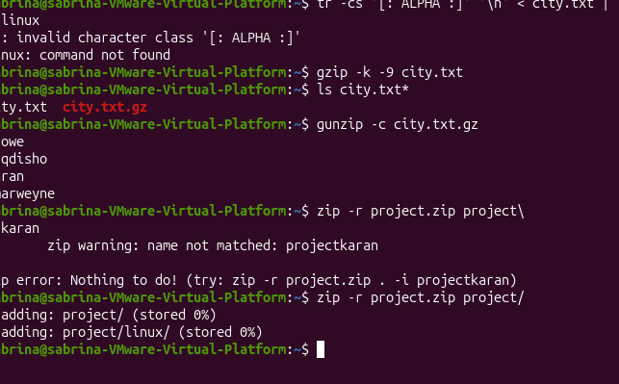

71.unzip=Extracts files from a ZIP archive.
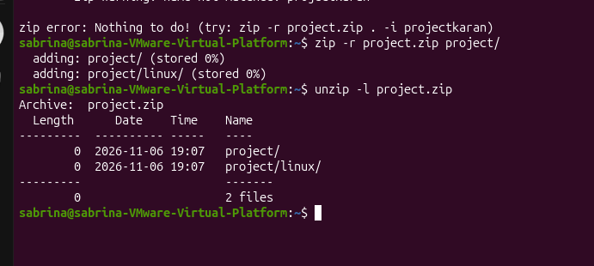

72.nano=Opens a text file in the Nano editor.
- Ctrl + O=Saves the current file (Write Out).
- Ctrl + X=Exits the Nano editor.
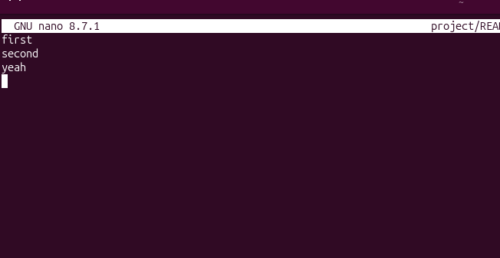
73.vim=Opens a file in the Vim text editor.
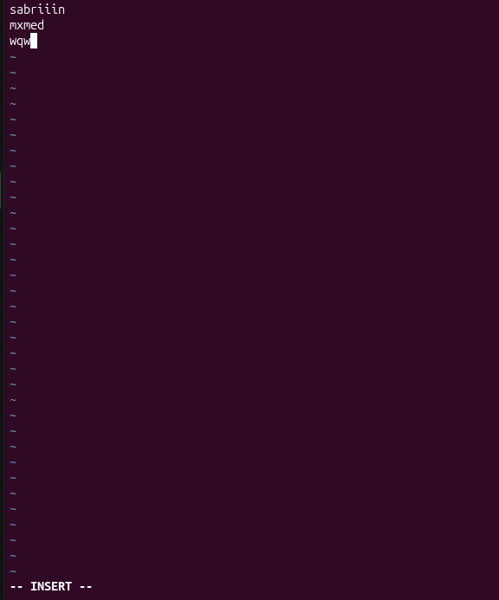

CHAPTER 4
PROCESS, SERVICE, AND SYSTEM MANAGEMENT
74. echo $$=Displays the PID of the current shell.
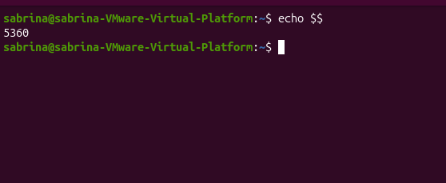
75.ps=Displays currently running processes.
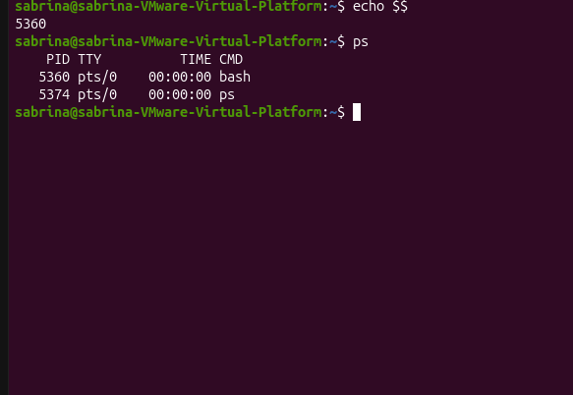
76.ps -f=Displays processes in full-format listing.
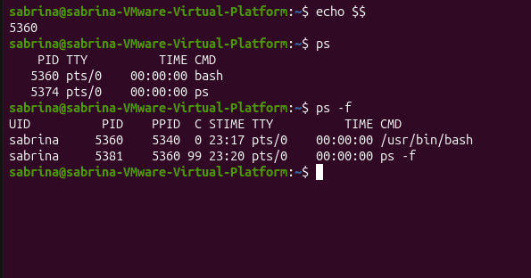
77.ps -p PID=Displays a process with a specific Process ID.
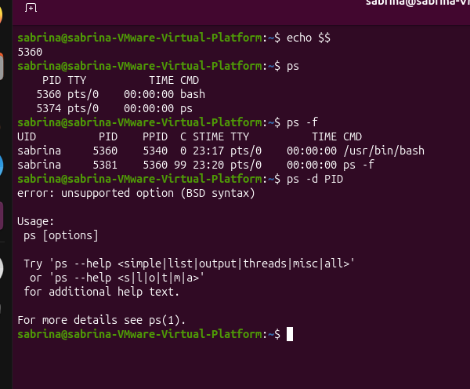
78.top=Displays real-time system and process information.
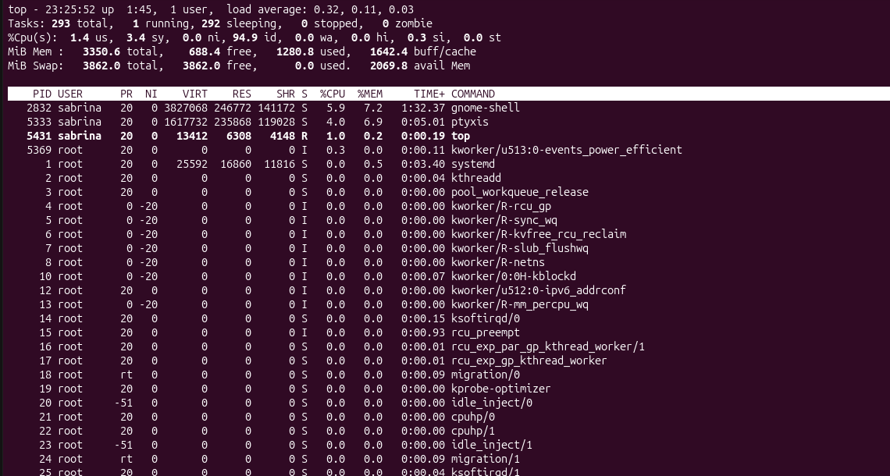
79.command -v HTOP=Checks the location of the command.
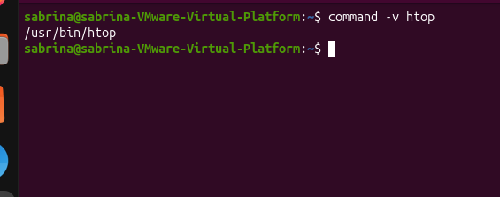
80.htop=Displays interactive real-time process information.
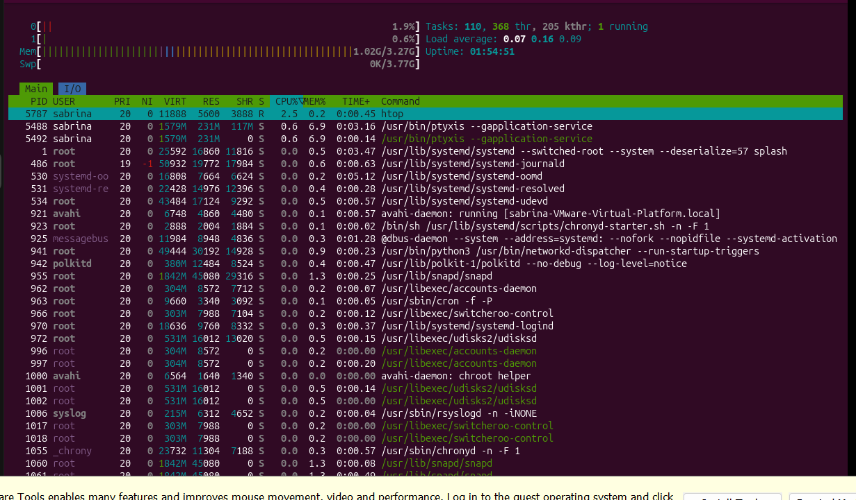
81.sleep 30 &=Runs the sleep command in the background.
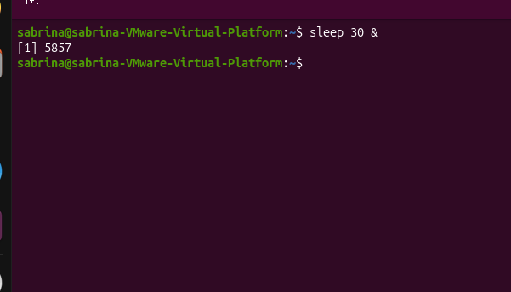
82. GNOME =is a graphical desktop environment for Linux operating systems.
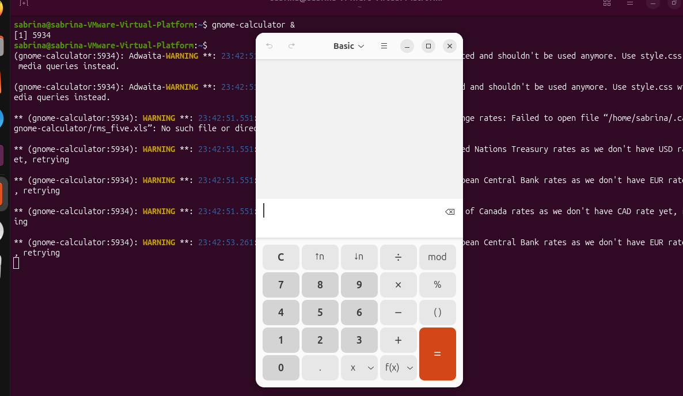
83.jobs=Lists jobs running in the current shell.

84.jobs -l=Lists jobs with their process IDs.

85.kill=Sends a signal to a process.
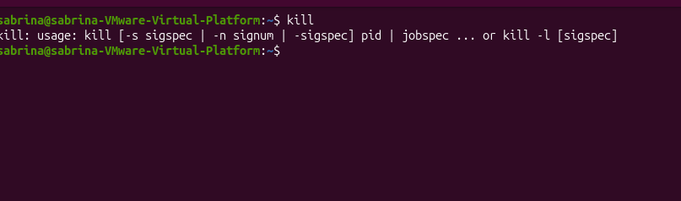
86.kill -l=Lists available signals.
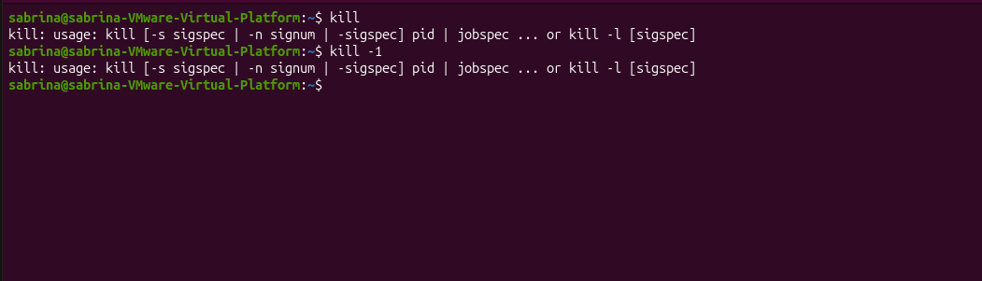
87.kill -l 15=Displays the name of signal number 15.
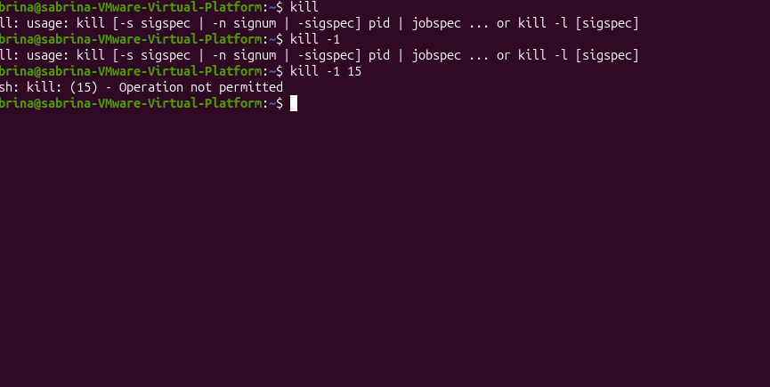
88.uname= Displays basic system information.
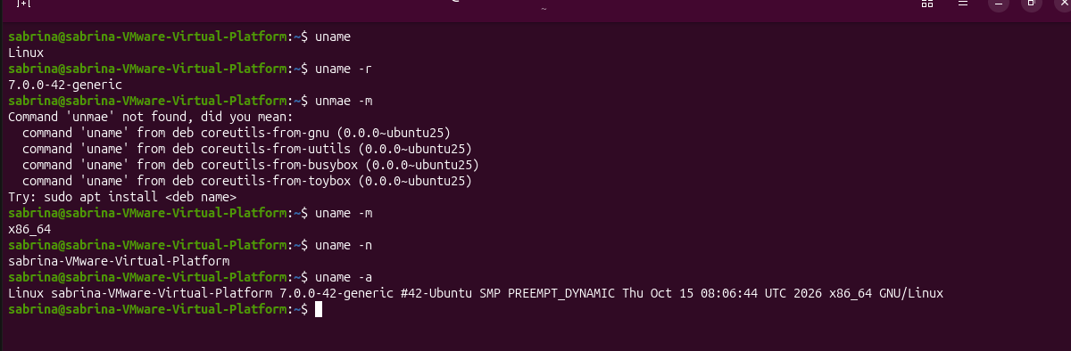
89.hostnamectl=Displays or manages system hostname information.
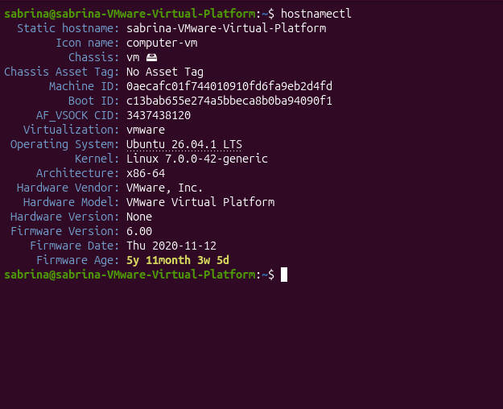
90.hostnamectl hostname=Displays the system hostname.
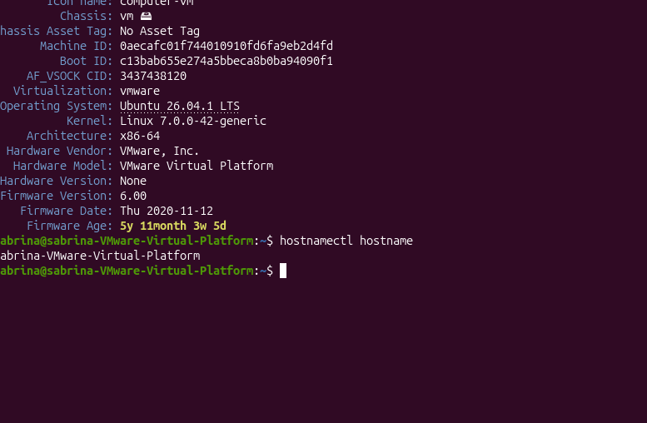
91.uptime=Displays how long the system has been running.
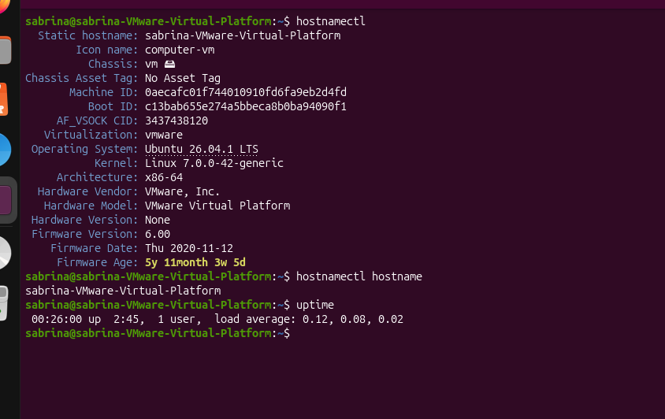
92.uptime -p=Displays system uptime in a readable format.
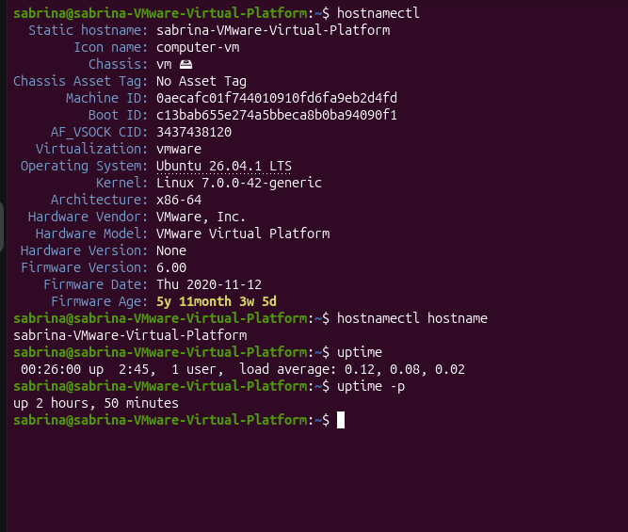

94.uptime -s=Displays the time when the system started.
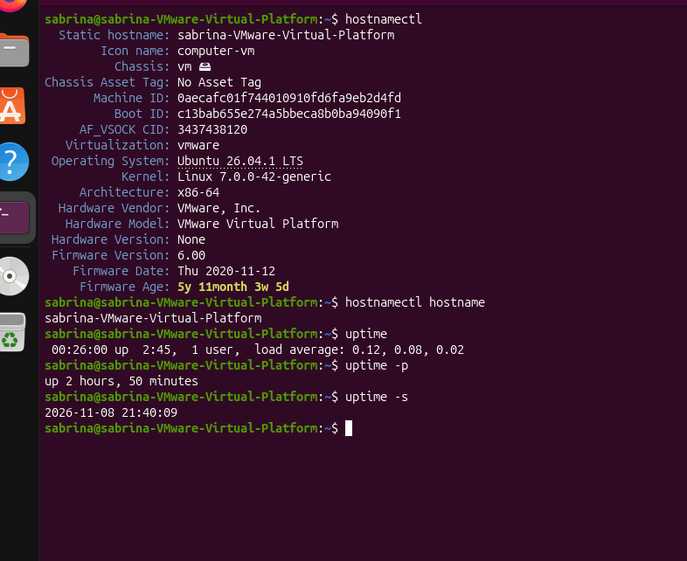
95.nproc=Displays the number of available processing units.
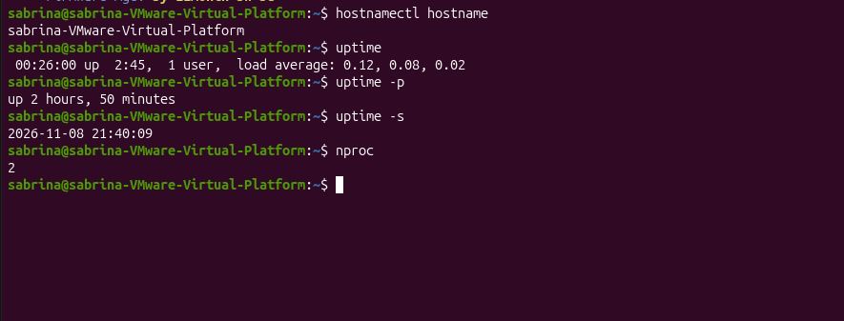
96.free=Displays memory usage information.
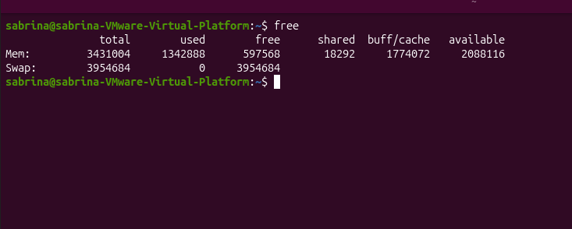
97.free -h=Displays memory information in human-readable units.
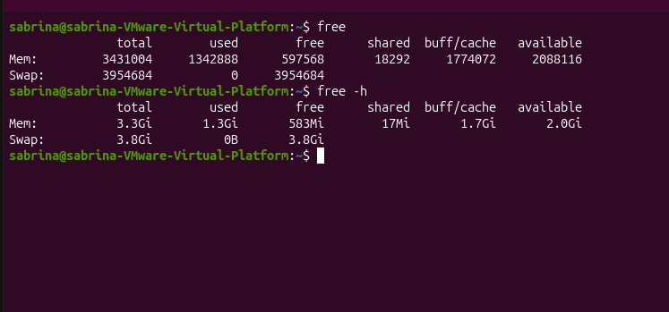
98.free -m=Displays memory information in megabytes.
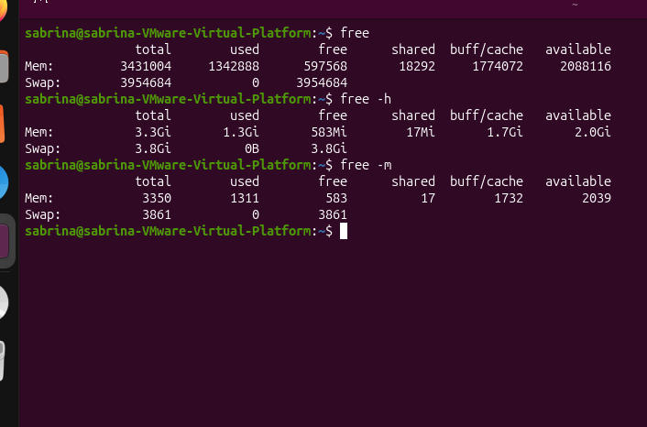
99.free -h -s 2=Displays memory information repeatedly every two seconds.
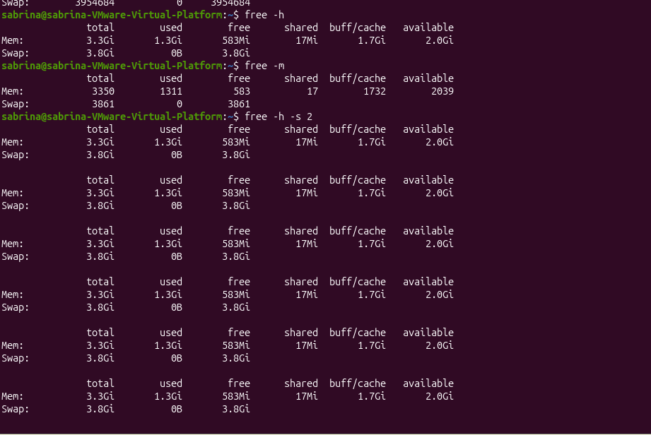
100.lscpu=Displays CPU architecture information.
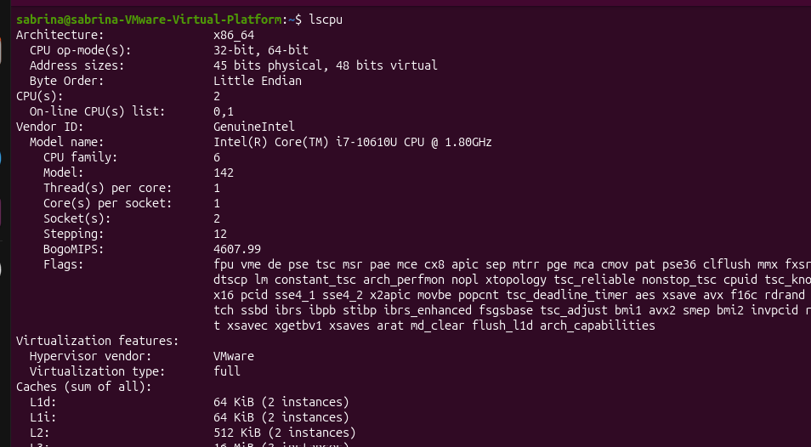
101.lscpu \| less=Displays CPU information page by page.
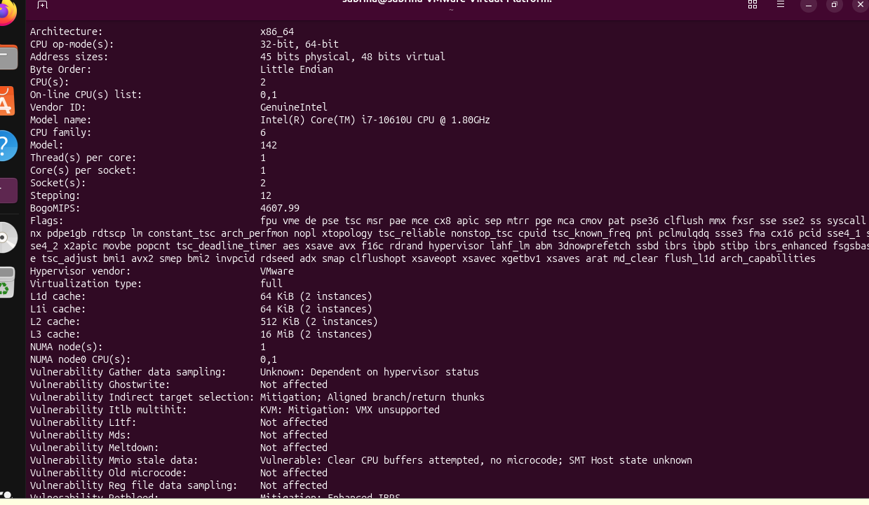
102.lsblk=Lists information about block devices.
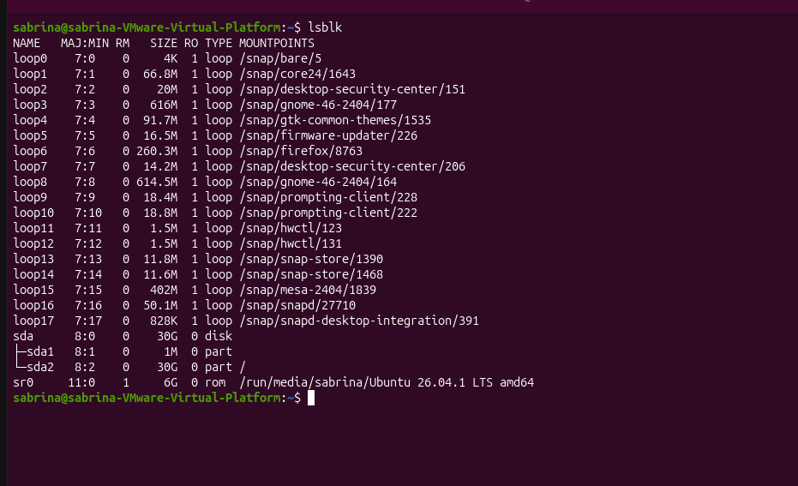
103.lsblk -e 7=Lists block devices while excluding device type 7.
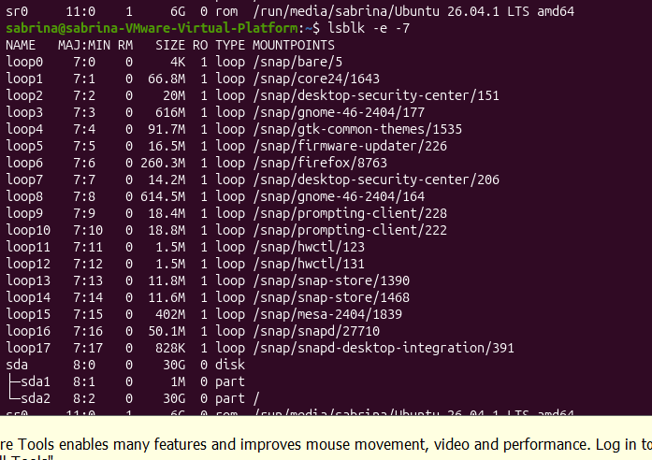
104.ls /proc=Lists entries in the /proc directory.
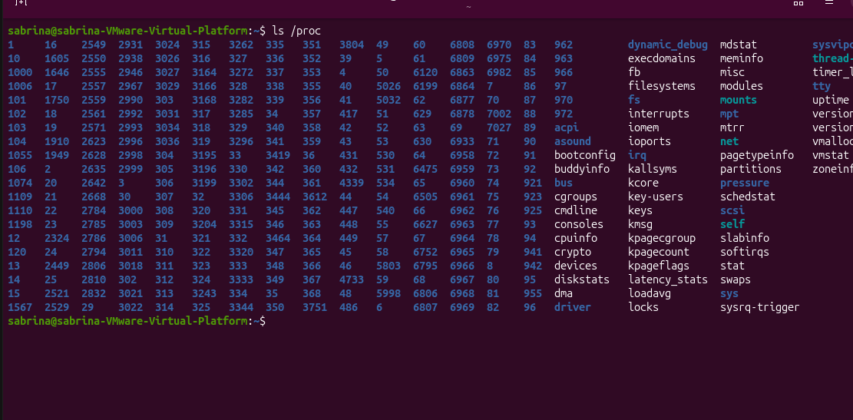
105.ls -l /proc/m=Displays detailed file information for me.
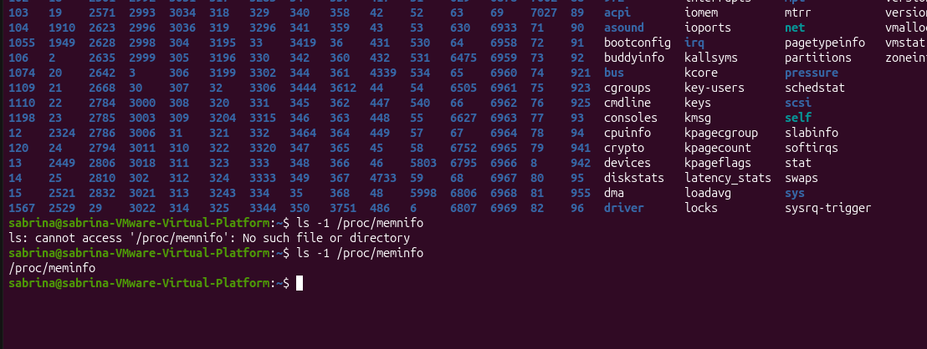

106.cat /proc/uptime=Displays system uptime information.
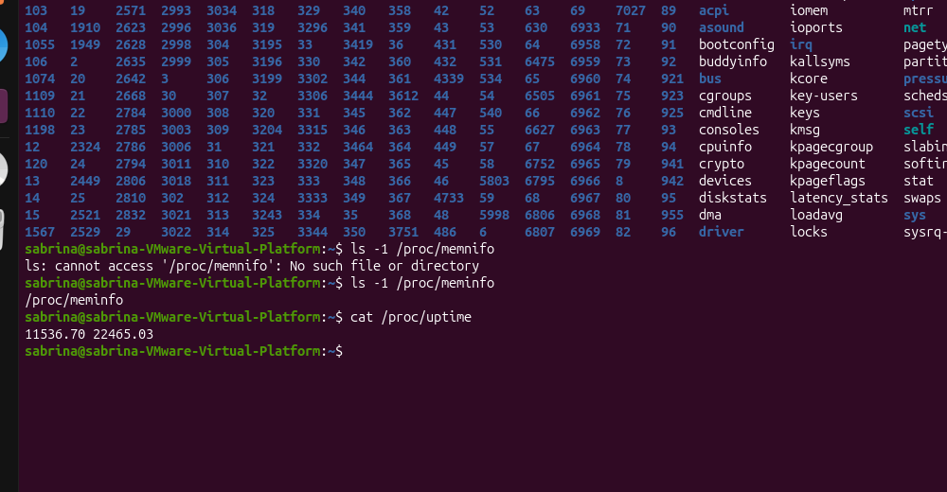
107. ls /proc/$$=Lists information about the current shell process.
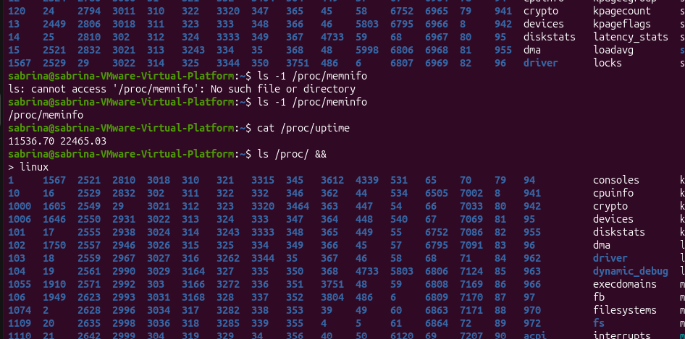
108.head -n 7 /proc/$$/status=Displays the first seven lines of the current process status.
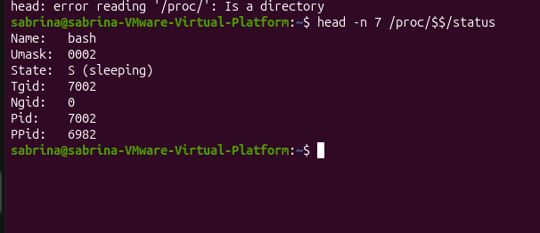

109.cat /proc/1/comm=Displays the command name of process ID 1.
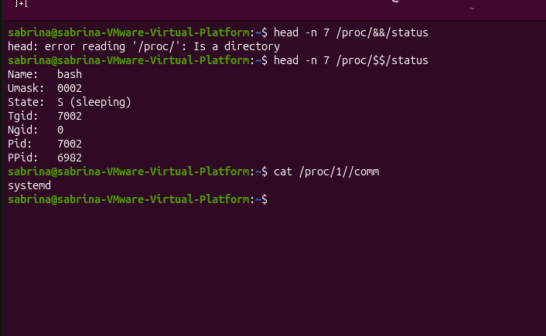
110.grep -m 1 "model name" /proc/cp=Finds the first CPU model name.
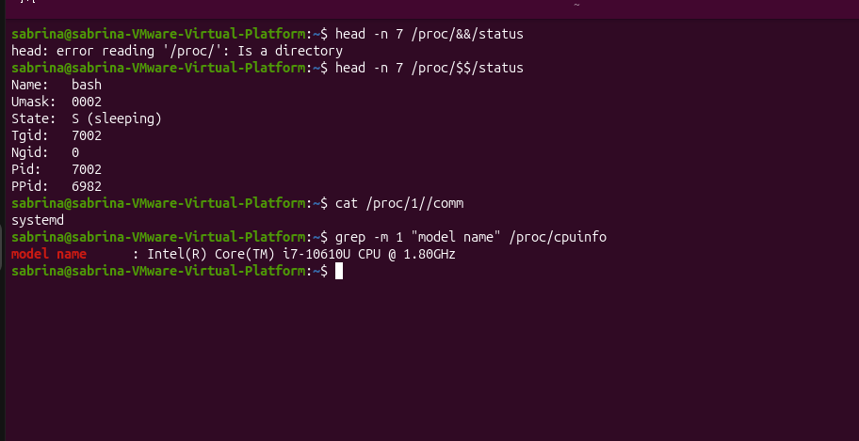
111.ls /sys=Lists entries in the /sys directory.
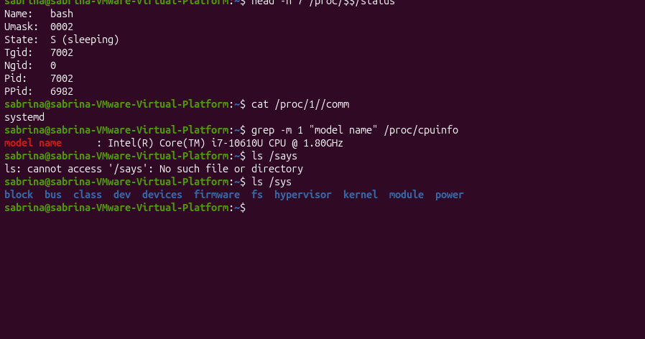
112.ls /sys/block==Lists block devices in the system.
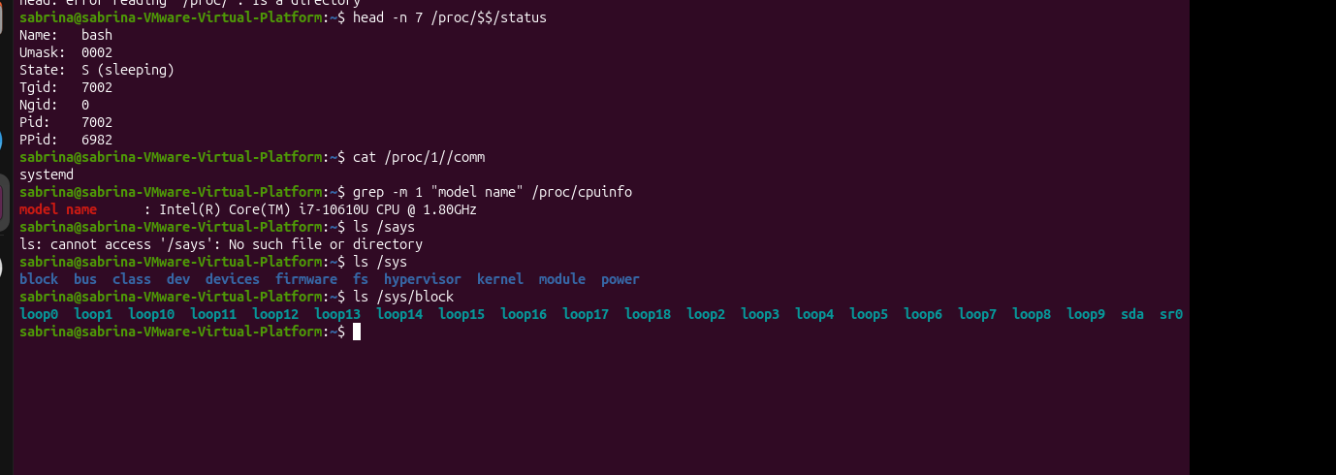

113.ls /sys/class/net=Lists network interfaces.
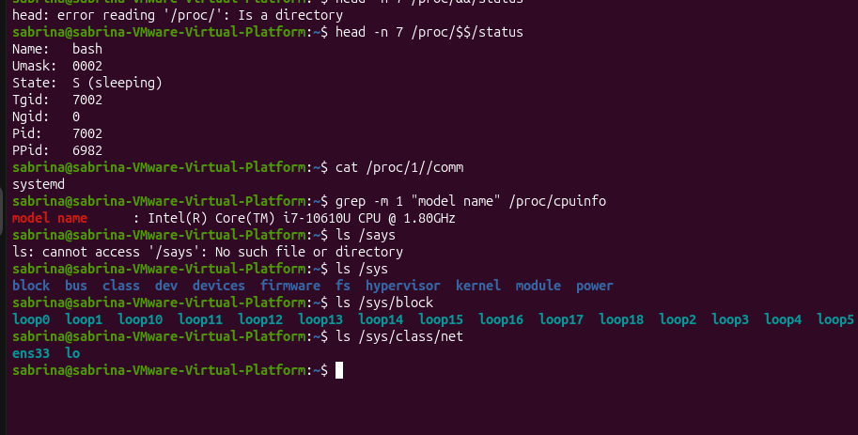

114.systemctl=Controls and manages system services.
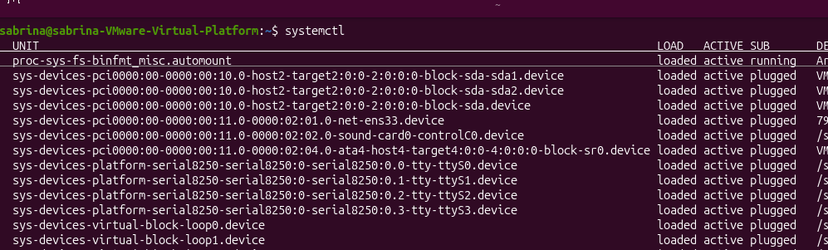

115.ps -p 1 -o pi=Displays the PID and command name of process 1.
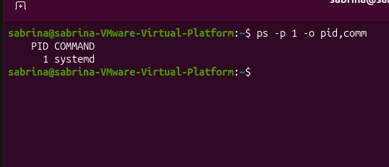

116.systemctl cat c=Displays the configuration files for the service.
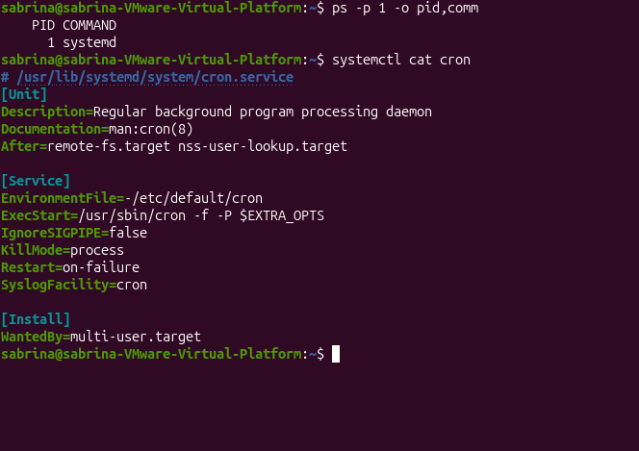
117.systemctl status c=Displays the status of the service.
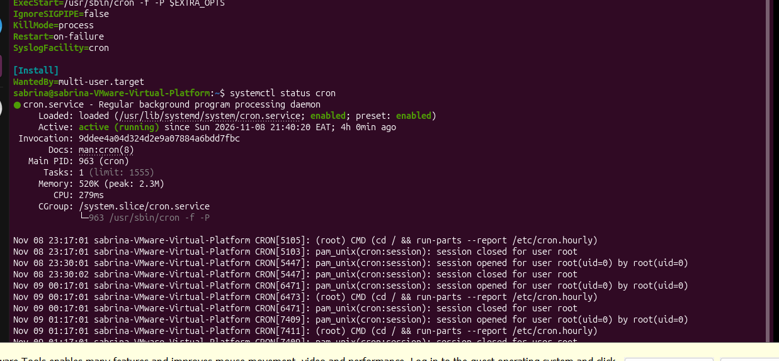
118.systemctl is-active c=Checks whether the service is active.
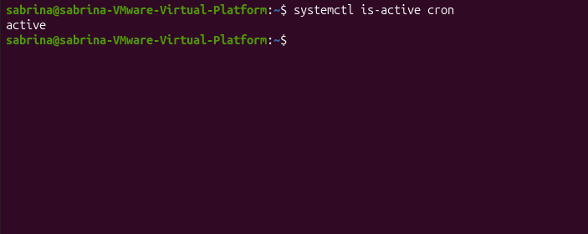

119.systemctl is-enabled c=Checks whether the service is enabled at startup.
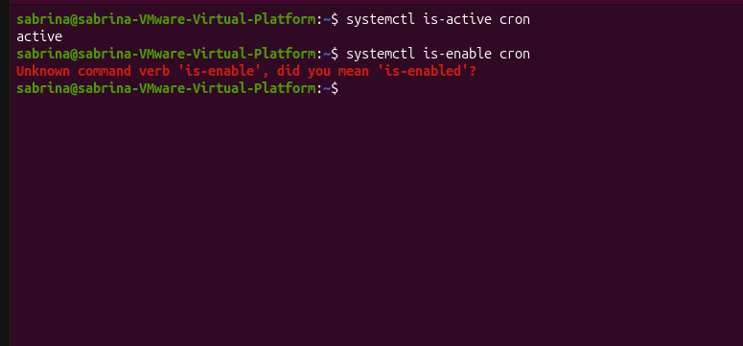

120.sudo system stop c=Stops the service.
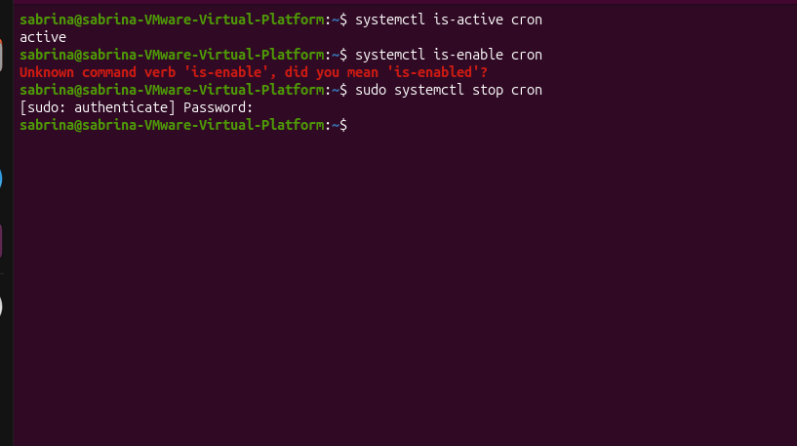

121.sudo sys enable c=Enables the c service to start automatically at boot.
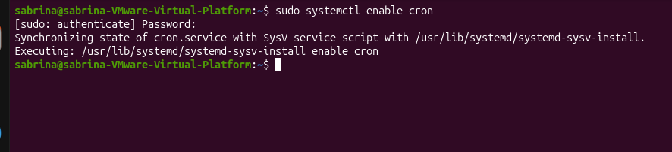

122.sudo sys disable c=Prevents the c service from starting automatically at boot.
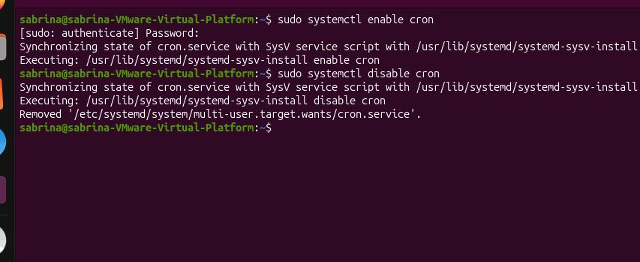
123. sys list-units --type=service --state=running=Lists currently running services.
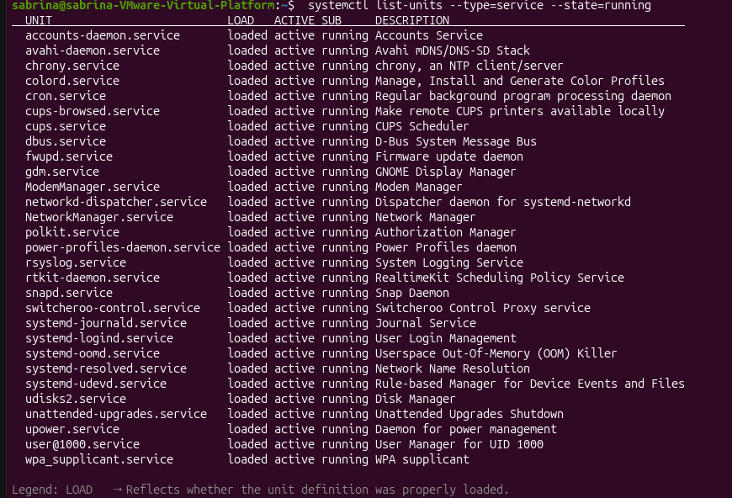
124.journalctl=Displays system logs collected by syste.
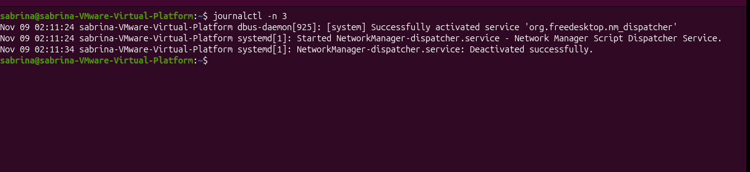
125.journalctl -n 3=Displays the latest three log entries.
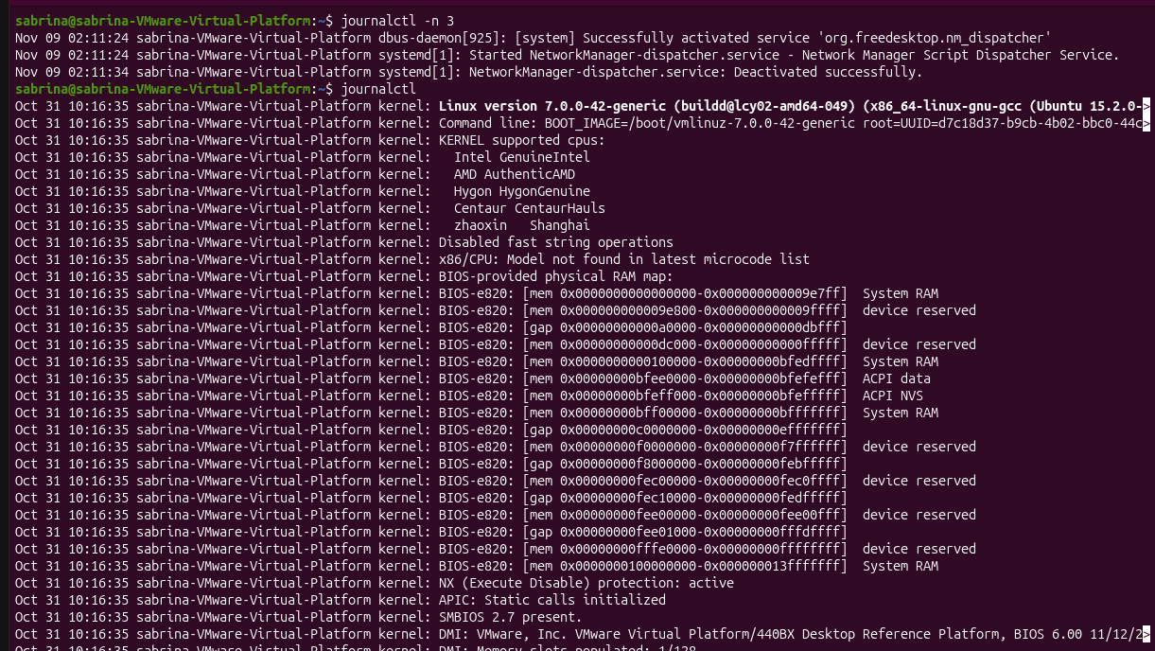
126.journalctl -b -p err=Displays error-level logs from the current boot.
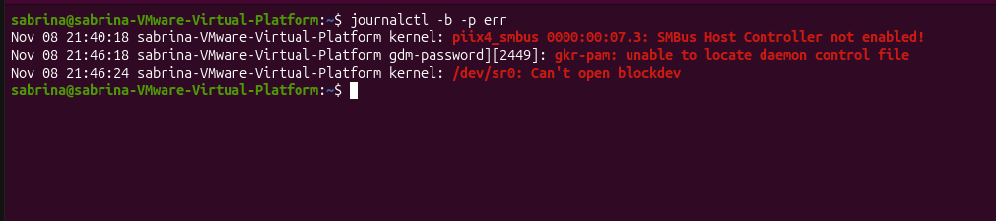
127.ls /var/log=Lists system log files.
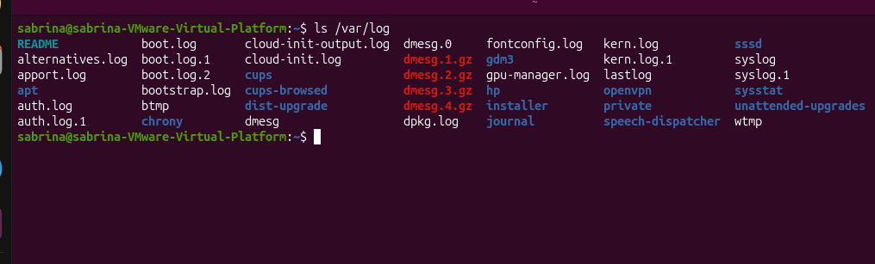
128.less /var/log/syslog=Reads the system log file page by page.
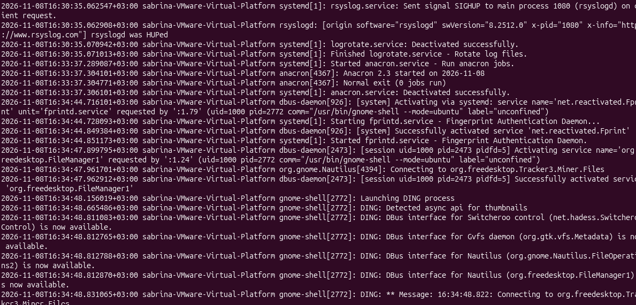

129.grep s /var/log/auth.log=Searches the authentication log for entries containing s.
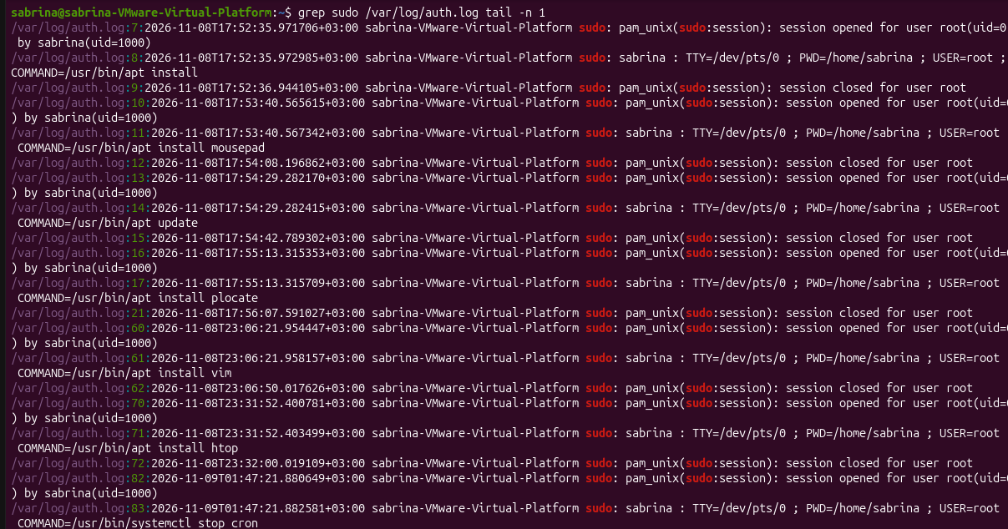
130.uptime=Displays how long the system has been running.
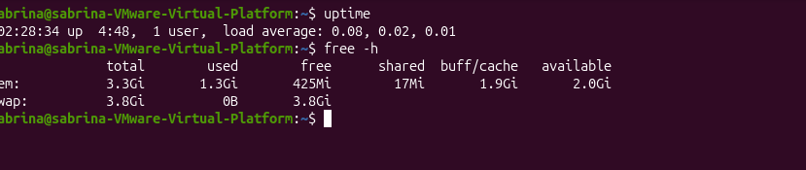
131.free -h=Displays memory usage in human-readable format.

