Report

We can use {targets} in Quarto by reading the R objects with tar_read().

Warning: package 'targets' was built under R version 4.4.3

# A tibble: 5,440 × 40  
 ppm Apple Banana Orange Carrot Broccoli Potato Tomato Almond  
 <dbl> <dbl> <dbl> <dbl> <dbl> <dbl> <dbl> <dbl> <dbl>  
 1 200. 0.0000276 0.0000382 0.0000179 3.24e-5 3.45e-5 1.65e-5 2.42e-5 5.32e-5  
 2 200. 0.0000283 0.0000383 0.0000182 3.20e-5 3.48e-5 1.67e-5 2.41e-5 5.15e-5  
 3 200. 0.0000290 0.0000383 0.0000185 3.17e-5 3.51e-5 1.68e-5 2.41e-5 5.00e-5  
 4 200. 0.0000297 0.0000384 0.0000189 3.13e-5 3.54e-5 1.69e-5 2.40e-5 4.84e-5  
 5 200. 0.0000303 0.0000385 0.0000192 3.09e-5 3.57e-5 1.70e-5 2.39e-5 4.69e-5  
 6 200. 0.0000309 0.0000386 0.0000195 3.05e-5 3.60e-5 1.71e-5 2.39e-5 4.54e-5  
 7 200. 0.0000315 0.0000386 0.0000199 3.01e-5 3.62e-5 1.72e-5 2.38e-5 4.39e-5  
 8 200. 0.0000321 0.0000387 0.0000202 2.97e-5 3.65e-5 1.73e-5 2.37e-5 4.25e-5  
 9 200. 0.0000327 0.0000388 0.0000205 2.92e-5 3.67e-5 1.74e-5 2.37e-5 4.11e-5  
10 200. 0.0000332 0.0000389 0.0000209 2.87e-5 3.69e-5 1.75e-5 2.36e-5 3.97e-5  
# ℹ 5,430 more rows  
# ℹ 31 more variables: Walnut <dbl>, MushroomPleurotus <dbl>, Lentil <dbl>,  
# Chickpea <dbl>, Tofu <dbl>, Tempeh <dbl>, Bread <dbl>,  
# WholeWheatBread <dbl>, Pasta <dbl>, WholeWheatPasta <dbl>, CousCous <dbl>,  
# Rice <dbl>, Quinoa <dbl>, Seitan <dbl>, CowCheese <dbl>, SheepCheese <dbl>,  
# GoatCheese <dbl>, Albumen <dbl>, Yolk <dbl>, Cod <dbl>, Mussel <dbl>,  
# Shrimp <dbl>, Salmon <dbl>, Chicken <dbl>, Pig <dbl>, Bresaola <dbl>, …

And not we plot the data

$Apple

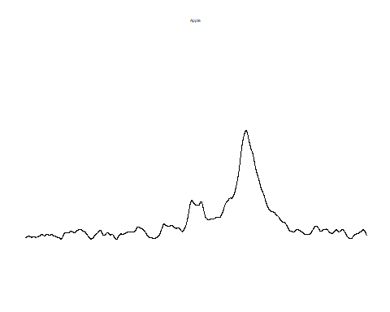

$Banana

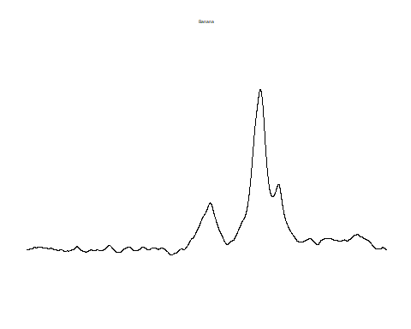

$Orange

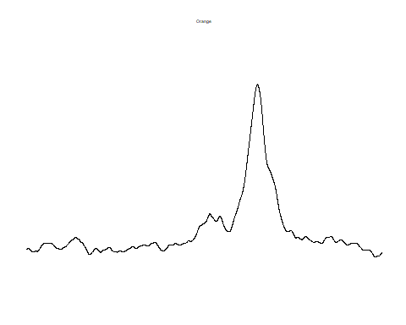

$Carrot

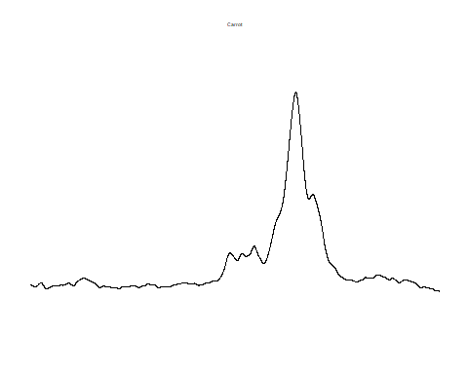

$Broccoli

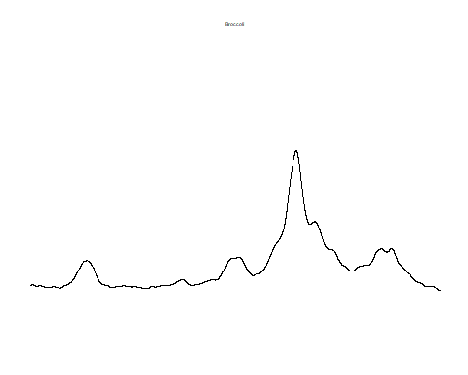

$Potato

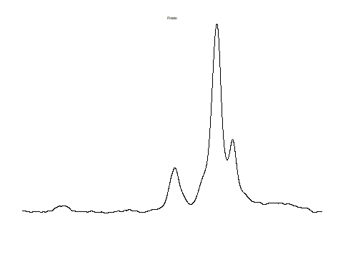

$Tomato

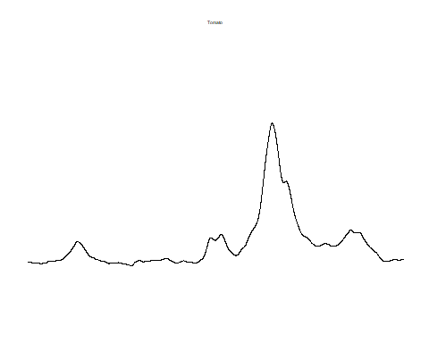

$Almond

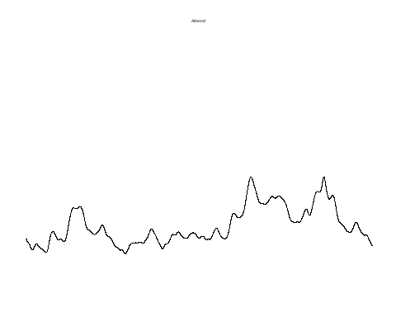

$Walnut

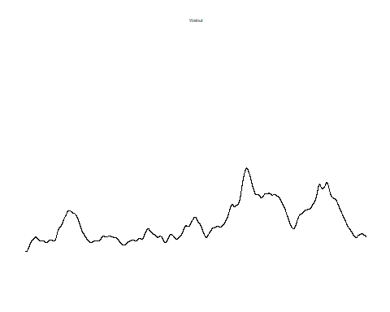

$MushroomPleurotus

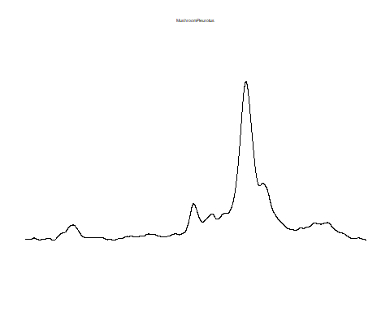

$Lentil

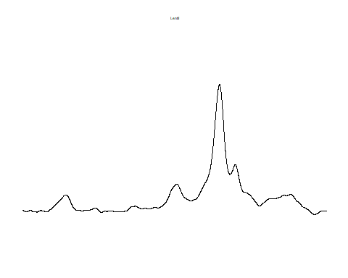

$Chickpea

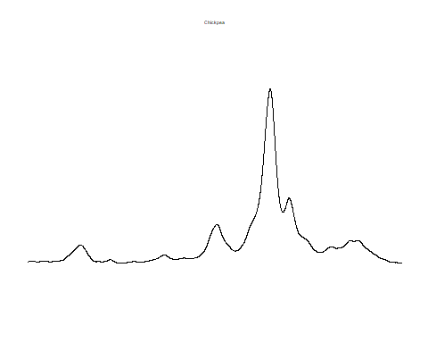

$Tofu

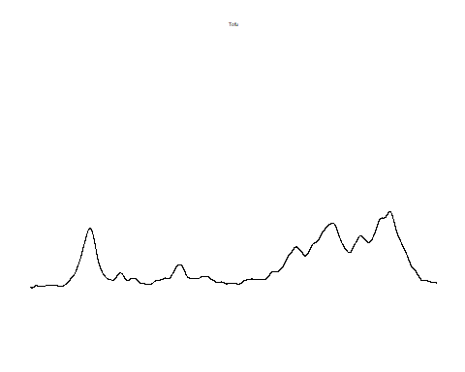

$Tempeh

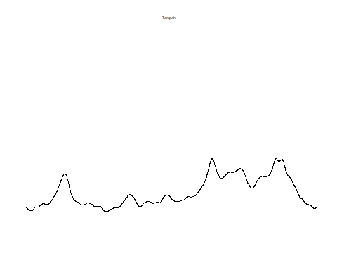

$Bread

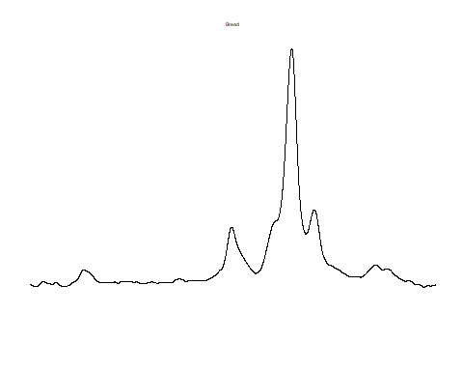

$WholeWheatBread

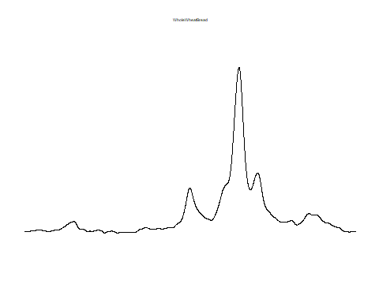

$Pasta

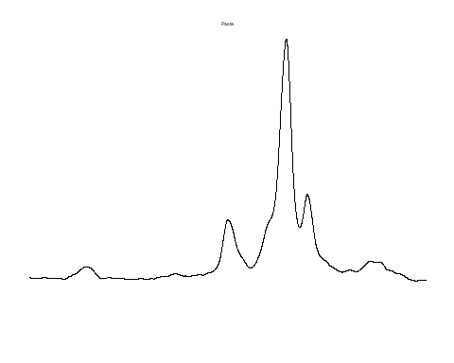

$WholeWheatPasta

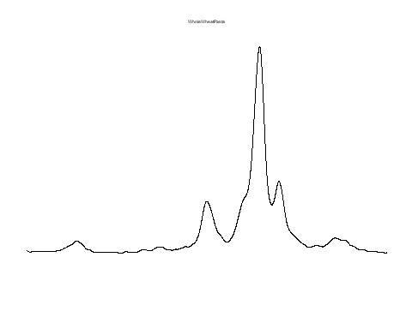

$CousCous

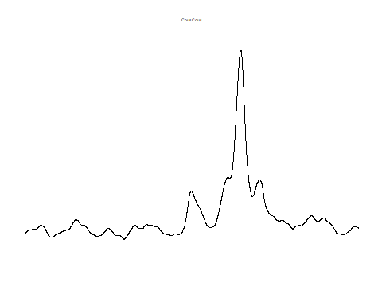

$Rice

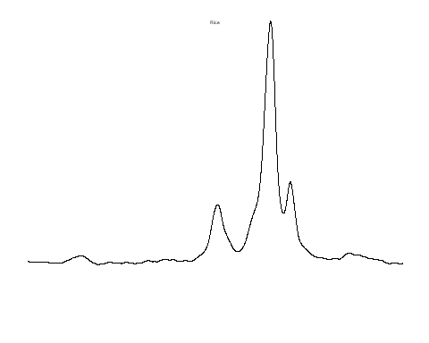

$Quinoa

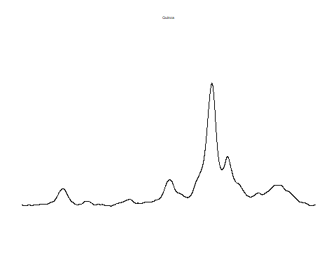

$Seitan

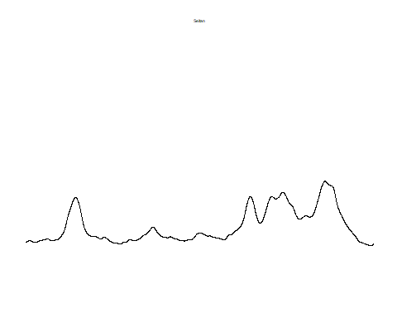

$CowCheese

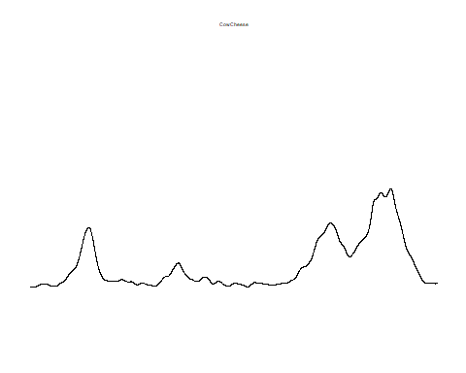

$SheepCheese

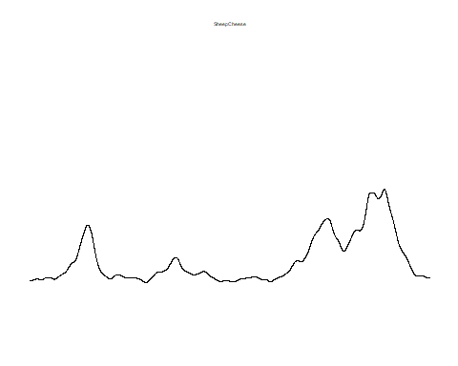

$GoatCheese

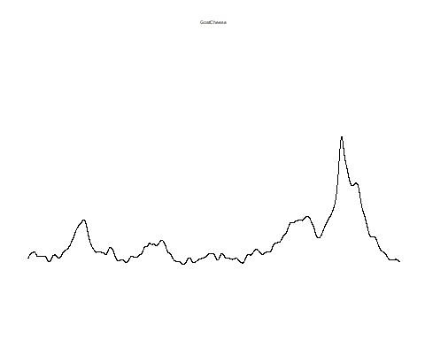

$Albumen

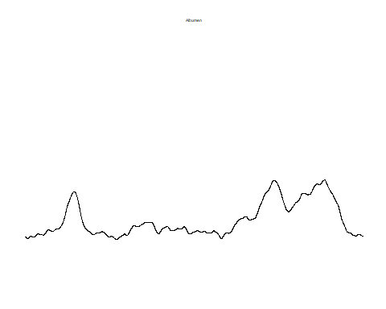

$Yolk

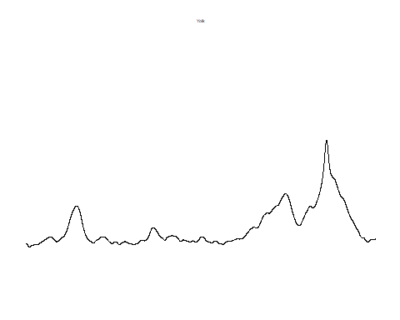

$Cod

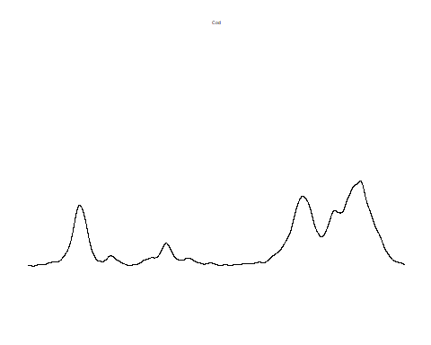

$Mussel

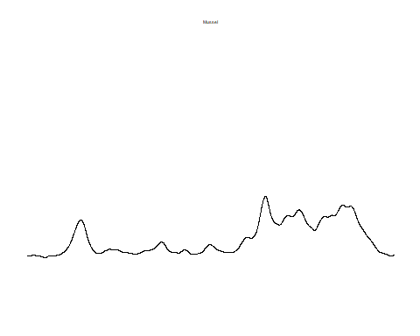

$Shrimp

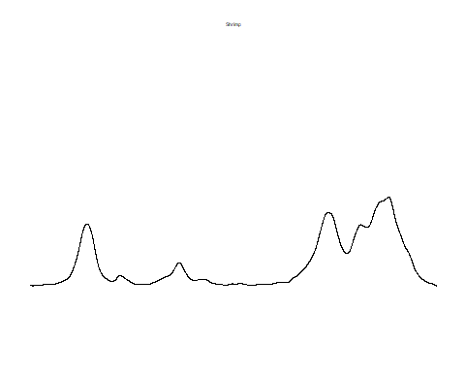

$Salmon

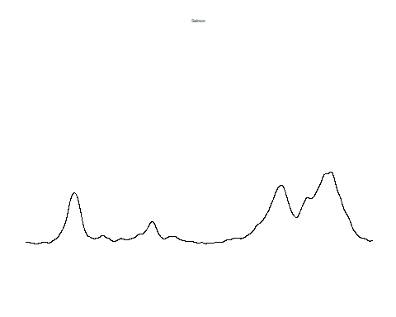

$Chicken

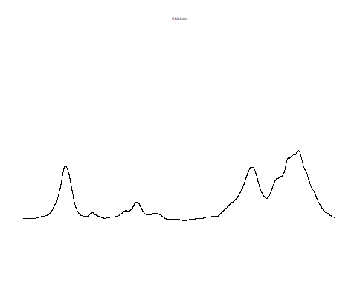

$Pig

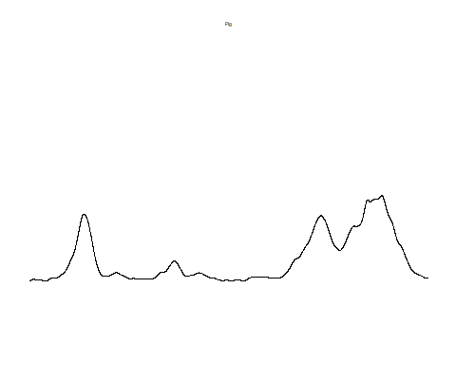

$Bresaola

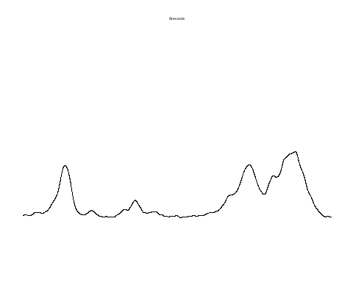

$Salami

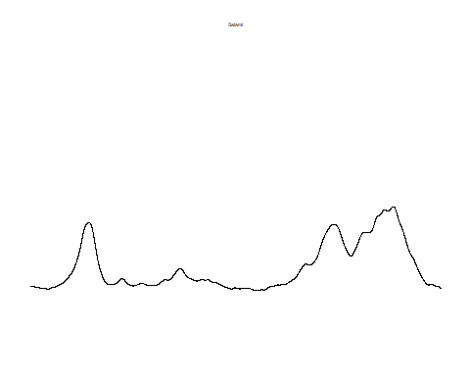

$Ham

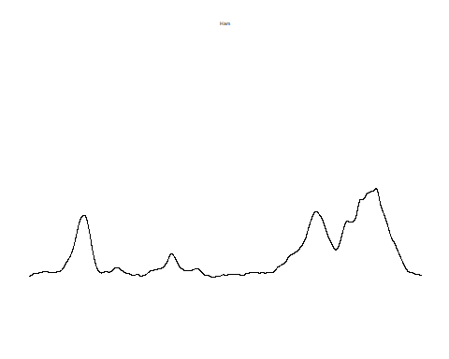

$Chocolate

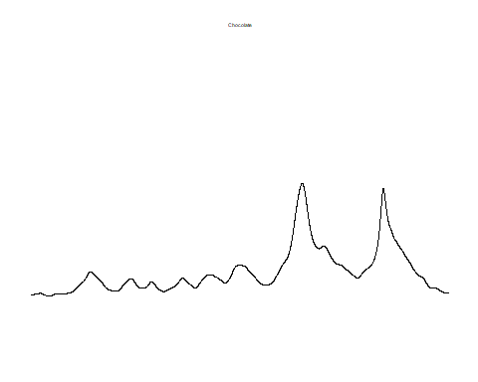

$Biscuit

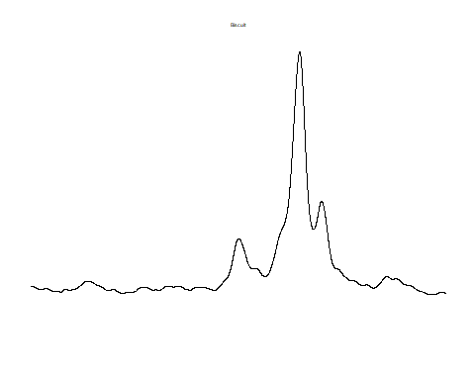

$OilEVO

