**FINAL PROJECT REPORT**

**by**

**Tofiquel Alam**

**Id: 123-35-311**

**Afsana Begum**

lecturer

Department of SWE

DaffodilInternationalUniversity



**DAFFODIL INTERNATIONAL UNIVERSITY**

**Dhaka, Bangladesh**

**DECLARATION**

I hereby declare that, this project has been done by us under the supervision of **Afsana**

**Begum, lecturer, Department of SWE** Daffodil International University.

**Supervised by:**

**Afsana Begum**

Lecturer

Department of SWE

Daffodil International University

**Submitted by:**

**Tofiquel Alam**

ID: - 123-35-311

Department of SWE

Daffodil International University

**ABSTRACT**

This project in on “Online Doctors appointment and management system” Add Hospital information By Supper admin Also given a ‘username and password’, Add a doctors information by Hospital management and Make an appointment by patient and maintain serial automatically. A patient gets all information about a hospital and doctors and makes appointment easily.

ODAMS deals with patient through automatically conformation message. First of all a patient find a hospital then he choose a department for his required and send an appointment request to the doctors. And it store in a Database and send anautomatically conformation message to the patient. Then Hospital management first at all Login the System and prints all individual Doctors appointment.To develop this Project most essential language is HTML, HTML5, CSS, CSS3, PHP, JavaScript and MySQL.After implementation of the function, the a system is tested in different stage and it works successfully as prototype.

**TABLE OF CONTENTS**

|  |  |
| --- | --- |
| **CONTENS** | **PAGE** |
| Declaration |  |
| Abstract |  |
| **CHAPTER** |  |
| **CHAPTER 1: CHAPTER NAME** |  |
| 1.1 Aim of the project |  |
| 1.2 Existing System  1.3 Proposed System  1.4 Scope of the Project  1.5 Methodology  1.6 Organization of the report  **CHAPTER 2:PROPOSED SYSTEM OVERVIEW**  2.1 Introduction  2.2 Problem with the existing system  2.3 Feature of the proposal system  2.4 Supper admin  2.4.1 Insert a Hospital Information  2.4.2 All Hospital List  2.4.3 Hospital management  2.4.3.1 Insert a Doctors Information  2.4.3.2 Updating information about doctors  2.5 Assign a user name or Id and Password  2.6 Benefited of the User  2.7 Hassle for the user and others  **CHAPTER 3: REQUEIREMENT ANALYSIS**  3.1 Introduction  3.2 Fact finding  3.2.1 Sampling of the existing system  3.2.2 Interview  3.2.3 Observation  3.2.4 Questionnaires  3.2.5 Research and site visits  3.3 Used fact finding technique  3.3.1 Interview with Doctors  3.3.2 Interview with Users  3.4 Supporting operating system platform  3.5 Software requirement  3.5.1 PHP  3.5.2 MySQL  3.5.3 CSS, CSS3  3.5.4 JavaScript  **CHAPTER 4: PROPOSED SYSTEM DESIGN**  4.1 Introduction  4.2 Contexts Diagram  4.3 E-R Diagram  4.4 Flow Chart  4.4.1  **CHAPTER 5: IMPLIMENTATION**  5.1 Introduction  5.2 Implementation of the system solution  5.2.1 Feature of the implemented  5.2.2 Feature of the application user   1. Administrator 2. Doctors 3. Patient   **CHAPTER 6: DATABASE DESIGN AND TABLE LIST**  6.1 Introduction  6.2 Database table  6.2.1 Supper admin and hospital admin database structure  6.2.2 Hospital department data base structure  6.2.3 Doctors database structure  6.2.4 Patient database structure  **CHAPTER 7: TESTING**  7.1 Introduction  7.2 Unit Testing  7.3 Integration testing  7.4 Conclusion  **CHAPTER 8: CONCLUSION**  8.1 Discussion  8.2 Conclusion  8.3 Suggestion for future use |  |
|  |  |
|  |  |
| **REFERENCES** |  |

**LIST OF FIGURES**

|  |  |
| --- | --- |
| **FIGURES** | **PAGE NO** |
| Figure 1.1: |  |
| Figure 2..3.1 |  |

**LIST OF TABLE**

**FIGURES**

Table :

**CHAPTER 1**

**Introduction**

* 1. **Aim of the Project**

This system which can provide full facilities to the patient, doctors and some others, The online doctor’s appointment and management system for doctors in such a system which can provide the facilities with very low cost and very fast then present. As the system is fully automated the system does not need much maintenance cost. As a result this will reduced the cost

**This system is very much efficient, because the full system is automated from the very beginning to the end.**

**By this system, every patient can get their apointment from any where in the world within a very short time, which is effective to patient, and the hospital management.**

**Main aim was to build a complete this system for Doctors successfully, which will be a fully automated apontment reception system anlog with our suppervisor. the goal of the project is to make every task of the patient and doctors about the appontment of the doctors much easier the present system. this system will ensure that, the patient get appointment without entering to the hospital physically with in a sort time .**

* 1. Existing system

**In our country, if it is observe about the patient appointment system then whats it gets? it ges a lot of complicacy, difficult and many problem of everythings. the problems are everywhere in the patient apponintment system.**

**we found the main problem in patient appoinment system at present time sll hospital authority maintain thir patient serial manually. patient need to collect their appointment from hospital physically.**

* 1. Proposed system

**To over come the problem of the patient appointment we have proposed this system. this will be full automated and the full system is internet based.**

**This is acctually internet based system, which content all the facilities of the getting the search result and so far through internet. its have been tried to build up a complete** appointment system**.** Which can fulfill all the requires and facilities of a patient will not have to go to the hospital.

* 1. **Scope of the project**

The goal is to make such an online doctor’s appointment and management system for doctors from where the patient will get the maximum benefits with less effort. In the proposed system, the patient can get their appointment without coming hospital. If this system can be implemented properly and completely then it has very bright future in Bangladesh actually not only Bangladesh it’s to be worldwide. For many reasons, automatic patient appointment through conformation message. In the Bangladesh is very useful this system can be used in the public and private hospital different type of medical institute by doing a very few changes.

* 1. **Methodology**

The term under taken several steps to make this project a success. They have visited several hospitals to finds the real problem and the available information, which can help to make this project. This also shared the ideas with the parent doctor of different hospital like what are the problems they are facing about getting appointment to the hospital and what the facilities they want to get from the hospital about getting the appointment

The term has gathers all of that information they got and then reconstructed those to give the optimal performance despite with limitation.

* 1. **Organization of the report**

Details discussion about proposed system is given in chapter-2, requirement analysis is given in chap-3, proposed system for doctors chap-4, implementation of proposed system in chap-5, database design and table list is in chapter-6 and testing is given in chap-7.

**CHAPTER 2**

**Proposed system overview**

2.1 **Introduction**

In this chapter we will discuss about present system and proposed system. The goal is to provide better service to patient in their appointment. By this proposed system we want reduced their hassle.

2.2 **Problem with the existing system**

In Bangladesh, if it is observed about the hospital appointment system, then what it get? It gets a lot of compliancy, difficult and many problem of everything’s. the problem are everywhere in the hospital of Bangladesh.

Main problem is to time required for getting appointment. Patient have to go hospital for their appointment physically.

2.3**Feature of the proposed system**

The proposed system should have the following facilities to serve the better service.

1. Its all of the power should have to “**supper admin**”.
2. A hospital administrator want to permission to the Supper admin for involve in the system.
3. Should be a patient get all of the information about the doctors through internet.
4. A patient can get appointment of a doctor through internet.
5. If any use want to get information about blood group.
6. A doctor’s information can easily insert in the system by Hospital management.
7. Also update and delete information about doctors by hospital management.
8. A hospital management can easily get the all of the patient request and print this.
9. “**Supper admin**” have total system controlling power.

2.4 **Supper admin**

In this system has a supper admin. When a supper admin entering the system it first face is login by ‘username and password’. Basically in this have two type of user first one is hospital management and second one is patient. A supper admin insert, delete and update information about the hospital management. But it can’t add any data about Doctors. Given a figure that’s show about supper admin form:

SUPER ADMIN FORM

**IMAGE**

Figure :

**2.4.1 Inserting Hospital**

Hospital information insert within system database by supper admin figure given bellow:

**IMAGE**

Figure

2.4.2 **All Hospital List**

Given bellow figure how can seen all hospital list:

**IMAGE**

Fig

2.4.3 **Hospital management**

Given bellow a figure about hospital management forms:

**IMAGE**

Fig

2.4.3.1 **Insert a doctor’s information by hospital management**

Insert a doctor’s information form given bellow.

**IMAGE**

Figure

2.4.3.2 **Updating information about doctors**

**IMAGE**

Figure

2.5 **Assign a username and password**

Supper admin given a username or id and password to the Hospital management system for his Login.

2.6 **Benefit of the user**

In this section we will discussed which kind of advantage and which one get this advantage.

* Patient: The patient get the maximum benefit from it. Actually this system is made for helping the patient. This system makes the appointment very much easier and faster. Access from anywhere within the whole world through internet. In Bangladesh so many people living under internet network through mobile company. Within some days rest the area will be covered by internet. That’s why any patient can get their appointment through internet. Its too much time consuming because a patient do not go to the hospital physically.
* Doctors: a doctors Also get the benefits from it actually this system made for helping for doctors.

CHAPTER 3

RREQUEIREMENT ANALYSIS

3.1 **Introduction**

Requirement analysis is concerned with discovered and deciding what the new system is required to do? In this chapter we will discussed about the requirement for the proposed system.

3.2 **Fact finding**

Fact finding is one of the important steps toward any system development. It is essential to gather all of information and facts about an existing system to ensure that all strength and weakness are discovered. Thus a new system is designed as many of the weakness as possible are eliminated, whilst retaining the strength. There are five general techniques available; those used depend upon the particular circumstances.

3.2.1 **Sampling of Existing Documents:** To follow this particular method of fact finding, analyst has to study well existing documentation forms and files of existing system. A good analyst gets fact first from existing documentation rather than from people.

3.2.2 **Interview:** these techniques of fact finding is most popular, productive for good analyst and most probably widely used. Interviews are a fact finding techniques where by the system analyst collect information from individual’s fact to face interviewing can be used to find-facts, verifying facts , clearing fact general enthusiasm etc.

3.2.3 **Observation:** Observation could beformal or informal. This is most effective when and analyst wants to obtain an understanding of a system. This techniques used when analyst wants either participates in or watches a person perform activities to learn about the system.

3.2.4 **Questionnaires:** This is special purpose document that allow the analyst to collect information and opinions from respondents. Questionnaires become useful when a little information is required from a number of people.

3.2.5 **Research and site visits:** Analyst has to research with data of the organization. The data could be collect form the documents, files or from computer. Most organization likes to maintain their web site. Analyst can get data and information of their existing system.

3.3 **Fact finding Techniques**

From these five techniques I have used interview.

Why choose Interview? Because it is most effective techniques for fact finding and some shortly small problems could find out by these technique.

3.3.1 **Interview with doctors:** I have visited some doctors for investigation of my project. After finishing the interview with doctors, I have reached to my goal . cause problem with existing system have come out during the interview.

**Doctor’s problem:**

* **Time effective service for patient**
* **Patient appointment serial management**
* **Patient record management**

3.3.2**Interview with patient:**I have talking with some patient for investigation of my project. After finishing the interview with patient, I have reached to my goal. Cause problem of existing system have come out during the interview.

**Patient’s problem:**

* **Very lengthy process to get appointment**
* **They have waited long time to visit doctor.**

**3.4 Supported Operating system platforms**

This system supported all of the operating system. Mostly it can be used windows 7. Some of feature are unsupported various browser and operating system. It can used more effectively and reliably. Windows OS is the most popular in this world so we are make up this project based on windows OS. But it doesn’t mean it’s only for windows it’s for all of the OS.

Now what we can see: Windows OS has many feature and tools that will make using our computer easy effective and entertaining. For example we can use remote desktop to access out work computer and its resources from home and to view files and document on our computers from co workers computer. With net meeting we can have virtual meeting with anyone anywhere and we can participate in discussion using audio, video, or chat getting help never been easier: with remote assistance, Se just send emailto our favorite computer expert or help desk personnel and they can help us fix aproblem from their location. Windows operating system provides extensive online help for all operating feature, as well as a digital tour to help us discovered the possibilities awaiting us.

3.5**Software requirement**

We have used some of the software which are help for build our project as possible. The required software description is given bellow:

3.5.1 **PHP: Hypertext preprocessor** is a widely used, general purpose scripting language that was originally designed for web development to produced dynamic web pages. For this purpose, PHP code is embedded into the HTML source document and interpreted by a web server with a PHP processor module, which generate the web page document. As a general purpose programming language, PHP is processed by an interpreter application in command line mode performing desired operating system operation and producing program output on its standard output channel. it may also function as graphical application. PHP is available as a processor for most modern web server and as standalone interpreter on most operating system and computing platform.

3.5.2 **MySql:** is a relational database management system that runs as a server providing multi user access to a number of databases. It is named for original developer Michael Widenius’smy. The MySql development project has made its source code available under the terms of the GNU general public licensed, as well as under a variety of propriety agreements. MySql is owned and sponsored by a single for-profit firm, the Swedish company MySql AB, Now Owned by sun Microsystem,asubsidiary of oracle Corporaton. Member of the Mysql community have created several forks as Drizzle. Ourdeltapercona Server and mariaDB. All of the forks were in progress before the oracle acquisition.

Free software project that require a full featured database management system often use MySql. Such project includes WordPress, PHP, and others software built on the LAMP software stack. MySql is also used in many high profile, large scale world wide web products including Wikipedia, Google and Face Book.

3.5.3 **Cascading style sheets (CSS):** is a style sheet language used to describe the presentation semantics of documenting writing in markup language. It the most common application is to style web pages written in HTML and XHTML, but the language can also be applied to any kind of XML documentation including SVG and XUL.

CSS is designed primarily to enable the separation of document content (written in HTML or a similar Markup language) from document presentation, including eliments such as the layout colors and fonts. This separation can improve content accessibility, prove more flexibility and control in the specification of presentation characteristics, enable multiple pages to share formatting and reduces complexity and repetition in the structural content.

3.5.4 **JavaScript:** is an implementation of the ECMAScripting language standard and is typically used to enable programmatic access to computational objects within a host environment. It can be characterized as a prototype based object oriented scripting language that is dynamic. Weakly typed and has first class functions. It is also considered a functional programming language. JavaScript is primarily used in the form of client side JavaScript, implemented as part of web browser in order to provide enhanced user interface and dynamic websites. However its use in application outside webpage.

**CHAPTER 4**

**PROPOSED SYSTEM DESIGN**

**4.1 Intruduction:**

This chapter description about full system graphically view with helping diagram and flow chart.

**4.2 Context Diagram:**

There are basics rules of information communication system that are define which data are valid and which data are not valid and which one flow or not. The hole system define a diagram is called context diagram.

Here is the hole system define in a context diagram.

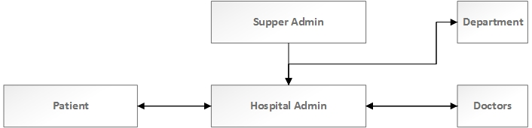

Fig: Context diagram of the system.

**4.3 E-R Diagram:**

When we develop a software then a most importanr is step is graphical representation. E-R diagran is one kind of graphical representation that is a abstract and conceptual representation. Entity realationship is a database modeling system. That is aconceptual model of data. Created in this process is called entity relationship diagram. Following a figure of entity relational diagram.

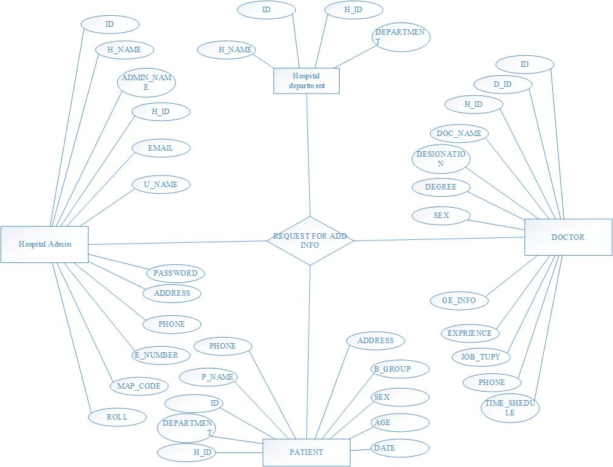

Fig: E-R diagram of this system.

**4.4** **Flow Chart for patient**

Sample:

1. Given a flow chart for the patient how will get an appointment and how can search a doctors

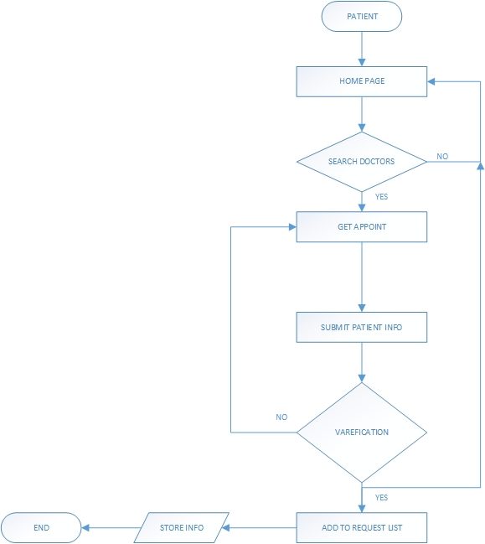

**4.5 Hospital admin working procedure flow chart**

Sample:

1. Given a flow chart for how can hospital admin insert a doctor’s information and patient request print for the doctors also update all information

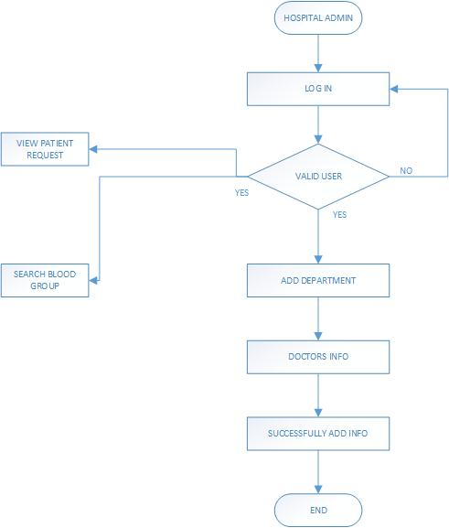

**4.6 Flow chart for the Supper admin**

Sample:

1. Given a flow chart for the supper admin. How can a supper admin insert a hospital and administrate all working procedure

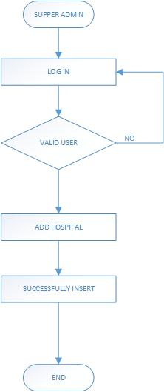

**CHAPTER 5**

**IMPLIMENTATION**

**5.1** **Introduction**

This chapter we will discuss about the implementation feature of the project also describe by the appropriate figure.

**5.2 Implementation of this System**

This is totally online based system which contents all facilities for the patient. We are tried to buildup complete “Get My Doctor”. Which can fulfill all requirements of the student about the result?

This software is beneficial for the both student, faculties of the university in the university. In sense that all activities about the result that was published manually in previous can now be received through mobile from anywhere in the world.

**5.2.1** **Feature of the implemented**

We tried to produced by this system online appointment and confirmation message and searching also management system. Two type of management system first one is supper admin and second one is hospital admin.

This system has the following facilities:

1. Getting all information about hospital and doctors.
2. The patient gets appointment.
3. And Management system.
   * 1. **Feature of the application user**

There are three type of mainly user in the application who uses the service and management properly.

**Administrator**: Supper admin and Hospital admin

Sample:

1. **Supper admin:** A supper admin home page is given bellow. The administrator can manipulate all working procedure such as Insert a hospital, updating and manipulate all information.

**IMAGE**

Figure

Sample:

**Hospital admin:** A hospital admin permitted by the supper admin and he can permitted insert a doctors information, update information and also can seen patient appointment request for the doctors and print this.

**IMAGE**

**Sample:**

**Patient how to make a doctor appointment:** This the home page of patient. How can a patient select a hospital then department and select doctors then final step get appointment.

**IMAGE**

Fig:

**Some step follow make an easy appointment:**

* **First step:**

**IMAGE**

* **Second step:**

**IMAGE**

* **Third step:**

**IMAGE**

* **Final step:**

**IMAGE**

**CHAPTER 6**

**DATABASE DESIGN AND TABLE LIST**

**6.1 Introduction**

In this proposed system there are five tables. We have designed in 2nd normal form. We didn’t need to use 3rd normal form because there is no repetition of any data. Details discussion about given bellow.

* 1. **Database Table**

**IMAGE**

Supper admin and hospital admin database structure

Hospital department database structure

Doctor database structure

Patient database structure

6.2.1 **Supper admin and hospital admin database structure**

**IMAGE**

**6.2.2 Hospital department database structure**

**IMAGE**

**6.2.2 Doctor database structure**

**IMAGE**

**6.2.2 Patient database structure**

**IMAGE**

**CHAPTER 7**

**TESTING**

**7.1 Introduction**

There are many strategies that can be used to test software. A software tem could wait until the system is fully constructed and the conduct test ion the overall system in hopes of finding error. This approach, although appealing simple does not work. It will result in buggy software that disappoints the customer and end user. At the other others extreme, a software engineer could conduct test only basis, when ever any part of the system is constructed. This approaches although less appealing too many can be very effective.

A testing that is chosen by most software teams falls between the two extreme it take an incremental view of testing, beginning with the testing of individuals programs unit, moving test designed to facilities the integration of the unit and culmination with test that exercised e constructed system. Each of these classes of tests is described in the section that follows.

**7.2 Unit Testing**

Unit testing focuses verification effort on the smallest unit of software the software component or module. Using the component level design description as a guide. Impotent control paths are tested to uncover errors those within the boundary of the module. the relative complexity of test and the errors those tests uncover is limited by the constrained scope established for unit testing. The unit test focuses on the internal processing logic and data structure within the boundaries of component.

The goal of the unit testing is to isolate each part old the program and show that the individual’s part are correct. Unit testing provides a strict, written contract that the piece of code must satisfy several benefits.

Unit testing help eliminate uncertainty in the unit themselves and can be used in a bottom up testing style approach. By testing the part of the program first and then testing the sum of its parts, integration testing must easer.

**7.3** **Integration Testing**

Integration testing is a systematic technique for construction the software architecture while at the same time conducting tests to uncover errors associated with interfacing. The objective is to take unit test component and build a program structure that has been dictated by design.

There is often tendency to attempt no incremental integration that is to construct the program using a big bang approach. All components are combined in advanced. The enter program is tested as a whole. And chaos usually result a set of errors in encountered. Correction is difficult because isolation of causes in complicated by the vast expense of the entire program.

Incremental approach is the big bang antithesis approach. The program is constructed and tested in small increment, where errors easier to isolate and correct interfaces are more likely to be tested completely and a systematic test approach may be applied.

**7.4** **Conclusion**

There were number of testing technique is real time software. Rut we tested our system is two testing system. Those two systems were unit testing and integration testing. As beginning of the coding section is unit testing. Where we make our different module we tested by unit testing. After complete our full system we tested by integration testing system. In every test section we found some problem and at that time we solve that problem. After then we complete our desire system.

**CHAPTER 8**

**CONCLUTIONS**

**8.1 Discussion**

In the proposed system the goal was to make such a project by which the full appointment system can be automation which will help, reduce time and complexity for patient and doctor.

Here the target system the patient must have Internet to get Appointment, discuss about it, and take a better plan to implement the system more efficient and reliable to the users.

In the present system the patient must have Internet to get Appointment from this system. If anyone does not have Internet, then they can’t use this system.

**8.2 Conclusion**

This project will work as a virtual Appointment system by Internet through email service. It requires lost of data and time. If this system can be implemented properly and completely then it has a very bright future in Bangladesh. For many reasons, “Get My Doctor” in Bangladesh is very useful. This system can be used in the public and private Hospital, different kind of Medical institutions by doing a very few changes.

**8.3 Suggestion for Future Use**

In the future will try to update all feature of our project and we try to solve current problem of our project. Some future plan is given bellow:

* I future payment feature will added this web application
* By this system patient will create his account using this web application
* It will also capable to send appointment serial through SMS gateway
* In future by the developed system international doctor will be able to be a member of the System.
* By this system all private and public hospital will get different kinds of facilities