**Quesiton 1)**

**a-**

**b-**

**Partc)**

**For quick sort my laptop doesnt compile the lengths after** 4194304.It was giving me stackoverflow error in the beginning. I increased the stack size but then program automatically stopped after some amount of time.

So these are my results:

**HEAPSORT**

**Part d)**

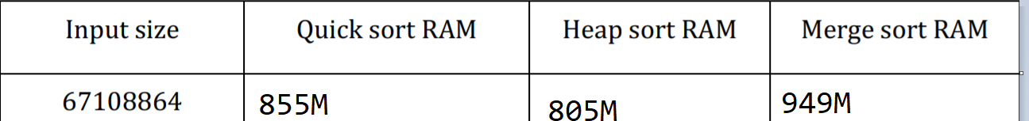

**As we can see from table results merge sort uses the most ram amonf three. The reason fort his is because each time we divide the array we need to specify an array to put division result. That causes memory usage more.**

**Second is Quick sort. It also uses more memory compare to heap sort because here also there is a memory allocaion for array results after partition.**