**A)**

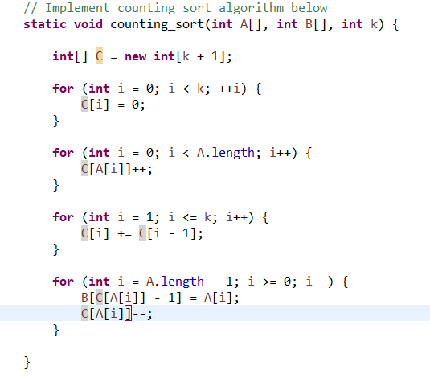

**B)**

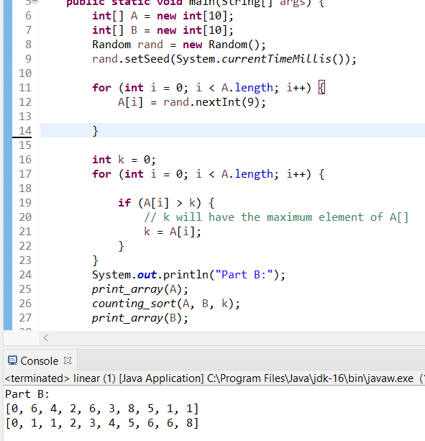

**C)**

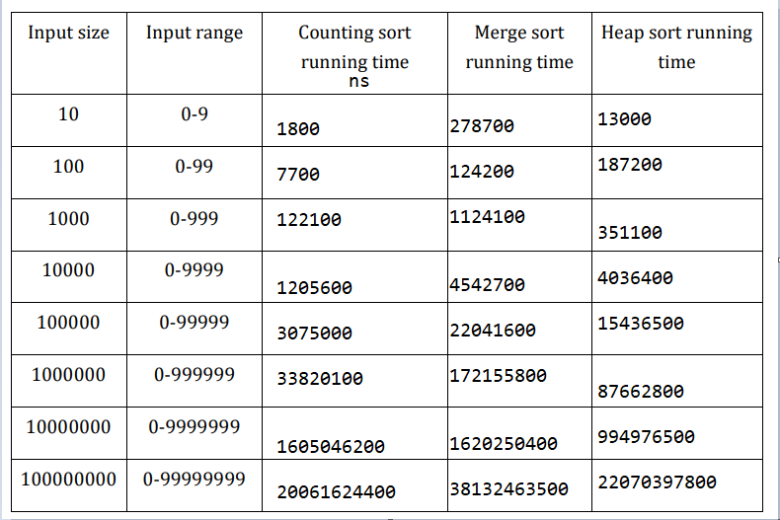

* Counting sort is the fastest algorithm for almost all of the input sizes. Merge sort is almost always the slowest algorithm. If we compare running times-> Merge>Heap>Counting in ns.

**D)**

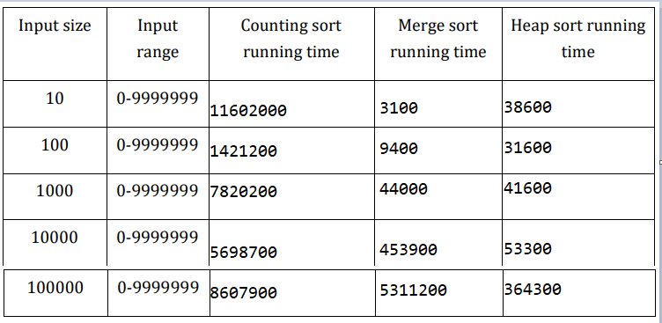

* When the range changes Counting sort has the worst time. It is always the slowest. Merge sort is faster than heap sort until input size becomes bigger than 1000. Then, Heap sort becomes the fastest among all of them.

E)

* Merge Sort uses the most memory. Heap sort and counting sort don’t have that much of a big difference. The memory usages are in terms of KB and gained using Windows Resource Monitor. If we compare ram usage Merge>Counting>Heap.