Part a)

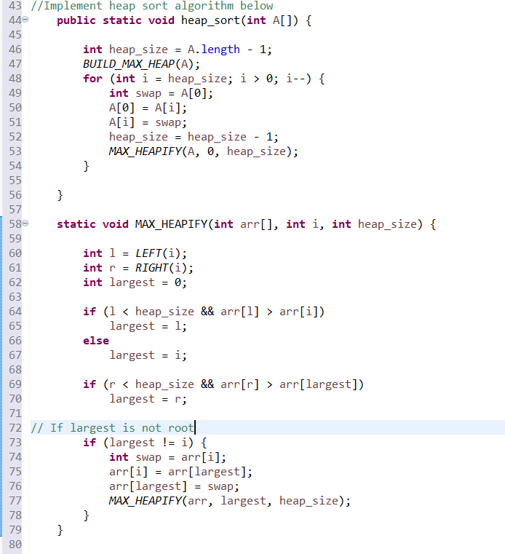

**Part b)**

**Part c)**

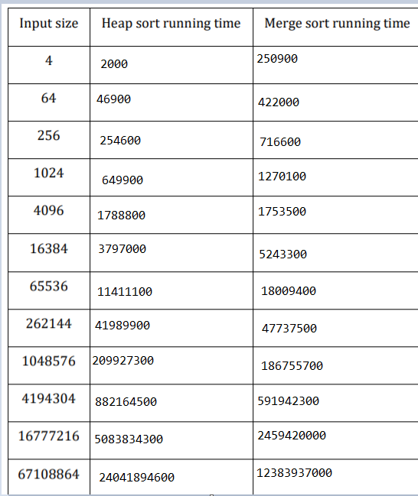

**Which shows heap sort is slower than merge sort.**

**Part d)**

**Mem usage of Heap:**

861 java 99.6 00:06.34 27/1 3 117 277M 0B 0B 493 493

**277 M**

**Part e:**

**Mem usage of merge:**

881 java 100.5 00:07.84 27/1 3 117 778M+ 0B 0B 493 493

778 M

**Merge sort consumes more memory than heap sort.**