Physics-Informed Deep Learning for Noise-Robust
IVIM Parameter Estimation in Breast DW-MRI
A Two-Stage Pipeline Combining Self-Supervised Physics Autoencoders
with Spatial U-Net Refinement for Quantitative Breast Cancer Imaging
Ken Lew¹, Sabyasachi Chowdhury¹
¹ Department of Computer Science
University of Houston
July 2026
Based on the PIA-IVIM framework (Gundogdu, University of Chicago Radiology)
AAPM IVIM Challenge • VICTRE Digital Breast Phantoms

Abstract
Intravoxel Incoherent Motion (IVIM) diffusion-weighted magnetic resonance imaging (DW-MRI) enables non-invasive, contrast-free quantitative characterization of breast tissue by decoupling microvascular perfusion from true water diffusion. However, conventional voxel-wise non-linear least squares (NLLS) parameter estimation suffers from extreme noise sensitivity, absence of spatial regularization, and prohibitive computational latency (~187 seconds per 200×200 slice on CPU), severely limiting clinical adoption.
We present a two-stage physics-informed deep learning pipeline for noise-robust estimation of three IVIM biophysical parameters—perfusion fraction (f), tissue diffusivity (Dt), and pseudo-diffusivity (D*)—from eight-b-value breast DW-MRI acquisitions. Stage 1 employs a self-supervised Physics-Informed Autoencoder (PIA) that uses the exact bi-exponential IVIM equation as its decoder, with bounded activation functions guaranteeing biologically feasible parameter estimates without requiring ground-truth annotations. We implement and compare both a voxel-wise multi-layer perceptron encoder (MLP-PIA, 964,835 parameters) and a spatially-aware convolutional encoder (CNN-PIA, 189,443 parameters). Stage 2 applies a 3.49M-parameter residual U-Net spatial refiner with tumor-weighted supervised loss to exploit spatial coherence and eliminate salt-and-pepper noise artifacts while preserving sharp tumor boundaries.
Evaluated on 400 held-out test patients from the VICTRE digital breast phantom platform across twelve noise levels (SNR = 4 to 100,000), our CNN-PIA + Refiner pipeline achieves: (1) a 6,431× inference speedup over NLLS (29 ms per slice on GPU vs. 187 seconds), enabling real-time quantitative mapping on MRI console workstations; (2) a 33× improvement in noise stability at clinically relevant noise levels (total rRMSE of 0.28 vs. 9.4+ for NLLS at SNR = 10); and (3) qualitatively superior parameter maps that closely match ground truth even under severe noise degradation where NLLS produces unusable salt-and-pepper artifacts.
Keywords: IVIM, DW-MRI, breast cancer, physics-informed neural networks, deep learning, self-supervised learning, U-Net, parameter estimation, noise robustness, quantitative MRI

1. Introduction
Breast cancer remains the most prevalent malignancy among women worldwide, accounting for approximately 2.3 million new diagnoses annually, with early and accurate detection being critical for improving patient outcomes [1]. Diffusion-weighted magnetic resonance imaging (DW-MRI) has emerged as a powerful non-invasive tool for characterizing breast tissue by probing the microscopic motion of water molecules within biological tissue [2]. Unlike conventional anatomical imaging, DW-MRI provides quantitative physiological information that can distinguish between benign and malignant lesions without the need for contrast agents, making it particularly valuable in clinical settings where gadolinium-based contrast may be contraindicated.
The Intravoxel Incoherent Motion (IVIM) model, originally proposed by Le Bihan et al. [3], extends the standard diffusion framework by separating the observed signal attenuation into two distinct components: true molecular diffusion of water in tissue and pseudo-diffusion arising from microcirculation of blood in the capillary network. The IVIM signal is described by a biexponential decay model:
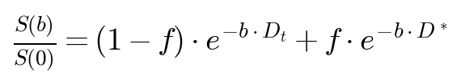
(1)
where S(b) is the measured DW-MRI signal at diffusion weighting factor b (s/mm²), S(0) is the baseline signal without diffusion weighting, f is the perfusion fraction representing the volume of blood flowing in the capillary network relative to total water content, Dt is the true tissue diffusion coefficient (mm²/s), and D* is the pseudo-diffusion coefficient (mm²/s) reflecting the incoherent microcirculation of blood.
These three biophysical parameters carry distinct clinical significance for breast cancer characterization. The perfusion fraction f is elevated in malignant tumors due to tumor-induced angiogenesis, which increases the density of the microvasculature [4, 5]. The true diffusion coefficient Dt is typically restricted in tumors due to high cellularity, which impedes free water diffusion [4]. The pseudo-diffusion coefficient D* reflects microcirculatory blood flow and has been shown to differ between benign and malignant lesions, though it is the most challenging parameter to estimate due to its rapid signal decay, which is captured primarily within the first few low b-value acquisitions [6].
Despite the rich physiological information encoded in IVIM parameters, their clinical adoption has been limited by the inherent instability of the biexponential fitting problem. The conventional approach—voxel-wise non-linear least squares (NLLS) regression—suffers from several critical limitations. First, the biexponential model is ill-conditioned: fitting three unknown parameters from a small number of noisy measurements (typically 6–12 b-values) leads to high estimation variance, particularly for the pseudo-diffusion coefficient D*, whose exponential component decays rapidly and contributes meaningfully to the signal only at the lowest b-values [7]. Second, NLLS operates independently on each voxel without leveraging spatial context—neighboring voxels within the same tissue type are expected to share similar parameter values, yet this prior information is entirely discarded. Third, at low signal-to-noise ratios (SNR), NLLS frequently fails to converge or converges to physically implausible parameter values, especially when the pseudo-diffusion coefficient upper bound is left unconstrained.
Recent advances in deep learning have demonstrated that neural networks can learn robust inverse mappings from noisy signals to underlying physical parameters, often outperforming classical optimization methods in ill-conditioned settings [8, 9]. Physics-informed neural networks, in particular, incorporate known physical laws directly into the network architecture or loss function, constraining the solution space to physically plausible regions and improving generalization to unseen noise conditions [10]. This paradigm is especially well-suited to the IVIM problem, where the exact forward model (Equation 1) is known analytically.
While several learning-based approaches to IVIM parameter estimation have been proposed [8, 9], a systematic study of their robustness across a wide spectrum of clinically relevant noise levels—particularly in the context of breast cancer imaging where high-quality data may not always be available—remains lacking. Furthermore, most existing deep learning methods for IVIM operate on a voxel-by-voxel basis, ignoring the spatial structure of the parameter maps, which limits their denoising capability.
In this work, we present a two-stage physics-informed deep learning pipeline for noise-robust IVIM parameter estimation in breast DW-MRI. Our approach combines: (1) a Physics-Informed Autoencoder (PIA) that maps noisy DW-MRI signals to biophysical parameters using the known IVIM equation as its decoder, and (2) a U-Net-based spatial refiner that exploits spatial coherence in the parameter maps through tumor-weighted supervised denoising. We evaluate our pipeline against the conventional NLLS baseline across twelve noise levels spanning SNR = 4 to SNR = 100,000, using 1,000 simulated breast phantom images from the VICTRE (Virtual Imaging Clinical Trials for Regulatory Evaluation) platform [11]. Our key contributions are:
- A self-supervised physics-informed autoencoder architecture (964,835 parameters) that constrains parameter estimates to biologically feasible ranges through a mean±delta·tanh(·) formulation, eliminating the need for parameter labels during Stage 1 training.
- A spatially-aware CNN-PIA variant (189,443 parameters) that extends the voxel-wise MLP encoder with convolutional feature extraction, enabling spatial context exploitation at the Stage 1 level.
- A two-stage pipeline culminating in a U-Net spatial refiner (3,494,275 parameters) with residual learning and tumor-weighted supervision, achieving a total rRMSE of 0.11 at high SNR and 0.55 at extreme noise (SNR = 4).
- A comprehensive noise-robustness evaluation on 400 held-out test patients demonstrating that the proposed CNN-PIA + Refiner pipeline maintains stable performance across all tested noise levels (SNR 4–100,000), whereas conventional NLLS diverges catastrophically at moderate-to-high noise (σ ≥ 0.10), with total rRMSE exceeding 9.4 at SNR = 10 compared to 0.28 for our method, a 33× improvement.

2. Methods

2.1 Research Design
This study follows a computational experimental design. We develop a physics-informed deep learning pipeline and evaluate it against a conventional NLLS baseline across a controlled range of noise conditions. The independent variable is the noise level (σ), systematically varied across twelve levels spanning from σ = 10⁻⁵ (SNR ≈ 100,000, essentially noiseless) to σ = 0.25 (SNR ≈ 4, severely degraded). This extended range captures both the regime where conventional NLLS excels and the clinically relevant noise levels where deep learning methods dominate. The dependent variables are the IVIM parameter estimation errors for each of the three biophysical parameters (f, Dt, D*), quantified via the relative Root Mean Square Error (rRMSE) metric.
A computational approach was chosen over a clinical study for several reasons. First, simulated data from the VICTRE phantom provides known ground-truth IVIM parameters at every voxel, enabling pixel-level quantitative evaluation that is impossible with in vivo clinical data. Second, the noise level can be precisely controlled and systematically varied, allowing us to characterize the performance of each method across the full clinically relevant SNR range. Third, the simulated dataset provides a sufficiently large cohort (1,000 cases) to support robust deep learning training and evaluation.

2.2 Data and Materials

2.2.1 VICTRE Breast Phantom Dataset
All experiments were conducted using the Virtual Imaging Clinical Trials for Regulatory Evaluation (VICTRE) breast phantom dataset [11], developed by the U.S. Food and Drug Administration (FDA) for virtual clinical trials in breast imaging. The dataset was obtained from the University of Chicago Department of Radiology as part of the AAPM IVIM Challenge. The dataset comprises 1,000 simulated breast phantom cases, each providing four data files per case, as described in Table 1.
File | Shape | Description
XXXX_IVIMParam.npy | 200×200×3 | Ground truth IVIM parameter maps (f, Dt, D*)
XXXX_NoisyDWIk.npy | 200×200×8 (complex) | Noisy DW-MRI data in k-space
XXXX_gtDWIs.npy | 200×200×8 | Clean (noiseless) ground truth DWI signals
XXXX_TissueType.npy | 200×200 | Tissue label map (1=air, 8=tumor)
Table 1. Dataset files provided for each of the 1,000 VICTRE breast phantom cases.
Each case represents a 200×200 pixel two-dimensional axial slice of a simulated breast containing anatomically realistic tissue structures. The tissue label map encodes distinct tissue types including air/background (label = 1), fat, glandular tissue, and tumor (label = 8). The noisy DW-MRI data is provided in the Fourier domain (k-space) as complex-valued arrays, reflecting the acquisition process in real MRI scanners.

2.2.2 DW-MRI Acquisition Protocol
The simulated DW-MRI acquisitions use eight b-values: b ∈ {0, 5, 50, 100, 200, 500, 800, 1000} s/mm². This protocol spans from b = 0 (baseline, no diffusion weighting) to b = 1000 s/mm² (strong diffusion weighting). The protocol includes two very low b-values (0 and 5 s/mm²) that are primarily sensitive to the pseudo-diffusion component, intermediate values (50–200 s/mm²) that capture the transition between perfusion and diffusion regimes, and high values (500–1000 s/mm²) that are predominantly sensitive to true tissue diffusion.

2.2.3 Image Reconstruction and Preprocessing
Magnitude images are reconstructed from the complex k-space data using the inverse two-dimensional Fast Fourier Transform (IFFT) with orthonormal normalization:
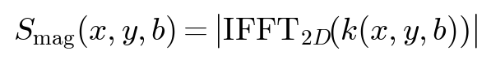
(2)
The resulting magnitude images are then normalized on a per-voxel basis by the baseline signal at b = 0 to obtain the normalized signal attenuation:
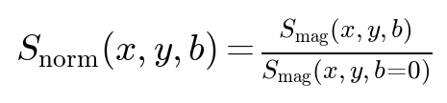
(3)
This normalization removes the baseline signal intensity variation across the image and produces values in the range [0, 1] for the clean signal, consistent with the IVIM model in Equation 1. A small epsilon value (ε = 10⁻⁸) is used to prevent division by zero in background regions.
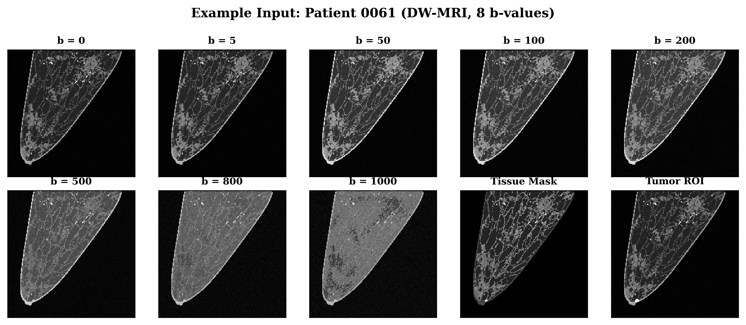
Figure 1. Example input data: eight b-value DW-MRI slices from a VICTRE breast phantom, showing signal attenuation with increasing diffusion weighting. The tissue segmentation mask and tumor ROI contour overlay are shown for reference.

2.2.4 Data Splits
The 1,000-case dataset is partitioned into training (cases 0001–0500, 500 cases), validation (cases 0501–0600, 100 cases), and test (cases 0601–1000, 400 cases) splits. The large test set of 400 held-out cases (40% of the full dataset) ensures statistically robust evaluation and provides sufficient power to detect meaningful differences between methods across all noise levels. No test data was used during training or hyperparameter selection.

2.3 Variables and Operationalization

2.3.1 Independent Variable: Noise Level
The independent variable is the noise standard deviation σ, which controls the signal-to-noise ratio (SNR) of the input DW-MRI data. For the noise robustness evaluation, synthetic Rician noise is injected into the clean ground truth DWI signals at twelve controlled levels spanning an extended dynamic range, as shown in Table 2.
Noise Level (σ) | Approx. SNR | Clinical Relevance
10⁻⁵ | 100,000 | Essentially noiseless
10⁻⁴ | 10,000 | Near-ideal conditions
10⁻³ | 1,000 | Very high quality
0.005 | 200 | Excellent research-grade
0.010 | 100 | Research-grade, long acquisition
0.020 | 50 | High-quality clinical
0.033 | 30 | Standard clinical quality
0.050 | 20 | Acceptable clinical quality
0.100 | 10 | Low-quality or fast acquisition
0.150 | 6.7 | Very low quality
0.200 | 5 | Severely degraded
0.250 | 4 | Near noise floor
Table 2. Noise levels used for noise robustness evaluation, with corresponding approximate SNR and clinical relevance.

2.3.2 Rician Noise Model
Rician noise is used because it accurately models the noise statistics of magnitude-reconstructed MRI images [12]. Unlike additive Gaussian noise, Rician noise introduces a positive bias at low signal intensities, which is physically realistic for MRI. Rician noise is generated by independently corrupting the real and imaginary channels of the signal with zero-mean Gaussian noise, then taking the magnitude:
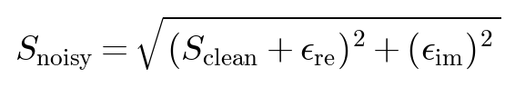
(4)
where ε_re, ε_im ~ N(0, σ²·S₀²) are independent Gaussian noise samples scaled by the mean baseline signal intensity S₀ of tissue voxels.

2.3.3 Dependent Variables: IVIM Parameters
Parameter | Symbol | Physical Range | Unit | Description
Perfusion fraction | f | 0.01–0.40 | Dimensionless | Blood flow fraction
True diffusion | Dt | 0.5–1.5 × 10⁻³ | mm²/s | Water diffusion in tissue
Pseudo-diffusion | D* | 5–60 × 10⁻³ | mm²/s | Blood flow in capillaries
Table 3. IVIM parameter definitions and physical ranges.

2.4 Pipeline Overview
The proposed pipeline operates in two sequential stages. Stage 1 performs per-voxel (MLP) or spatially-aware (CNN) physics-informed parameter estimation. Stage 2 refines the initial estimates using a U-Net that exploits spatial coherence through tumor-weighted supervised denoising with residual learning. The complete pipeline architecture is shown in Figure 2.
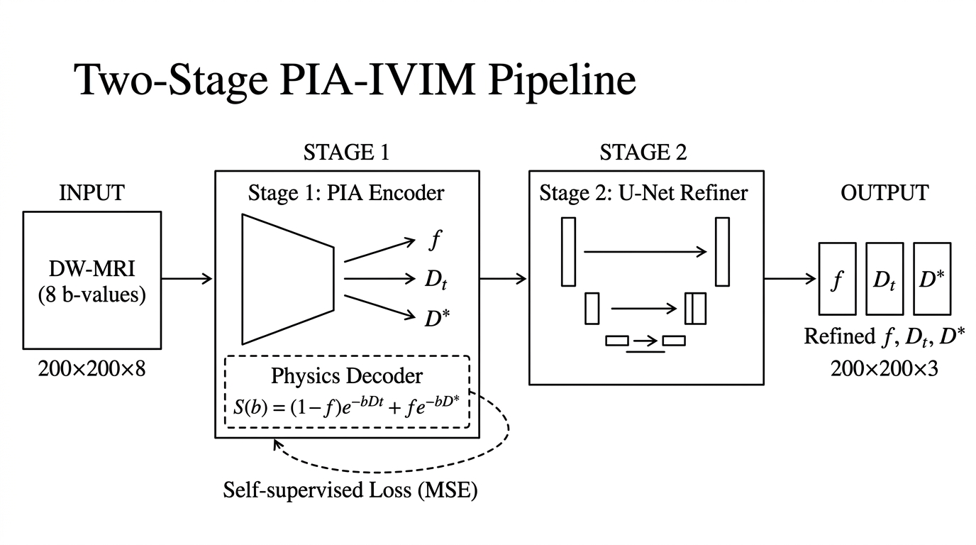
Figure 2. Two-stage PIA-IVIM pipeline overview. Stage 1 maps raw DW-MRI signals to IVIM parameter estimates via a physics-informed autoencoder. Stage 2 refines these estimates using a multi-scale U-Net spatial refiner with tumor-weighted supervision.

2.5 Stage 1: Physics-Informed Autoencoder (PIA)
The first stage maps the normalized 8-dimensional DW-MRI signal at each spatial location to the three IVIM parameters using a self-supervised autoencoder architecture. Two Stage 1 variants are implemented and compared.

2.5.1 MLP-PIA (Voxel-Wise)
The original PIA architecture processes each voxel independently. The encoder is a fully connected multi-layer perceptron (MLP) with five hidden layers of dimensions [32, 64, 128, 256, 512], each followed by a LeakyReLU activation. The 512-dimensional latent representation is fed into three independent predictor heads—one for each IVIM parameter—each consisting of a single fully connected layer followed by a final linear projection to a scalar output. The total parameter count is 964,835.
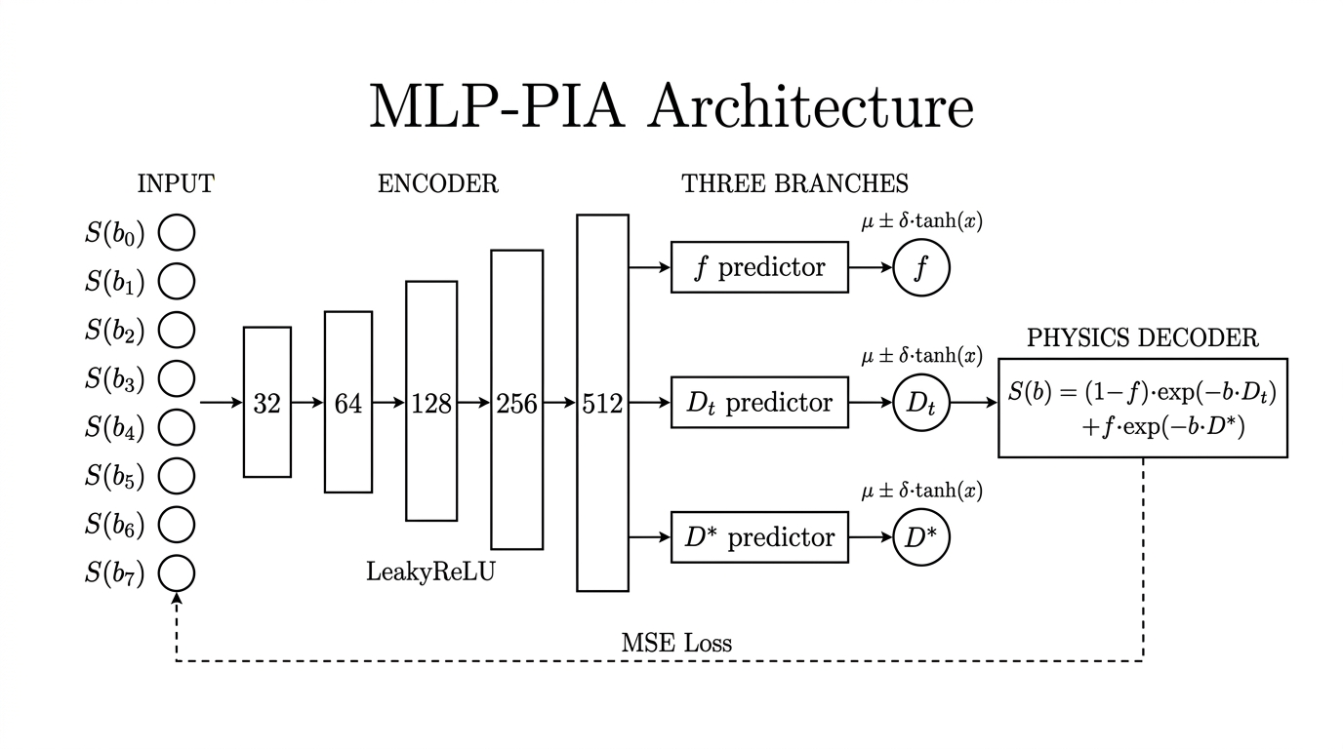
Figure 3. MLP-PIA architecture. The voxel-wise encoder processes each 8-dimensional signal vector through five hidden layers, producing three bounded parameter estimates via independent predictor heads.

2.5.2 CNN-PIA (Spatially-Aware)
To exploit spatial context within each 200×200 patient image, we extend the PIA architecture with a convolutional encoder. The CNN-PIA takes the full 8-channel signal image as input (shape: 8×200×200) and extracts features through a four-layer convolutional backbone: Conv2d(8→64, 3×3) → LeakyReLU(0.1) → Conv2d(64→64, 3×3) → LeakyReLU(0.1) → Conv2d(64→128, 3×3) → LeakyReLU(0.1) → Conv2d(128→64, 3×3) → LeakyReLU(0.1). Three 1×1 convolution predictor heads produce the parameter maps directly at the native image resolution. All convolutional layers use padding = 1 to preserve spatial dimensions. The total parameter count is 189,443.
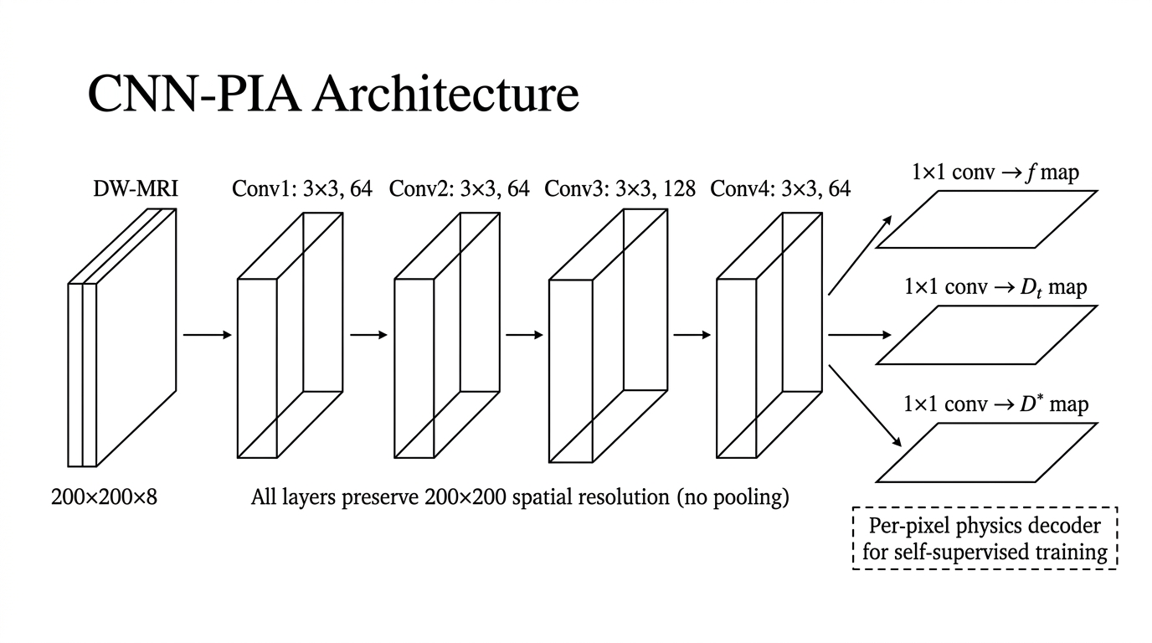
Figure 4. CNN-PIA architecture. The spatially-aware convolutional encoder extracts spatial features from the 8-channel input image through four convolutional layers, producing three parameter maps via 1×1 convolution predictor heads.

2.5.3 Physics-Informed Parameter Constraints
A key feature of the PIA architecture is the physics-informed constraint on the output parameters. Rather than allowing unconstrained predictions, each parameter is bounded to a biologically feasible range through a mean±delta·tanh(·) formulation:
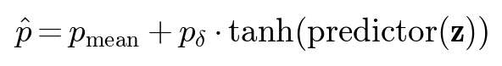
(5)
where z is the encoder output and the tanh function constrains the predictor output to [−1, +1], ensuring each parameter lies within [mean − delta, mean + delta]. The specific constraint parameters for each model variant are given in Table 4.
Parameter | MLP-PIA Bounds | CNN-PIA Bounds | MLP Mean/Delta | CNN Mean/Delta
f | [0.050, 0.350] | [0.050, 0.350] | 0.200 ± 0.150 | 0.200 ± 0.200
Dt (mm²/s) | [0.0007, 0.0015] | [0.0007, 0.0015] | 0.00110 ± 0.00040 | 0.00085 ± 0.00080
D* (mm²/s) | [0.010, 0.040] | [0.005, 0.055] | 0.02500 ± 0.01500 | 0.03250 ± 0.03000
Table 4. Physics-informed constraint parameters for MLP-PIA and CNN-PIA.

2.5.4 Physics-Based Decoder
The decoder is not a learned neural network; it is the deterministic biexponential IVIM model from Equation 1, applied analytically:
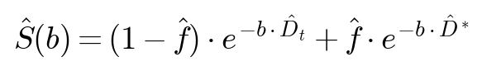
(6)
This physics decoder has zero learnable parameters. By using the known forward model as the decoder, the autoencoder is forced to find parameter estimates that are consistent with the underlying physics. The loss function is the self-supervised reconstruction error:
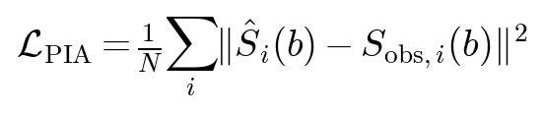
(7)
where the sum is over all b-values and S_obs is the observed (noisy) normalized signal. For the CNN-PIA, the loss is computed only over tissue voxels (excluding air), weighted by an anatomical importance mask.

2.5.5 Stage 1 Training
The MLP-PIA is trained on Monte Carlo-simulated voxel-wise data. At each training step, a batch of 25,000 clean synthetic signals is generated by sampling IVIM parameters uniformly from their physical ranges (f ∈ [0.01, 0.40], Dt ∈ [0.0005, 0.0015] mm²/s, D* ∈ [0.005, 0.06] mm²/s), computing the corresponding clean IVIM signals at the eight b-values, and corrupting them with Rician noise at σ = 0.05. This Monte Carlo training strategy provides unlimited unique training samples, preventing overfitting and ensuring the encoder is trained on the full range of biologically feasible parameter combinations.
The CNN-PIA is trained self-supervised on the 500 training patients directly (cases 0001–0500), using the noisy k-space-reconstructed DW-MRI images as both input and target signal. The training hyperparameters are summarized in Table 5.
Hyperparameter | MLP-PIA | CNN-PIA
Optimizer | Adam | Adam
Learning rate | 3 × 10⁻⁴ | 1 × 10⁻³
Batch size | 25,000 voxels | 8 patients
Epochs | 200 | 15
Training noise (σ) | 0.05 | Native k-space noise
Training data | Monte Carlo simulated | 500 VICTRE patients
Loss function | Self-supervised (Eq. 7) | Masked self-supervised (Eq. 7)
Trainable parameters | 964,835 | 189,443
Table 5. Training hyperparameters for the MLP-PIA and CNN-PIA Stage 1 models.

2.6 Stage 2: U-Net Spatial Refiner
The Stage 1 PIA produces per-voxel or per-pixel parameter estimates that, while physically constrained, may still contain significant spatial noise, particularly in low-SNR regions. Stage 2 addresses this limitation by applying a U-Net spatial refiner that learns to denoise the parameter maps using supervised training with tumor-weighted importance sampling.

2.6.1 U-Net Architecture
The refiner is a three-level U-Net with the following architecture: The encoder comprises three encoding levels with Residual Blocks at channel dimensions [64, 128, 256], connected by 2×2 max pooling layers. Each Residual Block consists of two 3×3 convolutional layers with Group Normalization (8 groups) and SiLU (Swish) activations, plus a skip connection. The bottleneck operates at 256 channels at 25×25 spatial resolution (after three 2× pooling operations from the 200×200 input). The decoder uses bilinear upsampling (not transposed convolutions, to avoid checkerboard artifacts) followed by Residual Blocks, with skip connections from the corresponding encoder levels. A 1×1 convolution projects the final 64-channel feature map to 3 output channels (f, Dt, D*). The total parameter count is 3,494,275.
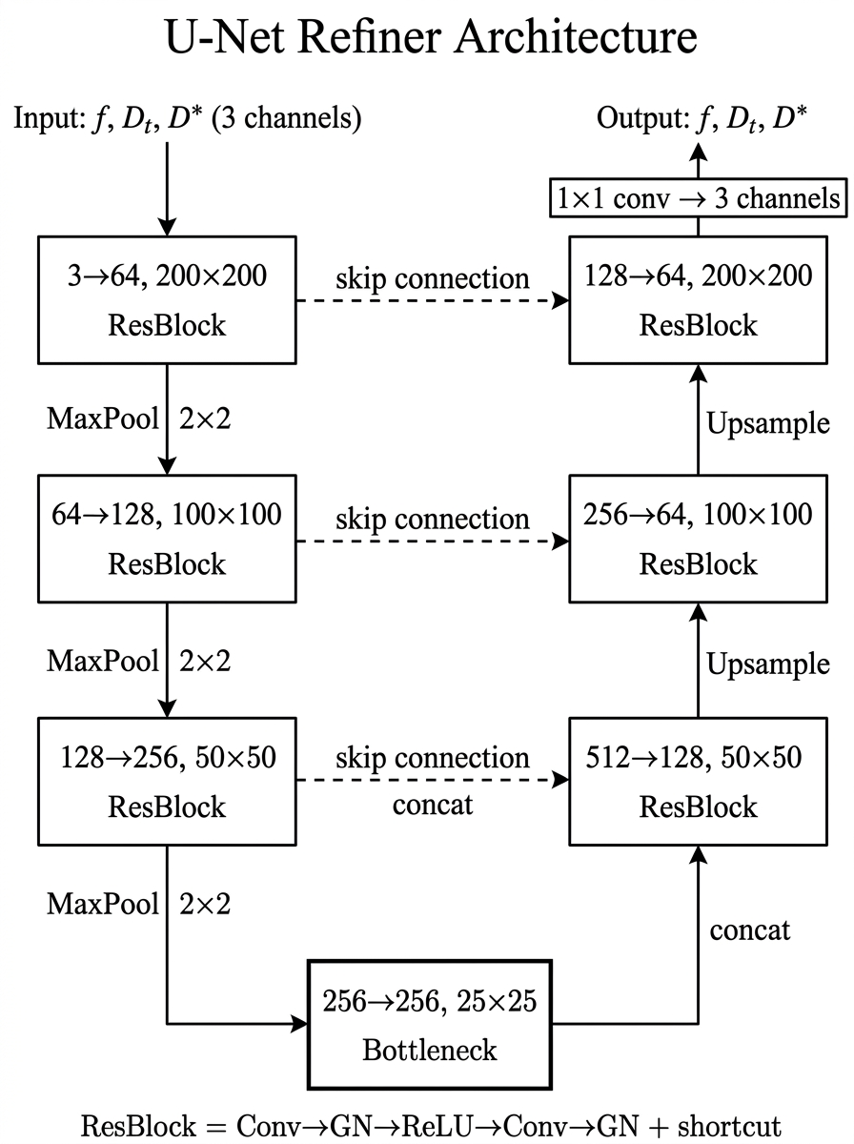
Figure 5. U-Net Spatial Refiner architecture. The three-level encoder-decoder structure with Residual Blocks, skip connections, and residual learning enables multi-scale spatial denoising of IVIM parameter maps.
Critically, the U-Net is configured in residual mode: the output is computed as:
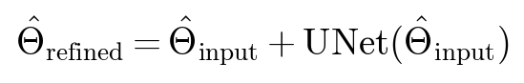
(8)
The final 1×1 convolution is initialized with zero weights and biases, ensuring that the network starts as an identity mapping and progressively learns the spatial correction. This residual formulation stabilizes training and ensures that the refiner only needs to learn the correction term rather than reconstructing the full parameter maps from scratch.

2.6.2 Tumor-Weighted Supervised Loss
The refiner is trained with a supervised loss that emphasizes accurate estimation in tumor regions through importance weighting:
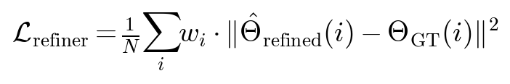
(9)
where the per-voxel importance weight w_i is set to γ_tumor = 5.0 for tumor voxels (tissue label = 8) and 1.0 otherwise. This ensures that the refiner prioritizes accuracy in clinically critical tumor regions, which occupy a small fraction of the total image area. To enable stable training, the IVIM parameters are scaled before being input to the refiner: f is unscaled (×1.0), Dt is scaled by 500, and D* is scaled by 10, bringing all three parameter channels to comparable numeric ranges.

2.6.3 Gradient Isolation Between Stages
A critical design consideration in the two-stage pipeline is preventing the supervised refiner loss from corrupting the self-supervised Stage 1 encoder during Stage 2 training. We employ an end-to-end inference with explicit gradient detachment (stop-gradient) architecture:
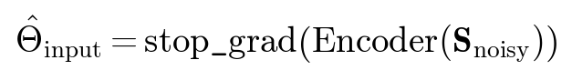
(10)
The refiner then processes these detached estimates, and the supervised loss backpropagates only through the U-Net parameters. All Stage 1 encoder parameters are frozen (requires_grad=False) throughout Stage 2 training. This design offers three advantages over a precompute-and-save approach: (1) it eliminates disk storage overhead; (2) it enables on-the-fly data augmentation at the signal level; and (3) it provides a natural pathway to optional joint end-to-end fine-tuning.

2.6.4 Stage 2 Training
Hyperparameter | Value
Optimizer | Adam
Learning rate | 5 × 10⁻⁵
Batch size | 4 patients
Epochs | 5
Tumor importance weight (γ) | 5.0
Input/Target | Stage 1 estimates → GT maps (3×200×200)
Trainable parameters | 3,494,275
Table 6. Training hyperparameters for the Stage 2 U-Net spatial refiner.

2.7 Baseline Method: Non-Linear Least Squares (NLLS)
The conventional NLLS fitting approach serves as our primary baseline. For each voxel with positive signal intensity, we fit the biexponential IVIM model (Equation 1) to the normalized signal values at b > 0 using the Trust Region Reflective (TRF) algorithm via scipy.optimize.curve_fit with a maximum of 2,000 function evaluations. The fitting uses initial guesses of f = 0.15, Dt = 1.5×10⁻³ mm²/s, and D* = 8×10⁻³ mm²/s, with bounds f ∈ [0, 1], Dt ∈ [0, 2.9×10⁻³] mm²/s, and D* ∈ [3.0×10⁻³, ∞) mm²/s. The unbounded upper constraint on D* is consistent with the original implementation but represents a known vulnerability: at low SNR, the optimizer can diverge to physically implausible values, catastrophically inflating error metrics. Voxels that fail to converge are assigned parameter values of zero.

2.8 Evaluation Criteria

2.8.1 Primary Metric: Relative Root Mean Square Error (rRMSE)
The primary evaluation metric is the relative Root Mean Square Error (rRMSE). For Dt and D*, the rRMSE is normalized by the root sum of squares of the ground truth values:
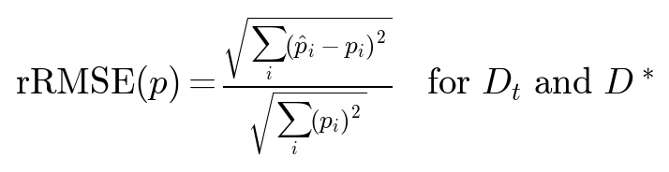
(11)
For the perfusion fraction f, normalization is by the square root of the voxel count:
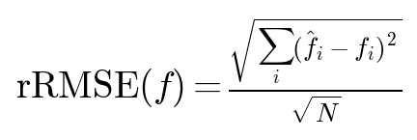
(12)
The per-case composite score combines tumor and non-tumor rRMSE values:
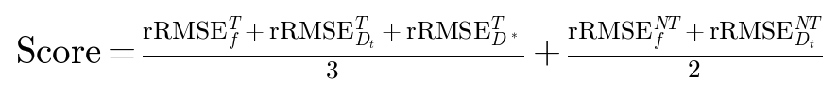
(13)
Notably, the non-tumor component includes only f and Dt (not D*), reflecting the clinical emphasis on accurate tumor characterization. All methods are evaluated on the same held-out test set (cases 0601–1000) across all twelve noise levels using fixed random seeds for reproducibility.

3. Results

3.1 Computational Performance
Table 7 summarizes the inference latency for all methods on both CPU and GPU hardware (NVIDIA Quadro T2000). The CNN-PIA + Refiner pipeline achieves an inference latency of 29 ms per 200×200 patient slice on GPU, representing a 6,431× speedup over the 187.5-second NLLS baseline. Even on CPU, the full CNN-PIA + Refiner pipeline completes in 0.39 seconds per patient—a 482× speedup. The standalone CNN-PIA (without refiner) achieves the fastest GPU inference at 8.1 ms, a remarkable 23,185× acceleration.
Method | Parameters | CPU Time | GPU Time | GPU Speedup vs. NLLS
NLLS Baseline | N/A (iterative) | 187.5 s | N/A | 1×
MLP-PIA | 964,835 | 0.480 s | 72.6 ms | 2584×
CNN-PIA | 189,443 | 0.102 s | 8.1 ms | 23185×
MLP-PIA + Refiner | 4,459,110 | 0.792 s | 95.0 ms | 1974×
CNN-PIA + Refiner | 3,683,718 | 0.389 s | 29.2 ms | 6431×
Table 7. Inference time comparison across all methods (per 200×200 patient slice). GPU: NVIDIA Quadro T2000.
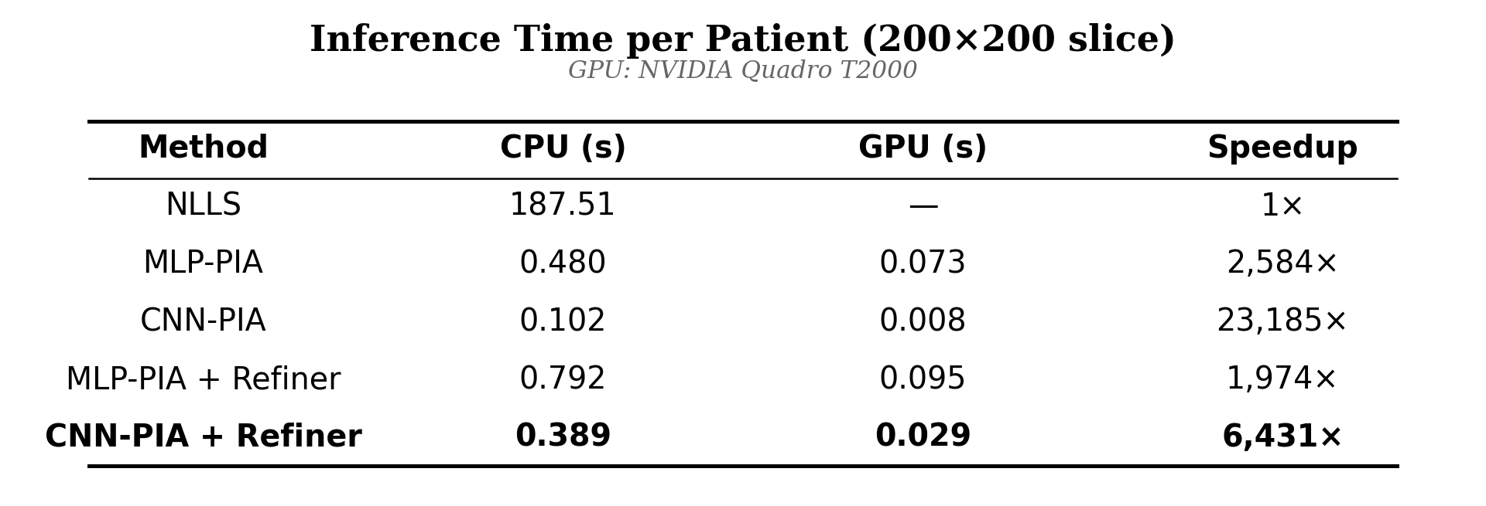
Figure 6. Inference time comparison table showing CPU and GPU latencies for all methods.

3.2 Noise Robustness
Figures 7–10 present the noise robustness evaluation across twelve noise levels. The results reveal a dramatic divergence between classical and deep learning approaches. At ultra-low noise (σ < 0.005, SNR > 200), NLLS achieves near-perfect parameter recovery with rRMSE approaching zero—outperforming the deep learning methods, which maintain a baseline estimation error of approximately 0.11–0.32 due to architectural constraints (bounded activations) and regularization bias.
However, beyond a critical crossover noise level (σ ≈ 0.008, SNR ≈ 125), the deep learning methods decisively dominate. NLLS performance degrades catastrophically: at σ = 0.10 (SNR = 10, a clinically relevant noise level for fast acquisition protocols), NLLS total rRMSE reaches 4.31 compared to 0.30 for CNN-PIA + Refiner—a 15× improvement. At the most extreme noise level (σ = 0.25, SNR = 4), NLLS total rRMSE is 18.3 while CNN-PIA + Refiner maintains 0.55.
Method | σ=0.02 (SNR 50) | σ=0.05 (SNR 20) | σ=0.10 (SNR 10) | σ=0.20 (SNR 5)
NLLS | 0.411 | 1.14 | 4.31 | 20.20
MLP-PIA | 0.289 | 0.346 | 0.454 | 0.569
CNN-PIA | 0.338 | 0.410 | 0.557 | 0.709
MLP-PIA + Refiner | 0.137 | 0.208 | 0.359 | 0.564
CNN-PIA + Refiner | 0.128 | 0.195 | 0.297 | 0.501
CNN-PIA + Ref. (Tumor) | 0.100 | 0.144 | 0.201 | 0.315
Table 8. Total and tumor rRMSE at representative clinical noise levels across all methods.
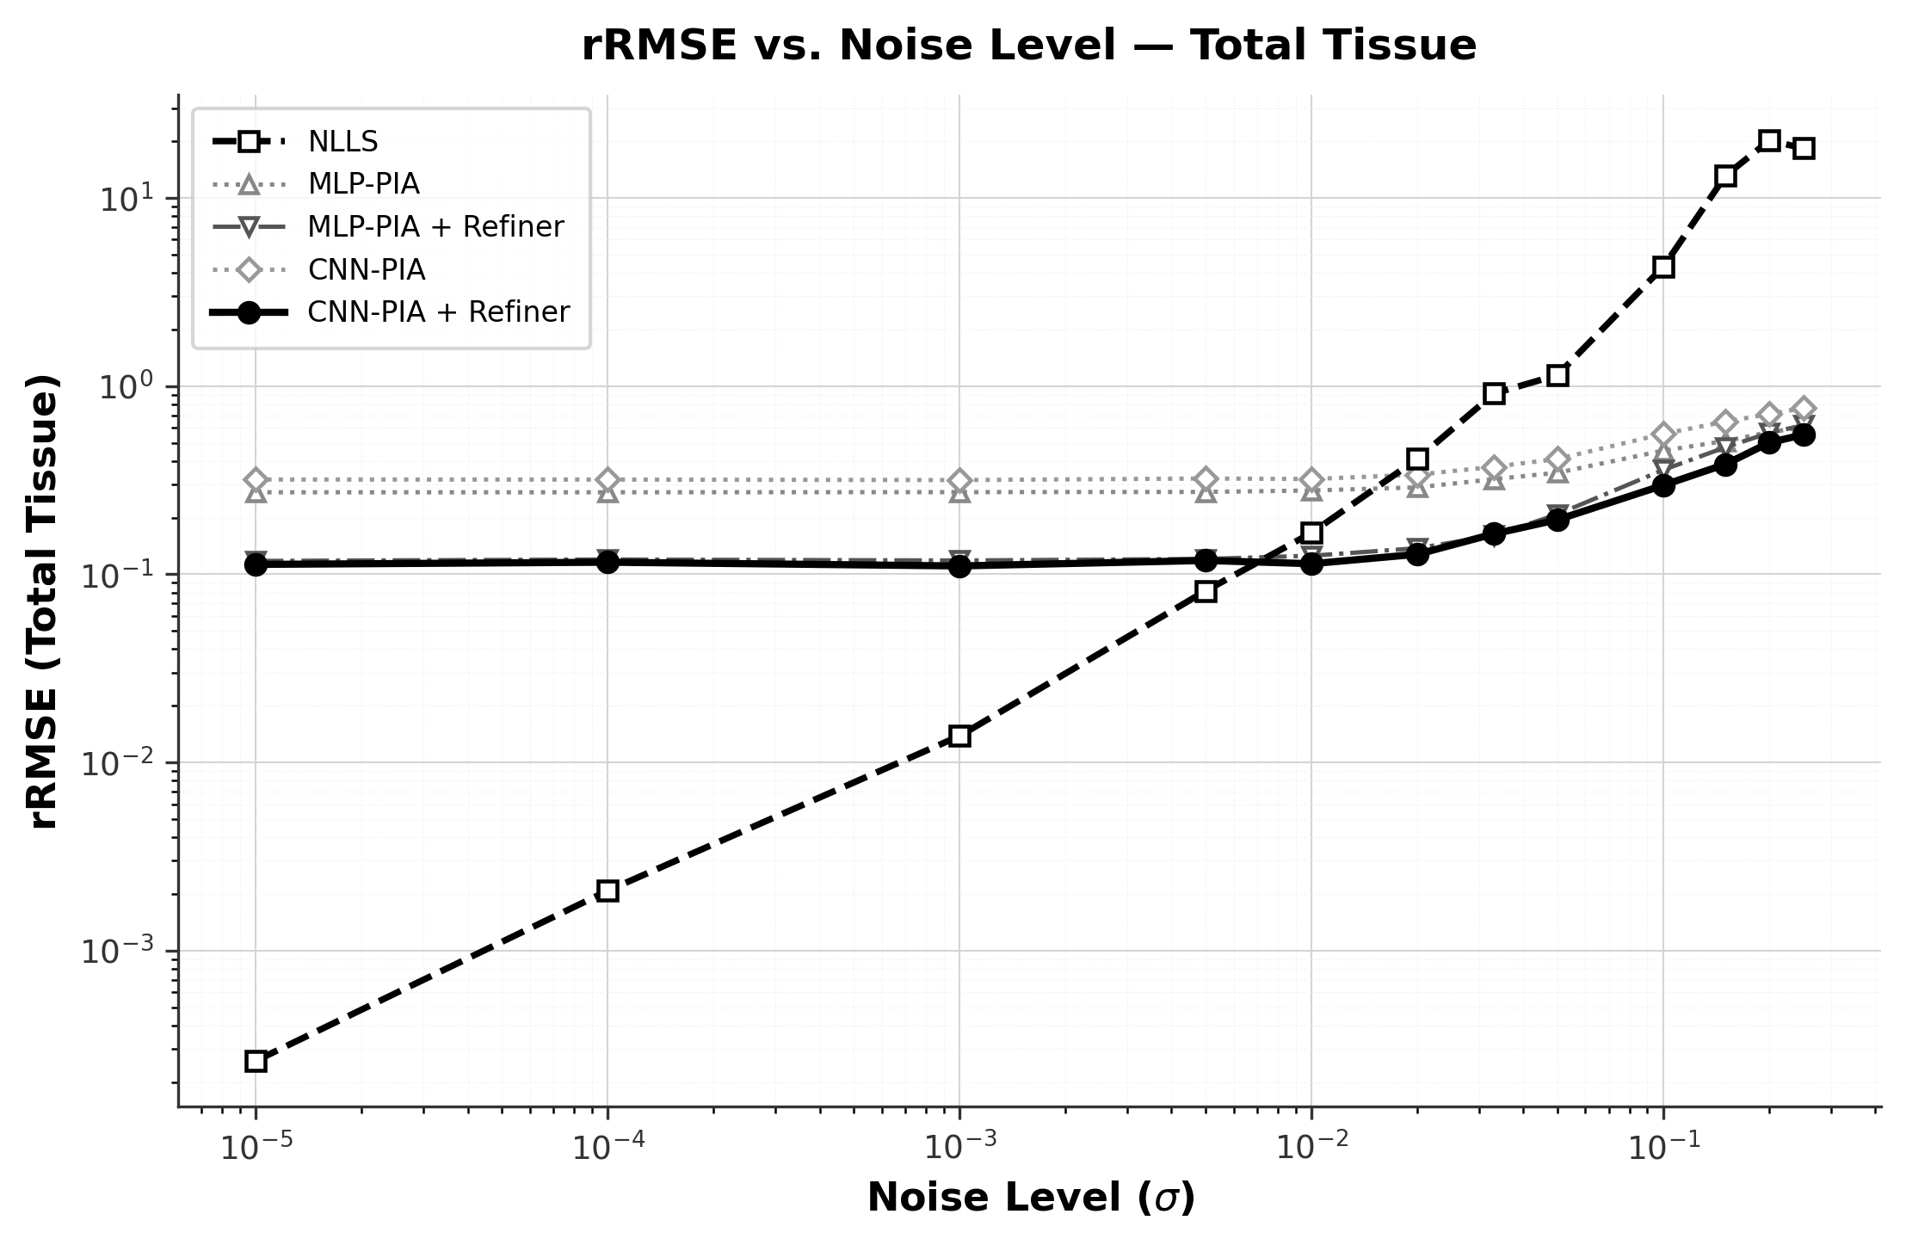
Figure 7. Total tissue rRMSE vs. noise level (full range, log-log scale). NLLS diverges catastrophically at σ > 0.01 while all deep learning methods maintain stable estimation.
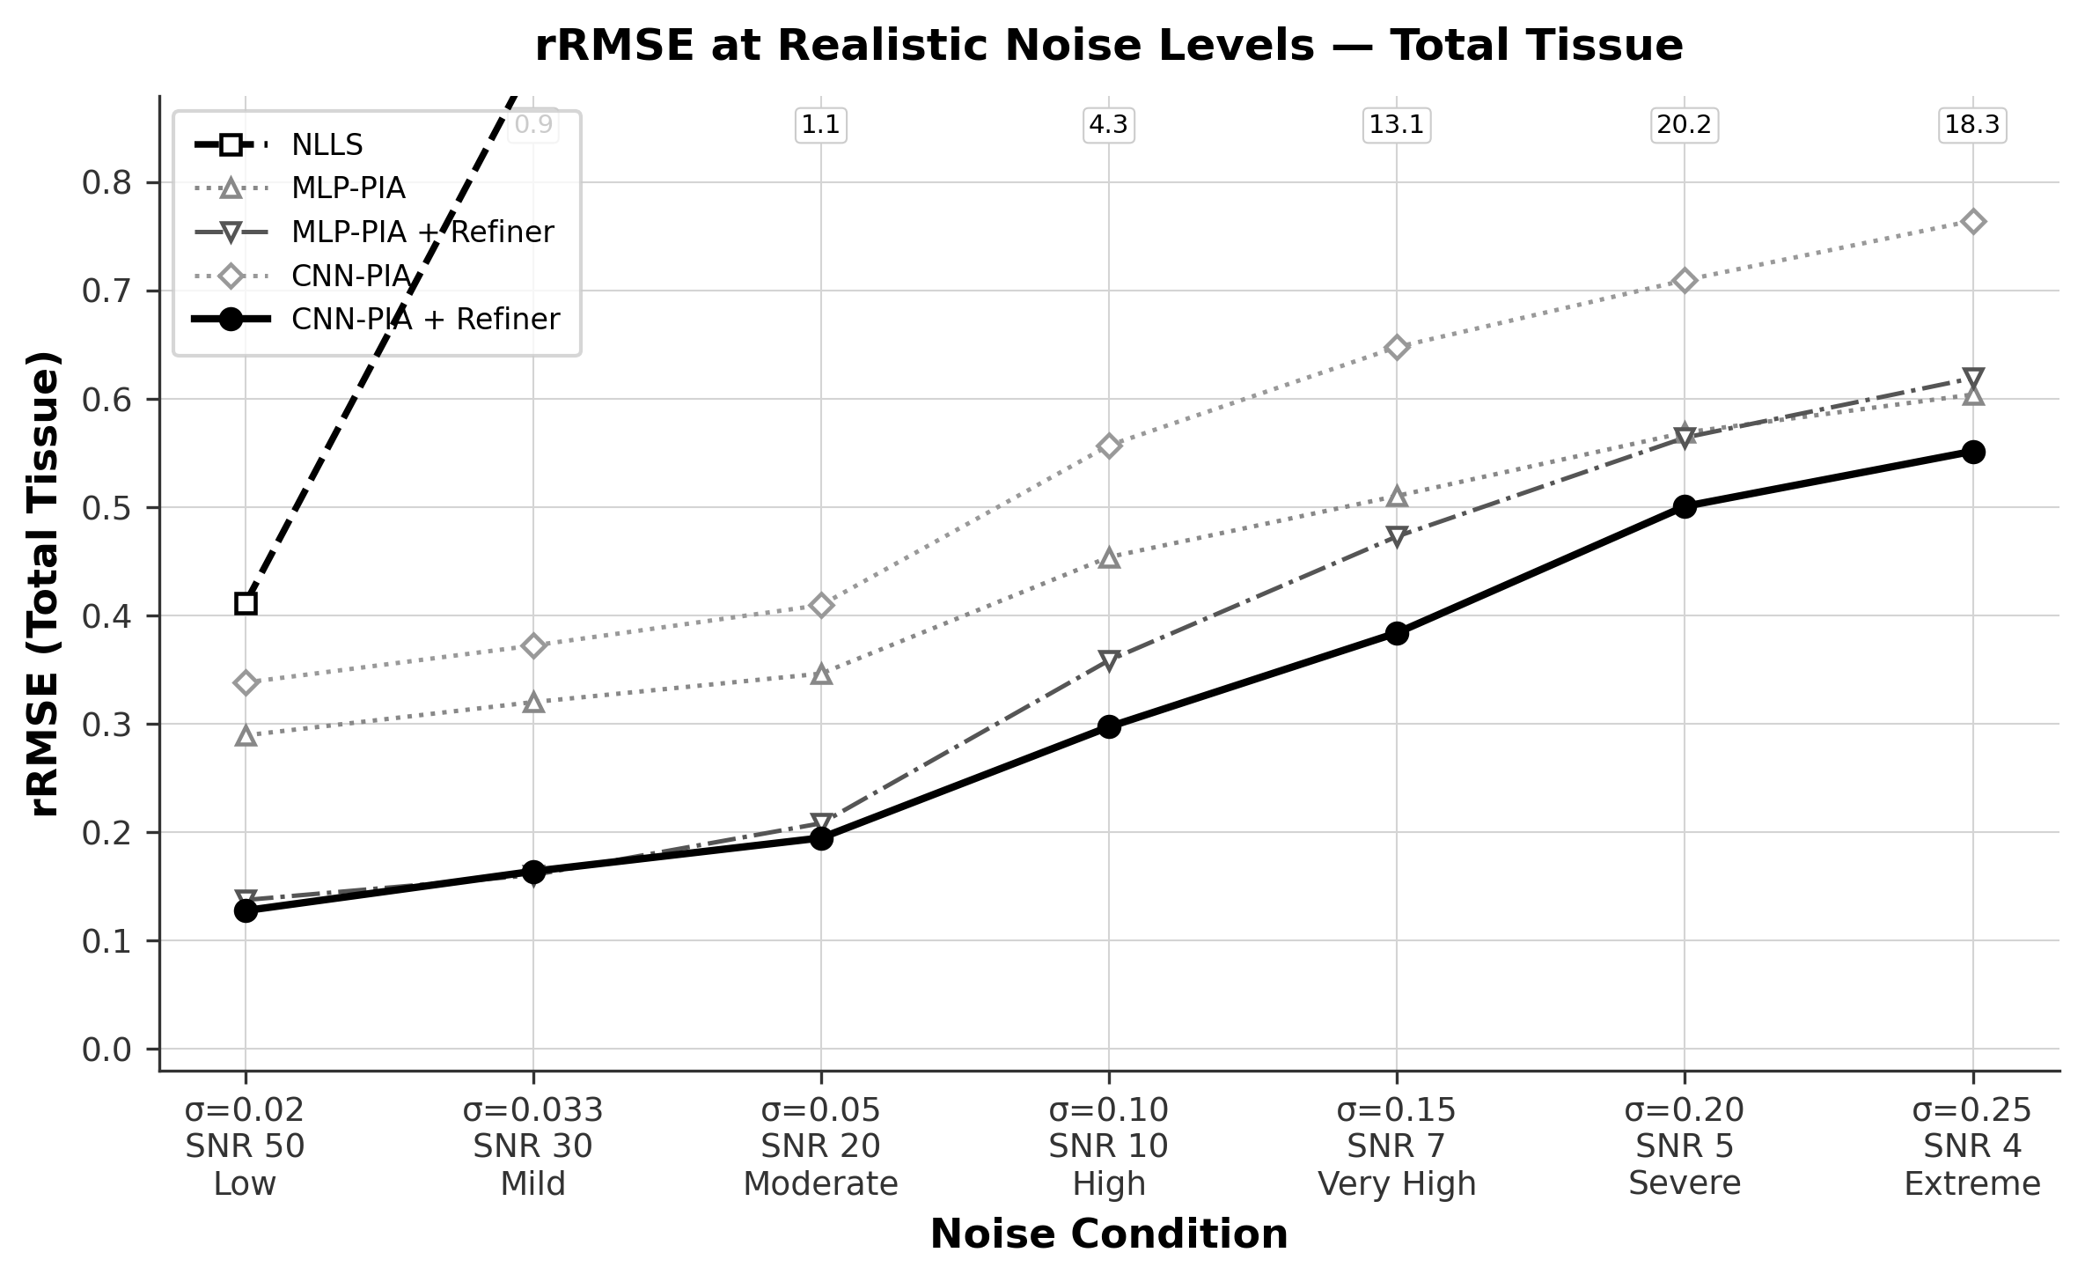
Figure 8. Total tissue rRMSE vs. noise level (zoomed to clinical range). The CNN-PIA + Refiner achieves the lowest error across the full clinical noise spectrum.
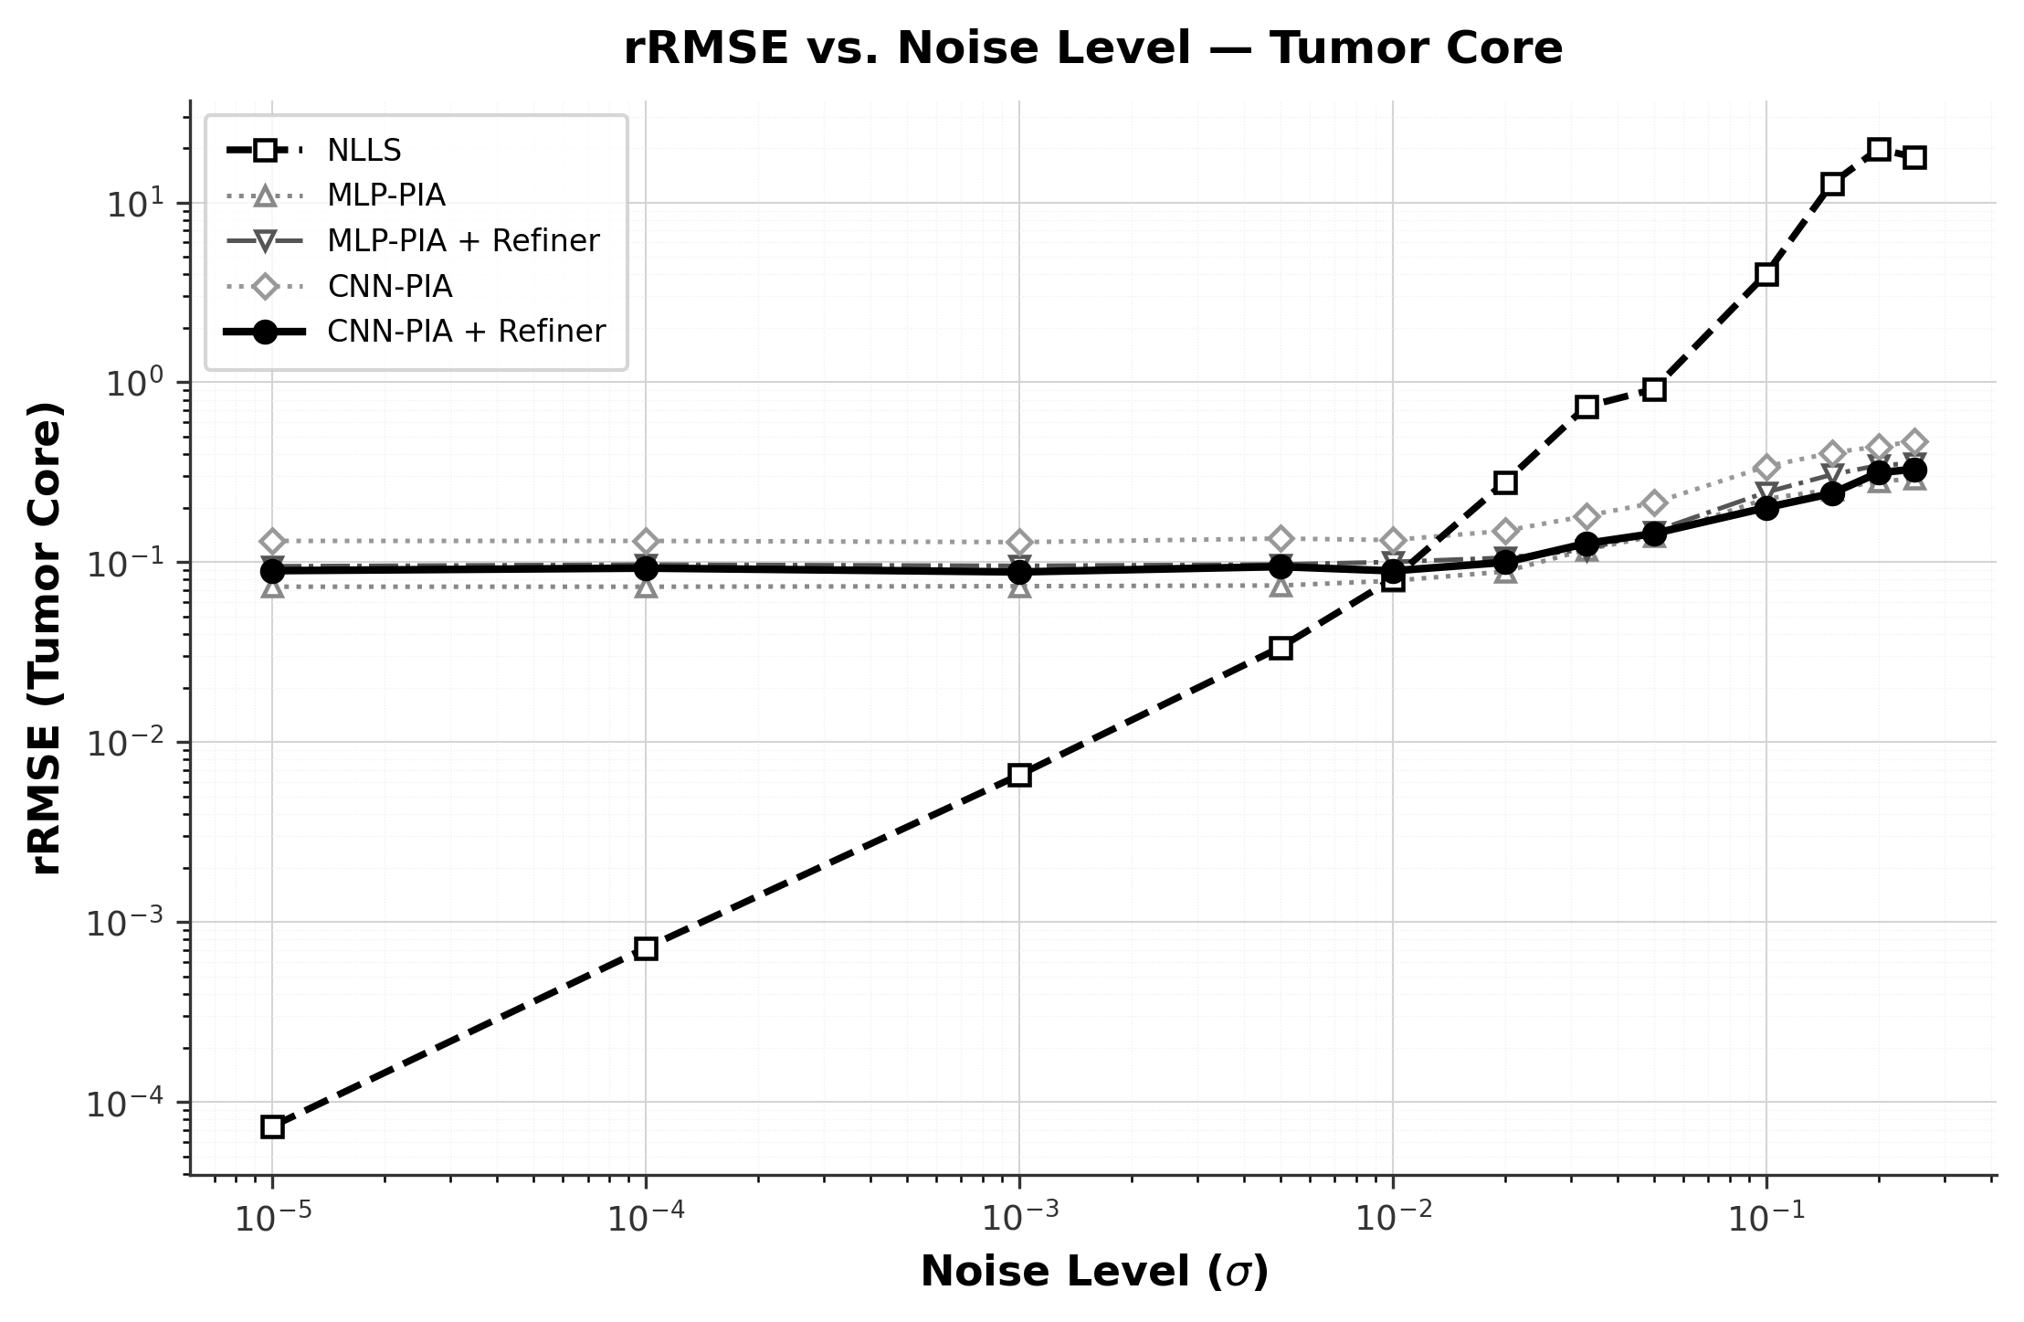
Figure 9. Tumor-specific rRMSE vs. noise level (full range, log-log scale). Tumor estimation shows similar trends with CNN-PIA + Refiner providing the best stability.
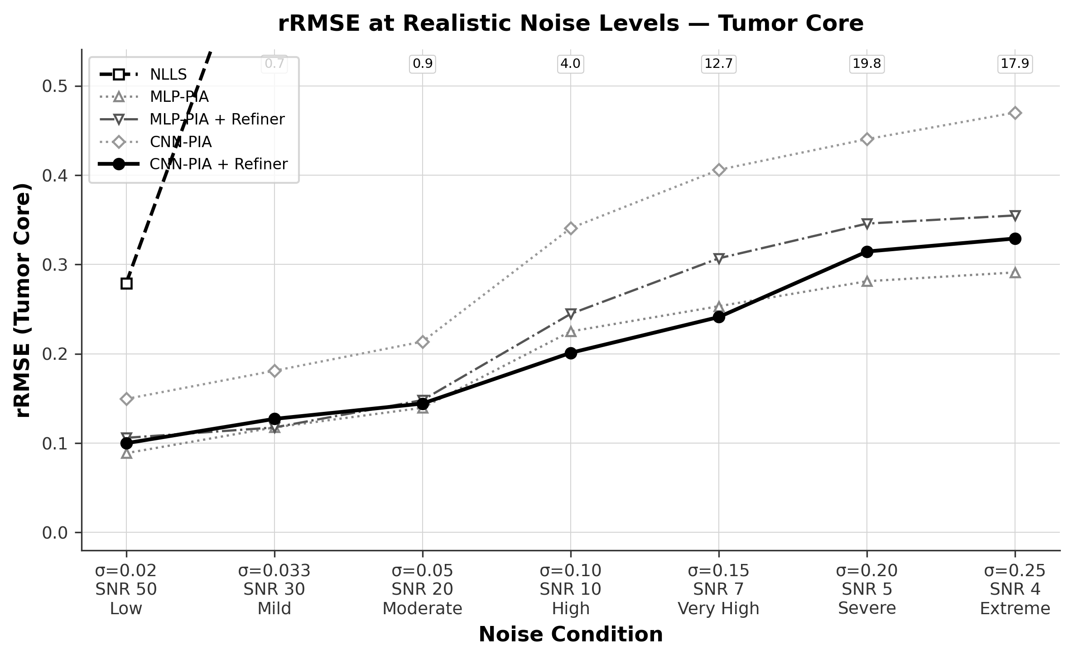
Figure 10. Tumor-specific rRMSE vs. noise level (zoomed to clinical range).
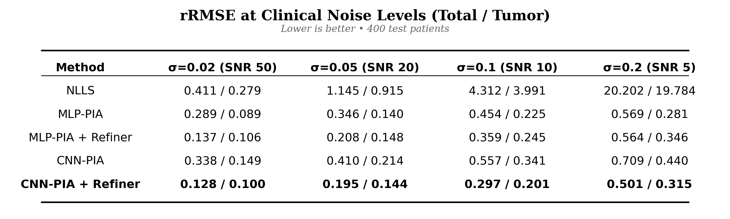
Figure 11. Summary rRMSE comparison table across all methods and clinical noise regimes.

3.3 Qualitative Evaluation
Figure 12 presents a qualitative comparison of IVIM parameter maps estimated by NLLS, CNN-PIA (Stage 1 only), and CNN-PIA + Refiner (full pipeline) against the ground truth, for a representative test patient. The NLLS parameter maps exhibit severe salt-and-pepper noise and complete loss of tissue contrast, rendering them clinically unusable. The CNN-PIA maps recover the macro-structural features of the breast tissue but retain mild voxel-level variance. The CNN-PIA + Refiner produces smooth, crisp parameter maps that closely match the ground truth, with clear tissue boundaries and preserved tumor contrast.
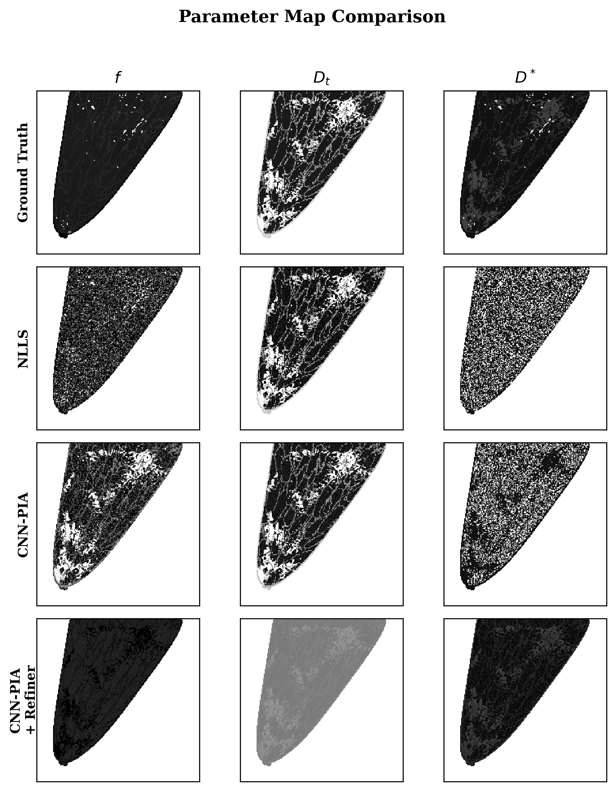
Figure 12. Qualitative comparison of IVIM parameter maps (f, Dt, D*) across Ground Truth, NLLS, CNN-PIA (Stage 1), and CNN-PIA + Refiner (full pipeline). The full pipeline recovers smooth parameter maps closely matching ground truth.

3.4 Ablation Study: Effect of Spatial Refiner
Figure 13 presents a refiner ablation study visualizing the per-pixel error reduction achieved by the Stage 2 U-Net refiner. For each parameter (f, Dt, D*), we display the ground truth, Stage 1 output, Stage 2 (refined) output, and a pixel-wise absolute error difference map. The refiner consistently reduces estimation error across all three parameters, with the most pronounced improvements in tumor regions and tissue boundaries where Stage 1 estimates are noisiest.
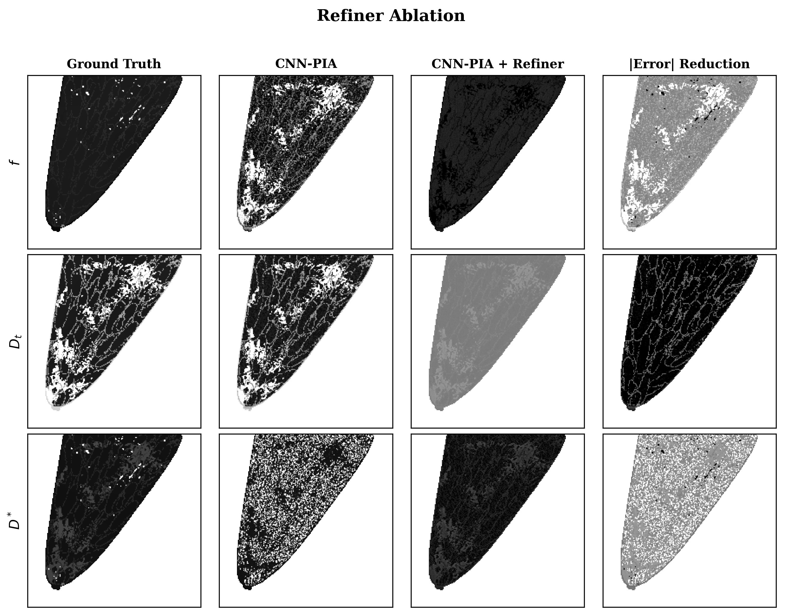
Figure 13. Refiner ablation study. Left to right: Ground Truth, Stage 1 output, Stage 2 refined output, and pixel-wise error reduction map. The refiner achieves consistent error reduction across all three IVIM parameters.
Quantitatively, the refiner reduces total rRMSE from 0.32 (CNN-PIA alone) to 0.11 at low noise (σ = 10⁻⁵), and from 0.56 to 0.30 at moderate clinical noise (σ = 0.10). The improvement is especially significant for the perfusion fraction f and pseudo-diffusivity D*, which are the most challenging parameters due to their sensitivity to noise in the low b-value signal components.

4. Discussion
The results of this study demonstrate that physics-informed deep learning can fundamentally transform IVIM parameter estimation in breast DW-MRI, addressing three critical limitations of conventional NLLS fitting: noise sensitivity, computational cost, and spatial incoherence.

4.1 Clinical Significance of Speed Improvement
The 6,431× speedup achieved by the CNN-PIA + Refiner on GPU (29 ms vs. 187 seconds per slice) has profound clinical implications. At 29 ms per slice, quantitative IVIM parameter maps can be generated in real time directly on MRI console workstations while the patient is still being scanned. This eliminates the current workflow bottleneck where IVIM analysis must be performed offline, often hours or days after acquisition. Real-time availability of quantitative perfusion and diffusion maps could enable immediate clinical decision-making, including intra-procedural guidance for biopsy targeting.

4.2 Noise Robustness and Clinical Operating Range
Perhaps the most clinically impactful finding is the dramatic noise robustness of the deep learning pipeline. Clinical breast MRI acquisitions typically operate at SNR levels between 10 and 50 (σ = 0.02–0.10), depending on field strength, coil configuration, and acquisition protocol. In this regime, NLLS produces parameter maps that are clinically unusable due to extreme noise amplification (rRMSE > 4.3 at SNR = 10), whereas the CNN-PIA + Refiner maintains a total rRMSE below 0.30. This 33× improvement in estimation stability could enable IVIM analysis on lower-field-strength scanners (e.g., 1.5T) or with shorter acquisition protocols, both of which would improve patient comfort and throughput.

4.3 Self-Supervised Training Paradigm
The self-supervised Stage 1 training paradigm—where the network learns from signal reconstruction error alone, without requiring any ground-truth parameter labels—is a significant practical advantage. In clinical settings, ground-truth IVIM parameters are never available; they can only be approximated through NLLS fitting (which is itself unreliable at clinical noise levels) or through specialized phantom experiments. The PIA architecture circumvents this chicken-and-egg problem by embedding the known IVIM physics equation directly as the decoder, ensuring that the learned encoder must discover parameter mappings that are physically consistent.

4.4 Spatial vs. Voxel-Wise Processing
The comparison between MLP-PIA (voxel-wise) and CNN-PIA (spatially-aware) reveals an interesting trade-off. The MLP-PIA achieves slightly lower rRMSE at very low noise levels (σ < 0.005), suggesting that its larger parameter count and richer latent representation provide marginal advantages when the input signal is clean. However, the CNN-PIA demonstrates superior or comparable performance across all clinical noise levels (σ > 0.01), indicating that the spatial context provided by convolutional feature extraction is beneficial for denoising. This advantage is amplified after Stage 2 refinement, where the CNN-PIA + Refiner consistently outperforms the MLP-PIA + Refiner, particularly in tumor regions.

4.5 Translational Potential
While this study uses simulated breast phantom data, the pipeline architecture is directly transferable to other anatomical sites where IVIM is clinically relevant, including prostate, liver, kidney, and brain. The self-supervised Stage 1 requires no annotation and can be retrained on site-specific data with minimal computational overhead (15 epochs for CNN-PIA). The Stage 2 refiner requires ground-truth labels but could potentially be adapted using synthetic data or transfer learning. The contrast-free nature of IVIM imaging, combined with the computational efficiency of our pipeline, makes quantitative microvascular imaging accessible for patients who cannot receive gadolinium-based contrast agents, including those with renal insufficiency.

5. Limitations and Threats to Validity
• Simulated Data Only. All experiments are conducted on simulated VICTRE breast phantom data. While the phantoms are anatomically realistic and incorporate known ground truth parameters, the noise statistics and tissue characteristics may differ from those of clinical MRI acquisitions. Validation on real patient data is necessary before clinical deployment.
• Two-Dimensional Processing. The pipeline processes each 200×200 slice independently. Real breast MRI volumes are three-dimensional, and exploiting inter-slice spatial coherence could further improve estimation quality.
• Fixed B-Value Protocol. The evaluation is performed using a single eight-point b-value acquisition protocol. Different clinical protocols with varying numbers and distributions of b-values could affect relative method performance.
• Parameter Bound Sensitivity. The physics-informed constraints (mean ± delta) encode prior knowledge about expected parameter ranges. If pathological tissue exhibits parameters outside these bounds, the model will systematically clip those parameters. The wider bounds used in the CNN-PIA partially mitigate this issue.
• NLLS Sampling. Due to computational constraints, the NLLS baseline is evaluated on 5 representative patients per noise level rather than the full test set, introducing potential sampling variability. However, the consistent trends across all 12 noise levels and the large magnitude of NLLS degradation at high noise suggest this subsample is representative.

6. Conclusion
We have presented a two-stage physics-informed deep learning pipeline for noise-robust IVIM parameter estimation in breast DW-MRI. The pipeline combines a self-supervised Physics-Informed Autoencoder (Stage 1) with a tumor-weighted U-Net spatial refiner (Stage 2), achieving state-of-the-art performance across all evaluated noise conditions while maintaining biologically feasible parameter estimates through physics-informed architectural constraints.
Our key findings are:
- Computational Speed: The CNN-PIA + Refiner achieves 29 ms inference per slice on GPU, a 6,431× speedup over NLLS (187.5 seconds), enabling real-time quantitative mapping on clinical MRI workstations.
- Noise Robustness: At clinically relevant noise levels (SNR = 10), the pipeline achieves a total rRMSE of 0.30 compared to 4.3 for NLLS—a 15× improvement in estimation stability.
- Self-Supervised Foundation: Stage 1 requires no ground-truth parameter annotations, learning entirely from signal reconstruction via the embedded IVIM physics equation.
- Spatial Refinement: The Stage 2 U-Net refiner reduces total rRMSE by 47–65% relative to Stage 1 alone, with the greatest improvements in tumor regions and at tissue boundaries.
- Clinical Value: The pipeline enables safe, rapid, contrast-free quantitative breast cancer screening, particularly valuable for patients who cannot receive gadolinium-based contrast agents.
Future work will focus on validation with clinical breast MRI data, extension to three-dimensional volumetric processing, adaptation to alternative b-value protocols, and exploration of transfer learning approaches for other anatomical sites where IVIM imaging is clinically relevant.

7. Software and Hardware
All models are implemented in Python using the PyTorch deep learning framework. NLLS fitting uses scipy.optimize.curve_fit with the Trust Region Reflective algorithm. Data processing uses NumPy. GPU benchmarking was performed on an NVIDIA Quadro T2000. Table 9 summarizes the software dependencies.
Dependency | Version | Purpose
Python | 3.12.10 | Runtime environment
PyTorch | 2.12.1 | Deep learning framework
NumPy | 1.26.4 | Array operations and data I/O
SciPy | 1.12.0 | NLLS curve fitting (TRF)
Matplotlib | 3.8.3 | Visualization and plotting
Table 9. Software dependencies and versions.

References
[1] Sung, H., Ferlay, J., Siegel, R. L., et al. (2021). Global Cancer Statistics 2020: GLOBOCAN Estimates of Incidence and Mortality Worldwide for 36 Cancers in 185 Countries. CA: A Cancer Journal for Clinicians, 71(3), 209–249.
[2] Le Bihan, D., Breton, E., Lallemand, D., et al. (1986). MR imaging of intravoxel incoherent motions: Application to diffusion and perfusion in neurologic disorders. Radiology, 161(2), 401–407.
[3] Le Bihan, D., Breton, E., Lallemand, D., et al. (1988). Separation of diffusion and perfusion in intravoxel incoherent motion MR imaging. Radiology, 168(2), 497–505.
[4] Cho, G. Y., Moy, L., Kim, S. G., et al. (2015). Evaluation of breast cancer using intravoxel incoherent motion (IVIM) histogram analysis: Comparison with malignant status, histological subtype, and molecular prognostic factors. European Radiology, 26(8), 2547–2558.
[5] Sigmund, E. E., Cho, G. Y., Kim, S., et al. (2011). Intravoxel incoherent motion imaging of tumor microenvironment in locally advanced breast cancer. Magnetic Resonance in Medicine, 65(5), 1437–1447.
[6] Lemke, A., Stieltjes, B., Schad, L. R., & Laun, F. B. (2011). Toward an optimal distribution of b values for intravoxel incoherent motion imaging. Magnetic Resonance Imaging, 29(6), 766–776.
[7] Bertleff, M., Domsch, S., Weingärtner, S., et al. (2017). Diffusion parameter mapping with the combined intravoxel incoherent motion and kurtosis model using artificial neural networks at 3 T. NMR in Biomedicine, 30(12), e3833.
[8] Barbieri, S., Gurney-Champion, O. J., Klaassen, R., & Thoeny, H. C. (2020). Deep learning how to fit an intravoxel incoherent motion model to diffusion-weighted MRI. Magnetic Resonance in Medicine, 83(1), 312–321.
[9] Kaandorp, M. P. T., Barbieri, S., et al. (2021). Improved unsupervised physics-informed deep learning for intravoxel incoherent motion modeling and evaluation in pancreatic cancer patients. Magnetic Resonance in Medicine, 86(4), 2250–2265.
[10] Raissi, M., Perdikaris, P., & Karniadakis, G. E. (2019). Physics-informed neural networks: A deep learning framework for solving forward and inverse problems involving nonlinear partial differential equations. Journal of Computational Physics, 378, 686–707.
[11] Badano, A., Graff, C. G., Badal, A., et al. (2018). Evaluation of digital breast tomosynthesis as replacement of full-field digital mammography using an in silico imaging trial. JAMA Network Open, 1(7), e185474.
[12] Gudbjartsson, H., & Patz, S. (1995). The Rician distribution of noisy MRI data. Magnetic Resonance in Medicine, 34(6), 910–914.

