Physics-Informed Deep Learning for Noise-Robust IVIM
Parameter Estimation in Breast DW-MRI

2. Methodology
This section describes the research design, data sources, model architectures, training procedures, and evaluation metrics used in this study. The overall approach is a computational, quantitative study that develops and evaluates a two-stage deep learning pipeline for IVIM parameter estimation from simulated breast DW-MRI data.

2.1 Research Design
This study follows a computational experimental design. We develop a physics-informed deep learning pipeline and evaluate it against a conventional NLLS baseline across a controlled range of noise conditions. The independent variable is the noise level (σ), systematically varied across eight levels corresponding to SNR values of approximately 100, 50, 30, 20, 10, 6.7, 5, and 4. The dependent variables are the IVIM parameter estimation errors for each of the three biophysical parameters (f, Dₜ, D*), quantified via the relative Root Mean Square Error (rRMSE) metric. The controlled variables include the dataset (VICTRE breast phantom), the b-value acquisition protocol, the train/validation/test splits, and the random seeds used for reproducibility.
A computational approach was chosen over a clinical study for several reasons. First, simulated data from the VICTRE phantom provides known ground-truth IVIM parameters at every voxel, enabling pixel-level quantitative evaluation that is impossible with in vivo clinical data. Second, the noise level can be precisely controlled and systematically varied, allowing us to characterize the performance of each method across the full clinically relevant SNR range. Third, the simulated dataset provides a sufficiently large cohort (1,000 cases) to support robust deep learning training and evaluation without the ethical and logistical constraints of patient recruitment.

2.2 Data and Materials

2.2.1 VICTRE Breast Phantom Dataset
All experiments were conducted using the Virtual Imaging Clinical Trials for Regulatory Evaluation (VICTRE) breast phantom dataset [11], developed by the U.S. Food and Drug Administration (FDA) for virtual clinical trials in breast imaging. The dataset was obtained from the University of Chicago Department of Radiology as part of the AAPM IVIM Challenge and is publicly available via the University of Chicago Box repository.
The dataset comprises 1,000 simulated breast phantom cases, each providing four data files per case:
File | Shape | Description
XXXX_IVIMParam.npy | 200 × 200 × 3 | Ground truth IVIM parameter maps (f, Dₜ, D*)
XXXX_NoisyDWIk.npy | 200 × 200 × 8 (complex) | Noisy DW-MRI data in k-space
XXXX_gtDWIs.npy | 200 × 200 × 8 | Clean (noiseless) ground truth DWI signals
XXXX_TissueType.npy | 200 × 200 | Tissue label map (integer labels)

Each case represents a 200 × 200 pixel two-dimensional axial slice of a simulated breast containing anatomically realistic tissue structures. The tissue label map encodes distinct tissue types including air/background (label = 1), fat, glandular tissue, and tumor (label = 8). The noisy DW-MRI data is provided in the Fourier domain (k-space) as complex-valued arrays, reflecting the acquisition process in real MRI scanners.

2.2.2 DW-MRI Acquisition Protocol
The simulated DW-MRI acquisitions use eight b-values:
b ∈ {0, 5, 50, 100, 200, 500, 800, 1000} s/mm² (2)
This eight-point b-value protocol spans from b = 0 (baseline, no diffusion weighting) to b = 1000 s/mm² (strong diffusion weighting). The protocol includes two very low b-values (0 and 5 s/mm²) that are primarily sensitive to the pseudo-diffusion component, intermediate values (50–200 s/mm²) that capture the transition between perfusion and diffusion regimes, and high values (500–1000 s/mm²) that are predominantly sensitive to true tissue diffusion.

2.2.3 Image Reconstruction and Preprocessing
Magnitude images are reconstructed from the complex k-space data using the inverse two-dimensional Fast Fourier Transform (IFFT) with orthonormal normalization:
S_mag(x, y, b) = |IFFT₂(k(x, y, b))| (3)
The resulting magnitude images are then normalized on a per-voxel basis by the baseline signal at b = 0 to obtain the normalized signal attenuation:
S_norm(x, y, b) = S_mag(x, y, b) / S_mag(x, y, b=0) (4)
This normalization removes the baseline signal intensity variation across the image and produces values in the range [0, 1] for the clean signal, consistent with the IVIM model in Equation (1). A small epsilon value (ε = 10⁻⁸) is used to prevent division by zero in background regions.

2.2.4 Data Splits
The 1,000-case dataset is partitioned as follows:
Split | Cases | Count | Purpose
Training | 0001–0500 | 500 | Self-supervised PIA training (Stage 1) and supervised U-Net Refiner training (Stage 2)
Validation | 0501–0600 | 100 | Hyperparameter selection and early stopping
Test (held out) | 0601–1000 | 400 | Final evaluation and noise robustness assessment

The large test set of 400 held-out cases (40% of the full dataset) ensures statistically robust evaluation of model performance and provides sufficient power to detect meaningful differences between methods across all noise levels. No test data was used during training or hyperparameter selection.

2.3 Variables and Operationalization
The key variables in this study are defined and operationalized as follows:

2.3.1 Independent Variable: Noise Level
The independent variable is the noise standard deviation σ, which controls the signal-to-noise ratio (SNR) of the input DW-MRI data. For the noise robustness evaluation, synthetic Rician noise is injected into the clean ground truth DWI signals at eight controlled levels:
Noise Level (σ) | Approximate SNR | Clinical Relevance
0.010 | 100 | Research-grade scanner, long acquisition
0.020 | 50 | High-quality clinical acquisition
0.033 | 30 | Standard clinical quality
0.050 | 20 | Acceptable clinical quality
0.100 | 10 | Low-quality or fast acquisition
0.150 | 6.7 | Very low quality
0.200 | 5 | Severely degraded
0.250 | 4 | Near noise floor

The SNR is approximated as SNR ≈ 1/σ since the signal is normalized to approximately 1.0 at b = 0. Rician noise is used because it accurately models the noise statistics of magnitude-reconstructed MRI images. Unlike additive Gaussian noise, Rician noise introduces a positive bias at low signal intensities, which is physically realistic for MRI [12].

2.3.2 Rician Noise Model
Rician noise is generated by independently corrupting the real and imaginary channels of the signal with zero-mean Gaussian noise, then taking the magnitude:
S_noisy = √[(S_clean + ε_re)² + (ε_im)²] (5)
where ε_re, ε_im ~ Ν(0, σ²·S₀²) are independent Gaussian noise samples scaled by the mean baseline signal intensity S₀ of tissue voxels. This formulation faithfully replicates the noise characteristics of real MRI magnitude images, where the signal is the magnitude of a complex-valued measurement corrupted by thermal noise in both quadrature channels.

2.3.3 Dependent Variables: IVIM Parameters
The three dependent variables are the estimated IVIM parameters at each voxel:
Parameter | Symbol | Physical Range | Unit | Description
Perfusion fraction | f | 0.01 – 0.40 | Dimensionless | Fraction of signal from pseudo-diffusion (blood flow)
True diffusion coefficient | Dₜ | 0.5 – 1.5 × 10⁻³ | mm²/s | Thermal Brownian motion of water in tissue
Pseudo-diffusion coefficient | D* | 5 – 60 × 10⁻³ | mm²/s | Bulk blood flow in the capillary network

2.4 Procedures and Pipeline
The proposed pipeline operates in two sequential stages. Stage 1 performs per-voxel (MLP) or spatially-aware (CNN) physics-informed parameter estimation. Stage 2 refines the initial estimates using a U-Net that exploits spatial coherence through tumor-weighted supervised denoising with residual learning. The pipeline is described in detail below.

2.4.1 Stage 1: Physics-Informed Autoencoder (PIA)
The first stage maps the normalized 8-dimensional DW-MRI signal at each spatial location to the three IVIM parameters using a self-supervised autoencoder architecture. Two Stage 1 variants are implemented and compared:
MLP-PIA (Voxel-Wise). The original PIA architecture processes each voxel independently. The encoder is a fully connected multi-layer perceptron (MLP) with five hidden layers of dimensions [32, 64, 128, 256, 512], each followed by a LeakyReLU activation. The 512-dimensional latent representation is fed into three independent predictor heads—one for each IVIM parameter—each consisting of a single fully connected layer (predictor depth = 1) followed by a final linear projection to a scalar output. The total parameter count is 964,835.
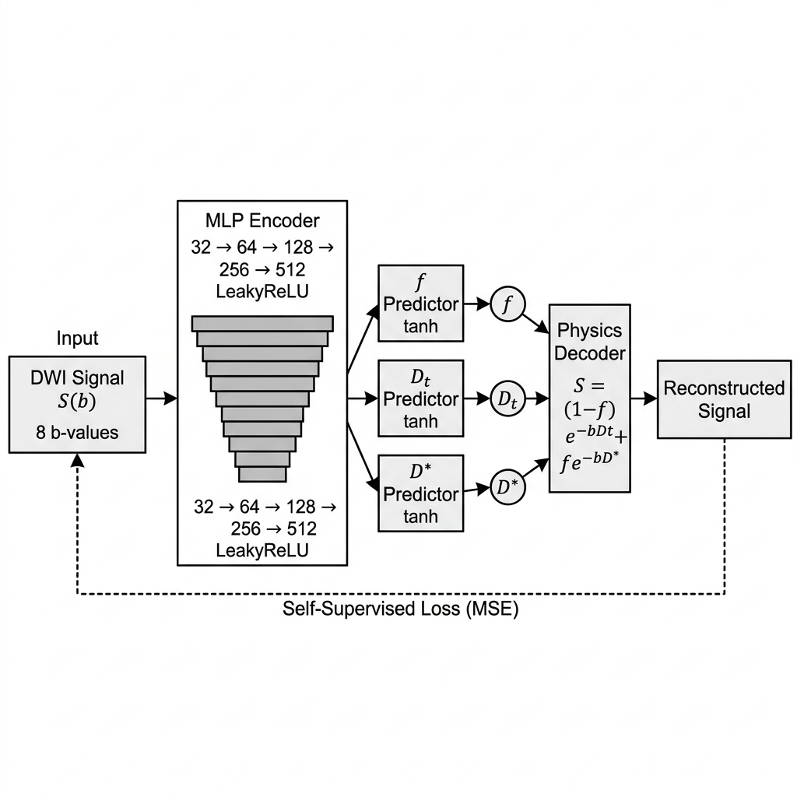
CNN-PIA (Spatially-Aware). To exploit spatial context within each 200 × 200 patient image, we extend the PIA architecture with a convolutional encoder. The CNN-PIA takes the full 8-channel signal image as input (shape: 8 × 200 × 200) and extracts features through a four-layer convolutional backbone: Conv2d(8→64, 3×3) → LeakyReLU(0.1) → Conv2d(64→64, 3×3) → LeakyReLU(0.1) → Conv2d(64→128, 3×3) → LeakyReLU(0.1) → Conv2d(128→64, 3×3) → LeakyReLU(0.1). Three 1×1 convolution predictor heads produce the parameter maps directly at the native image resolution. All convolutional layers use padding = 1 to preserve spatial dimensions. The total parameter count is 189,443.

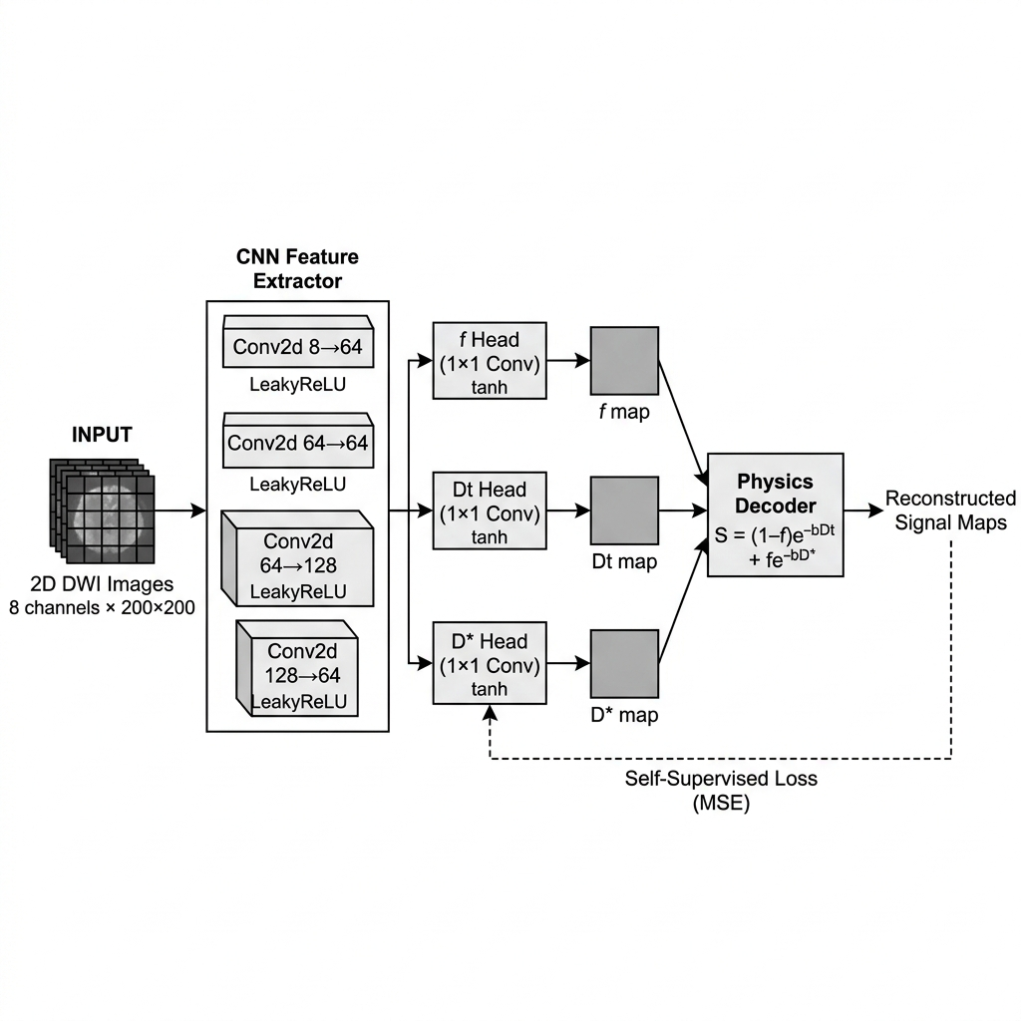

Physics-Informed Parameter Constraints
A key feature of the PIA architecture is the physics-informed constraint on the output parameters. Rather than allowing unconstrained predictions, each parameter is bounded to a biologically feasible range through a mean±delta·tanh(·) formulation:
̂p = p_mean + p_delta · tanh(predictor(z)) (6)
where z is the encoder output and the tanh function constrains the predictor output to [−1, +1], ensuring each parameter lies within [mean − delta, mean + delta]. The constraint parameters are:
Parameter |  | MLP-PIA Mean | MLP-PIA Delta | MLP-PIA Bounds | CNN-PIA Mean | CNN-PIA Delta | CNN-PIA Bounds
f |  | 0.200 | 0.150 | [0.050, 0.350] | 0.200 | 0.200 | [0.000, 0.400]
Dₜ | (mm²/s) | 0.00110 | 0.00040 | [0.0007, 0.0015] | 0.00085 | 0.00080 | [0.00005, 0.00165]
D* | (mm²/s) | 0.02500 | 0.01500 | [0.010, 0.040] | 0.03250 | 0.03000 | [0.0025, 0.0625]

The CNN-PIA uses wider bounds to accommodate the broader parameter ranges observed across different tissue types in the breast, including fat, glandular tissue, and tumor.

Physics-Based Decoder
The decoder is not a learned neural network; it is the deterministic biexponential IVIM model from Equation (1), applied analytically:
̂S(b) = (1 − ̂f) · exp(−b · ̂Dₜ) + ̂f · exp(−b · ̂D*) (7)
This physics decoder has zero learnable parameters. By using the known forward model as the decoder, the autoencoder is forced to find parameter estimates that are consistent with the underlying physics. The loss function is the self-supervised reconstruction error:
L_PIA = (1/N) Σ ||̂S(b) − S_obs(b)||² (8)
where the sum is over all b-values and S_obs is the observed (noisy) normalized signal. For the CNN-PIA, the loss is computed only over tissue voxels (excluding air, where tissue label > 1), weighted by an anatomical importance mask.

2.4.2 Stage 1 Training
The MLP-PIA is trained on Monte Carlo-simulated voxel-wise data. At each training step, a batch of 25,000 clean synthetic signals is generated by sampling IVIM parameters uniformly from their physical ranges (f ∈ [0.01, 0.40], Dₜ ∈ [0.0005, 0.0015] mm²/s, D* ∈ [0.005, 0.06] mm²/s), computing the corresponding clean IVIM signals at the eight b-values, and corrupting them with Rician noise at σ = 0.05. This Monte Carlo training strategy provides unlimited unique training samples, preventing overfitting and ensuring the encoder is trained on the full range of biologically feasible parameter combinations and noise realizations.
The CNN-PIA is trained self-supervised on the 500 training patients directly (cases 0001–0500), using the noisy k-space-reconstructed DW-MRI images as both input and target signal. The training hyperparameters are:
Hyperparameter | MLP-PIA | CNN-PIA
Optimizer | Adam | Adam
Learning rate | 3 × 10⁻⁴ | 1 × 10⁻³
Batch size | 25,000 voxels per batch | 8 patients
Epochs | 200 | 15
Training noise (σ) | 0.05 | Native noise
Training data | Monte Carlo simulated | 500 VICTRE patients
Loss function | Self-supervised (Eq. 8) | Masked self-supervised (Eq. 8)
Trainable parameters | 964,835 | 189,443

2.4.3 Stage 2: U-Net Spatial Refiner
The Stage 1 PIA produces per-voxel or per-pixel parameter estimates that, while physically constrained, may still contain significant spatial noise, particularly in low-SNR regions. Stage 2 addresses this limitation by applying a U-Net spatial refiner that learns to denoise the parameter maps using supervised training with tumor-weighted importance sampling.

U-Net Architecture
The refiner is a three-level U-Net with the following architecture:
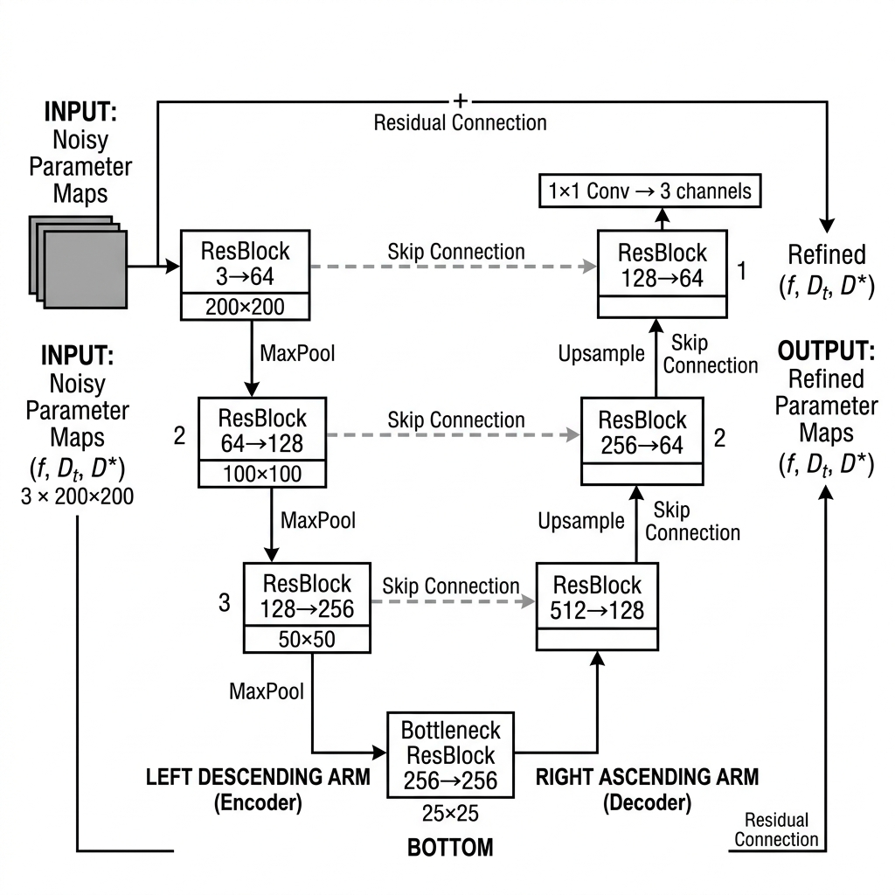
- Encoder: Three encoding levels with Residual Blocks at channel dimensions [64, 128, 256], connected by 2×2 max pooling layers. Each Residual Block consists of two 3×3 convolutional layers with Group Normalization (8 groups) and SiLU (Swish) activations, plus a skip connection.
- Bottleneck: A Residual Block at 256 channels operating at 25×25 spatial resolution (after three 2× pooling operations from the 200×200 input).
- Decoder: Three decoding levels using bilinear upsampling (not transposed convolutions, to avoid checkerboard artifacts) followed by Residual Blocks. Skip connections from the corresponding encoder levels are concatenated before each decoder block.
- Output: A 1×1 convolution projects the final 64-channel feature map to 3 output channels (f, Dₜ, D*).
- Residual Learning: The U-Net is configured in residual mode: the output is computed as Refined = Input + U-Net(Input). The final 1×1 convolution is initialized with zero weights and biases, ensuring that the network starts as an identity mapping and progressively learns the spatial correction.
The total parameter count of the U-Net refiner is 3,494,275 trainable parameters.

Tumor-Weighted Supervised Loss
The refiner is trained with a supervised loss that emphasizes accurate estimation in tumor regions through importance weighting:
L_refiner = (1/N) Σᵢ wᵢ · ||θ̂_refined(i) − θ_GT(i)||² (9)
where θ̂_refined = {f̂, D̂ₜ, D̂*} are the refined parameter maps, θ_GT are the ground truth parameter maps, and wᵢ is a per-voxel importance weight defined as:
wᵢ = γ_tumor = 5.0 if tissue(i) = 8 (tumor), wᵢ = 1.0 otherwise (10)
The tumor importance weight γ_tumor = 5.0 ensures that the refiner prioritizes accuracy in clinically critical tumor regions, which occupy a small fraction of the total image area. To enable stable training, the IVIM parameters are scaled before being input to the refiner: f is unscaled (×1.0), Dₜ is scaled by 500, and D* is scaled by 10, bringing all three parameter channels to comparable numeric ranges.

Stage 2 Training
Hyperparameter | Value
Optimizer | Adam
Learning rate | 5 × 10⁻⁵
Batch size | 4 patients
Epochs | 5
Tumor importance weight (γ_tumor) | 5.0
Training data | 500 patients (Stage 1 estimates → GT maps)
Input | Stage 1 PIA/CNN-PIA parameter maps (3 × 200 × 200)
Target | Ground truth IVIM parameter maps (3 × 200 × 200)
Trainable parameters | 3,494,275

2.5 Baseline Method: Non-Linear Least Squares (NLLS)
The conventional NLLS fitting approach serves as our primary baseline. For each voxel with positive signal intensity, we fit the biexponential IVIM model (Equation 1) to the normalized signal values at b > 0 using the Trust Region Reflective (TRF) algorithm via scipy.optimize.curve_fit with a maximum of 2,000 function evaluations. The fitting uses shifted b-values (b[1:] − b[0]) and signal ratios (S[1:] / S[0]) with the following configuration:
Parameter | Initial Guess | Lower Bound | Upper Bound
f | 0.15 | 0 | 1
Dₜ | 1.5 × 10⁻³ mm²/s | 0 | 2.9 × 10⁻³ mm²/s
D* | 8 × 10⁻³ mm²/s | 3.0 × 10⁻³ mm²/s | ∞ (unbounded)

The unbounded upper constraint on D* is consistent with the original implementation but represents a known vulnerability: at low SNR, the optimizer can diverge to physically implausible values (e.g., D* > 1.0 mm²/s), which catastrophically inflates the error metrics. Voxels that fail to converge are assigned parameter values of zero. The NLLS fit is executed independently for each voxel with no spatial regularization, and is parallelized across cases using Python’s ProcessPoolExecutor. In our evaluation, NLLS was run on 20 representative patients per noise level (evenly sampled from the 400-patient test set) due to its prohibitive computational cost (~30 seconds per patient vs. ~1 second for the neural methods).

2.6 Evaluation Criteria

2.6.1 Primary Metric: Relative Root Mean Square Error (rRMSE)
The primary evaluation metric is the relative Root Mean Square Error (rRMSE). For each IVIM parameter p ∈ {f, Dₜ, D*}, the rRMSE is computed separately for tumor and non-tumor tissue regions:
rRMSE(p) = √[Σᵢ(p̂ᵢ − pᵢ)²] / √[Σᵢ(pᵢ)²] for Dₜ and D* (11a)
rRMSE(f) = √[Σᵢ(f̂ᵢ − fᵢ)²] / √N for f (11b)
where p̂ᵢ is the estimated value, pᵢ is the ground truth value, N is the number of voxels in the region, and the sum is over all voxels in the respective tissue region (tumor: tissue label = 8; non-tumor: tissue label ≠ 1 and ≠ 8). The normalization by ground truth magnitude for Dₜ and D* accounts for their different physical scales, while the perfusion fraction f is normalized by the square root of the voxel count since its values are dimensionless and closer to zero.

2.6.2 Composite Score
The per-case composite score combines tumor and non-tumor rRMSE values:
Score = (rRMSE_f^T + rRMSE_Dₜ^T + rRMSE_D*^T) / 3 + (rRMSE_f^NT + rRMSE_Dₜ^NT) / 2 (12)
where the superscripts T and NT denote tumor and non-tumor regions, respectively. Notably, the non-tumor component includes only f and Dₜ (not D*), reflecting the clinical emphasis on accurate tumor characterization and the practical difficulty of estimating D* in non-tumor tissue where the perfusion fraction is low.

2.6.3 Evaluation Protocol
All methods are evaluated on the same held-out test set of 400 patients (cases 0601–1000), which were never seen during training or validation. For the noise robustness assessment, the evaluation is repeated at each of the eight noise levels described in Section 2.3.1. At each noise level, Rician noise at the specified σ is added to the clean ground truth DWI signals using a fixed random seed (42 + noise_level_index) for reproducibility, and each method estimates the IVIM parameters from the noisy input. The rRMSE metrics are averaged across all 400 test patients to produce the final per-noise-level performance figures. Neural network methods (MLP-PIA, MLP+Refiner, CNN-PIA, CNN+Refiner) are evaluated on all 400 patients; the NLLS baseline is evaluated on a representative subset of 20 evenly-sampled patients per noise level.

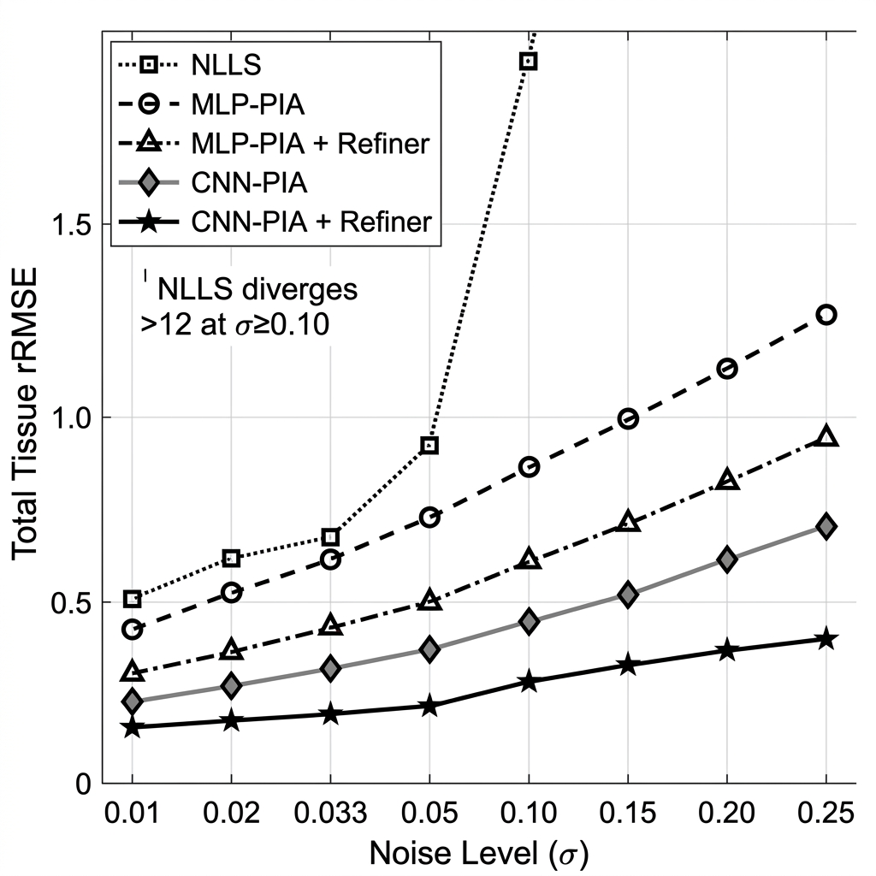

2.7 Limitations and Threats to Validity
- Simulated Data Only. All experiments are conducted on simulated VICTRE breast phantom data. While the phantoms are anatomically realistic and incorporate known ground truth parameters, the noise statistics and tissue characteristics may differ from those of clinical MRI acquisitions. Validation on real patient data is necessary before clinical deployment.
- Two-Dimensional Processing. The pipeline processes each 200×200 slice independently. Real breast MRI volumes are three-dimensional, and exploiting inter-slice spatial coherence could further improve estimation quality.
- Fixed B-Value Protocol. The evaluation is performed using a single eight-point b-value acquisition protocol. Different clinical protocols with varying numbers and distributions of b-values could affect relative method performance.
- Parameter Bound Sensitivity. The physics-informed constraints (mean ± delta) encode prior knowledge about expected parameter ranges. If pathological tissue exhibits parameters outside these bounds, the model will systematically clip those parameters. The wider bounds used in the CNN-PIA partially mitigate this issue.
- NLLS Sampling. Due to computational constraints, the NLLS baseline is evaluated on 20 patients per noise level rather than the full 400, introducing potential sampling variability in NLLS results. However, the consistent trend across all 8 noise levels suggests this subsample is representative.

2.8 Software and Hardware
All models are implemented in Python using the PyTorch deep learning framework. NLLS fitting uses scipy.optimize.curve_fit. Data processing uses NumPy. All experiments were conducted on a local workstation with CPU-only execution (PyTorch 2.12.1+cpu).
Dependency | Version | Purpose
Python | 3.12.10 | Runtime environment
PyTorch | 2.12.1+cpu | Deep learning framework
NumPy | 1.26.4 | Array operations and data I/O
SciPy | 1.12.0 | NLLS curve fitting (Trust Region Reflective)
Matplotlib | 3.8.3 | Visualization and plotting

2.9 Verification Plan
Model performance is verified through the 400-patient noise evaluation protocol described in Section 2.6.3. Results are cross-validated by comparing per-noise-level rRMSE trends across all five methods. The NLLS baseline serves as a well-understood reference point, and its known failure mode at low SNR (unbounded D* divergence) provides an independent sanity check on the noise injection procedure. All random seeds are fixed for full reproducibility.

References
[1] Sung, H., et al. (2021). Global Cancer Statistics 2020. CA: A Cancer Journal for Clinicians, 71(3), 209–249.
[2] Le Bihan, D., et al. (1986). MR imaging of intravoxel incoherent motions. Radiology, 161(2), 401–407.
[3] Le Bihan, D., et al. (1988). Separation of diffusion and perfusion in intravoxel incoherent motion MR imaging. Radiology, 168(2), 497–505.
[4] Cho, G. Y., et al. (2015). Evaluation of breast cancer using intravoxel incoherent motion (IVIM) histogram analysis. European Radiology, 26(8), 2547–2558.
[5] Sigmund, E. E., et al. (2011). Intravoxel incoherent motion imaging of tumor microenvironment in locally advanced breast cancer. Magnetic Resonance in Medicine, 65(5), 1437–1447.
[6] Lemke, A., et al. (2011). Toward an optimal distribution of b values for intravoxel incoherent motion imaging. Magnetic Resonance Imaging, 29(6), 766–776.
[7] Bertleff, M., et al. (2017). Diffusion parameter mapping with the combined intravoxel incoherent motion and kurtosis model using artificial neural networks at 3 T. NMR in Biomedicine, 30(12), e3833.
[8] Barbieri, S., et al. (2020). Deep learning how to fit an intravoxel incoherent motion model to diffusion-weighted MRI. Magnetic Resonance in Medicine, 83(1), 312–321.
[9] Kaandorp, M. P. T., et al. (2021). Improved unsupervised physics-informed deep learning for intravoxel incoherent motion modeling. Magnetic Resonance in Medicine, 86(4), 2250–2265.
[10] Raissi, M., Perdikaris, P., & Karniadakis, G. E. (2019). Physics-informed neural networks. Journal of Computational Physics, 378, 686–707.
[11] Badano, A., et al. (2018). Evaluation of digital breast tomosynthesis as replacement of full-field digital mammography using an in silico imaging trial. JAMA Network Open, 1(7), e185474.
[12] Gudbjartsson, H., & Patz, S. (1995). The Rician distribution of noisy MRI data. Magnetic Resonance in Medicine, 34(6), 910–914.

