

DIAMOND PRICE PREDICITON

BY -

SABYASACHI GHOSH

TABLE OF CONTENT

- Introduction---------------------------------------------------------------3
- Overall Description------------------------------------------------------3
- Analysis of Data-set-----------------------------------------------------3
- Observation---------------------------------------------------------------11
- Conclusion-----------------------------------------------------------------12
- Summary-------------------------------------------------------------------12

INTRODUCTION
Diamond Price Analysis using Python aims to explore the factors influencing diamond prices and build a
predictive model to estimate diamond prices based on various features. This project is essential for
stakeholders in the jewellery industry to understand the market dynamics and make informed decisions
regarding pricing strategies and inventory management.

DIAMOND PRICE ANALYSIS USING PYTHON
The dataset used in this project is sourced from Kaggle. It contains information on various features such as carat weight, cut, colour, clarity, and price for thousands of diamonds. Data preprocessing involved handling missing values, encoding categorical variables, and scaling numerical features to prepare the data for analysis.
You can download the dataset from: https://www.kaggle.com/shivam2503/diamonds . And python libraries:
Pandas, NumPy, Matplotlib, Seaborn, Scikit-learn.
Now we will start the task of Diamond Price Analysis by importing the necessary Python libraries and the dataset:

ANALYSIS:


[2]: #importing all the libraies

import numpy as np

import pandas as pd

import seaborn as sns

import matplotlib.pyplot as plt

from sklearn.model_selection import train_test_split from sklearn.tree import DecisionTreeRegressor from sklearn.metrics import mean_squared_error from sklearn import metrics

from sklearn.metrics import mean_squared_error,mean_absolute_error

import plotly.express as px

import plotly.graph_objects as go


[3]: # taking the data set input

data = pd.read_csv("C:\\Users\\KIIT\\Desktop\\diamondss.csv")

data.head(5)

[3]: | Unnamed: 0 | carat | cut color clarity |  |  | depth | table | price | x | y \
0 | 1 | 0.23 | Ideal | E | SI2 | 61.5 | 55.0 | 326 | 3.95 | 3.98
1 | 2 | 0.21 | Premium | E | SI1 | 59.8 | 61.0 | 326 | 3.89 | 3.84
2 | 3 | 0.23 | Good | E | VS1 | 56.9 | 65.0 | 327 | 4.05 | 4.07
3 | 4 | 0.29 | Premium | I | VS2 | 62.4 | 58.0 | 334 | 4.20 | 4.23
4 | 5 | 0.31 | Good | J | SI2 | 63.3 | 58.0 | 335 | 4.34 | 4.35
- 2.43

1 2.31

2 2.31

3 2.63

4 2.75

[4]: # Shape

data.shape

[4]: (53940, 11)

Data Pre-processing :

- Steps involved in Data Preprocessing

- Data Cleaning

- Identifying and removing the outliers

- Encoding categorical variables

[5]: # Removing the first column because it is the same as index

data.drop(["Unnamed: 0"], axis = 1) #Axis 1 for selecting columns data.describe()

[5]: | Unnamed: 0 | carat | depth | table | price \
count | 53940.000000 | 53940.000000 | 53940.000000 | 53940.000000 | 53940.000000
mean | 26970.500000 | 0.797940 | 61.749405 | 57.457184 | 3932.799722
std | 15571.281097 | 0.474011 | 1.432621 | 2.234491 | 3989.439738
min | 1.000000 | 0.200000 | 43.000000 | 43.000000 | 326.000000
25% | 13485.750000 | 0.400000 | 61.000000 | 56.000000 | 950.000000
50% | 26970.500000 | 0.700000 | 61.800000 | 57.000000 | 2401.000000
75% | 40455.250000 | 1.040000 | 62.500000 | 59.000000 | 5324.250000
max | 53940.000000 | 5.010000 | 79.000000 | 95.000000 | 18823.000000
 | x | y | z
count | 53940.000000 | 53940.000000 | 53940.000000
mean | 5.731157 | 5.734526 | 3.538734
std | 1.121761 | 1.142135 | 0.705699
min | 0.000000 | 0.000000 | 0.000000
25% | 4.710000 | 4.720000 | 2.910000
50% | 5.700000 | 5.710000 | 3.530000
75% | 6.540000 | 6.540000 | 4.040000
max | 10.740000 | 58.900000 | 31.800000

Now removing the “x”,“y”,“z”, values which are zero because they are faulty values


[6]: data = data.drop(data[data["x"]==0].index)

data = data.drop(data[data["y"]==0].index)

data = data.drop(data[data["z"]==0].index)

data.shape #data shape after removing the "x","y","z" values having 0

[6]: (53920, 11)

We lost 20 data points by deleting the dimensionless(2D or 1D) diamonds.

Exploratory Data analysis


[7]: figure = px.scatter(data_frame = data, x = "carat", y= "price",size =␣ ↪"depth",color = "cut",trendline = "ols")
figure.show()

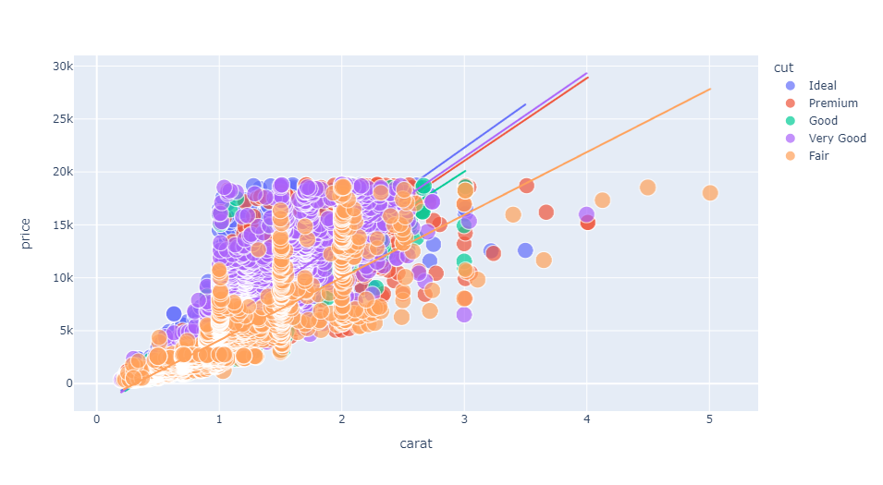
The above figure concludes two features of diamonds:

1. Premium cut diamond are relatively larger than other diamonds.

2. There's linear relationship between the size of all types of diamonds and their prices

Now let’s have a look at the price of all the types of all the types of diamonds based on their colour:

[8]: fig = px.box(data, x = "cut", y = "price",color = "color")

fig.show()

Now let’s have a look at the price of all the types of diamonds based on their clarity :

[10]: fig = px.box(data, x = "cut", y = "price", color ="clarity")

fig.show()
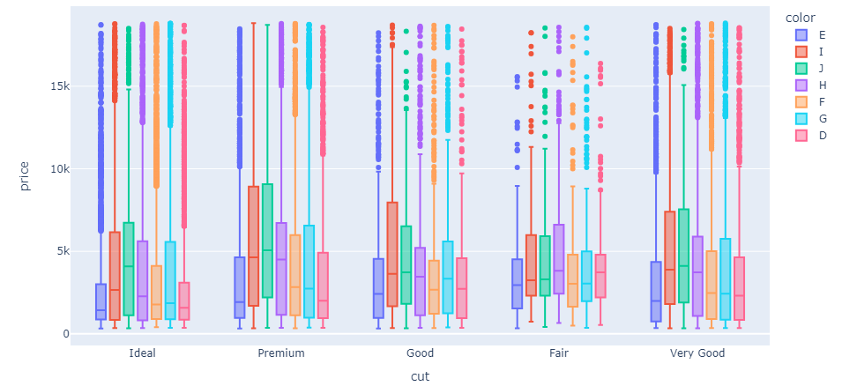

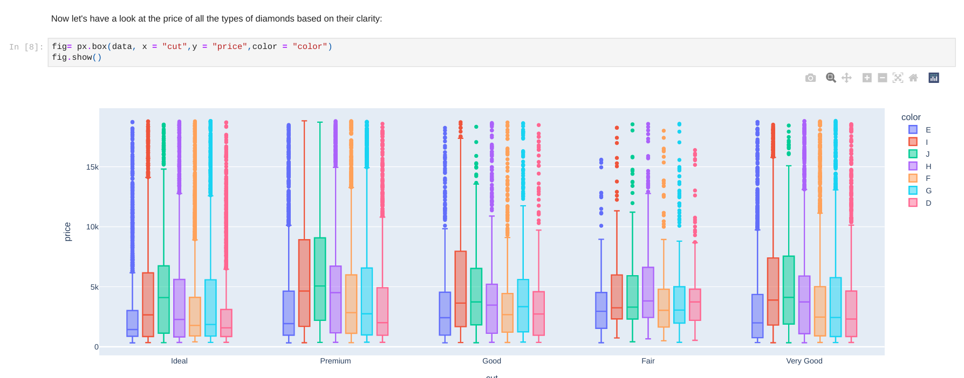

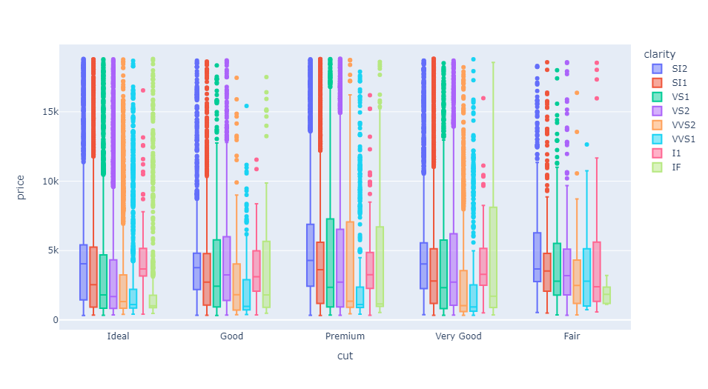

Data Pre-processing -2


[11]: data['cut'] = data['cut'].map({'Ideal':5,'Premium': 4, 'Very Good' :3,'Good':

↪2,'Fair':1})

data['color'] = data['color'].map({'D':7,'E':6,'F':5,'G':4,'H':3,'I':2,'J':1})
data['clarity']=data['clarity'].map({'IF':8,'VVS1':7,'VVS2':6,'VS1':5,'VS2':

↪4,'SI1':3,'ST2':2,'IF':1})

Correlation

Now let’s have a look at the correlation between diamonds prices and other features in the dataset:

[12]: data.corr()

[12]: | Unnamed: 0 | carat | cut | color | clarity | depth \
Unnamed: 0 | 1.000000 | -0.378173 | 0.096584 | 0.095062 | 0.085568 | -0.035058
carat | -0.378173 | 1.000000 | -0.134953 -0.291360 -0.157390 |  |  | 0.028259
cut | 0.096584 | -0.134953 | 1.000000 | 0.020517 | 0.074140 | -0.218073
color | 0.095062 | -0.291360 | 0.020517 | 1.000000 | 0.001894 | -0.047373
clarity | 0.085568 | -0.157390 | 0.074140 | 0.001894 | 1.000000 | -0.033082
depth | -0.035058 | 0.028259 | -0.218073 -0.047373 -0.033082 |  |  | 1.000000
table | -0.100872 | 0.181646 | -0.433306 -0.026481 -0.060149 -0.295733
price | -0.307092 | 0.921592 | -0.053491 -0.172431 -0.063147 -0.010729
x | -0.406331 | 0.977779 | -0.126232 -0.270671 -0.167572 -0.025017
y | -0.396480 | 0.953991 | -0.122181 -0.263915 -0.164300 -0.029069
z | -0.401758 | 0.961048 | -0.150647 -0.270011 -0.165640 |  |  | 0.095023
 | table | price | x | y | z

Unnamed: 0 -0.100872 -0.307092 -0.406331 -0.396480 -0.401758

Plotting the correlation heatmap :

[13]: plt.figure(figsize = (10,10))

sns.heatmap(data.corr(),annot = True, cmap = 'coolwarm')

plt.title('Correlation Heatmap')

plt.show()
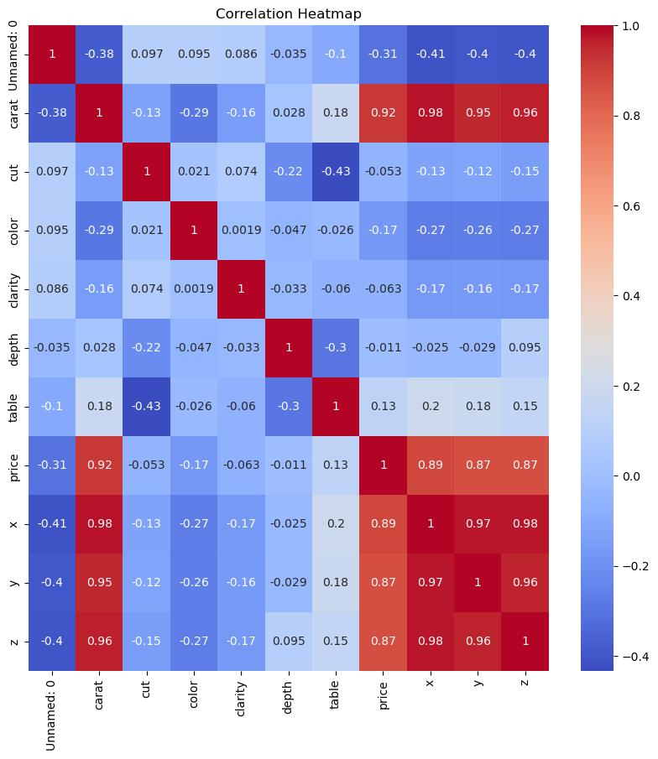
carat | 0.181646 | 0.921592 | 0.977779 | 0.953991 | 0.961048
cut | -0.433306 -0.053491 -0.126232 -0.122181 -0.150647
color | -0.026481 -0.172431 -0.270671 -0.263915 -0.270011
clarity | -0.060149 -0.063147 -0.167572 -0.164300 -0.165640
depth | -0.295733 -0.010729 -0.025017 -0.029069 |  |  |  | 0.095023
table | 1.000000 | 0.127245 | 0.196097 | 0.184493 | 0.152483
price | 0.127245 | 1.000000 | 0.887231 | 0.867864 | 0.868206
x | 0.196097 | 0.887231 | 1.000000 | 0.974918 | 0.975435

Plotting the relationship between Price and Carat

[14]: sns.lineplot(x = 'carat',y ='price', data = data)

plt.title('Carat vs Price')

plt

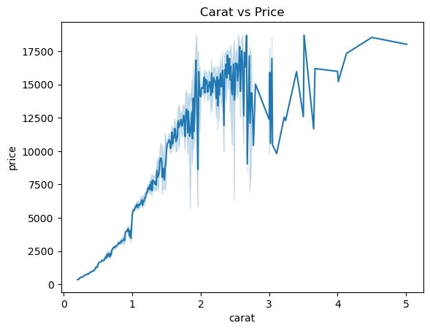

From the line-plot it is quite clear that the price of diamonds increase with the increase in the carat of the diamond. However, Diamonds with less carat also have a high price. This is because of the other factors that affect the price of the diamonds.

Train Test Split

[15]: x_test,x_train,y_test,y_train = train_test_split(data.drop('price',axis =␣ ↪1),data['price'])

Model Building

Decision Tree Regressor

[16]: dt = DecisionTreeRegressor()

dt

[16]: DecisionTreeRegressor()

Train the model

[17]: dt.fit(x_train,y_train)

[17]: DecisionTreeRegressor()

Train accuracy

[18]: dt.score(x_train,y_train)

[18]: 0.7934132493503449

[19]: #predicting the test set

dt_pred = dt.predict(x_test)

Model Evaluation

Distribution plot for actual and predict values
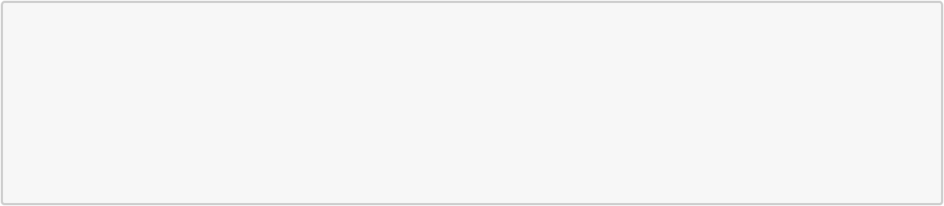

[20]: ax = sns.distplot(y_test, hist = False, color = 'y', label = 'Actual Value') sns.distplot(dt_pred,hist = False, color = 'b', label = 'Fitted Values', ax =␣
↪ax)

plt.title('Actual vs Fitted Values for Price')
plt.xlabel('Price')

plt.ylabel('Proportion of Diamonds')

plt.show()

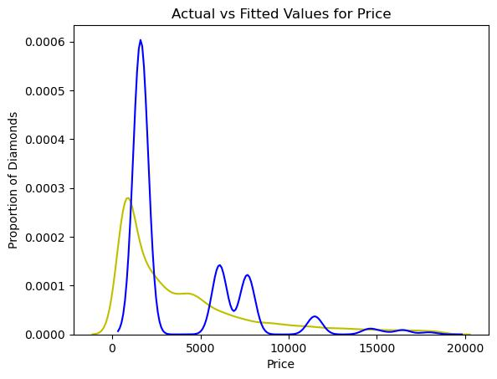


[21]: print("Decision Tree Regressor RMS:" , np. ↪sqrt(mean_squared_error(y_test,dt_pred)))
print('Decision Tree Regressor ACCURACY:',dt.score(x_test,y_test))
print('Decision Tree Regressor MAE:', mean_absolute_error(y_test,dt_pred))

Decision Tree Regressor RMS: 1810.2308988961279

Decision Tree Regressor ACCURACY: 0.8951691025250194

Decision Tree Regressor MAE: 1064.8658494661686

OBSERVATION: Model Accuracy : 0.895169102525019

CONCLUSION: In conclusion, this project provided valuable insights into the factors affecting diamond prices and developed an accurate predictive model for estimating prices based on various features. Understanding these factors can assist stakeholders in making informed decisions regarding pricing strategies and inventory management in the jewellery industry.

SUMMARY: In summary, the diamond price analysis reveals that carat weight, cut quality, colour, and clarity are key determinants of diamond prices. By leveraging machine learning techniques, businesses can gain valuable insights into market dynamics and make data-driven decisions to drive growth and success in the jewellery industry.

