A PROJECT REPORT

on

“Library Management System Website”

Submitted to

KIIT Deemed to be University

In Partial Fulfilment of the Requirement for the Award of

BACHELOR’S DEGREE IN

INFORMATION TECHNOLOGY

BY

SABYASACHI GHOSH

2129093

UNDER THE GUIDANCE OF

GUIDE NAME



SCHOOL OF COMPUTER ENGINEERING

KALINGA INSTITUTE OF INDUSTRIAL TECHNOLOGY

BHUBANESWAR, ODISHA - 751024

December 2023

A PROJECT REPORT

on

“LIBRARY MANAGEMENT SYSTEM WEBSITE”

Submitted to

KIIT Deemed to be University

In Partial Fulfilment of the Requirement for the Award of

BACHELOR’S DEGREE IN INFORMATION TECHNOLOGY

BY

SABYASACHI GHOSH

2129093

UNDER THE GUIDANCE OF

GUIDE NAME

SCHOOL OF COMPUTER ENGINEERING

KALINGA INSTITUTE OF INDUSTRIAL TECHNOLOGY

BHUBANESWAE, ODISHA -751024

December 2023

KIIT Deemed to be University

School of Computer Engineering
Bhubaneswar, ODISHA 751024

CERTIFICATE

This is certify that the project entitled

“LIBRARY MANAGEMENT SYSTEM WEBSITE”

submitted by

SABYASACHI GHOSH

2129093

is a record of bonafide work carried out by them, in the partial fulfilment of the requirement for the award of Degree of Bachelor of Engineering (Computer Sci-ence & Engineering OR Information Technology) at KIIT Deemed to be university, Bhubaneswar. This work is done during year 2022-2023, under our guidance.

Date: 20/11 /23

(Mr. Sourav Kumar Giri)
Project Guide

Acknowledgements

We extend our sincere gratitude to all those who have contributed to the realization of the Library Management System, a project that has been a significant milestone in my academic journey.
We would like to express my deepest appreciation to Sourav Kumar Giri sir, whose guidance and mentorship were instrumental in shaping the vision and execution of this project. Their expertise in database management systems provided invaluable insights that greatly contributed to the development of a robust and efficient system.

Sabyasachi Ghosh(2129093)

ABSTRACT

Online Library Management System is a system which maintains the information about the books present in the library, their authors, the members of library to whom books are issued, library staff and all. This is very difficult to organize manually. Maintenance of all this information manually is a very complex task.
Owing to the advancement of technology, organization of an Online Library becomes much simple. The Online Library Management has been designed to computerize and automate the operations performed over the information about the members, book issues and returns and all other operations. This computerization of library helps in many instances of its maintenances. It reduces the workload of management as most of the manual work done is reduced

Keywords:
- Catalog Management: The LMS provides an efficient cataloging system, enabling librarians to organize and classify a diverse array of materials, from traditional print resources to digital content, in a unified manner.
- User-Friendly Interface: A user-centric design facilitates seamless navigation for patrons and librarians alike. Intuitive interfaces empower users to explore the catalog, borrow materials, and engage with library resources effortlessly.
- Circulation System: The automated circulation system expedites the borrowing and returning of items, leveraging RFID technology to enhance accuracy and efficiency. Overdue notifications contribute to improved user compliance.
- Digital Resource Integration: The LMS seamlessly integrates digital resources, expanding the library's virtual collection. Users gain access to e-books, online journals, and multimedia content through a unified interface.
- Analytics and Reporting: Robust reporting functionalities empower librarians to generate custom reports, facilitating trend analysis, resource utilization assessments, and informed decision-making for collection development.
- Security Measures: A stringent data security framework ensures the confidentiality and integrity of user information. Access controls safeguard sensitive data, adhering to privacy standards and regulations.
- Notification System: A proactive notification system keeps users informed about due dates, reservation availability, and library updates. Librarians receive alerts for critical events, enabling timely intervention.

TABLE OF CONTENTS
- INTRODUCTION 6
  - PROJECT AIMS AND OBJECTIVES 6
  - BACKGROUND OF PROJECT 7
  - OPERATION ENVIRONMENT 8
- SYSTEM ANALYSIS 9
  - SOFTWARE REQUIREMENT SPECIFICATION 9
  - EXISTING VS PROPOSED 15
  - SOFTWARE TOOL USED 16
- SYSTEM DESIGN 20
  - TABLE DESIGN 20
  - DATA FLOW DIAGRAM’S 24
- SYSTEM IMPLEMENTATION 30
  - MODULE DESCRIPTION 30
  - SCREEN SHOTS 80
- SYSTEM TESTING 85
  - UNIT TESTING 85
  - INTEGRATION TESTING 87
- CONCLUSION & FUTURE SCOPE 88
CHAPTER 1 INTRODUCTION

This chapter gives an overview about the aim , objectives ,background and operation environment of the system.

  - PROJECT AIMS AND OBJECTIVES
The project aims and objectives that will be achieved after completion of this project are discussed in this subchapter. The aims and objectives are as follows:
    - Online book reading.
    - A search column to search availability of books.
    - Facility to download required book.
    - Video tutorial for students.
      - An Admin login page where admin can add books, videos or page sources
      - Open link for Learning Websites

BACKGROUND OF PROJECT

E-Library Management System is an application which refers to library systems which are generally small or medium in size. It is used by librarian to manage the library using a computerized system where he/she can add new books, videos and Page sources.

Books and student maintenance modules are also included in this system which would keep track of the students using the library and also a detailed description about the books a library contains. With this computerized system there will be no loss of book record or member record which generally happens when a non computerized system is used.

All these modules are able to help librarian to manage the library with more convenience and in a more efficient way as compared to library systems which are not computerized

CHAPTER 2
SYSTEM ANALYSIS

In this chapter, we will discuss and analyze about the developing process of Library Management System including software requirement specification (SRS) and comparison between existing and proposed system . The functional and non functional requirements are included in SRS part to provide complete description and overview of system requirement before the developing process is carried out. Besides that, existing vs proposed provides a view of how the proposed system will be more efficient than the existing one.

PROBLEM STATEMENT:
The problem occurred before having computerized system includes:
- File damaged - When a computerized system is not there file is always lost due to some accdent like spilling of water by some member on file accidentally. Besides some natural disaster like floods or fires may also damage the files.
  - Difficult to search record - When there is no computerized system there is always a difficulty in searching of records if the records are large in number .
  - Space consuming - After the number of records become large the space for physical storage of file and records also increases if no computerized system is implemented.
  - Cost consuming - As there is no computerized system the to add each record paper will be needed which will increase the cost for the management of library.

SYSTEM OBJECTIVES
  - Improvement in control and performance
The system is developed to cope up with the current issues and problems of library
The system can add user, validate user and is also bug free.
  - Save cost - After computerized system is implemented less human force will be required to maintain the library thus reducing the overall cost.
  - Save time - Librarian is able to search record by using few clicks of mouse and few search keywords thus saving his valuable time.
  - Option of online Notice board - Librarian will be able to provide a detailed description of workshops going in the college as well as in nearby colleges
  - Lecture Notes - Teacher have a facility to upload lectures notes in a pdf file having size not more than 10mb

SYSTEM REQUIREMENTS
      - NON FUNCTIONAL REQUIREMENTS
        - Product Requirements EFFICIENCY REQUIREMENT
When a library management system will be implemented librarian and user will easily acess library as searching and book transaction will be very faster .
RELIABILITY REQUIREMENT
The system should accurately performs member registration ,member validation, report generation, book transaction and search.
USABILITY REQUIREMENT
The system is designed for a user friendly environment so that student and staff of library can perform the various tasks easily and in an effective way.

USABILITY REQUIREMENT
The system is designed for a user friendly environment so that student and staff of library can perform the various tasks easily and in an effective way.

ORGANIZATIONAL REQUIREMENT IMPLEMENTATION REQUIREMNTS
In implementing whole system it uses html in front end with php as server side scripting language which will be used for database connectivity and the backend ie the database part is developed using mysql.

DELIVERY REQUIREMENTS
The whole system is expected to be delivered in six months of time with a weekly evaluation by the project guide.

FUNCTIONAL REQUIREMENTS
1. NORMAL USER
  - USER LOGIN Description of feature
This feature used by the user to login into system. They are required to enter user id and password before they are allowed to enter the system .The user id and password will be verified and if invalid id is there user is allowed to not enter the system.
Functional requirements
-user id is provided when they register
-The system must only allow user with valid id and password to enter the system
-The system performs authorization process which decides what user level can access to.
-The user must be able to logout after they finished using system.
  - REGISTER NEW USER Description of feature
This feature can be performed by all users to register new user to create account.
Functional requirements
-System must be able to verify information
-System must be able to delete information if information is wrong
  - REGISTER NEW BOOK Description of feature
This feature allows to add new books to the library Functional requirements
-System must be able to verify information
-System must be able to enter number of copies into table.
-System must be able to not allow two books having same book id.
DESCRIPTION OF FEATURE
This feature is found in book maintenance part . we can search book based on book id , book name , publication or by author name.
Functional requirements
- System must be able to search the database based on select search type
- System must be able to filter book based on keyword entered.
- System must be able to show the filtered book in table view
Functional requirements
-System should be able to add detailed information about events .
-System should be able to display information on notice board available in the homepage of site

SOFTWARE AND HARDWARE REQUIREMENTS
This section describes the software and hardware requirements of the system
      - SOFTWARE REQUIREMENTS
        - Operating system- Windows 7 is used as the operating system as it is stable and supports more features and is more user friendly
        - Database MYSQL-MYSQL is used as database as it easy to maintain and retrieve records by simple queries which are in English language which are easy to understand and easy to write.
Development tools and Programming language- HTML is used to write the whole code and develop webpages with css, java script for styling work and php for sever side scripting.
Existing System:
- Early days Libraries are managed manually. It required lot of time to record or to retrieve the details. The employees who have to record the details must perform their job very carefully. Even a small mistake would create a lot of problems. Security of information is very less. Report generations of all the information is very tough task.
- Maintenance of Library catalogue and arrangement of the books to the catalogue is very complex task. In addition to its maintenance of member details, issue dates and return dates etc. manually is a complex task.
- All the operations must be performed in perfect manner for the maintenance of the library with out any degradation which may finally result in the failure of the entire system.

SOFTWARE TOOLS USED
The whole Project is divided in two parts the front end and the back end.
The front end is designed using of html , Php ,css, Java script


HTML- HTMLorHyper Text Markup Language is the main markuplanguage for creating web pages and other information that can be displayed in a web browser.HTML is written in the form of HTML elements consisting of tags enclosed in angle brackets (like <html>), within the web page content. HTML tags most commonly come in pairs like <h1> and </h1>, although some tags represent empty elements and so are unpaired, for example <img>. The first tag in a pair is the start tag, and the second tag is the end tag (they are also called opening tags and closing tags). In between these tags web designers can add text, further tags, comments and other types of text-based content. The purpose of a web browser is to read HTML documents and compose them into visible or audible web pages. The browser does not display the HTML tags, but uses the tags to interpret the content of the page.HTML elements form the building blocks of all websites. HTML allows images and objects to be embedded and can be used to create interactive forms. It provides a means to create structured documents by denoting structural semantics for text such as headings, paragraphs, lists, links, quotes and other items. It can embed scripts written in languages such as JavaScript which affect the behavior of HTML web pages.

- CSS- Cascading Style Sheets(CSS) is a style sheet language used fordescribing the look and formatting of a document written in a markup language. While most often used to style web pages and interfaces written in HTML and XHTML, the language can be applied to any kind of XML document, including plain XML, SVG and XUL. CSS is a cornerstone specification of the web and almost all web pages use CSS style sheets to describe their presentation.CSS is designed primarily to enable the separation of document content from document presentation, including elements such as the layout, colors, and fonts. This separation can improve content accessibility, provide more flexibility and control in the specification of presentation characteristics, enable multiple pages to share formatting, and reduce complexity and repetition in the structural content (such as by allowing for table less web design).CSS can also allow the same markup page to be presented in different styles for different rendering methods, such as on-screen, in print, by voice (when read out by a speech-based browser or screen reader) and on Braille-based, tactile devices. It can also be used to allow the web page to display differently depending on the screen size or device on which it is being viewed. While the author of a document typically links that document to a CSS file, readers can use a different style sheet, perhaps one on their own computer, to override the one the author has specified. However if the author or the reader did not link the document to a specific style sheet the default style of the browser will be applied.CSS specifies a priority scheme to determine which style rules apply if more than one rule matches against a particular element. In this so-called cascade, priorities or weights are calculated and assigned to rules, so that the results are predictable.

JAVA-SCRIPT- JavaScript(JS) is a dynamic computer programminglanguage. It is most commonly used as part of web browsers, whose implementations allow client- side scripts to interact with the user, control the browser, communicate asynchronously, and alter the document content that is displayed. It is also being used in server-side programming, game development and the creation of desktop and mobile applications. JavaScript is a prototype-based scripting language with dynamic typing and has first-class functions. Its syntax was influenced by C. JavaScript copies many names and naming conventions from Java, but the two languages are otherwise unrelated and have very different semantics. The key design principles within JavaScript are taken from the Self and Scheme programming languages. It is a multi- paradigm language, supporting object-oriented, imperative, and functional programming styles. The application of JavaScript to use outside of web pages—for example, in PDF documents, site-specific browsers, and desktop widgets—is also significant. Newer and faster JavaScript VMs and platforms built upon them (notably Node.js) have also increased the popularity of JavaScript for server-side web applications. On the client side, JavaScript was traditionally implemented as an interpreted language but just-in-time compilation is now performed by recent (post-2012) browsers.
PHP- PHPis a server-side scripting language designed for web-development but also used as a general-purpose programming language. PHP is now installed on more than 244 million websites.

MYSQL- MySQL("My S-Q-L", officially, but also called "My Sequel") is (as of July 2013) the world's second most widely used open-source relational database management system (RDBMS). It is named after co-founder Michael Widenius daughter, My. The SQL phrase stands for Structured Query Language. The MySQL development project has made its source code available under the terms of the GNU General Public License, as well as under a variety of proprietary agreements. MySQL was owned and sponsored by a single for-profit firm, the Swedish company MySQL AB, now owned by Oracle Corporation, MySQL is a popular choice of database for use in web applications, and is a central component of the widely used LAMP open source web application software stack (and other 'AMP' stacks). LAMP is an acronym for "Linux, Apache, MySQL, Perl/PHP/Python." Free-software-open source projects that require a full-featured database management system often use MySQL. For commercial use, several paid editions are available, and offer additional functionality. Applications which use MySQL databases include: TYPO3, MODx, Joomla, WordPress, phpBB, MyBB, Drupal and other software. MySQL is also used in many high-profile, large-scale websites, including Wikipedia, Google (though not for searches), Facebook, Twitter, Flickr, and YouTube.

CHAPTER 3 SYSTEM DESIGN

TABLE DESIGN
VARIOUS TABELS TO MAINTAIN INFORMATION

Library Table from Database:

  - Admin Table from Database

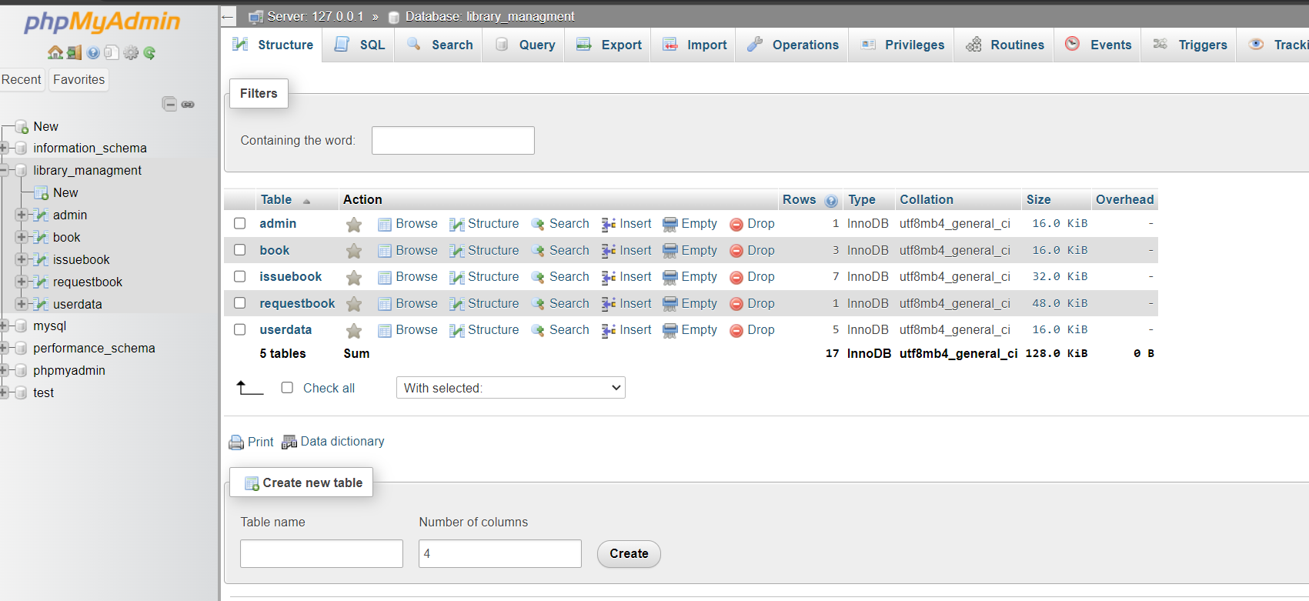

Subjects Table from Database
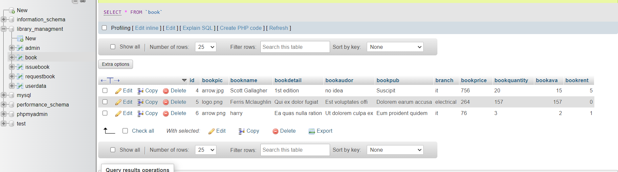
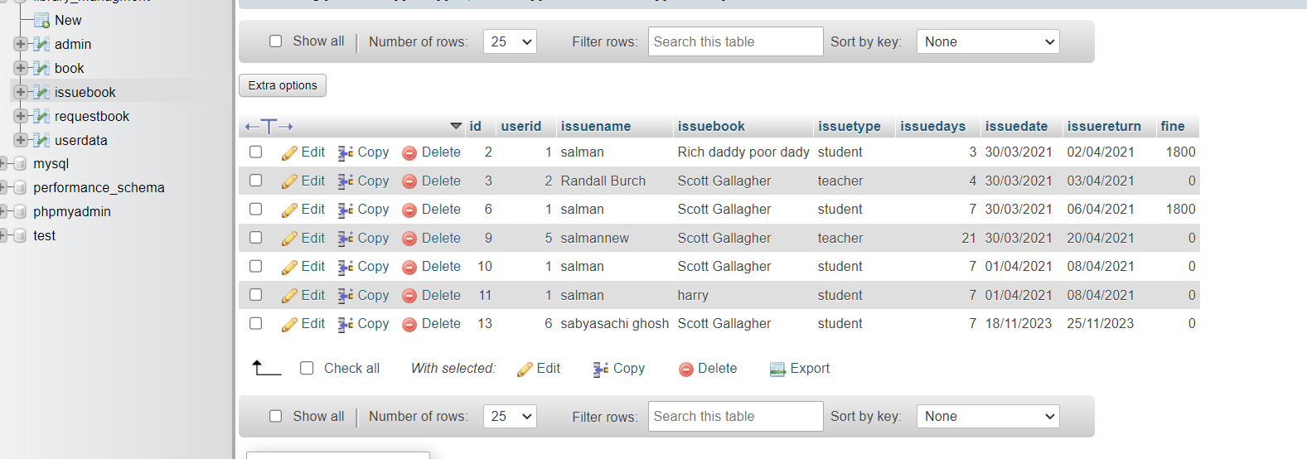
- Books Table from Database Issue Books Table from Database

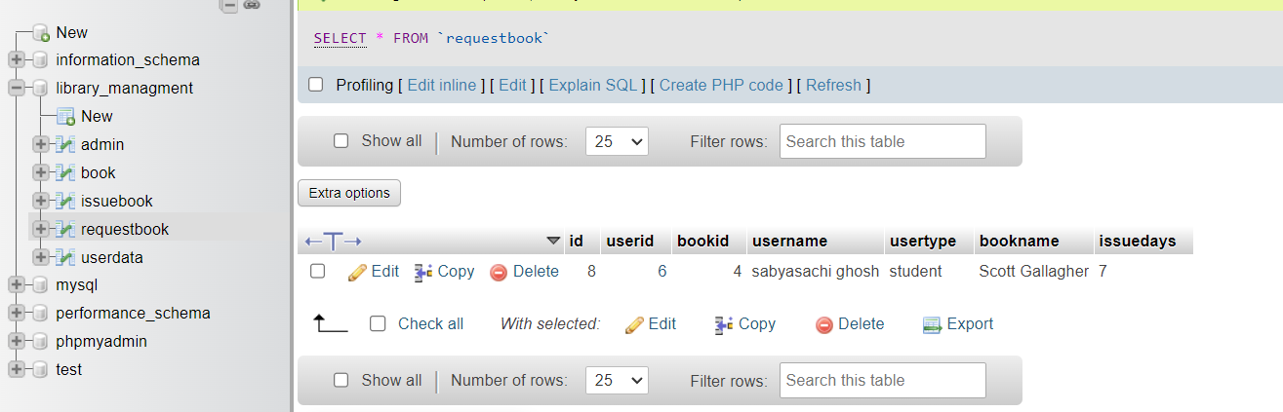
Request Table from Database

  - DATA FLOW DIAGRAMS
DATA FLOW DIAGRAM FOR ASMIN LOGIN

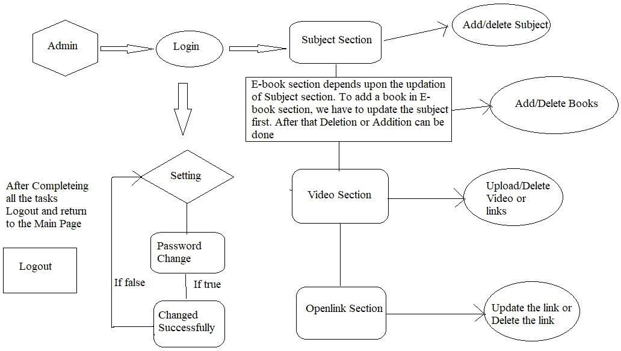

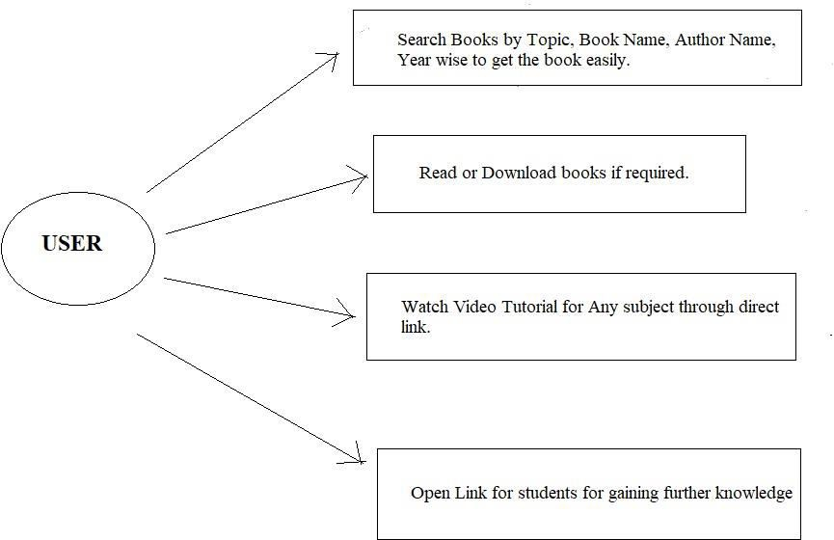
USE CASES DIAGRAM FOR USE

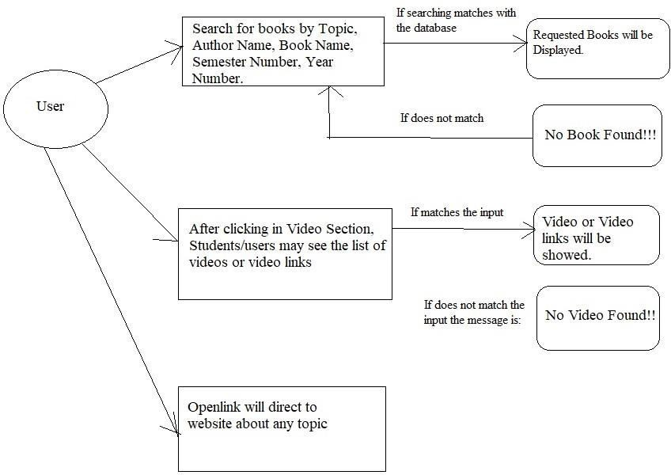
DATA FLOW DIAGRAM FOR USER

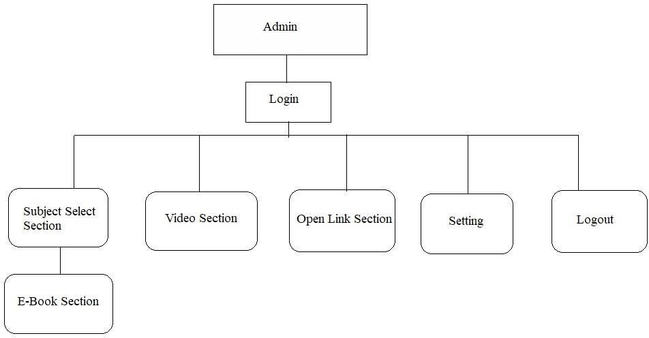
USER CASE DIAGRAM FOR ADMIN

DATA FLOW DIAGRAM FOR USER

CHAPTER 4 SYSTEM IMPLEMENTATION
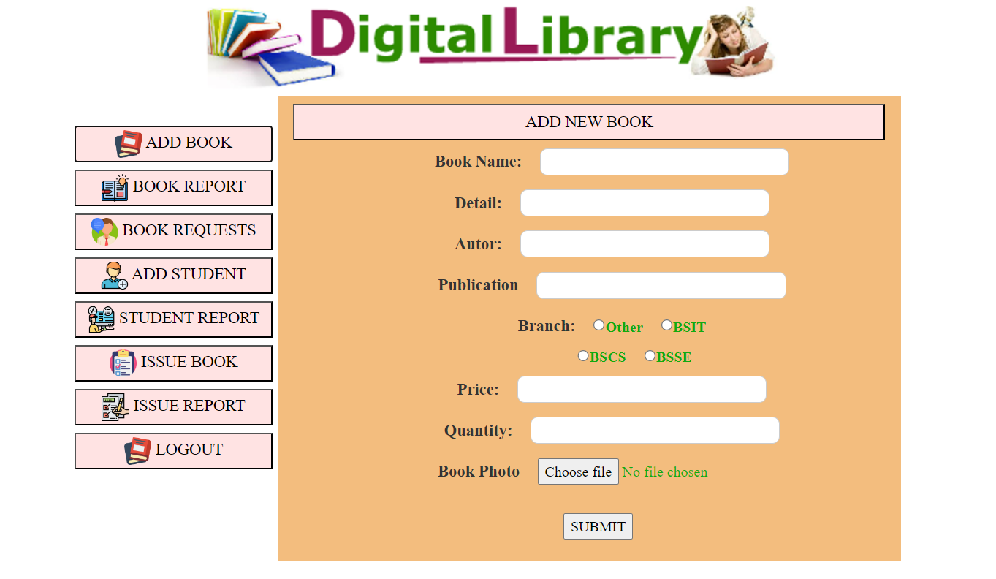
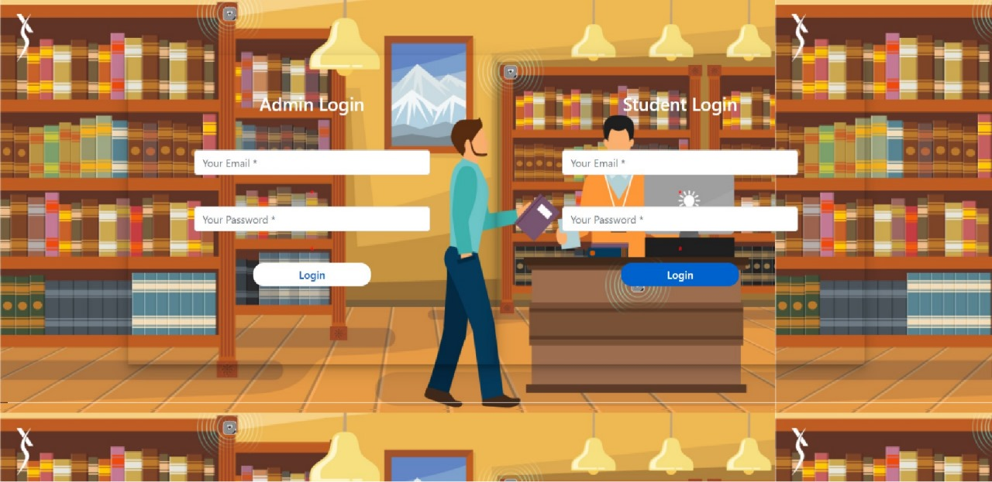
Screenshot for homepage
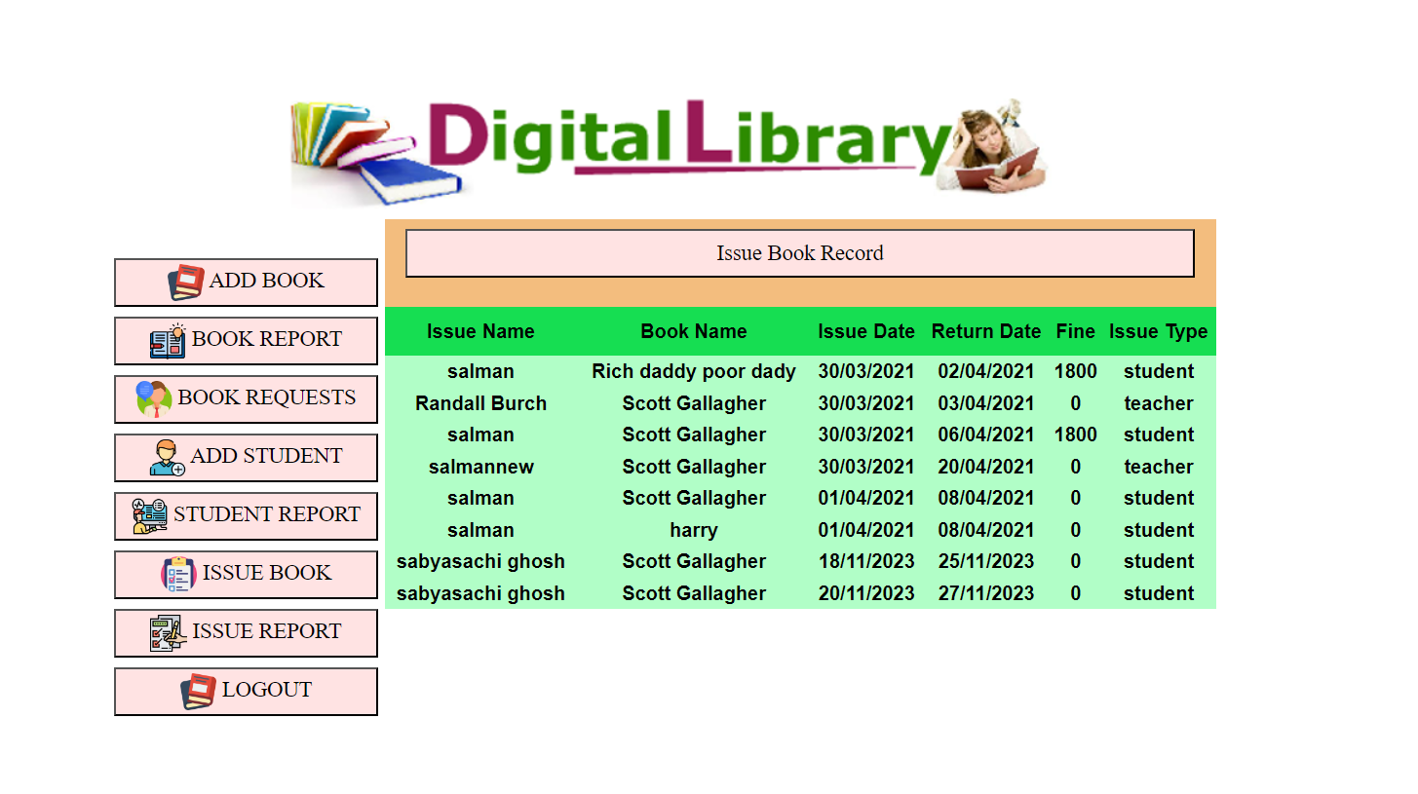
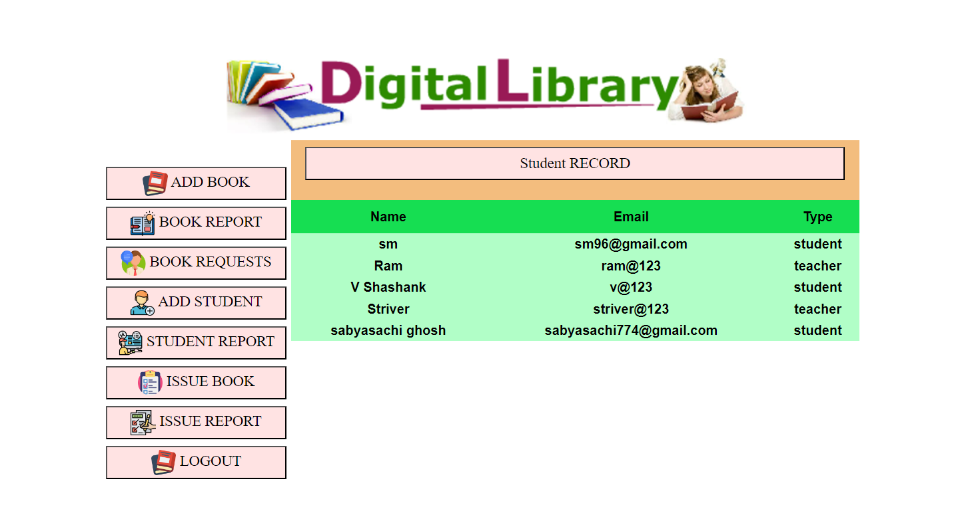

CHAPTER 5 SYSTEM TESTING

The aim of the system testing process was to determine all defects in our project .The program was subjected to a set of test inputs and various observations were made and based on these observations it will be decided whether the program behaves as expected or not. Our Project went through two levels of testing
1.Unit testing
2.integration testing
UNIT TESTING
Unit testing is undertaken when a module has been created and succesfully reviewed .In order to test a single module we need to provide a complete environment ie besides the module we would require
•The procedures belonging to other modules that the module under test calls
•Non local data structures that module accesses
•A procedure to call the functions of the module under test with appropriate parameters
Unit testing was done on each and every module that is described under module description of chapter 4
1.Test For the admin module
•Testing admin login form-This form is used for log in of administrator of the system.In this we enter the username and password if both are correct administration page will open other wise if any of data is wrong it will get redirected back to the login page and again ask for username and password
•Student account addition- In this section the admin can verify student details from student academinc info and then only add student details to main library database it contains add and delete buttons if user click add button data will be added to student database and if he clicks delete button the student data will be deleted.
•Book Addition- Admin can enter details of book and can add the details to the main book table also he can view the books requests .

2.Test for Student login module
•Test for Student login Form-This form is used for log in of Student .In this we enter thelibraryid, username and password if all these are correct student login page will open other wise if any of data is wrong it will get redirected back to the login page and again ask for libraryid, username and password.
•Test for account creation- This form is used for new account creation when student does not fill the form completely it asks again to fill the whole form when he fill the form fully it gets redirected to page which show waiting for conformation message as his data will be only added by administrator after verification.
3.Test for teacher login module-
Test for teacher login form- This form is used for logg in of teacher .In this we enter the username and password if all these are correct teacher login page will open other wise if any of data is wrong it will get redirected back to the login page and again ask for username and password.

INTEGRATION TESTING

In this type of testing we test various integration of the project module by providing the input
.The primary objective is to test the module interfaces in order to ensure that no errors are occurring when one module invokes the other module.

CHAPTER 6 CONCLUSION & FUTURE SCOPE

This website provides a computerized version of library management system which will benefit the students as well as the staff of the library.
It makes entire process online where student can search books, staff can generate reports and do book transactions. It also has a facility for student login where student can login and can see status of books issued as well request for book or give some suggestions. It has a facility of teacher’s login where teachers can add lectures notes and also give necessary suggestion to library and also add info about workshops or events happening in our college or nearby college in the online notice board.
There is a future scope of this facility that many more features such as online lectures video tutorials can be added by teachers as well as online assignments submission facility , a feature Of group chat where students can discuss various issues of engineering can be added to this project thus making it more interactive more user friendly and project which fulfills each users need in the best way possible.

CHAPTER 7 REFERENCES
http://www.w3schools.com/html/html_intro.asp

http://www.Udemy.com/css/css_background.asp

http://www.w3schools.com/js/js_datatypes.asp

