Data structure Pfarrerbuch Sachsen

Person
- Name
- Last Name
- Born place
- Born Date
- Dead place
- Father
- Mother
- Children
- Wife
- Husband

Place
- Name
- Region
- Schools
- Pfarrerstelle
- Near to

School

Web App Colors:

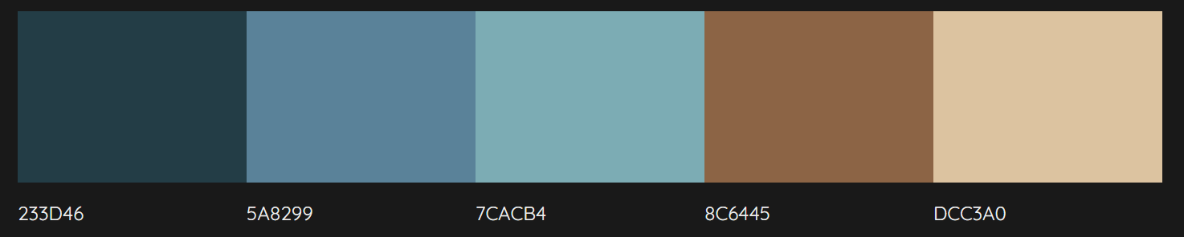

FrontEnd (2) Views:

- Form Search/Create View
- Data results View

Components:

Buttons




Icons:

Dividers:
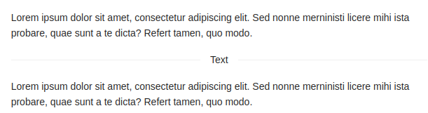
Grid:

Layout:
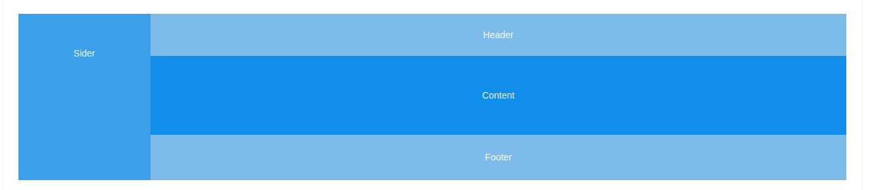

Space:
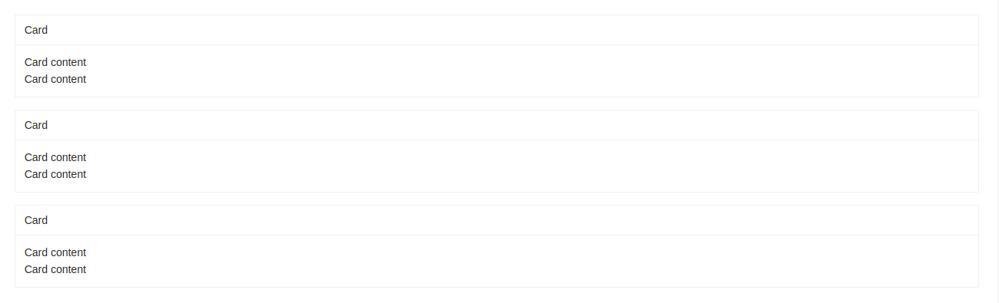

Breadcrumb:
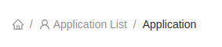

Dropdown:

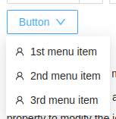

Navigation Menu:
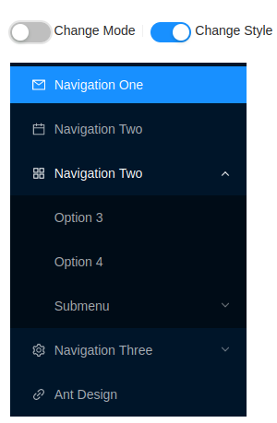

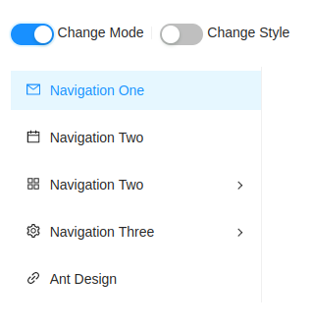

PageHeader for results view:

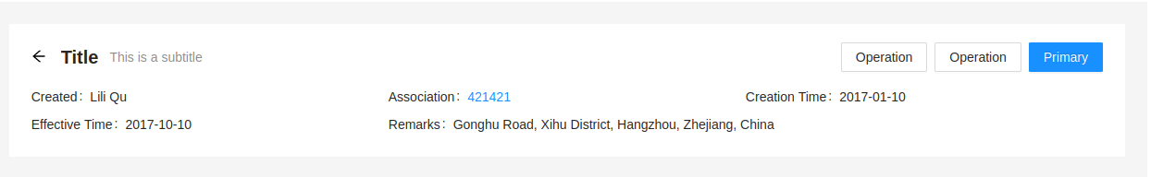

Pagination:

