**Add a project to GitHub the easy way**

The following approach isn’t the documented, academically endorsed approach to add a local project to a remote GitHub repo. Nevertheless, it’s easy, it works and it doesn’t have any negative ramifications other than a large *copy and paste*.

To quickly add your project to an existing GitHub repo, just follow these steps:

1. Create a new GitHub repo that contains a [README file](https://www.techtarget.com/searchsoftwarequality/tip/How-to-create-an-engaging-README-file).
2. Use Git to clone the GitHub repo locally.
3. Copy your project files into the folder created by the clone.
4. Perform a *git add .* and a *git commit.*
5. Push your changes up to GitHub.

**Copy and push benefits and drawbacks**

That’s it. That’s how easy it is to add an existing project on your filesystem to GitHub.

The benefit of this approach is that you can also add your project to a GitHub repo that already has files in it.

The generally prescribed method to add a project to an existing GitHub repo typically assumes the repository is blank. If the existing GitHub repo is not blank, you must dangerously push your project to GitHub with the *force* flag.

The drawback is that the location of your project on your filesystem changes, but that’s easily addressed with another copy and paste.

Personally, I like the easy approach.

Next, I’ll describe the alternate approach, which adds a remote reference to the GitHub server in your existing project’s config files.

**Proper steps to add existing code to GitHub**

The proper way to push a new project into an existing GitHub repository follows these steps:

1. Create a GitHub repository for the existing project.
2. Copy the GitHub URL for the new repo to the clipboard.
3. Perform a git init command in the root folder of the existing project.
4. Add all of the existing project’s files to the Git index and then commit.
5. Add the GitHub repo as a remote reference for the existing project.
6. Perform a git push operation with the -u and -f switches.
7. Verify that the existing project’s files have been pushed to GitHub.

**How to push code to GitHub**

Many DevOps professionals only want to know the Git commands necessary to push their existing project to GitHub.

To save those readers from going through the entire example, here are the Git commands used in this tutorial. These commands assume a push to a GitHub repo named *existing-website,* owned by a GitHub user named *cameronmcnz*:

* git init
* git add .
* git commit -m "Add existing project files to Git"
* git remote add origin **https://github.com/cameronmcnz/example-website.git**
* git push -u -f origin master

**Updating a remote GitHub repo**

To push an existing project to GitHub, you must first create a GitHub repository. To do this, simply click the green “Create repository” button in GitHub’s online console and provide a repository name.

For this example, we will name the repository *example-website*.

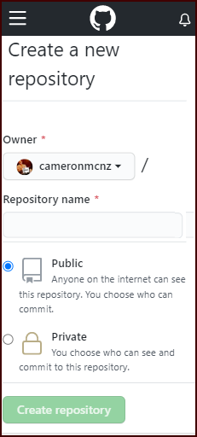

You must create a GitHub repo to manage your existing project’s files.

**Obtain the repo’s GitHub URL**

After you create the repository, click the green “Code” button. This reveals the GitHub URL for HTTPS connections.

Copy this value for use in a future step.

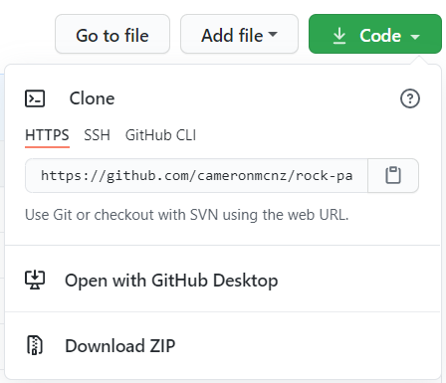

The GitHub URL is used to push the existing project to GitHub.

**Initialize Git in the existing project**

If the existing project does not already use Git, issue a git init command in the root folder. After the repository is initialized, add all of the project files to the Git index and perform a commit:

git add .

git commit -m "Add existing project files prior to the push to GitHub."

**Add a remote reference for GitHub**

To let your existing project synchronize with GitHub, issue a git remote add command to configure a reference from you local Git installation to the repository on GitHub. Note that the last segment of the git remote add command is your project’s GitHub URL.

git remote add origin https://github.com/**cameronmcnz/example-website.git**

**Push the first commit to GitHub**

Once you’ve added the remote reference, you are ready to push your existing project to GitHub.

Simply issue a git push command with the name of the current branch along with the -u and -f switches.

Note that older Git repositories create a *master* branch by default, while newer ones use *main*. Amend the git push command accordingly.

git push -u -f origin master

The -u switch makes the remote GitHub repo the default for your existing project. The -f switch forces Git to overwrite any files that already exist on GitHub with your existing project’s files.

**Verify the GitHub push**

To verify that the existing project was pushed to GitHub successfully, log into the GitHub website and browse the repository. All of the files from your existing project should be visible on GitHub.

And that’s how easy it is to push an existing project to a [Git or GitHub repository](https://www.theserverside.com/video/Full-Git-and-GitHub-tutorial-for-beginners).