Rhythmic Tunes: Your Melodic Companion

**Project Documentation**

## Team ID: NM2025TMID40024

**Team Size: 4 Team Leader:**

Name: SAIDHARSHINI.K

Mail [ID:sac2427bca5369@ssacollegechennai.com](mailto:sac2427bca5369@ssacollegechennai.com)

## Team Members:

1. Name: RESHMA BEGUM.M

Mail [ID:sac2427bca5257@ssacollegechennai.com](mailto:sac2427bca5257@ssacollegechennai.com)

1. Name: SHAHEEN KHATUN.R

Mail [ID:sac2427bca5773@ssacollegechennai.com](mailto:sac2427bca5773@ssacollegechennai.com)

1. Name: SABRIN SAABIRA.D

Mail [ID:sac2427bca5392@ssacollegechennai.com](mailto:sac2427bca5392@ssacollegechennai.com)

## Introduction

**Rhythmic Tunes:Your Melodic Partner** is a **browser-based music application**

developed to provide users with an **engaging** and **interactivespace** for

**composing**, **listening**, and **experimenting** with melodies. Built using **HTML**, **CSS**, and **JavaScript**, it ensures smooth performance across **modern browsers.** This platform serves as an **easy-to-use** yet effective tool for individuals who want to explore **rhythmic sounds** and **enjoy a personalized music experience**.

## Project Overview

This project delivers a **platform** where users can **interact** with and **customize tunes** in **real time**. It allows playback of rhythmic **beats**, **control of music flow**, and exploration of **various sound styles**. Thanks to its simple yet intuitive **interface**, even beginners can **navigate** the **applicationeffortlessly**. **Lightweight**, **responsive**, and **efficient**, **RhythmicTunes** is designed to be a reliable musical **companion** for melody lovers who appreciate simplicity **blended with creativity.**

## Architecture

* + **Front end**: HTML, CSS, JavaScript
  + **Platform**: Web Browser
  + **MusicHandling**: JavaScript Audio API with DOM-based controls

## Execution Flow:

1. The user launches the application in their **browser**.
2. **Rhythm** and **melody** options load on the **interface**.
3. **Upon interaction** (clicking/playing), **JavaScripttriggers** audio **functions**.
4. The system **produces output** as sound **waves or tunes**, which play **directly**

through the **browser**.

## 4. Setup Instructions

1. Install any updated web **browser (Google Chrome, Firefox, Edge).**
2. **Download** or **clone** the project **repository**.
3. Open the **index.html** file in the **browser**.
4. Make sure **internet access** is available if **external resources (e.g., sound libraries, font-awesome) are required.**

## Folder Structure

RhythmicTunes/

├── index.html # Primary file (UI + structure)│

├── /css

│ └── style.css # Styling and layout

│

├── /js

│ └── script.js # Main logic and functions

│

├── /assets

│ ├── /audio # Beat and melody files

│ │ ├── beat1.mp3

│ │ ├── beat2.mp3

│ │ └── melody1.mp3

│ ├── /images # UI icons and logo

│ │ └── logo.png

│ └── /fonts # Optional custom fonts

│

├── /docs

│ └── Documentation.docx # Detailed project documentation│

└── README.md # Basic project information

## Running the Application

1. Launch **index.html** in the browser.
2. Click **Play to start listening**.
3. Use **on-screen controls** to **pause**, **stop**, or **switchrhythms**.

## Adjust tempo or volumeif the options areavailable.

1. **API Documentation**

The project uses JavaScript methods to manage audio features:

* + **playTune()** → Begins playback of the chosen rhythm.
  + **pauseTune()** → Suspends the current playback.
  + **stopTune()** → Ends playback entirely.
  + **changeRhythm(type)** → Switches between available melody or rhythm options.
  + **adjustTempo(speed)** → Modifies playback speed (faster or slower).

(**Note:** Functions are based on the observed behavior of the app. Actual code may differ slightly.)

## Authentication

* + **No authentication** is **required**.
  + All users can **directly access** and **operate the application without login.**

## User Interface

* + Simple and elegant layout designed with **HTML + CSS.**
  + Buttons for **Play**, **Pause**, **Stop**, and **Rhythm Change.**
  + Fully **responsive design** for different **screen sizes.**
  + Smooth **audio** playback powered by **JavaScript.**

## Testing

The application has been tested successfully on **Chrome**, **Firefox**, and **Edge**. **Tested Features:**

* + **Play/Pause** operations
  + **Switching** between rhythms
  + **Continuous** and **smooth playback**
  + All **core features workedwithout noticeable lag**

1. **Screenshots/Demo**

# Demo-1 image:

This screenshot illustrates the home interface of the **RythamicTunesapplication**, highlighting its clean layout and user-friendly navigation.

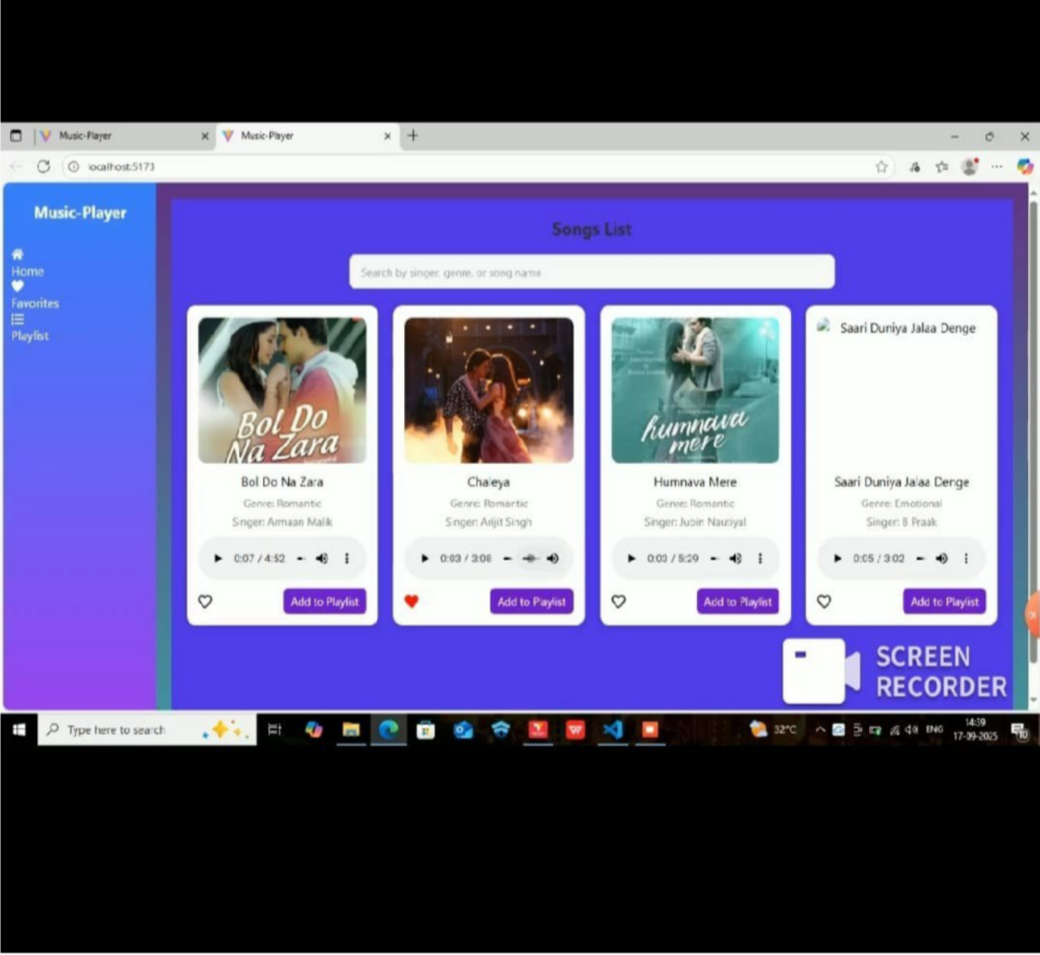

# Demo-2 image:

This image showcases the active demo of the application, where rhythmic tunes are being played and controlled through the provided options

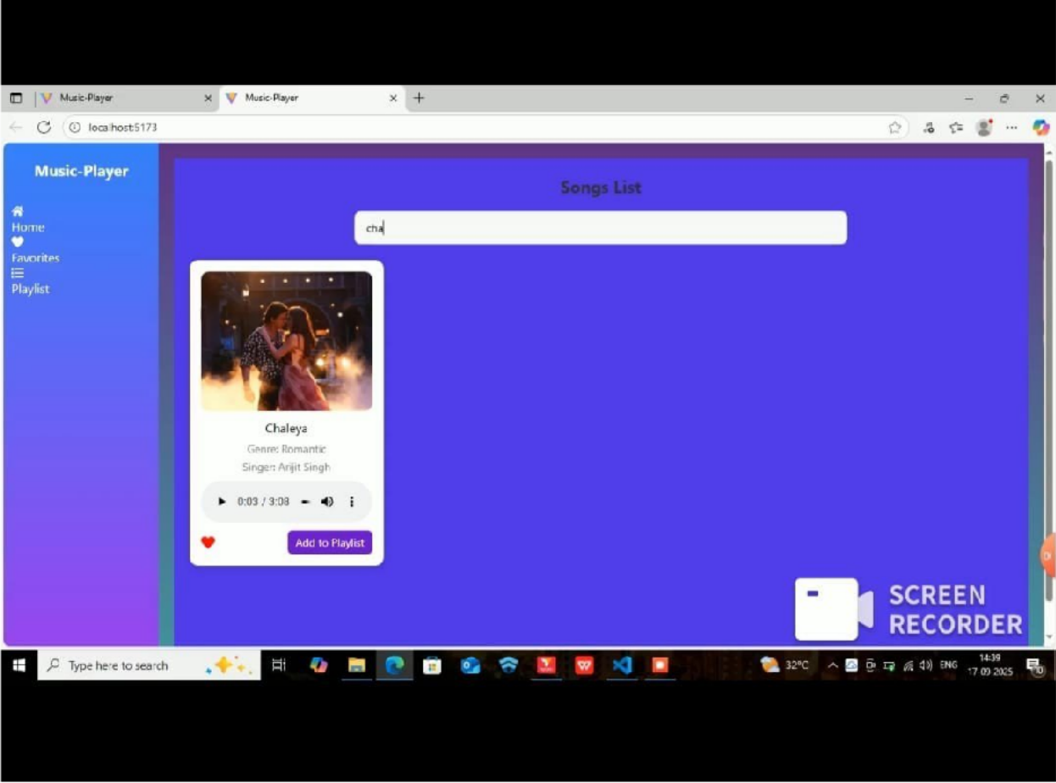

## Known Issues

* + Limited variety of beats and melodies at present.
  + Minor delay in playback may occur depending on system performance.
  + No offline support for extended music libraries.

## Future Enhancements

* + Expand the **collection** of **beats** and **melodies**.
  + Provide **users with the ability** to **create** and **customize** their **own tunes**.
  + Add dark and light **themes** for **better user experience**.
  + Enable **saving**, **recording**, and **downloading** of **createdtunes**.
  + Introduce a **mobile application** using **React Native or Flutter.**