WEEK 3 TASK
Advanced Data Analysis and Visualization in Logistics
A Python-based exploratory analysis of a hypothetical logistics dataset

Student Name: VASANTHI M
Course / Department: B.Sc Computer Science
Institution: St. Anne's Arts and Science College
Submission Date: 20-10-2026

1. Executive Summary
This report analyses 120 simulated shipments to understand delivery speed, transport costs, shipment volumes, and regional performance. The dataset is hypothetical and is used only to demonstrate a reproducible analytics workflow. The overall average delivery time is 4.55 days, the median is 4.05 days, and the average transport cost is ₹161.57 per shipment. Approximately 71.7% of shipments are labelled delayed using the illustrative rule of delivery time greater than 3.2 days. Distance is positively associated with delivery time (correlation 0.47) and transport cost (correlation 0.59). These patterns can help managers plan delivery estimates, compare transport modes, and investigate delay hotspots.

2. Objectives
- Create a realistic but hypothetical logistics dataset with delivery, distance, volume, cost, region, and transport-mode fields.
- Perform exploratory data analysis (EDA), including descriptive statistics, distributions, and correlations.
- Create visualizations that reveal trends, variation, and relationships between logistics metrics.
- Interpret the results and recommend practical ways to improve operational efficiency.

3. Dataset Simulation and Structure
The dataset contains 120 fictional shipment records. Each row represents one shipment. Values were generated using Python's NumPy random functions, with a fixed random seed so the example can be reproduced. No real customer or company data is included.
Variable | Description
Shipment_ID | Unique shipment identifier, e.g., S001.
Region | Destination region: North, South, East, or West.
Transport_Mode | Transport method: Truck, Van, or Rail.
Distance_km | Approximate shipment distance in kilometres.
Shipment_Volume_units | Number of units in the shipment.
Weight_kg | Estimated shipment weight in kilograms.
Delivery_Time_days | Simulated time from dispatch to delivery, in days.
Transport_Cost_INR | Simulated transport cost in Indian rupees.
Delayed | Yes if delivery time exceeds 3.2 days; otherwise No. This is an illustrative threshold, not an industry standard.
Sample records (first 8 rows):
Shipment_ID | Region | Transport_Mode | Distance_km | Shipment_Volume_units | Weight_kg | Delivery_Time_days | Transport_Cost_INR | Delayed
S001 | South | Van | 197 | 80 | 1524.4 | 0.5 | 188.55 | No
S002 | West | Rail | 516 | 20 | 185.5 | 9.29 | 142.85 | Yes
S003 | East | Truck | 1109 | 94 | 1402.7 | 6.36 | 260.47 | Yes
S004 | East | Truck | 557 | 94 | 827.7 | 4.83 | 188.56 | Yes
S005 | North | Truck | 138 | 52 | 816.1 | 2.04 | 108.19 | No
S006 | North | Truck | 1100 | 89 | 1262.1 | 5.26 | 218.71 | Yes
S007 | North | Van | 319 | 43 | 878.4 | 1.55 | 119.71 | No
S008 | West | Rail | 536 | 37 | 477.8 | 9.98 | 87.11 | Yes

4. Methodology and Python Tools
The analysis uses Python, pandas, NumPy, and Matplotlib. pandas organises the records and calculates summary statistics; NumPy supports reproducible data simulation and numerical calculations; Matplotlib creates the charts. The workflow is: simulate data → inspect structure and quality → calculate descriptive statistics → compare groups → calculate correlations → visualise patterns → interpret results.

5. Exploratory Data Analysis

5.1 Data quality checks
The dataset has 120 rows and 9 columns. Missing values: 0. Duplicate shipment IDs: 0. Because the data was generated for this task, it is relatively clean. In a real logistics system, the analyst should also validate impossible distances, negative costs, inconsistent timestamps, and duplicated shipment records.

5.2 Central tendency and spread
Mean is the arithmetic average, median is the middle observation, and standard deviation measures how widely values vary around the mean.
Metric | Mean | Median | Std. dev. | Minimum | Maximum
Distance km | 709.79 | 737.5 | 341.42 | 44.0 | 1190.0
Shipment Volume units | 52.31 | 49.0 | 29.43 | 5.0 | 100.0
Weight kg | 815.21 | 711.9 | 528.47 | 45.9 | 2136.3
Delivery Time days | 4.55 | 4.06 | 2.54 | 0.5 | 11.59
Transport Cost INR | 161.57 | 161.88 | 53.92 | 48.75 | 312.28
Delivery time has a mean of 4.55 days and a median of 4.05 days. Comparing mean and median helps identify whether unusually long deliveries pull the average upward. The range and standard deviation help assess consistency.

5.3 Transport mode comparison
Mode | Shipments | Avg days | Avg cost (₹) | Avg distance (km) | Delay rate (%)
Rail | 17 | 9.88 | 180.34 | 789.88 | 100.0
Truck | 64 | 4.23 | 156.65 | 677.53 | 81.25
Van | 39 | 2.75 | 161.47 | 727.82 | 43.59
These are unadjusted averages. A mode may appear slower or more expensive simply because it is used for longer routes or different shipment types; comparisons should account for distance and load before making policy decisions.

5.4 Regional comparison
Region | Shipments | Avg days | Avg cost (₹) | Delay rate (%)
East | 25 | 4.7 | 151.82 | 80.0
North | 34 | 4.73 | 163.87 | 67.65
South | 30 | 4.46 | 170.2 | 73.33
West | 31 | 4.31 | 158.57 | 67.74

6. Visualizations and Interpretation
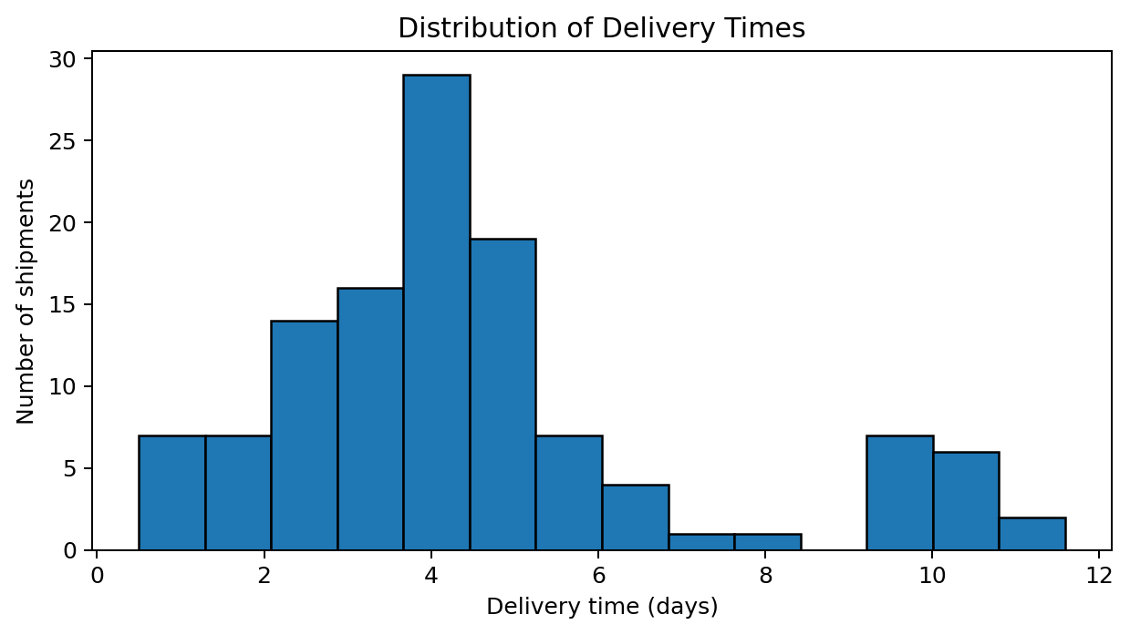
Figure 1. Delivery-time distribution.
A histogram groups delivery times into intervals and shows where shipments are concentrated. A long right tail would indicate a smaller number of slow deliveries and could suggest that the average is affected by outliers.
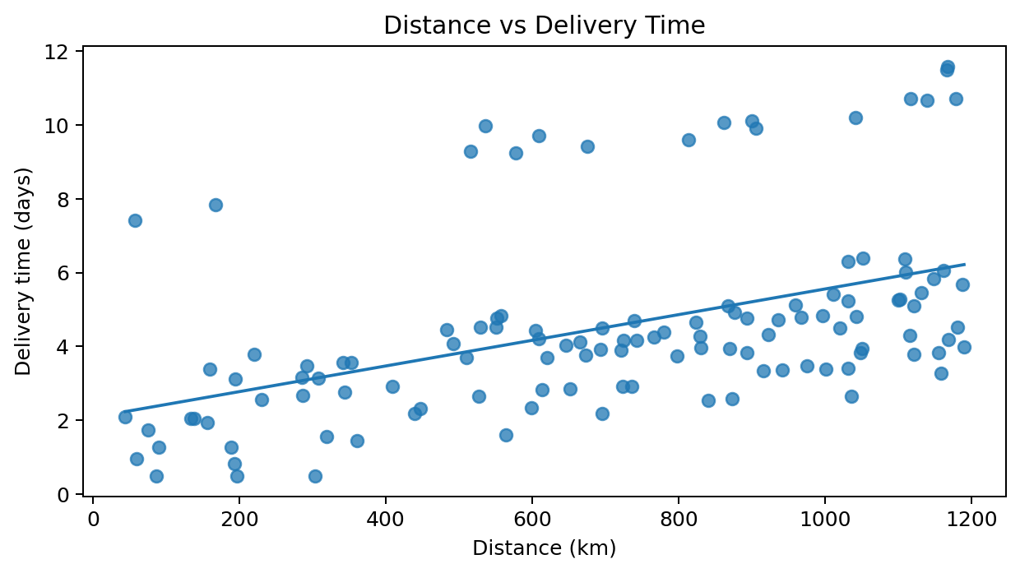
Figure 2. Distance versus delivery time.
The scatter plot shows each shipment as a point. The correlation is 0.47, indicating a positive relationship in this simulated dataset: longer routes generally take more time. The fitted line summarises the overall direction, but it does not prove that distance is the only cause.
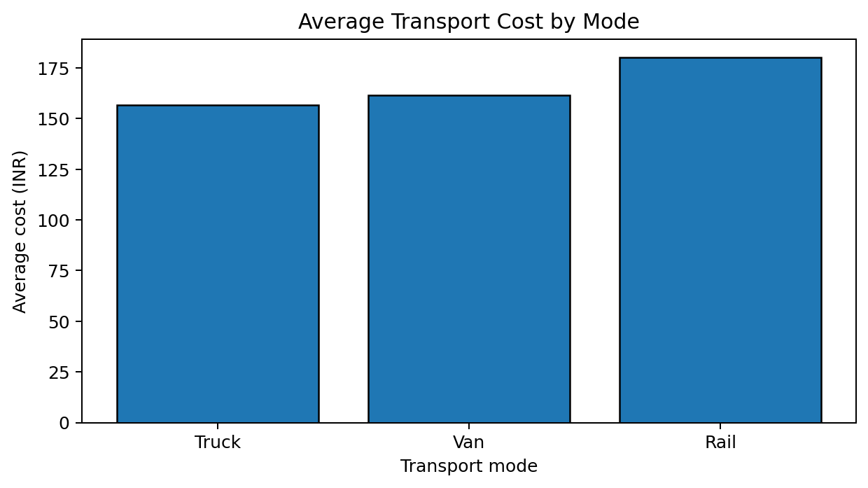
Figure 3. Average transport cost by mode.
A bar chart is suitable for comparing category averages. It highlights cost differences between Truck, Van, and Rail. Before switching modes, compare equivalent routes, service levels, capacity, handling, and reliability.
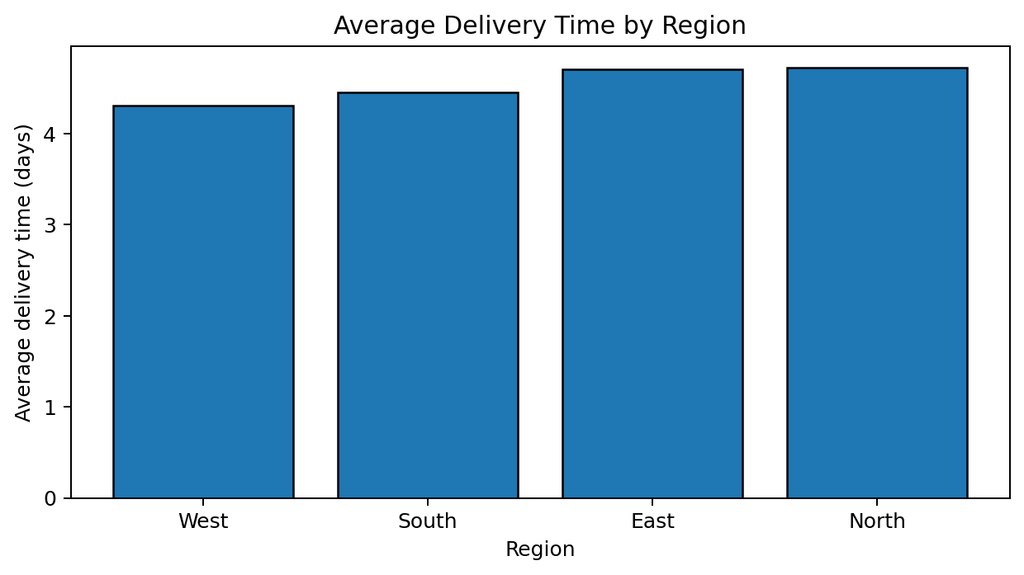
Figure 4. Average delivery time by region.
The regional bar chart helps identify areas with longer average delivery times. Regions with high averages should be examined for route distance, traffic, hand-off delays, weather, and warehouse processing time.
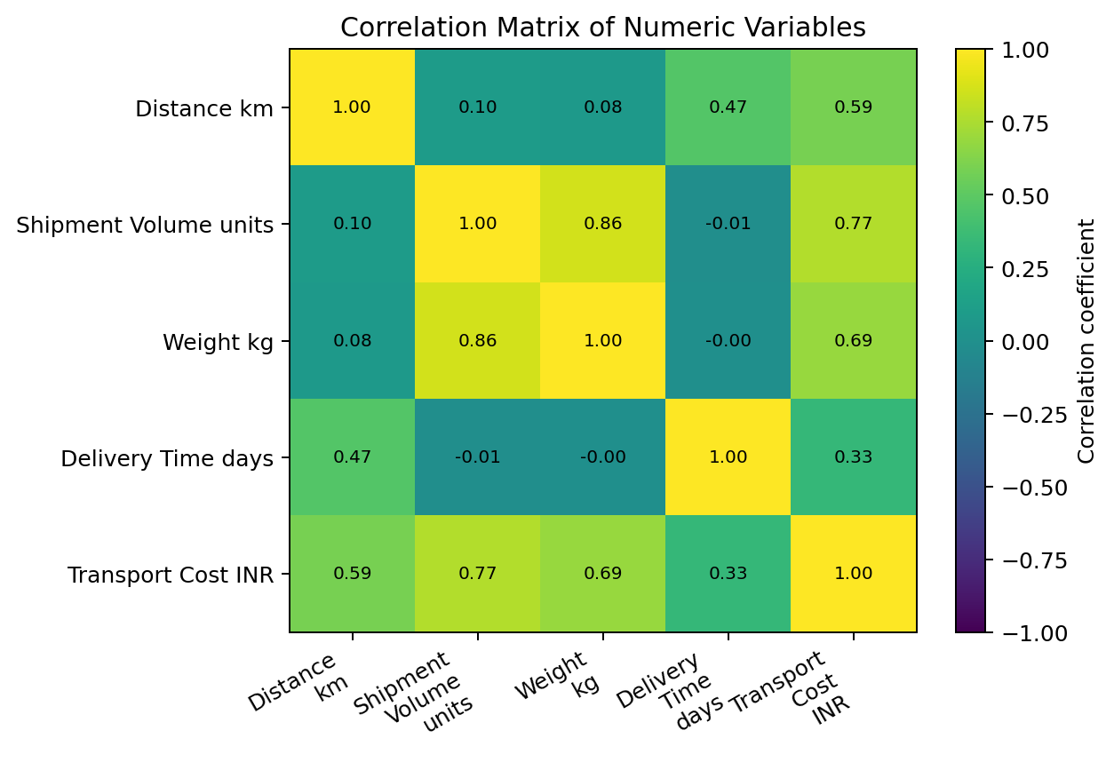
Figure 5. Correlation matrix.
The correlation matrix summarises linear relationships. Distance and cost have correlation 0.59; shipment volume and cost have correlation 0.77. Positive values mean the two measures tend to increase together. Correlation is not proof of causation and may be affected by other variables.
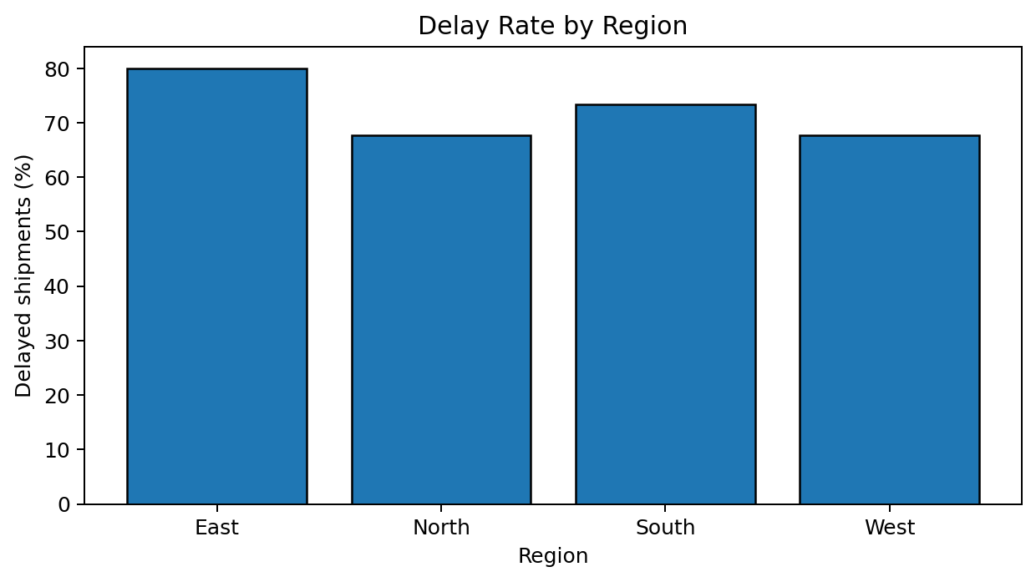
Figure 6. Delay rate by region.
This chart compares the percentage of shipments crossing the chosen 3.2-day threshold. A rate is more comparable than raw counts when regions have different shipment volumes. The threshold is a demonstration rule and should be replaced by a real service-level agreement in practice.

7. Key Analytical Findings
1. Delivery performance: average delivery time is 4.55 days; 71.7% of shipments exceed the illustrative 3.2-day threshold.
2. Regional variation: West has the lowest average delivery time (4.31 days), while North has the highest (4.73 days). This is a prompt for investigation, not proof of poor regional management.
3. Cost comparison: Truck has the lowest average cost per shipment (₹156.65) and Rail the highest (₹180.34) in this generated sample.
4. Distance matters: the correlation between distance and delivery time is 0.47; the correlation between distance and cost is 0.59. Route length should therefore be considered when planning budgets and delivery promises.
5. Data limitations: the dataset is synthetic, small, and generated from assumed relationships. Results demonstrate analytical methods and must not be treated as real business evidence.

8. Recommendations
- Monitor on-time delivery and define the delay threshold using the organisation’s actual service-level agreement.
- Investigate the slowest regions using route-level details, traffic patterns, warehouse dwell time, and hand-off timestamps.
- Compare transport modes on similar distances, volumes, and service requirements before reallocating shipments.
- Use distance and shipment volume when estimating transport costs; review unexpected cost outliers for fuel, tolls, extra handling, or data-entry errors.
- Build a weekly dashboard with average and median delivery time, delay rate, cost per shipment, cost per kilometre, and shipment volume.
- Collect real operational data over a longer period and repeat the analysis monthly to identify seasonality and improvement trends.

9. Limitations and Ethical Use
This is a learning exercise based on fictional records. The data cannot establish actual logistics performance, and correlation does not establish causation. The 3.2-day delay threshold is illustrative. For real use, document data sources, protect personal and commercial information, validate data quality, and explain assumptions clearly.

10. Python Code Appendix
The following example demonstrates how to load the CSV, inspect the data, calculate statistics, and create the main charts. The dataset file is supplied separately with this report.
import pandas as pd
import matplotlib.pyplot as plt

# Load the hypothetical dataset
df = pd.read_csv("hypothetical_logistics_dataset.csv")

# Inspect the dataset and check quality
print(df.head())
print(df.info())
print(df.isnull().sum())
print(df.describe())

# Central tendency and spread
metrics = ["Distance_km", "Shipment_Volume_units",
"Delivery_Time_days", "Transport_Cost_INR"]
print(df[metrics].agg(["mean", "median", "std", "min", "max"]))

# Correlation between numeric variables
print(df[metrics].corr())

# Histogram: delivery-time distribution
plt.hist(df["Delivery_Time_days"], bins=14, edgecolor="black")
plt.xlabel("Delivery time (days)")
plt.ylabel("Number of shipments")
plt.title("Distribution of Delivery Times")
plt.tight_layout()
plt.show()

# Scatter plot: distance and delivery time
plt.scatter(df["Distance_km"], df["Delivery_Time_days"], alpha=0.7)
plt.xlabel("Distance (km)")
plt.ylabel("Delivery time (days)")
plt.title("Distance vs Delivery Time")
plt.tight_layout()
plt.show()

# Bar chart: average cost by transport mode
df.groupby("Transport_Mode")["Transport_Cost_INR"].mean().plot(
kind="bar", edgecolor="black"
)
plt.xlabel("Transport mode")
plt.ylabel("Average cost (INR)")
plt.title("Average Transport Cost by Mode")
plt.tight_layout()
plt.show()

# Delay rate by region (illustrative threshold)
df["Delayed"] = df["Delivery_Time_days"] > 3.2
(df.groupby("Region")["Delayed"].mean() * 100).plot(
kind="bar", edgecolor="black"
)
plt.xlabel("Region")
plt.ylabel("Delayed shipments (%)")
plt.title("Delay Rate by Region")
plt.tight_layout()
plt.show()

11. Conclusion
This task demonstrates how exploratory data analysis and visualisation can turn shipment records into understandable operational evidence. Descriptive statistics summarise typical performance, charts reveal variation and possible bottlenecks, and correlation analysis helps identify relationships between distance, time, volume, and cost. The most useful next step is to apply the same workflow to validated real logistics data and check whether the patterns persist.

Appendix: Dataset File
The accompanying CSV file contains all 120 simulated shipment records: hypothetical_logistics_dataset.csv.

