WEEK 4 TASK
Predictive Modeling and Optimization in Logistics Systems
Forecasting delivery time with Python and developing operational recommendations

Student Name: VASANTHI M
Course / Department: B.Sc Computer Science
Institution: St. Anne's Arts and Science College
Submission Date: 20-10-2026

1. Executive Summary
This report demonstrates a predictive analytics workflow for logistics by forecasting shipment delivery time from operational features. A synthetic dataset of 300 shipments was created with distance, shipment volume, weight, transport mode, region, traffic level, and weather conditions. Three regression models were trained and compared using a hold-out test set: Linear Regression, Decision Tree, and Random Forest. The best model by test RMSE was Linear Regression, with MAE 0.47 days, RMSE 0.60 days, and R-squared 0.810. Five-fold cross-validation on the training data gave an average RMSE of 0.56 days. These results demonstrate a process, not a production-ready service: the data is simulated and the values should not be treated as real logistics performance.

2. Problem Definition
Logistics teams need reliable delivery estimates to communicate with customers, allocate vehicles, plan warehouse operations, and identify shipments at risk of delay. The prediction problem in this report is: given the known shipment and operating conditions, estimate the number of days required to deliver a shipment.
Target variable: Delivery_Time_days (continuous numeric value). This is a regression problem because the output is a number of days, not a category. The prediction is intended to support planning; it should not replace dispatcher judgement or verified tracking information.

3. Dataset Simulation and Features
The dataset contains 300 fictional shipment records and was generated with NumPy using a fixed random seed for reproducibility. The target delivery time was simulated using distance and additional effects for mode, traffic, weather, region, shipment volume, and random variation.
Feature | Meaning
Distance_km | Estimated distance from origin to destination, in kilometres.
Shipment_Volume_units | Number of units in the shipment.
Weight_kg | Estimated shipment weight, in kilograms.
Transport_Mode | Van, Truck, or Rail.
Region | North, South, East, or West.
Traffic_Level | Low, Medium, or High.
Weather | Clear or Rainy.
Delivery_Time_days (target) | Simulated delivery duration, in days.
Shipment_ID is a record identifier and is excluded from model inputs because it has no meaningful predictive information. In a real system, features must be available at the time a prediction is made; information recorded only after delivery must not be used.

4. Methodology and Workflow
- Generate the hypothetical shipment dataset and save it as CSV.
- Inspect rows, data types, missing values, and descriptive statistics.
- Separate predictors (X) from the target (y).
- Split data into 80% training and 20% test data using a fixed random state.
- Impute missing numeric values with the median and categorical values with the most frequent category.
- Convert categorical features into numeric indicator columns using one-hot encoding.
- Train three regression models using a consistent preprocessing pipeline.
- Compare test-set MAE, RMSE, and R-squared; select the model with the lowest RMSE.
- Use five-fold cross-validation on training data to check performance stability.
- Translate model insights into practical optimization actions.

5. Model Selection

5.1 Linear Regression
Linear Regression provides a simple baseline and estimates a linear relationship between input features and delivery time. It is relatively easy to explain, but may not capture complex interactions or non-linear patterns.

5.2 Decision Tree Regressor
A Decision Tree splits data into feature-based groups and can represent non-linear relationships. It is easy to explain conceptually, but a deep tree may overfit. The example limits tree depth and sets a minimum leaf size.

5.3 Random Forest Regressor
Random Forest combines predictions from many decision trees. Averaging helps reduce the instability of a single tree and can capture non-linear relationships. It is less interpretable than a simple linear model, so results should be checked and explained carefully.
All three models use the same train/test split and preprocessing approach for a fair comparison. The selected model is the one with the lowest test RMSE, while MAE and R-squared provide additional context.

6. Python Implementation
The following code excerpt shows the main training and evaluation process. The complete runnable script can be saved separately if required; this report includes the core reproducible workflow.
import pandas as pd
import numpy as np
from sklearn.model_selection import train_test_split, cross_val_score, KFold
from sklearn.compose import ColumnTransformer
from sklearn.preprocessing import OneHotEncoder
from sklearn.impute import SimpleImputer
from sklearn.pipeline import Pipeline
from sklearn.linear_model import LinearRegression
from sklearn.tree import DecisionTreeRegressor
from sklearn.ensemble import RandomForestRegressor
from sklearn.metrics import mean_absolute_error, mean_squared_error, r2_score

df = pd.read_csv("week4_logistics_prediction_dataset.csv")
target = "Delivery_Time_days"
features = [c for c in df.columns if c not in ["Shipment_ID", target]]
X, y = df[features], df[target]

num = ["Distance_km", "Shipment_Volume_units", "Weight_kg"]
cat = ["Transport_Mode", "Region", "Traffic_Level", "Weather"]
prep = ColumnTransformer([
("num", SimpleImputer(strategy="median"), num),
("cat", Pipeline([
("imputer", SimpleImputer(strategy="most_frequent")),
("encode", OneHotEncoder(handle_unknown="ignore"))
]), cat)
])
X_train, X_test, y_train, y_test = train_test_split(
X, y, test_size=0.20, random_state=42
)
models = {
"Linear Regression": LinearRegression(),
"Decision Tree": DecisionTreeRegressor(
max_depth=5, min_samples_leaf=4, random_state=42),
"Random Forest": RandomForestRegressor(
n_estimators=150, max_depth=10,
min_samples_leaf=3, random_state=42)
}

for name, model in models.items():
pipe = Pipeline([("prep", prep), ("model", model)])
pipe.fit(X_train, y_train)
pred = pipe.predict(X_test)
mae = mean_absolute_error(y_test, pred)
rmse = np.sqrt(mean_squared_error(y_test, pred))
r2 = r2_score(y_test, pred)
print(name, "MAE:", mae, "RMSE:", rmse, "R2:", r2)

7. Evaluation Metrics and Validation
Mean Absolute Error (MAE) is the average absolute difference between predicted and actual delivery time. It is easy to interpret in days and is less influenced by large errors than RMSE.
Root Mean Squared Error (RMSE) squares errors before averaging and then takes the square root. It is expressed in days and penalises large errors more strongly. Lower MAE and RMSE indicate better predictions.
R-squared (R²) measures how much variation in the target is explained by the model relative to a baseline. A value closer to 1 generally indicates better fit, but it does not directly show the size of prediction errors and can be negative on test data.
The dataset was split into 80% training and 20% test data. The test set was kept separate from model fitting. Five-fold cross-validation on the training data provides an additional estimate of how performance varies across different train/validation folds. In a real time-ordered logistics dataset, a chronological split may be more appropriate to avoid using future patterns to predict the past.

8. Model Performance Results
Model | MAE (days) | RMSE (days) | R-squared
Linear Regression | 0.469 | 0.597 | 0.810
Random Forest | 0.527 | 0.649 | 0.775
Decision Tree | 0.671 | 0.821 | 0.639
Based on the simulated test sample, Linear Regression produced the lowest RMSE (0.597 days). Its MAE was 0.469 days, meaning the average absolute prediction error was about 0.47 days. Its test R-squared was 0.810. The five-fold cross-validation RMSE for the selected model averaged 0.560 days. Since the data was generated from assumed patterns, this score measures how well the model recovers those simulated patterns; it does not guarantee the same performance on real shipments.
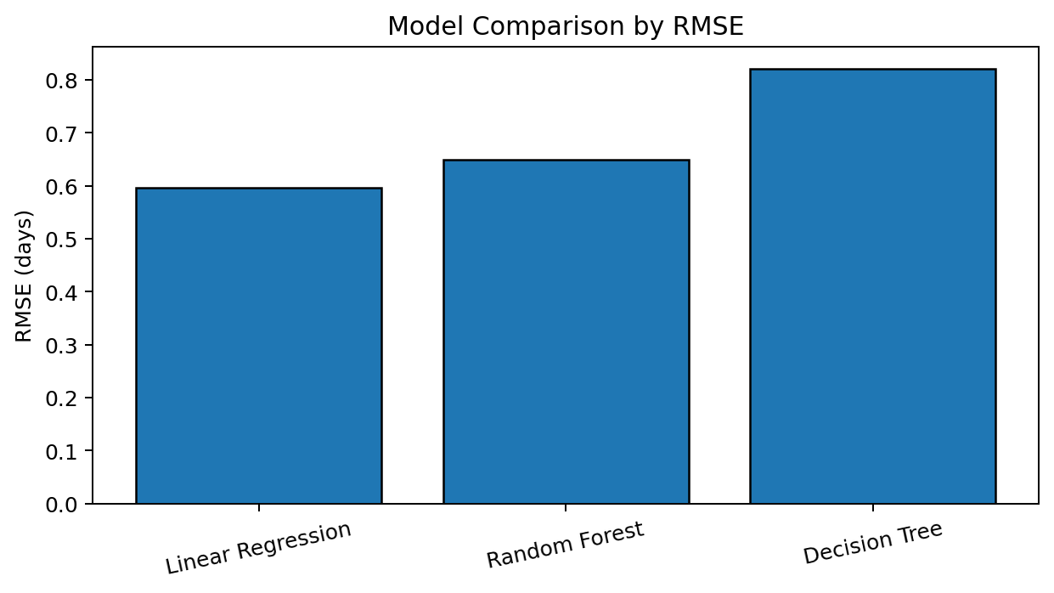
Figure 1. Comparison of models using RMSE. Lower bars indicate smaller typical squared-error-based prediction error.
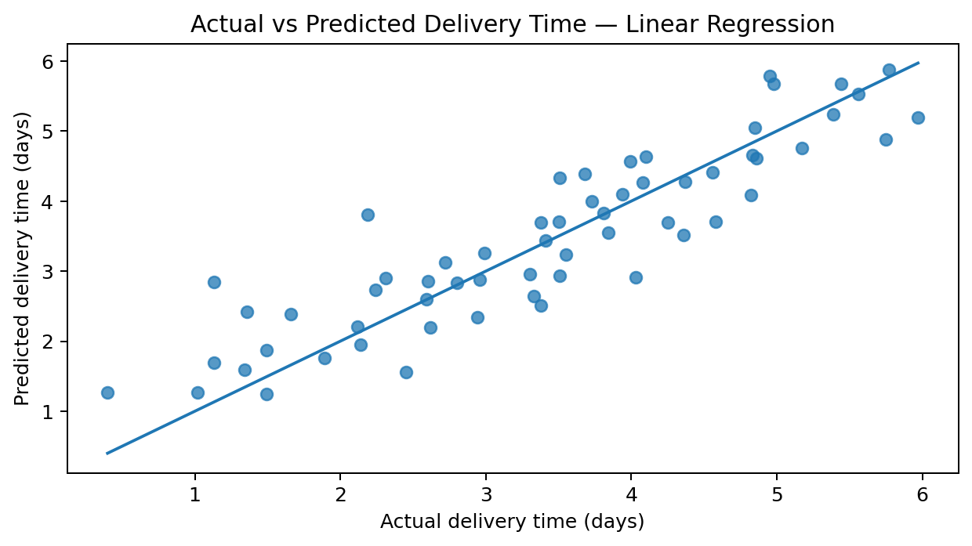
Figure 2. Actual versus predicted delivery times for the selected model. Points nearer the diagonal line indicate closer predictions.
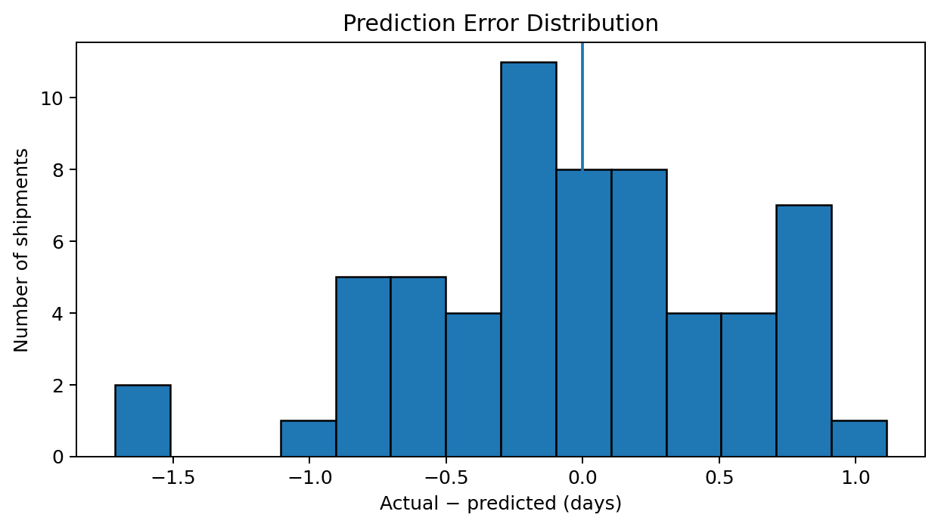
Figure 3. Prediction error distribution. Errors around zero indicate balanced predictions; a wide spread indicates less consistent estimates.

9. Optimization Strategies for Logistics
Predictive dispatch planning: Use predicted delivery duration to set realistic delivery windows and identify shipments that may need earlier dispatch.
Route and distance planning: Compare alternative routes using distance, expected traffic, weather, tolls, and service constraints. Do not choose the shortest route automatically if it is less reliable.
Transport-mode allocation: Compare vans, trucks, and rail for similar distances and loads. Balance cost, speed, capacity, handling, and reliability rather than selecting a mode from raw average cost alone.
Delay-risk monitoring: Flag shipments whose predicted duration exceeds the agreed service-level target. Send these for human review and update customers with realistic estimates.
Resource allocation: Use expected workload and shipment volume to plan drivers, vehicles, warehouse shifts, and loading capacity.
Cost optimization: Evaluate cost per kilometre and cost per unit alongside delivery time. Test operational changes on a pilot group before wider deployment.
Continuous model monitoring: Track MAE and RMSE over time. Retrain when route patterns, traffic, weather, demand, or operating policies change.

10. Proposed Optimization Workflow
- Collect current shipment data and verify that inputs are accurate.
- Generate delivery-time predictions before dispatch or at defined checkpoints.
- Compare predictions with delivery commitments and flag likely late shipments.
- Review feasible alternatives such as earlier dispatch, a different route, or another transport mode.
- Estimate the effect on time, cost, and capacity before making a change.
- Record the actual outcome and compare it with the prediction.
- Use the results to improve planning rules and retrain the model when appropriate.

11. Limitations and Responsible Use
- The dataset is synthetic and contains only 300 records; it does not represent actual logistics operations.
- The target was generated using assumed relationships, so model performance may be unusually favourable compared with real data.
- Important variables may be missing, including departure time, delivery deadline, driver hours, road closures, fuel costs, warehouse waiting time, and actual route choices.
- Correlation and predictive accuracy do not prove causation. A model should not automatically make expensive or safety-critical decisions.
- Real deployment requires representative historical data, privacy protection, monitoring, human review, and validation across different regions and operating conditions.

12. Conclusion
This task demonstrates a complete introductory predictive modelling workflow for logistics. A simulated dataset was prepared, three regression approaches were compared, and model quality was assessed using MAE, RMSE, R-squared, and five-fold cross-validation. Linear Regression performed best by test RMSE in this experiment. The predictions can inform delivery planning, route review, transport-mode comparison, resource allocation, and early delay-risk checks. The most important next step is to repeat the workflow using reliable real-world shipment records and test whether the results remain accurate before operational use.

Appendix: Dataset
The accompanying file week4_logistics_prediction_dataset.csv contains 300 simulated shipments and all predictor columns used in this task.

