PHASE 6
Project Testing Phase
AI Study Buddy API - Learn Mate: AI assistant for smarter learning and study support
Test strategy, test cases, evidence and bug fixes

1. Purpose
This phase verifies that every feature of AI Study Buddy works correctly, securely and reliably before release.

2. Testing Strategy
Type | Details
Unit testing | Individual functions such as token generation, password hashing, prompt builders.
API / integration testing | Endpoints tested with Postman: request, response, status code, database changes.
Security testing | Access without token, wrong role, tampered token, accessing another user's data.
Validation testing | Missing fields, invalid email, weak password, unsupported file type.
Performance check | Response time for normal APIs and AI-based APIs.

3. Test Cases
ID | Test scenario | Expected result | Actual | Status
TC-01 | Register with valid details | 201 Created, user saved, password hashed | As expected | Pass
TC-02 | Register with existing email | 400 Error - email already exists | As expected | Pass
TC-03 | Login with correct credentials | 200 OK with JWT token | As expected | Pass
TC-04 | Login with wrong password | 401 Unauthorised | As expected | Pass
TC-05 | Access protected route without token | 401 Not authorised | As expected | Pass
TC-06 | Student accesses admin route | 403 Forbidden | As expected | Pass
TC-07 | Upload valid PDF | 201 Created, text extracted | As expected | Pass
TC-08 | Upload unsupported file type | 400 Invalid file type | As expected | Pass
TC-09 | Generate summary | 200 OK, summary saved | As expected | Pass
TC-10 | Generate flashcards | 200 OK, cards array returned | As expected | Pass
TC-11 | Generate quiz | 200 OK, questions with options | As expected | Pass
TC-12 | Submit quiz answers | Score calculated, weak topics returned | As expected | Pass
TC-13 | Generate study plan | Day-wise plan returned | As expected | Pass
TC-14 | Access another user's material | 403 / 404 response | As expected | Pass
(Update the Actual and Status columns with your real test results.)

4. Test Evidence (Postman Screenshots)
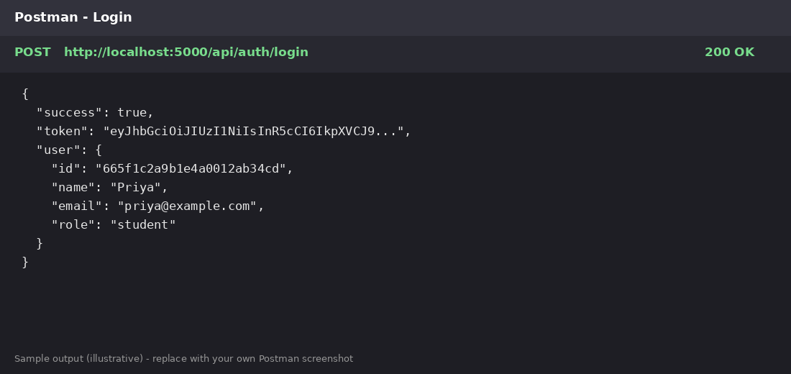
Figure 6.1: Login API test (sample - replace with your own screenshot)
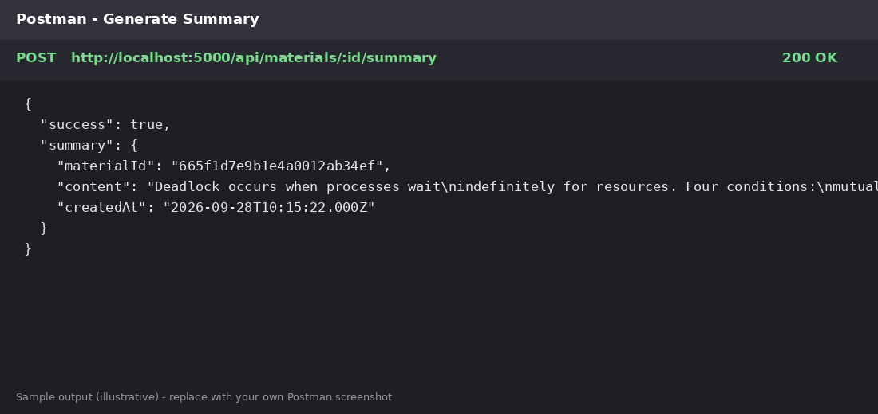
Figure 6.2: Summary generation API test (sample - replace with your own screenshot)

5. Bugs Found & Fixed
# | Bug | Fix
1 | Server crashed when Gemini returned invalid JSON | Added try/catch and JSON cleaning before parsing.
2 | Password returned in login response | Excluded password field using select('-password').
3 | Large PDF caused timeout | Implemented text chunking.

6. Test Summary
All planned test cases passed after bug fixes. The application handles invalid input, unauthorised access and AI errors gracefully and is ready for documentation and demonstration.

