PHASE 7
Project Documentation Phase
AI Study Buddy API - Learn Mate: AI assistant for smarter learning and study support
Final consolidated project documentation

1. Purpose
This document is the final consolidated project documentation for AI Study Buddy, so that any developer, evaluator or user can understand, install and use the system.

2. Abstract
AI Study Buddy (Learn Mate) is a RESTful backend built with Node.js, Express.js and MongoDB that lets students upload study material and receive AI-generated summaries, flashcards, quizzes and personalised study plans through the Google Gemini API. JWT authentication, bcryptjs password hashing and role-based access control secure the platform.

3. Problem Statement
Students such as Priya face information overload, lack of quick revision tools, no easy way to self-assess and scattered resources. AI Study Buddy addresses all these problems on one centralised platform.

4. Technology Stack
Layer | Technology
Backend | Node.js, Express.js (REST)
Database | MongoDB, Mongoose ODM
Security | JWT, RBAC, bcryptjs
AI | Google Gemini API
Testing | Postman

5. System Architecture
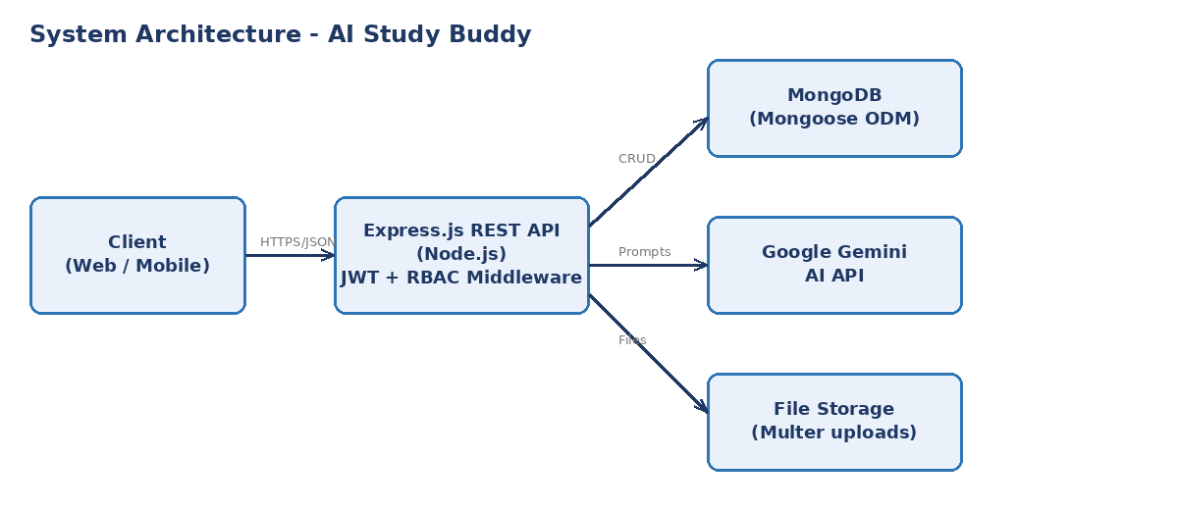
Figure 7.1: System architecture

6. Features
- Secure registration and login with JWT.
- Role-based access to premium and admin features.
- Upload of study material and text extraction.
- AI summaries, flashcards, quizzes and study plans.
- Central, secure storage of all generated resources.

7. Installation & Setup Guide
- Clone the repository: git clone <your-repo-url>
- Open the folder and run: npm install
- Create .env with PORT, MONGO_URI, JWT_SECRET, GEMINI_API_KEY
- Start the server: npm run dev (or npm start)
- Test the APIs with Postman using the provided collection.

8. API Documentation
Method | Endpoint | Description
POST | /api/auth/register | Register a new user
POST | /api/auth/login | Login and get JWT
POST | /api/materials | Upload study material
GET | /api/materials | List user's materials
POST | /api/materials/:id/summary | Generate AI summary
POST | /api/materials/:id/flashcards | Generate flashcards
POST | /api/materials/:id/quiz | Generate quiz
POST | /api/quizzes/:id/submit | Submit quiz answers
POST | /api/plans | Generate study plan

9. Results & Benefits
- Hours of reading reduced to minutes through instant summaries.
- Quick revision with flashcards; immediate feedback through quizzes.
- Organised preparation with personalised study plans.

10. Limitations & Future Scope
- Limitations: dependence on Gemini API availability and limits; AI output may need review.
- Future scope: React/Flutter front end, doubt-solving chatbot, OCR for handwritten notes, progress analytics dashboard, gamification and note sharing.

11. Conclusion
AI Study Buddy successfully demonstrates how Generative AI combined with a secure Node.js backend can automate summarisation, revision and self-assessment, helping students prepare smarter and faster.

12. References
- Node.js documentation - nodejs.org
- Express.js documentation - expressjs.com
- MongoDB and Mongoose documentation - mongodb.com, mongoosejs.com
- Google Gemini API documentation - ai.google.dev
- JSON Web Token introduction - jwt.io

