PHASE 8
Project Demonstration Phase
AI Study Buddy API - Learn Mate: AI assistant for smarter learning and study support
Demo plan, flow, screens and viva questions

1. Purpose
This document is the plan and script for demonstrating AI Study Buddy to evaluators, showing the problem, the solution and the working features end-to-end.

2. Demonstration Objectives
- Explain the problem faced by students like Priya.
- Show the working solution through live API/UI flow.
- Highlight security, AI integration and technology choices.

3. Pre-Demo Checklist
- MongoDB connected and server running without errors.
- Valid Gemini API key in .env and internet connection working.
- Postman collection imported; sample PDF ready (for example, Operating Systems notes).
- Sample student account and admin account created.
- Backup: screenshots / recorded video in case of network failure.

4. Demo Flow (About 10 Minutes)
Step | Activity | Time | What to show
1 | Introduction & problem | 1 min | Priya's case study and the five challenges.
2 | Architecture overview | 1 min | Architecture diagram and tech stack.
3 | Register and login | 1 min | JWT token received in response; hashed password in MongoDB.
4 | Upload material | 1 min | Upload a PDF; show saved material record.
5 | AI summary | 1.5 min | Generate and show summary.
6 | Flashcards | 1 min | Generated question/answer cards.
7 | Quiz and feedback | 1.5 min | Generate quiz, submit answers, show score and weak topics.
8 | Study plan | 1 min | Enter exam date and hours, show day-wise plan.
9 | Security demo | 0.5 min | Access without token (401) and student on admin route (403).
10 | Conclusion & Q and A | 1 min | Benefits, future scope, questions.

5. Demo Screens
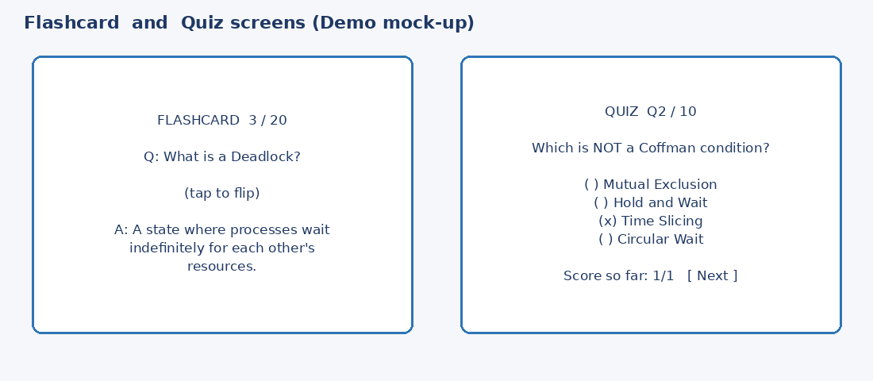
Figure 8.1: Flashcard and quiz screens (sample mock-up - replace with your own screenshots)
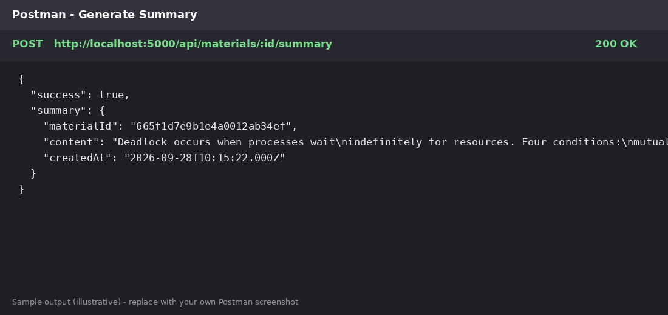
Figure 8.2: Summary API response in Postman (sample - replace with your own)

6. Key Points to Highlight
- Hours of reading reduced to a short AI-generated summary.
- Active recall with flashcards and instant self-assessment with quizzes.
- Personalised study plan based on exam date and available time.
- Secure design: JWT, RBAC and bcryptjs.

7. Expected Questions & Answers
Question | Suggested answer
Why Google Gemini? | Strong language understanding, easy API, generous free tier suitable for students.
Why MongoDB? | Flexible document schema suits AI-generated content like flashcards and quizzes.
How is user data secured? | Passwords hashed with bcryptjs, JWT authentication, RBAC and per-user data filtering.
What if the AI gives a wrong answer? | Output is validated and saved for review; students can regenerate content.
What is the future scope? | Front-end app, chatbot, OCR for handwritten notes, analytics and gamification.

8. Conclusion
The demonstration proves that AI Study Buddy solves Priya's core problems by giving her fast summaries, flashcards, quizzes and structured study plans in one secure platform.

