PHASE 3
Project Design Phase
AI Study Buddy API - Learn Mate: AI assistant for smarter learning and study support
Architecture, database, API and UI design

1. Purpose
This phase converts the requirements into a technical blueprint: system architecture, database design, API design, security design and user-interface layout.

2. System Architecture
The system follows a layered RESTful architecture. The client sends HTTPS requests to the Express.js API. Middleware validates the JWT and role, controllers handle business logic, Mongoose models talk to MongoDB, and a Gemini service module communicates with the Google Gemini API.
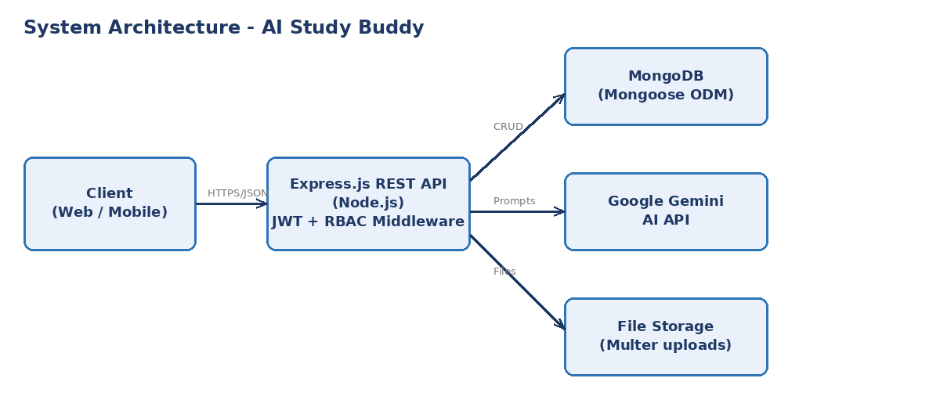
Figure 3.1: System architecture

3. Project Folder Structure
Folder / File | Responsibility
server.js / app.js | Application entry point, middleware and route mounting.
config/ | Database connection and environment configuration.
models/ | Mongoose schemas: User, Material, Summary, Flashcard, Quiz, StudyPlan.
routes/ | Route definitions for auth, materials, summaries, flashcards, quizzes, plans.
controllers/ | Business logic for each route.
middleware/ | JWT auth, RBAC, error handler, file upload.
services/ | Gemini AI service and PDF text extraction.

4. Database Design (MongoDB Collections)
Collection | Main fields
users | _id, name, email, password (hashed), role, createdAt
materials | _id, user (ref), title, fileName, extractedText, createdAt
summaries | _id, user (ref), material (ref), content, createdAt
flashcards | _id, user (ref), material (ref), cards[{question, answer}], createdAt
quizzes | _id, user (ref), material (ref), questions[{question, options[], correctAnswer, explanation}], createdAt
quizresults | _id, user (ref), quiz (ref), score, total, weakTopics[], takenAt
studyplans | _id, user (ref), examDate, dailyHours, plan[{date, topic, hours}], createdAt

Relationships: one user has many materials; each material can have many summaries, flashcard sets and quizzes; each quiz can have many results.

5. API Design
Method | Endpoint | Access | Purpose
POST | /api/auth/register | Public | Create account
POST | /api/auth/login | Public | Login and receive JWT
GET | /api/auth/me | Student | Get logged-in profile
POST | /api/materials | Student | Upload material
GET | /api/materials | Student | List own materials
DELETE | /api/materials/:id | Student | Delete material
POST | /api/materials/:id/summary | Student | Generate summary
POST | /api/materials/:id/flashcards | Student | Generate flashcards
POST | /api/materials/:id/quiz | Student / Premium | Generate quiz
POST | /api/quizzes/:id/submit | Student | Submit answers, get score
POST | /api/plans | Student / Premium | Generate study plan
GET | /api/admin/users | Admin | View all users

6. Security Design
- Authentication: JWT sent in the Authorization: Bearer header, with expiry.
- Password protection: bcryptjs hashing with salt rounds.
- Authorisation: RBAC middleware checks user role before premium/admin routes.
- Data protection: each user can access only their own data; secrets stored in .env.

7. AI Integration Design
A dedicated Gemini service builds a prompt for each task (summary, flashcards, quiz, plan) from the extracted text, requests structured JSON output, validates and parses the response, and saves it. Long documents are split into chunks before being sent.

8. UI Wireframe (Dashboard)
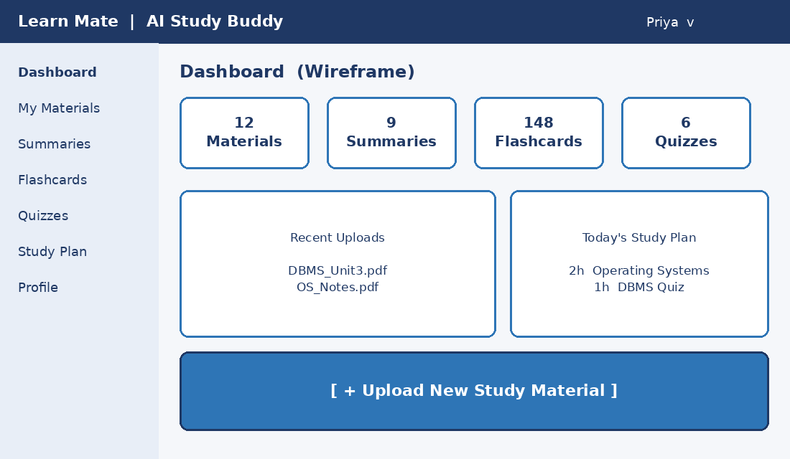
Figure 3.2: Dashboard wireframe

