PHASE 1
Brainstorming and Ideation Phase
AI Study Buddy API - Learn Mate: AI assistant for smarter learning and study support
Identifying the problem, generating ideas and selecting the solution

1. Project Overview
AI Study Buddy (Learn Mate) is an AI-powered learning assistance platform that helps students convert their study materials - lecture notes, PDFs, textbooks and handwritten notes - into concise summaries, flashcards, quizzes and personalised study plans using Generative AI. The backend is built with Node.js and Express.js, stores data in MongoDB, secures users with JWT and RBAC, and uses the Google Gemini API for natural language processing.

2. Problem Identification (Case Study: Priya)
Priya is a final-year Computer Science student balancing coursework, a final-year project and preparation for competitive exams and placement interviews. Brainstorming with her situation exposed the following pain points:
# | Problem | Impact on the student
1 | Information overload & time crunch | Reading 50+ page PDFs takes hours, leaving little time for understanding and practice.
2 | Inconsistent self-assessment | Creating mock questions manually is too time-consuming, so knowledge is rarely tested.
3 | Lack of quick revision tools | No flashcards or short summaries for last-minute revision before exams or interviews.
4 | Disorganised learning resources | Notes, summaries and questions are scattered across apps and folders.
5 | Poor exam-readiness tracking | No structured schedule, so weak topics are not identified in time.

3. Brainstorming Session

3.1 Ideas Generated
- Document summariser: upload a PDF and get a short, high-level summary.
- Flashcard generator: auto-extract key terms and definitions for active recall.
- Quiz generator: multiple-choice questions with instant feedback.
- Study planner: schedule built from exam dates and daily study hours.
- Centralised library: one secure place for materials and all AI-generated resources.
- Other ideas considered: voice notes to text, doubt-solving chatbot, streak/gamification, peer sharing of notes.

3.2 Idea Evaluation
Idea | Value to student | Feasibility | Priority | Decision
Summarisation | High | High | Must have | Selected
Flashcards | High | High | Must have | Selected
Quizzes | High | High | Must have | Selected
Study plan | Medium | High | Should have | Selected
Secure storage & auth | High | High | Must have | Selected
Doubt chatbot | Medium | Medium | Could have | Future scope
Gamification | Low | Medium | Could have | Future scope

4. Proposed Solution
A RESTful backend platform where a student registers, logs in, uploads study material and asks the system (through the Google Gemini API) to generate summaries, flashcards, quizzes and study plans. All generated content is saved in MongoDB against the student's account so it can be revised at any time.
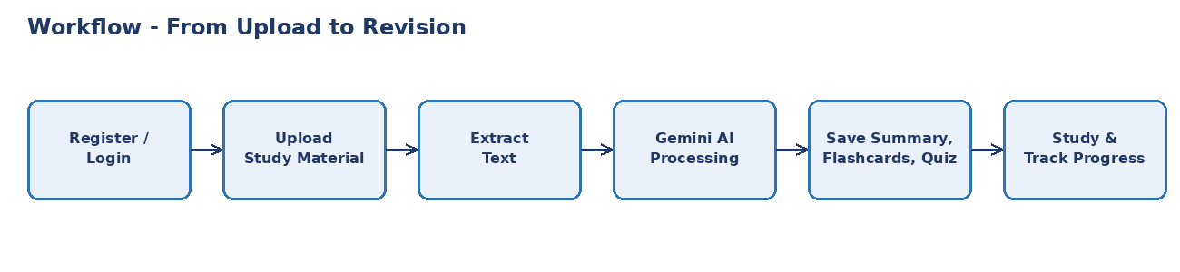
Figure 1.1: High-level idea flow - from upload to revision

5. Objectives
- Reduce the time students spend reading long study material.
- Provide instant, AI-generated tools for active recall and self-assessment.
- Help students track exam readiness with personalised study schedules.
- Keep all learning resources organised and secure in a single platform.

6. Target Users
- Students: school, college and competitive-exam aspirants (primary users).
- Premium students: access to advanced AI features controlled by RBAC.
- Admin: manages users and monitors the platform.

7. Expected Outcome
A working, scalable and secure AI study-assistant API that saves study time, improves revision quality and gives students a clear view of their preparation.

