PROJECT REPORT
AI FAQ Assistant API
AI-powered FAQ and customer support automation
Item | Details
Project Title | AI FAQ Assistant API
Technologies | Node.js, Express.js, MongoDB (Mongoose), JWT, bcrypt, Google Gemini (@google/genai)
Project Type | Headless REST API backend (MVC architecture)
Submitted By | Team leader : Petrina Shamitha. E [ sac2427csc5409@ssacollegechennai.com ]  Team members : Pooja. P [ sac2427csc5768@ssacollegechennai.com ]  Parvathi. K. M [ sac2427csc9482@ssacollegechennai.com ]  Noorul Thahira begum. M [ sac2427csc5405@ssacollegechennai.com ]
Guide / Institution | St Anne’s Arts And Science College
GitHub Repository | [Add your public GitHub repository link]
Demo Video | https://drive.google.com/file/d/1ajAZGgOaowPdyW2x5otcsLI84NeomSYJ/view?usp=drive_link

Contents
- Brainstorming & Ideation
- Requirement Analysis
- Project Design
- Project Planning
- Project Development
- Project Testing
- Project Documentation
- Project Demonstration
- Conclusion and Future Scope

1. Brainstorming & Ideation
The AI FAQ Assistant is a secure REST API that streamlines FAQ creation, user authentication and AI-powered content management. It uses Node.js and Express.js, stores data in MongoDB with Mongoose, protects routes with JWT and bcrypt, and generates FAQ content with Google Gemini.

1.1 Problem Statement
Priya is a customer support operations manager who handles a large backlog of repetitive user questions. She struggles to organise entries, classify topics, write precise answers and track question trends.
- Difficulty maintaining up-to-date documentation workflows.
- Limited visibility into keyword matches and quick query resolution.
- Time-consuming manual drafting of support answers.
- No unified permission layer protecting private documentation from public edits.

1.2 Ideas Considered and Selected Solution
Idea | Decision
FAQ CRUD API with categories | Selected
JWT login and role-based access | Selected
AI generation of FAQ question and answer from a topic (Gemini) | Selected
Keyword / semantic search and AI answers | Selected
Likes, feedback, tags, admin analytics dashboard, front-end app | Future scope

Selected solution: a centralised, secure backend that separates business logic from any front-end and offers authentication, FAQ management, search and AI generation. Key features: JWT authorization, AI FAQ generation, semantic search, full CRUD, category management, bcrypt encryption, centralised error handling, schema validation, RESTful modular design.

2. Requirement Analysis

2.1 Functional Requirements
- Register, log in and receive a JWT token; view own profile.
- Create FAQs (question, answer, category); update and delete only own FAQs.
- List all FAQs, view one FAQ and search by keyword (public).
- Generate an FAQ pair or an answer from a topic/question using Gemini AI (authenticated).
- Admin manages users, FAQs and categories.

2.2 Non-Functional Requirements
Security (bcrypt, JWT, CORS), reliability (centralised error handler), data integrity (Mongoose validation, unique email), performance (indexed search), scalability (modular MVC) and portability (Windows, macOS, Linux).

2.3 User Roles
Role | Permissions
Admin | Manage all users, any FAQ, categories and AI content; full access
Content Creator | Create FAQs, edit and delete own FAQs, generate FAQs with AI
Authenticated User | View and search FAQs, AI-assisted answers, own profile
Public User | View and search published FAQs only; no protected endpoints

2.4 Software and Hardware Requirements
Type | Requirement
Software | Windows 10/11, macOS or Linux; Node.js v18+; npm v9+; Express.js v4/v5; MongoDB with Mongoose; Postman or ThunderClient; VS Code; Google Gemini API key
Hardware | Intel Core i5 (8th Gen+) / AMD Ryzen 5; 8 GB RAM (16 GB recommended); 1 GB free disk space

3. Project Design
The system uses a layered server architecture: every request passes through parsing, authentication and validation before reaching the business logic and the database.

Figure 1: Technical architecture
Components: Express gateway (routing, JSON parsing, CORS); authentication middleware (JWT verification); services (business rules); Mongoose (database layer); Gemini service (AI generation); cross-cutting concerns (security, hashing, error handling, optional rate limiting).

3.1 Data Model (ER Diagram)

Figure 2: Entity-relationship diagram
User → FAQ is one-to-many (a user creates many FAQs) and Category → FAQ is one-to-many. The User collection stores name, email (unique), hashed password and role. The FAQ collection stores question, answer, category and createdBy (reference to User). AI generation and category are logical entities used before saving.

3.2 MVC Pattern

Figure 3: MVC architecture
Model: Mongoose schemas with rules and defaults. Controller: receives requests, checks constraints, delegates to models/services and returns JSON. View: in this headless backend, the API routing layer maps paths to controller handlers.

3.3 User Flow

Figure 4: User flow from registration to FAQ interaction
A user registers or logs in, receives a JWT, the role is verified, and every request follows the same path: token validation → role authorization → action (CRUD / search / AI) → JSON response.

4. Project Planning
The project was planned as five epics that follow the build order.
Epic | Goal | Key Tasks
1. Project Architecture | Decide layers and data model | Architecture, ER diagram, roles, user flow, MVC
2. Setup & Configuration | Prepare environment | Project and src folders, npm init, install packages
3. Backend Development | Build core scripts | server.js, app.js, middleware, controllers, services
4. Database Configuration | Model and connect data | db.js, User and FAQ schemas, routes
5. Project Execution | Run and verify | npm run dev, Postman tests, AI test, demo

Week | Activity | Deliverable
1 | Brainstorming, requirements, design | Phase 1–3 documents
2 | Planning and environment setup | Project skeleton
3 | Auth, middleware, models, FAQ routes | Register, login, CRUD working
4 | Gemini integration, search, validation | AI and search working
5 | Testing and documentation | Test report, README, GitHub upload
6 | Demo recording and submission | Demo video and final report

Main risks: Gemini quota or missing key (mitigated by .env and centralised error handling), database connection failure, weak JWT secret, and invalid input (mitigated by validation middleware and schema validation).

5. Project Development

5.1 Setup
npm init -y
npm install express mongoose dotenv cors jsonwebtoken bcrypt @google/genai

The project has a src folder with config (db.js), controllers (ai, auth, faq), middleware (auth, error, validation), models (FAQ, User), routes (ai, auth, faq), services (geminiService.js), utils (helpers.js), plus app.js, server.js and .env. Start the server with npm run dev.
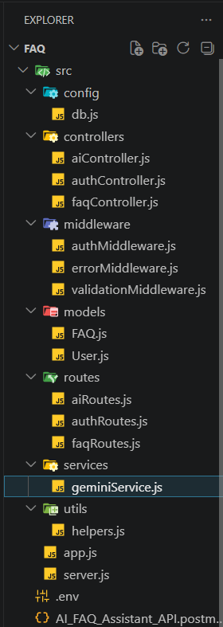
Figure 5: Project folder structure

5.2 Core Scripts
server.js connects to the database, reads PORT (default 5000), starts the listener and closes cleanly on unhandled rejections. app.js enables CORS, JSON parsing, a status route and registers /api/auth, /api/faqs and /api/ai.
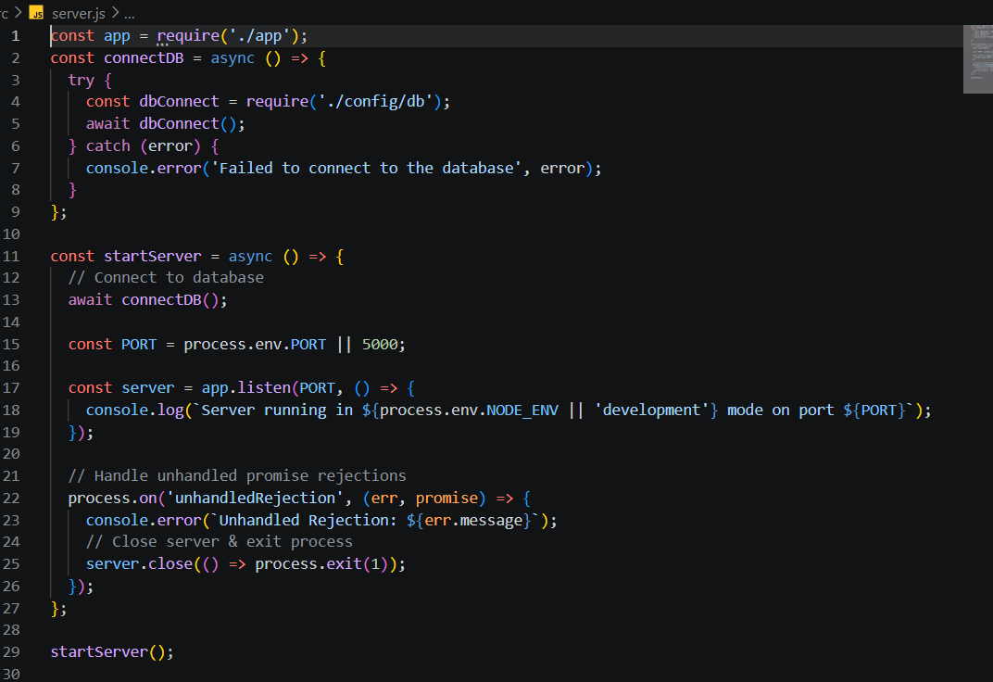  Figure 6: server.js | 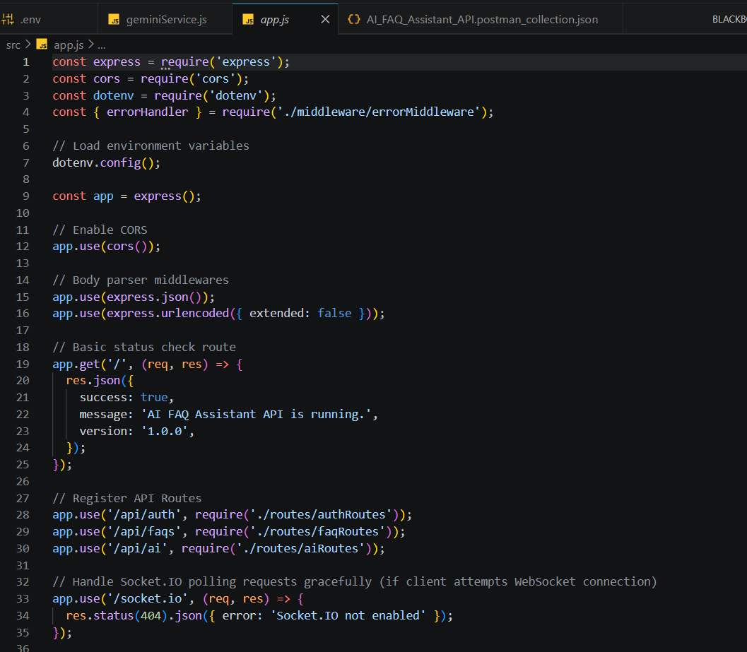  Figure 7: app.js

5.3 Security and Error Handling
authMiddleware.js verifies the Bearer token with JWT_SECRET, loads the user (without password) and returns 401 on failure. errorMiddleware.js returns clean JSON for Gemini/HTTP errors, duplicate keys, validation errors and invalid IDs, logging stack traces only for 500 errors.
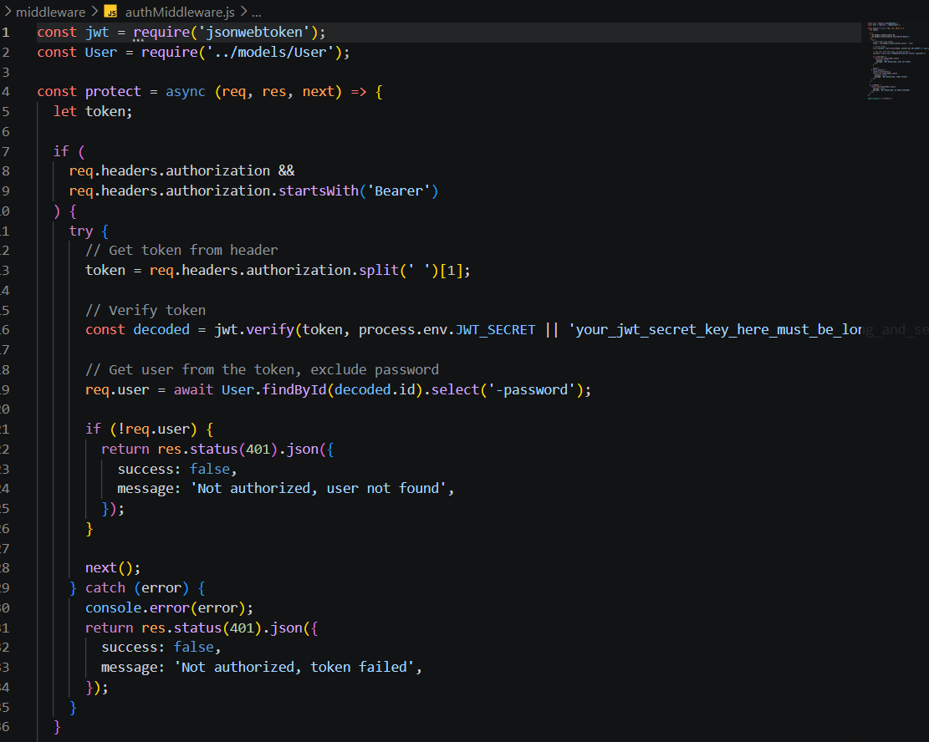  Figure 8: authMiddleware.js | 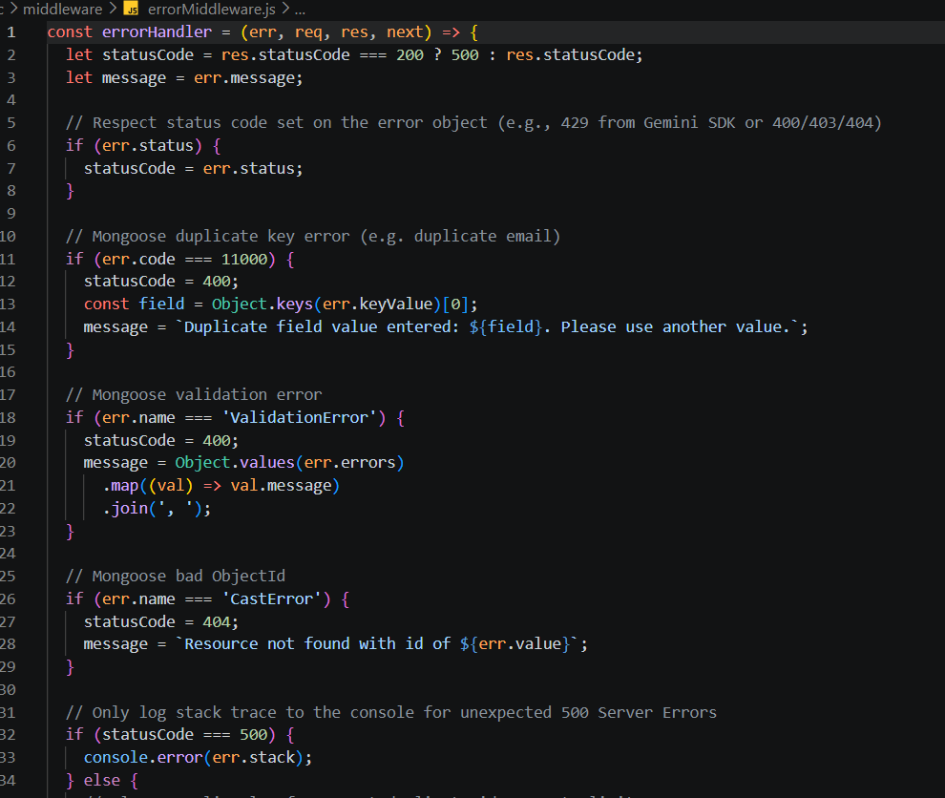  Figure 9: errorMiddleware.js

5.4 Database Schemas
User.js validates name, unique lowercase email and a password of at least 6 characters, and hashes the password with bcrypt (10 salt rounds) in a pre-save hook. FAQ.js stores question, answer, category (Technology, Education, Health, Banking, General) and createdBy (reference to User) with timestamps.
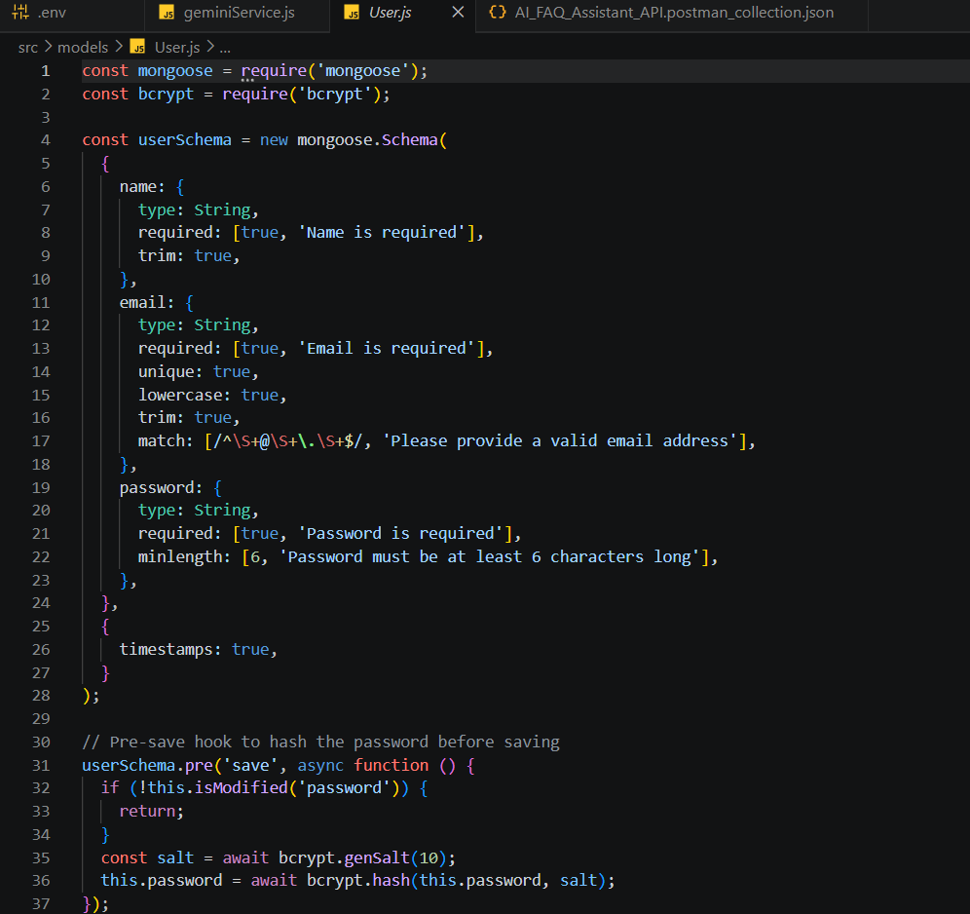  Figure 10: User.js | 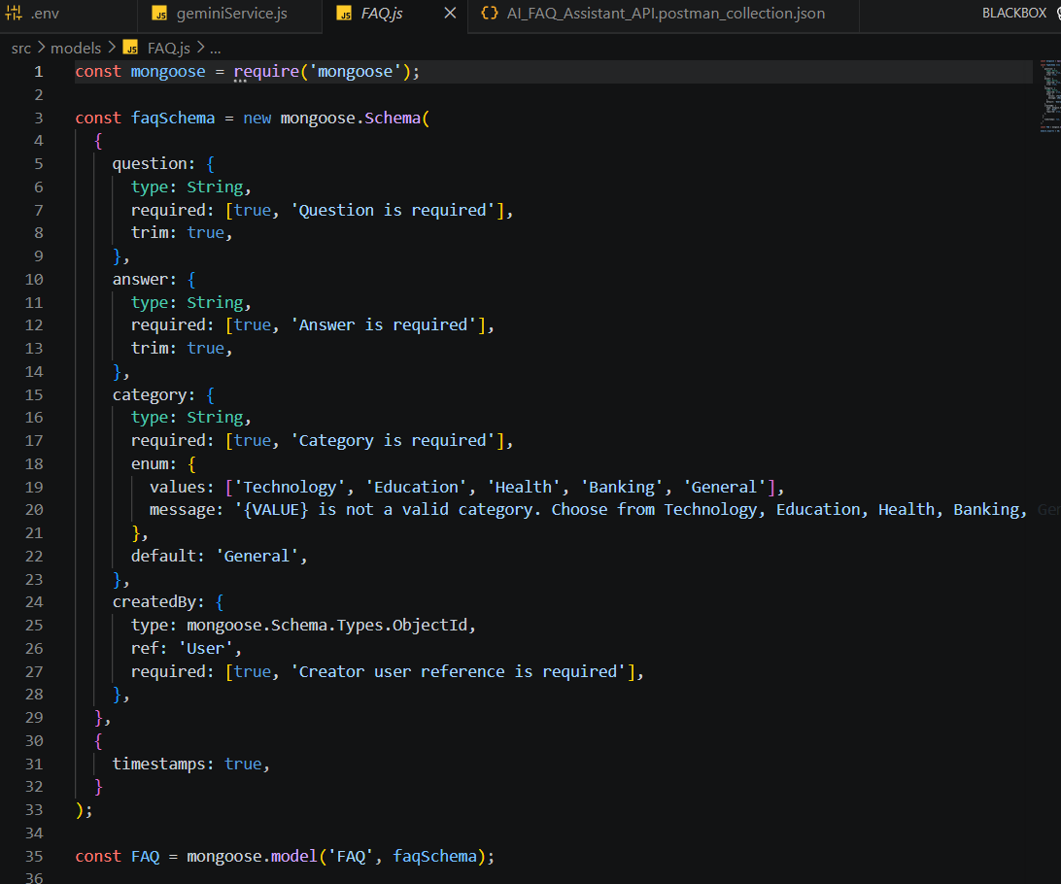  Figure 11: FAQ.js

5.5 API Routes
Method | Endpoint | Access | Purpose
POST | /api/auth/register | Public | Register user
POST | /api/auth/login | Public | Login, get JWT
GET | /api/auth/profile | Private | View profile
GET | /api/faqs, /api/faqs/search?q=, /api/faqs/:id | Public | List, search, view FAQ
POST | /api/faqs | Private | Create FAQ
PUT / DELETE | /api/faqs/:id | Private (owner) | Update / delete FAQ
POST | /api/ai/answer, /api/ai/generate-faq | Private | AI answer / AI FAQ

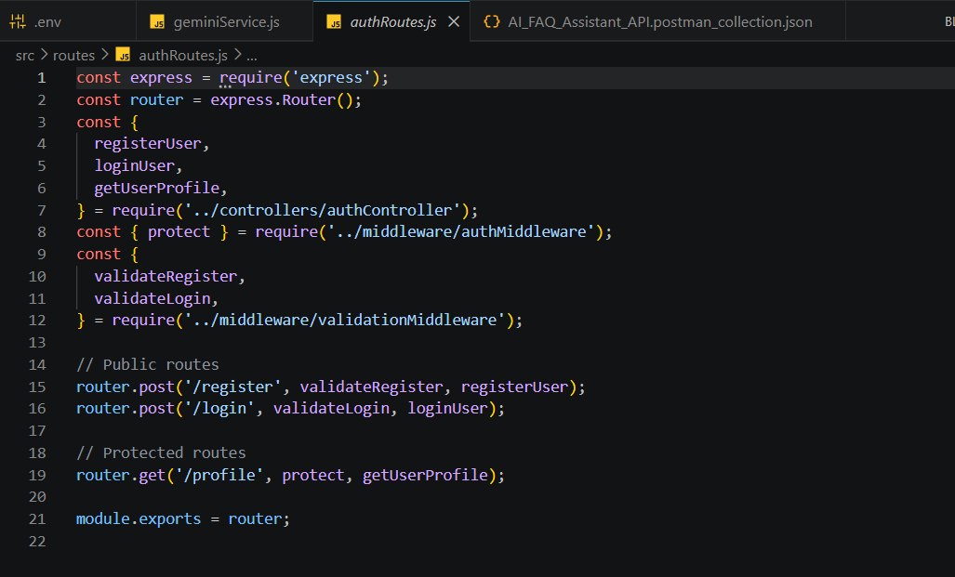  Figure 12: authRoutes.js | 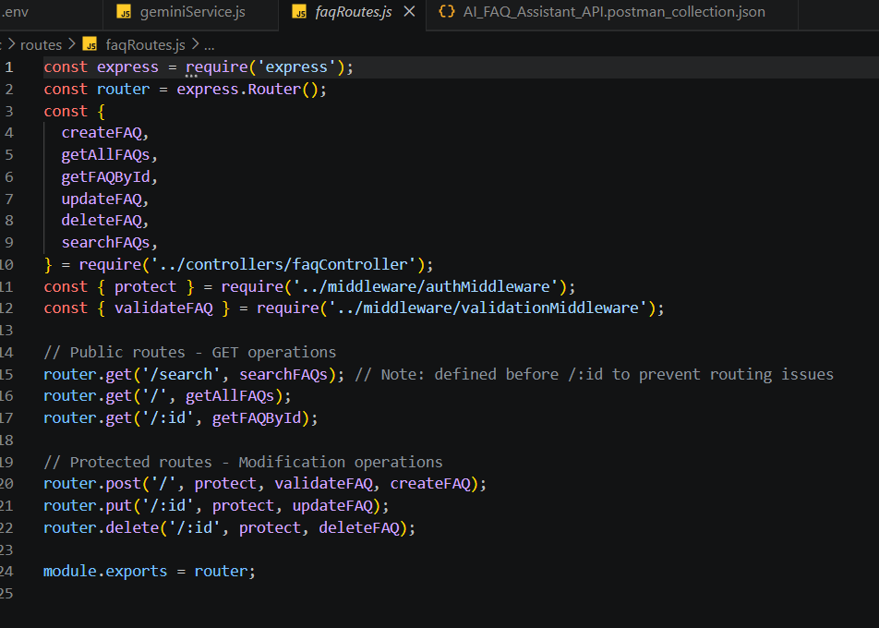  Figure 13: faqRoutes.js | 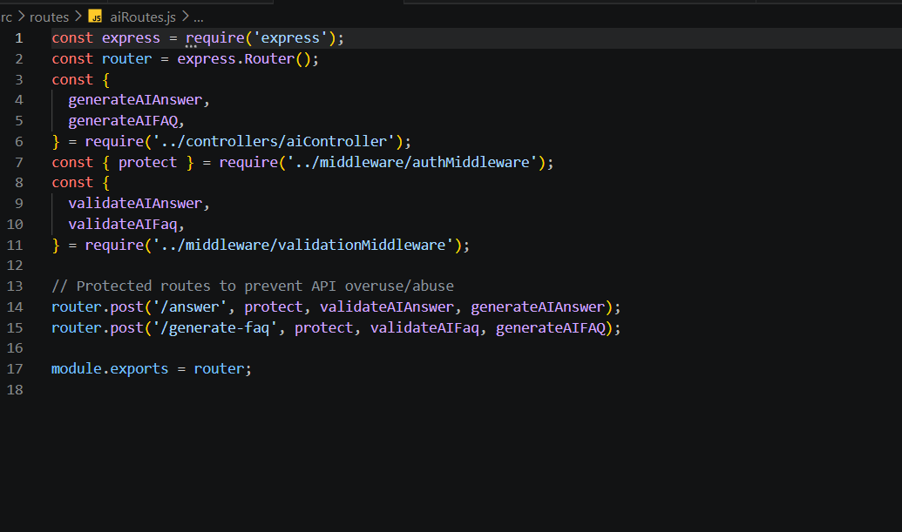  Figure 14: aiRoutes.js

6. Project Testing
All endpoints were tested in Postman / ThunderClient with the server running on port 5000.
ID | Test Case | Endpoint | Expected | Result
TC-01 | Register user | POST /api/auth/register | 201 Created + token | Pass
TC-02 | Login | POST /api/auth/login | 200 OK + token | Pass
TC-03 | Create FAQ (with token) | POST /api/faqs | 201 Created | Pass
TC-04 | Search FAQs | GET /api/faqs/search?q= | 200 OK + matches | Pass
TC-05 | AI generate FAQ | POST /api/ai/generate-faq | 200 OK + Q&A | [Attach result]

Sample request bodies
POST /api/auth/register { "name": "Priya Sharma", "email": "priya@writeflow.com", "password": "securepassword123" }
POST /api/faqs { "question": "What is node.js?", "answer": "...", "category": "Technology" }
POST /api/ai/generate-faq { "topic": "Mongoose schema indexing validation runtime workflow optimization" }
  Figure 15: Register – 201 Created |   Figure 16: Login – 200 OK
  Figure 17: Create FAQ – 201 Created |   Figure 18: Search FAQs – 200 OK
Note: the FAQ schema accepts only Technology, Education, Health, Banking or General, so category "Configuration" would be rejected. Use a valid category or extend the enum.

7. Project Documentation
Documentation includes the eight phase documents, a README with installation steps, and API reference tables. To run the project: install Node.js v18+ and MongoDB, clone the repository, run npm install, create a .env file (PORT, MongoDB connection string, JWT_SECRET, Gemini API key), then run npm run dev and call http://localhost:5000/.
Situation | Status | Message
Missing or invalid token | 401 | Not authorized, token failed
Duplicate email | 400 | Duplicate field value entered
Validation error | 400 | Combined validation messages
Invalid ObjectId | 404 | Resource not found
Server error | 500 | Generic message; stack logged on server only

Recommended GitHub layout: one folder per phase (1_Brainstorming_and_Ideation … 8_Project_Demonstration), source code in the development folder, and the README at the repository root. Do not upload the .env file.

8. Project Demonstration
The demo shows the API working end to end. Links:
- Demo video: https://drive.google.com/file/d/1ajAZGgOaowPdyW2x5otcsLI84NeomSYJ/view?usp=drive_link
- API testing video: https://drive.google.com/file/d/1u_w1sigiOynhmqTDbj4NBm3CLlMunEWN/view?usp=sharing
Step | Action
1 | Introduce the problem and architecture
2 | Start the server (npm run dev)
3 | Register and log in, copy the JWT token
4 | Create an FAQ with the Bearer token
5 | Search FAQs by keyword
6 | Generate an FAQ with AI from a topic
7 | Show a request without a token returning 401

9. Conclusion and Future Scope
The AI FAQ Assistant API delivers a secure, modular backend that reduces manual effort in creating and finding FAQs. JWT authentication and bcrypt protect users, schema validation keeps data consistent, and Google Gemini automates FAQ drafting, which directly addresses the problems faced by Priya.

Future Scope
- Likes, helpful/not-helpful feedback and tags for FAQs.
- Admin dashboard with analytics and logs.
- Front-end web and mobile applications.
- Rate limiting and caching for AI endpoints.

