PHASE 7 OF 8

Project Documentation Phase
User, developer and API documentation for the project
Item | Details
Project | AI FAQ Assistant API – AI-powered FAQ and customer support automation
Phase | 7. Project Documentation Phase
Tech Stack | Node.js, Express.js, MongoDB (Mongoose), JWT, bcrypt, Google Gemini (@google/genai)
Team / Author | [Add your name / team name]
Repository | [Add your public GitHub repository link]

1. Documentation Overview
This document consolidates everything a new user or developer needs to understand, install, run and use the AI FAQ Assistant API.

2. Project Summary
The AI FAQ Assistant is a headless REST API built with Node.js, Express.js and MongoDB. It provides JWT-based authentication, FAQ CRUD, category organisation, keyword/semantic search and Google Gemini powered FAQ and answer generation.

3. Installation and Setup Guide
- Install Node.js v18+, npm v9+ and MongoDB, and VS Code.
- Clone the repository from GitHub.
- Run npm install to install dependencies.
- Create a .env file in the root folder (see below).
- Start the server with npm run dev.
- Open Postman / ThunderClient and call http://localhost:5000/.

Environment variables (.env)
PORT=5000
NODE_ENV=development
MONGO_URI=<your MongoDB connection string>
JWT_SECRET=<a long random secret>
GEMINI_API_KEY=<your Google Gemini API key>
Note: use the exact variable names your db.js and geminiService.js read. Never upload the .env file to GitHub.

4. Project Structure
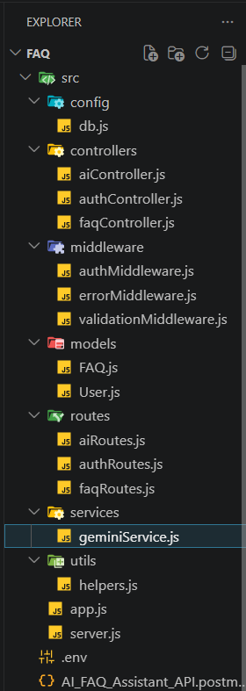
Figure 1: Project structure
Folder / File | Purpose
config/db.js | MongoDB connection
controllers/ | aiController, authController, faqController – request handling
middleware/ | authMiddleware (JWT), errorMiddleware, validationMiddleware
models/ | User.js and FAQ.js Mongoose schemas
routes/ | aiRoutes, authRoutes, faqRoutes
services/geminiService.js | Google Gemini integration
utils/helpers.js | Shared helper functions
app.js / server.js | Express setup / server start

5. API Reference
Method | Endpoint | Access | Body / Params | Success
POST | /api/auth/register | Public | name, email, password | 201
POST | /api/auth/login | Public | email, password | 200
GET | /api/auth/profile | Bearer token | – | 200
GET | /api/faqs | Public | – | 200
GET | /api/faqs/search | Public | ?q=keyword | 200
GET | /api/faqs/:id | Public | id in URL | 200
POST | /api/faqs | Bearer token | question, answer, category | 201
PUT | /api/faqs/:id | Bearer token (owner) | fields to update | 200
DELETE | /api/faqs/:id | Bearer token (owner) | id in URL | 200
POST | /api/ai/answer | Bearer token | question | 200
POST | /api/ai/generate-faq | Bearer token | topic | 200

Authorization header
Authorization: Bearer <JWT Token>

6. Roles Summary
Role | Can do
Admin | Everything, including managing users, categories and any FAQ
Content Creator | Create, edit, delete own FAQs; AI generation
Authenticated User | View, search, AI answers, profile
Public User | View and search only

7. Error Handling Reference
Situation | Status | Message
Missing/invalid token | 401 | Not authorized, token failed
User not found for token | 401 | Not authorized, user not found
Duplicate email | 400 | Duplicate field value entered: email
Schema validation error | 400 | Combined validation messages
Invalid ObjectId | 404 | Resource not found with id of ...
Server error | 500 | Generic error (stack logged only on server)

8. Documentation and Submission Links
Item | Link
GitHub public repository | [Add your public repository link]
API testing video | https://drive.google.com/file/d/1u_w1sigiOynhmqTDbj4NBm3CLlMunEWN/view?usp=sharing
Demo video | https://drive.google.com/file/d/1ajAZGgOaowPdyW2x5otcsLI84NeomSYJ/view?usp=drive_link

9. GitHub Folder Layout (Phase-wise)
1_Brainstorming_and_Ideation/
2_Requirement_Analysis/
3_Project_Design/
4_Project_Planning/
5_Project_Development/ (source code)
6_Project_Testing/
7_Project_Documentation/ (README, this document)
8_Project_Demonstration/ (demo link, notes)

