PHASE 3 OF 8

Project Design Phase
Architecture, data model, MVC pattern and user flow
Item | Details
Project | AI FAQ Assistant API – AI-powered FAQ and customer support automation
Phase | 3. Project Design Phase
Tech Stack | Node.js, Express.js, MongoDB (Mongoose), JWT, bcrypt, Google Gemini (@google/genai)
Team / Author | [Add your name / team name]
Repository | [Add your public GitHub repository link]

1. Design Overview
The AI FAQ Assistant uses a layered server architecture. Every incoming request passes through filters (parsing, authentication, validation) before it reaches the business logic and the database.

2. Technical Architecture

Figure 1: AI FAQ Assistant API – Technical Architecture

Components
- Interface: tools like Postman query route paths and receive JSON.
- Express Server Gateway: listens on the port, maps GET / POST / PUT / DELETE, parses JSON, handles CORS.
- Authentication Middleware: extracts the token from the header, validates it and checks authorization.
- Granular Services: enforce domain rules for user sessions and operations.
- Database Interface Layer: Mongoose converts application logic into native MongoDB queries.
- AI Flow: connects to Google Gemini so controllers can offload question answering and topic generation.
- Cross-cutting concerns: security (CORS), bcrypt hashing, JWT, centralised error handling, optional rate limiting.

3. Entity-Relationship (ER) Diagram

Figure 2: AI FAQ Assistant API – ER Diagram
Relationship | Description
User 1 – N FAQ | A user can create many FAQs.
Category 1 – N FAQ | A category can contain many FAQs.
User 1 – N AI-generated FAQ | A user can generate many AI-assisted FAQs that may later be saved.
FAQ → Search Results | Search retrieves FAQs using keyword and semantic matching.
FAQ 1 – N FAQ_LIKE / ANSWER_FEEDBACK / FAQ_TAG | Extended design for likes, feedback and tags (future scope).

4. MVC Architecture Pattern

Figure 3: MVC pattern used in the project
- Model layer: Mongoose schemas define fields, rules and defaults before data is saved.
- Controller layer: receives requests from routes, checks constraints, delegates to models or services and returns standard JSON.
- View layer: in this headless backend the view is the API routing layer that maps paths to controller handlers.

5. User Flow

Figure 4: User flow from registration to FAQ interaction
- User opens the application / API and registers or logs in.
- Credentials are validated; invalid credentials return an authentication error.
- A JWT token is generated and sent to the client.
- The token is decoded and the user role is verified (Admin, Editor, Author, Reader).
- The user performs role-specific actions: manage, create/edit FAQs, search, like or give feedback.
- Every request follows: token validation → authorize by role → perform action → JSON response.

6. API Design
Method | Endpoint | Access | Purpose
POST | /api/auth/register | Public | Register a user
POST | /api/auth/login | Public | Login and get JWT
GET | /api/auth/profile | Private | View own profile
GET | /api/faqs | Public | List all FAQs
GET | /api/faqs/search?q= | Public | Search FAQs
GET | /api/faqs/:id | Public | Get one FAQ
POST | /api/faqs | Private | Create FAQ
PUT | /api/faqs/:id | Private | Update FAQ
DELETE | /api/faqs/:id | Private | Delete FAQ
POST | /api/ai/answer | Private | AI answer to a question
POST | /api/ai/generate-faq | Private | AI-generated FAQ from a topic

7. Folder Structure Design
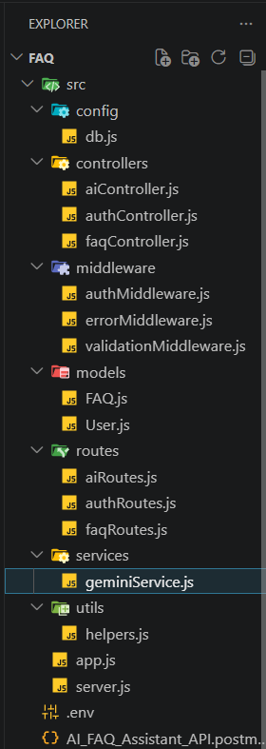
Figure 5: Planned project folder structure
Folders: config (db.js), controllers (ai, auth, faq), middleware (auth, error, validation), models (FAQ, User), routes (ai, auth, faq), services (geminiService), utils (helpers), plus app.js, server.js and .env.

