PHASE 5 OF 8

Project Development Phase
Setting up the project and implementing the backend
Item | Details
Project | AI FAQ Assistant API – AI-powered FAQ and customer support automation
Phase | 5. Project Development Phase
Tech Stack | Node.js, Express.js, MongoDB (Mongoose), JWT, bcrypt, Google Gemini (@google/genai)
Team / Author | [Add your name / team name]
Repository | [Add your public GitHub repository link]

1. Development Overview
This phase turns the design into working code. It covers project setup, the core server scripts, security and error middleware, database schemas and the API routes.

2. Project Setup
- Create a new folder with your project name.
- Inside it create a subfolder named src.
- Open the folder in VS Code.
- Open the terminal in the root folder and run the commands below.
npm init -y
npm install express mongoose dotenv cors jsonwebtoken bcrypt @google/genai

Folder and File Structure
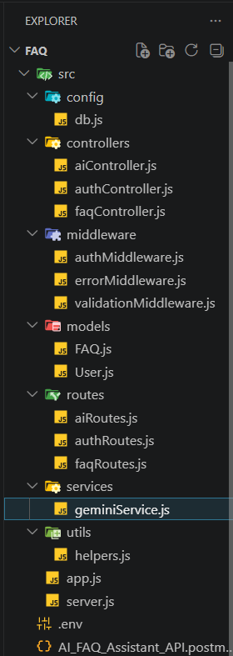
Figure 1: Final project folder structure in VS Code

3. Core System Scripts

3.1 Gateway Server (src/server.js)
Loads the app, connects to the database, reads PORT from the environment (default 5000), starts the listener and shuts down cleanly on unhandled promise rejections.
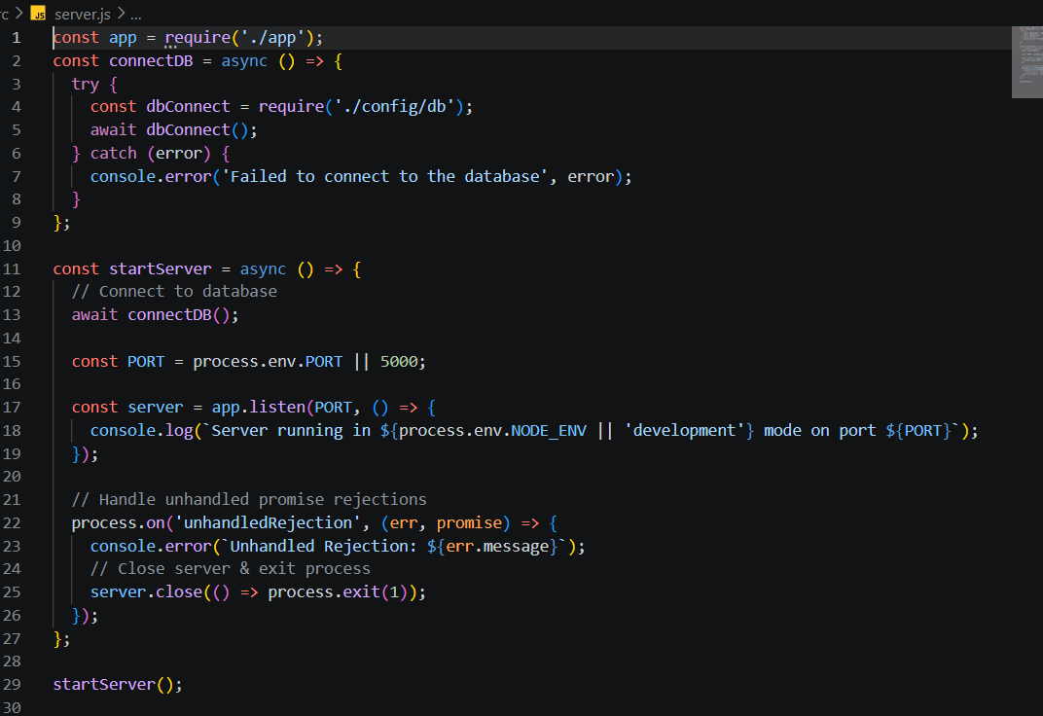
Figure 2: server.js

3.2 Express Setup (src/app.js)
Loads environment variables, enables CORS and JSON/URL-encoded body parsers, adds a status route ("AI FAQ Assistant API is running"), registers /api/auth, /api/faqs and /api/ai routes, and answers Socket.IO polling requests with a 404 message.
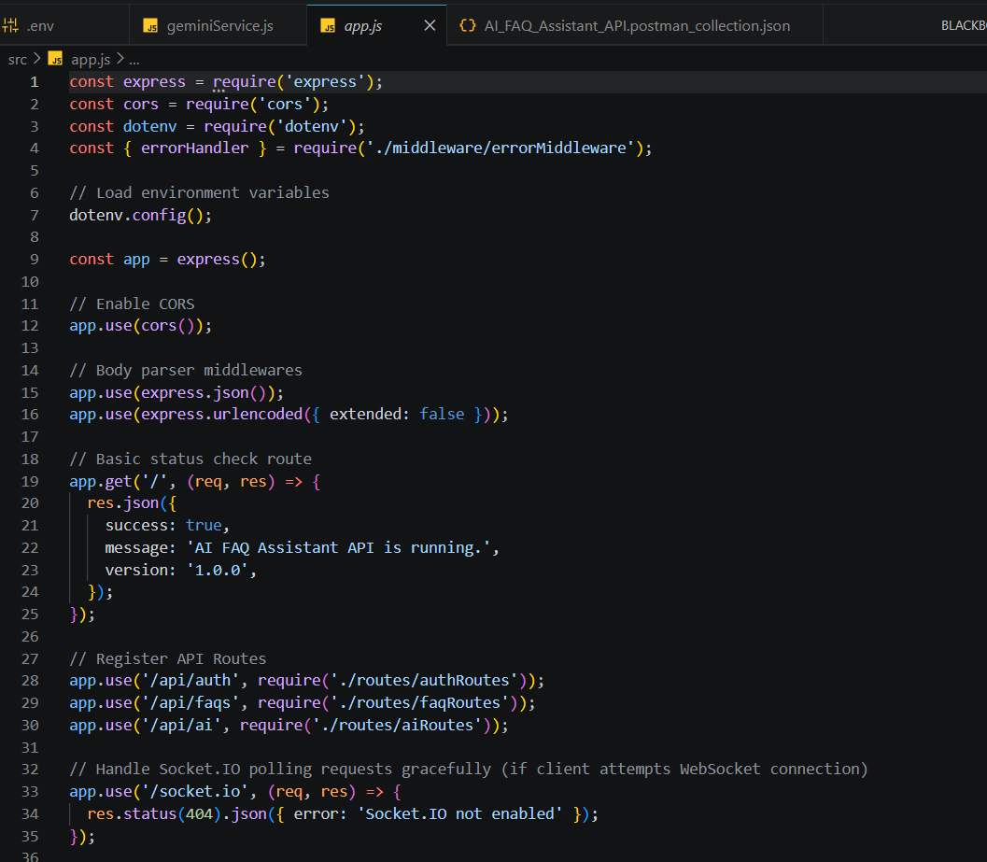
Figure 3: app.js

3.3 Security Middleware (src/middleware/authMiddleware.js)
The protect middleware reads the Bearer token from the Authorization header, verifies it with JWT_SECRET, loads the user without the password field and returns 401 if the user or token is invalid.
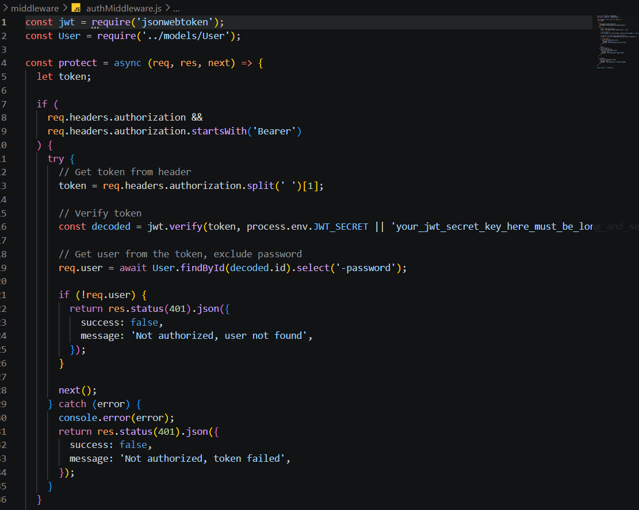
Figure 4: authMiddleware.js

3.4 Centralised Error Handler (src/middleware/errorMiddleware.js)
Converts errors into clean JSON responses: respects status codes from the Gemini SDK (for example 429), handles Mongoose duplicate key (11000), ValidationError and CastError, and logs stack traces only for 500 errors.
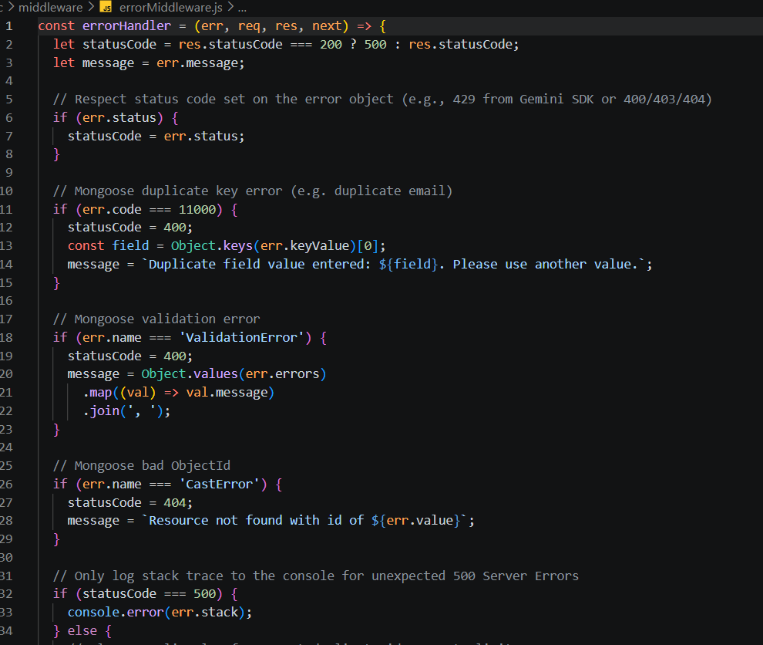
Figure 5: errorMiddleware.js

4. Database Schemas

4.1 User Schema (src/models/User.js)
Validates name, email (unique, lowercase, regex-matched) and password (minimum 6 characters). A pre-save hook hashes the password using bcrypt with a salt of 10 rounds whenever it is modified.
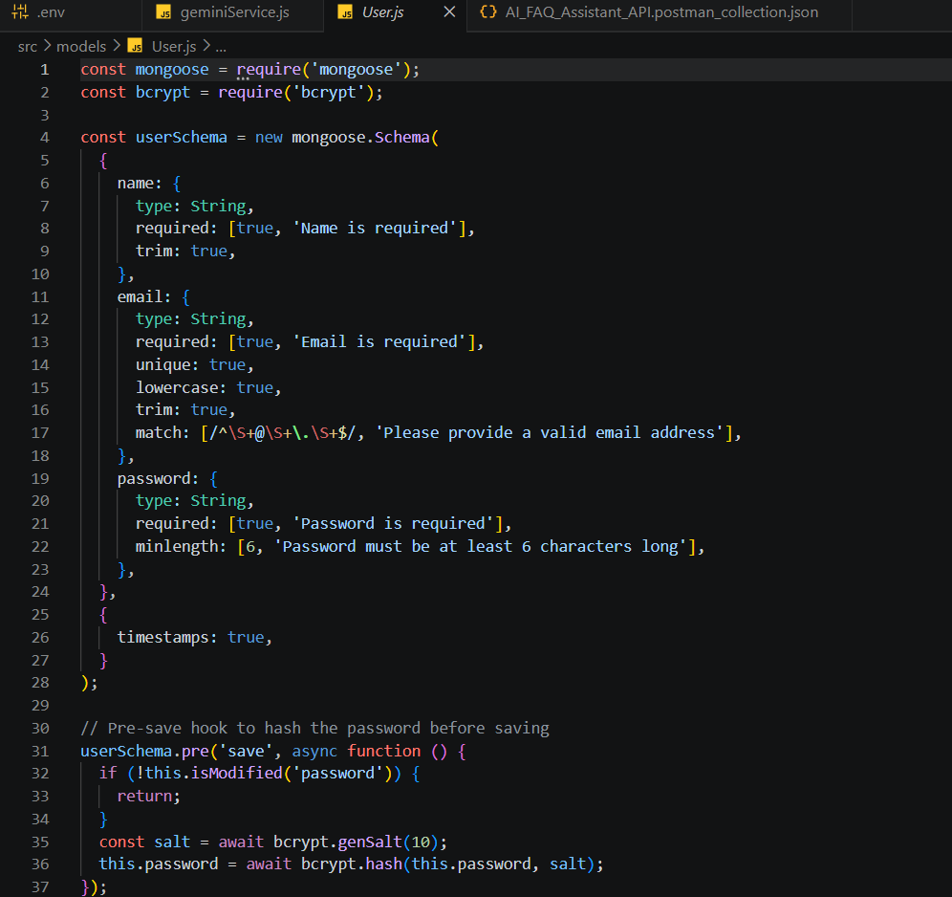
Figure 6: User.js

4.2 FAQ Schema (src/models/FAQ.js)
Stores question, answer, category and createdBy (ObjectId reference to User). Category is restricted to Technology, Education, Health, Banking or General (default General). Timestamps are enabled.
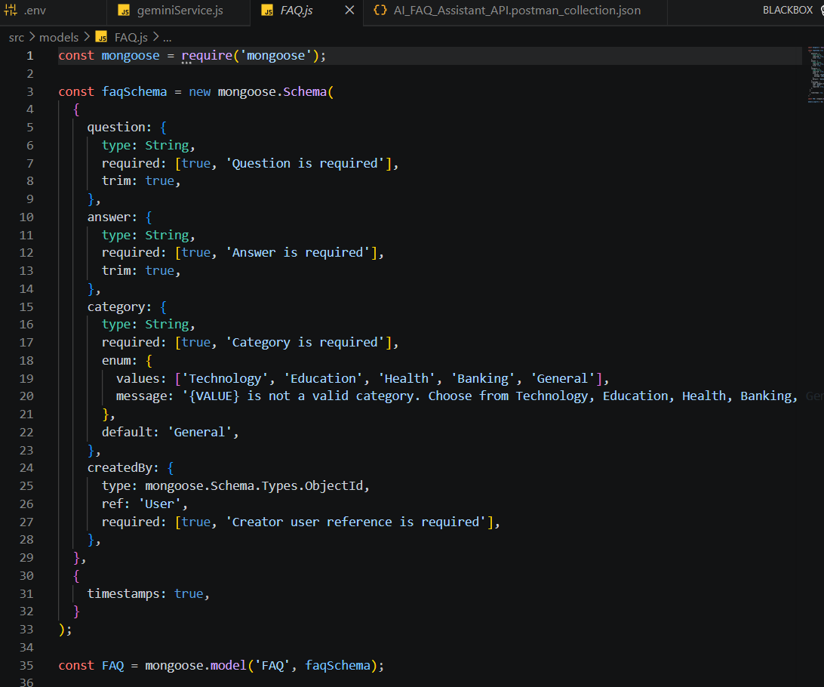
Figure 7: FAQ.js

5. API Routes

5.1 Authentication Routes (src/routes/authRoutes.js)
- POST /register – validateRegister → registerUser (public)
- POST /login – validateLogin → loginUser (public)
- GET /profile – protect → getUserProfile (private)
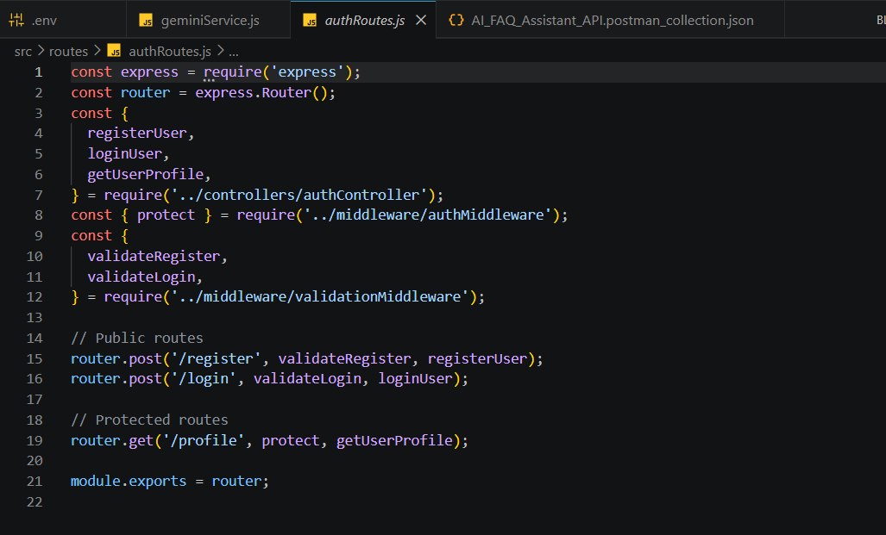
Figure 8: authRoutes.js

5.2 FAQ Routes (src/routes/faqRoutes.js)
- GET /search, GET /, GET /:id – public (search is defined before /:id to avoid routing conflicts)
- POST / – protect → validateFAQ → createFAQ
- PUT /:id and DELETE /:id – protect (owner-only changes)
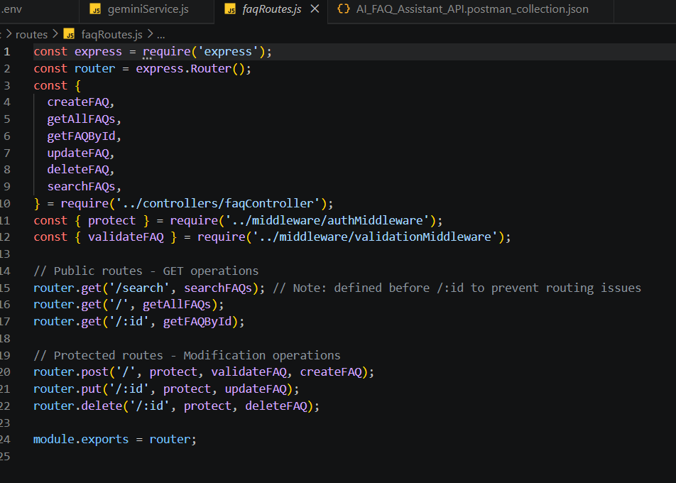
Figure 9: faqRoutes.js

5.3 AI Routes (src/routes/aiRoutes.js)
- POST /answer – protect → validateAIAnswer → generateAIAnswer
- POST /generate-faq – protect → validateAIFaq → generateAIFAQ
- Both routes are protected to prevent API overuse and abuse.
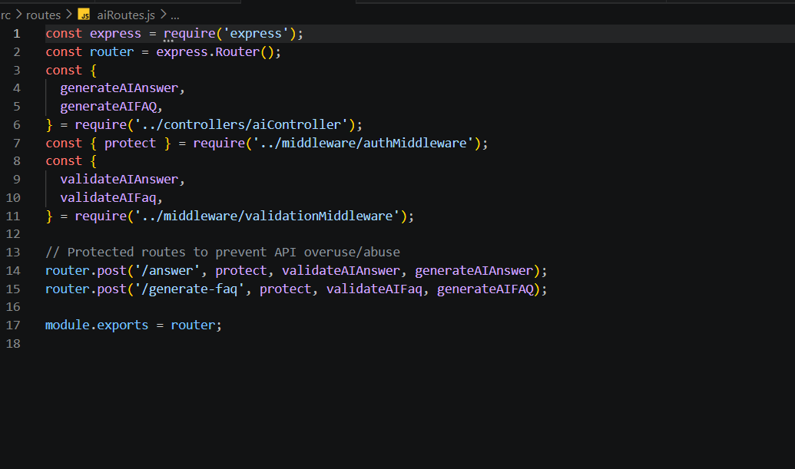
Figure 10: aiRoutes.js

6. Run the Server
npm run dev
Expected console output: Server running in development mode on port 5000.

7. Development Checklist
Item | Status
Project setup and packages installed | Done
server.js and app.js | Done
Auth and error middleware | Done
User and FAQ models | Done
Auth, FAQ and AI routes | Done
Gemini service (geminiService.js) | Done

