Indian Institute of Information Technology,

Allahabad



*Career Guidance Expert System*

Section’B’:Group15

Sachin Sharma (IIT2017099)

**Acknowledgement**

This project is successfully made under the supervision of Prof. Anupam sir and (TA) Mr. Gopal Chandra Jana (sir). This acknowledgement is for thanks to sir,

for mentoring us on project.

**Thankyou Sir,**

**Group(15)**

**Contents**

1. Abstract..............................................................................................................

2. Introduction........................................................................................................

3. Literature Survey................................................................................................

4. List of Similar Expert System…………………………………………………

5. Novelty of Work...............................................................................................

6 Background........................................................................................................

6.1 General Overview……..........................................................................

6.2 Algorithm…………………………………………………………….

6. Tools and Techniques.........................................................................................

6.1 Environmental Setup..............................................................................

6.2 Use-Case Diagram ……………….........................................................

7. Proposed Model...............................................................................................

7.1 Career Guidance................................................................................

7.2 Performance Requirements…………………………………………..

7.3 Safety and Security Requirements……………………………………

8. Results and comparisons………………………………………………………

9. Conclusion with Future Scope...............................................................................

10. References........................................................................................................

## **1. Abstract**

The aim of this project is to provide best career guidance for their good future. So they, don’t have to regret in future. Project mainly focused on your choices and likes to get best choice for you to occupy your passion as career.

**2. Introduction**

In field of Artificial Intelligence, the Expert System that have capability to make decisions like as humans.

An Expert System is designed to make decision like humans and also solve the complex computational problem through his knowledge stores in database. After that, Inference engine apply their logical rules on knowledge store in system to get the new information.

Expert System extended part is expert recommendation system, in which we filter the information according choices and interests of user’s .Then we compare user interest with some reference characteristics and provide suitable data for users.

**3. Literature Survey**

In 1990s firstly expert recommendation come in eyes of world. It was firstly mentioned by Jussi Karlgren in his report at Columbia University.

And It implemented at scale or work in technical reports (like complex computation).After it implemented at SICS, by research groups in MIT led by Pattie Maes. And at Many places and researcher implements it and do study and research on it.Work of Paul Resnick with GroupLens was awarded by 2010 Acm Software Systems Awards.

In 2000 there is specific type of recommender system is proposed by R.Burke in Encyclopedia of Library and Information Science.

**4. List of Similar Expert System**

In today’s Life, we are surrounded By a Recommendation system. There are many systems which we use on a daily basis like Google, and our social sites (Facebook, Instagram, etc.). They are doing this to make the user experience better on their platform.

CareeFitter and JobOut look etc. use the expert system according to choices of the user and their interests. Like, we are doing in this project.

**5. Novelty of Work**

The domain associated with career are complex. We are using forward chaining in the project. We makes it rule based expert system to easily work on this domain to make things easier.

**6. Background**

**6.1 General Overview**

Basically, the project is made for guiding the user for pursuing the suitable career,

By knowing the choices and interest of users.

It has following features:

1. Take input (choices) from console to get results.
2. It is Rule-based system, so it will consider choices at every point.
3. On basis of Rules it filter out the most suitable choice for user.

**6.2 Algorithm**

In our project we are using the Forward chaining algorithm. Forward chaining algorithm works on data which is already feed in knowledge base. And after that it uses the rules .Forward chaining is a form of reasoning which start with atomic sentences in the knowledge base and applies inference rules in forward direction to extract more data until a goal is reached. Forward Chaining is down-up approach i.e. it moves from bottom to top. Forward Chaining is a process in which the conclusion is based on known data, which is already in it.

The stepwise algorithm:

1. Algorithm start with facts which is known and then will choose the sentences that do not have implications.
2. In Step second, we check those facts which infer from known facts and with satisfied premises.
3. At last rule satisfies with substitution that infers all known facts. And hence

We achieved our goal.

**6.3 Dataset**

Simply data is feed by our self in project database. External source are not used in project.

**7. Tools and Techniques**

**7.1. Operating Environment**

To maintain the whole system these requirements can be followed to provide the best environment to operate.

1. **Operating System:** Our project can run on Windows operating systems.

1. **Programming Language:** Our system will require clips to be installed in the system.
2. **Server:** Localhost server is required for our system to run the software.

**7.2. User Interface**

There is no User Interface for this Expert System. All work will be done on Clips IDE (like prolog).

## 

## **7.3. Hardware Interfaces**

1. A compatible pc which runs essential software easily.
2. Local host is require to run the software.

**7.4 Software Interfaces**

1. Only Software need is Clips IDE is required for this project.
2. And all functional / non-functional requirements is fulfilled by IDE.

**7.5. Use-Case Diagram**

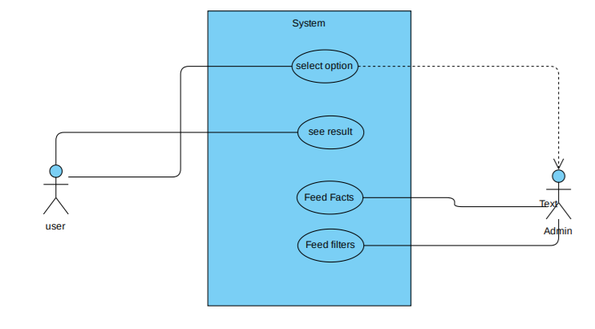

***Use case Diagram***

**8. Proposed Model**

**8.1 Career Guidance**

* **Phase-1(user Interfaces):**On phase -1 in user interface on IDE ,we ask users for their choices to filter the database.

**Some question we ask:**

1. What do you like?
2. What type of mindset you have?
3. Enter your preferred choice?
4. Tell about yourself?
5. What you love to do?

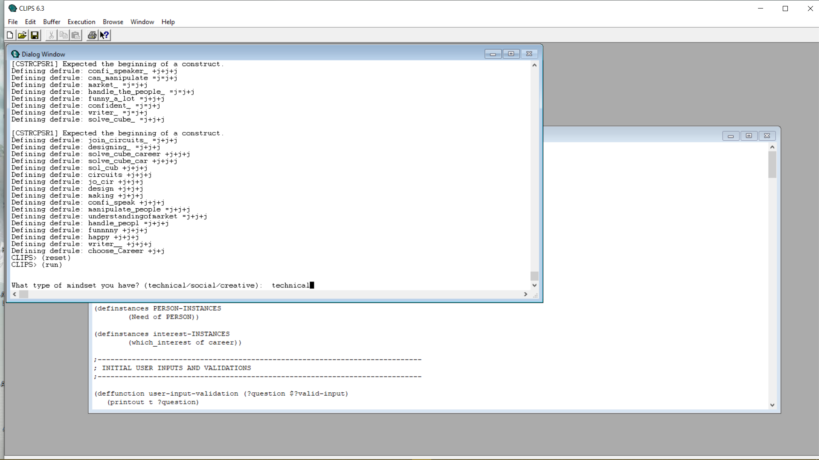

Fig 1

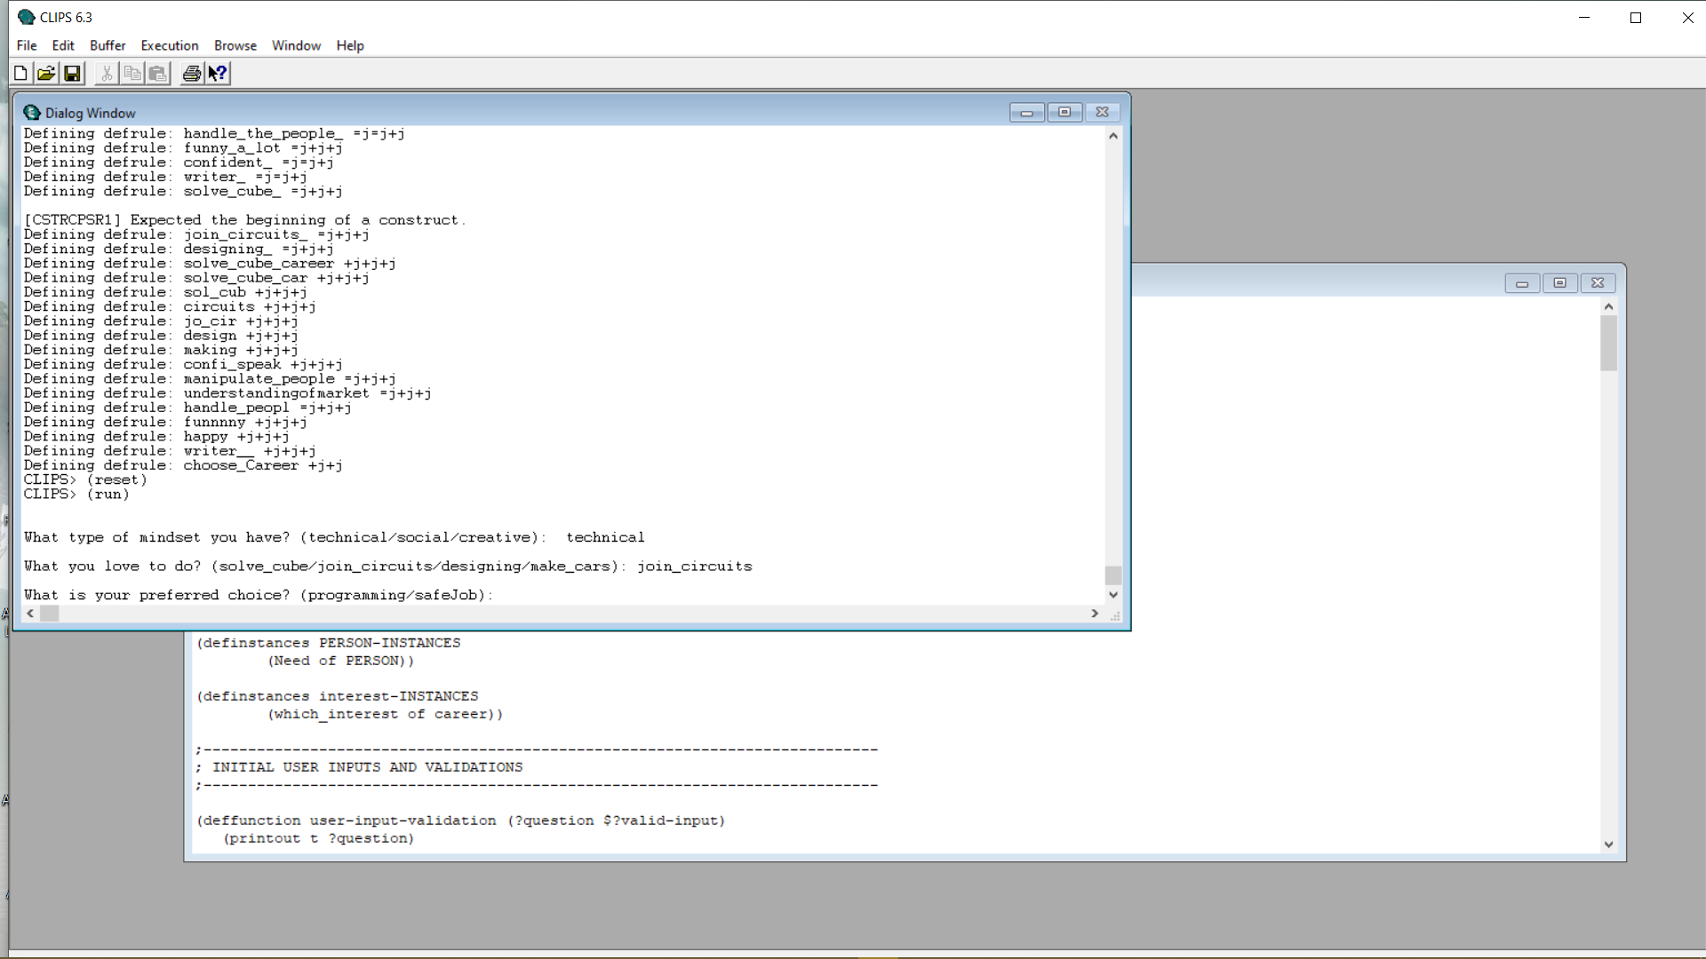

Fig 2

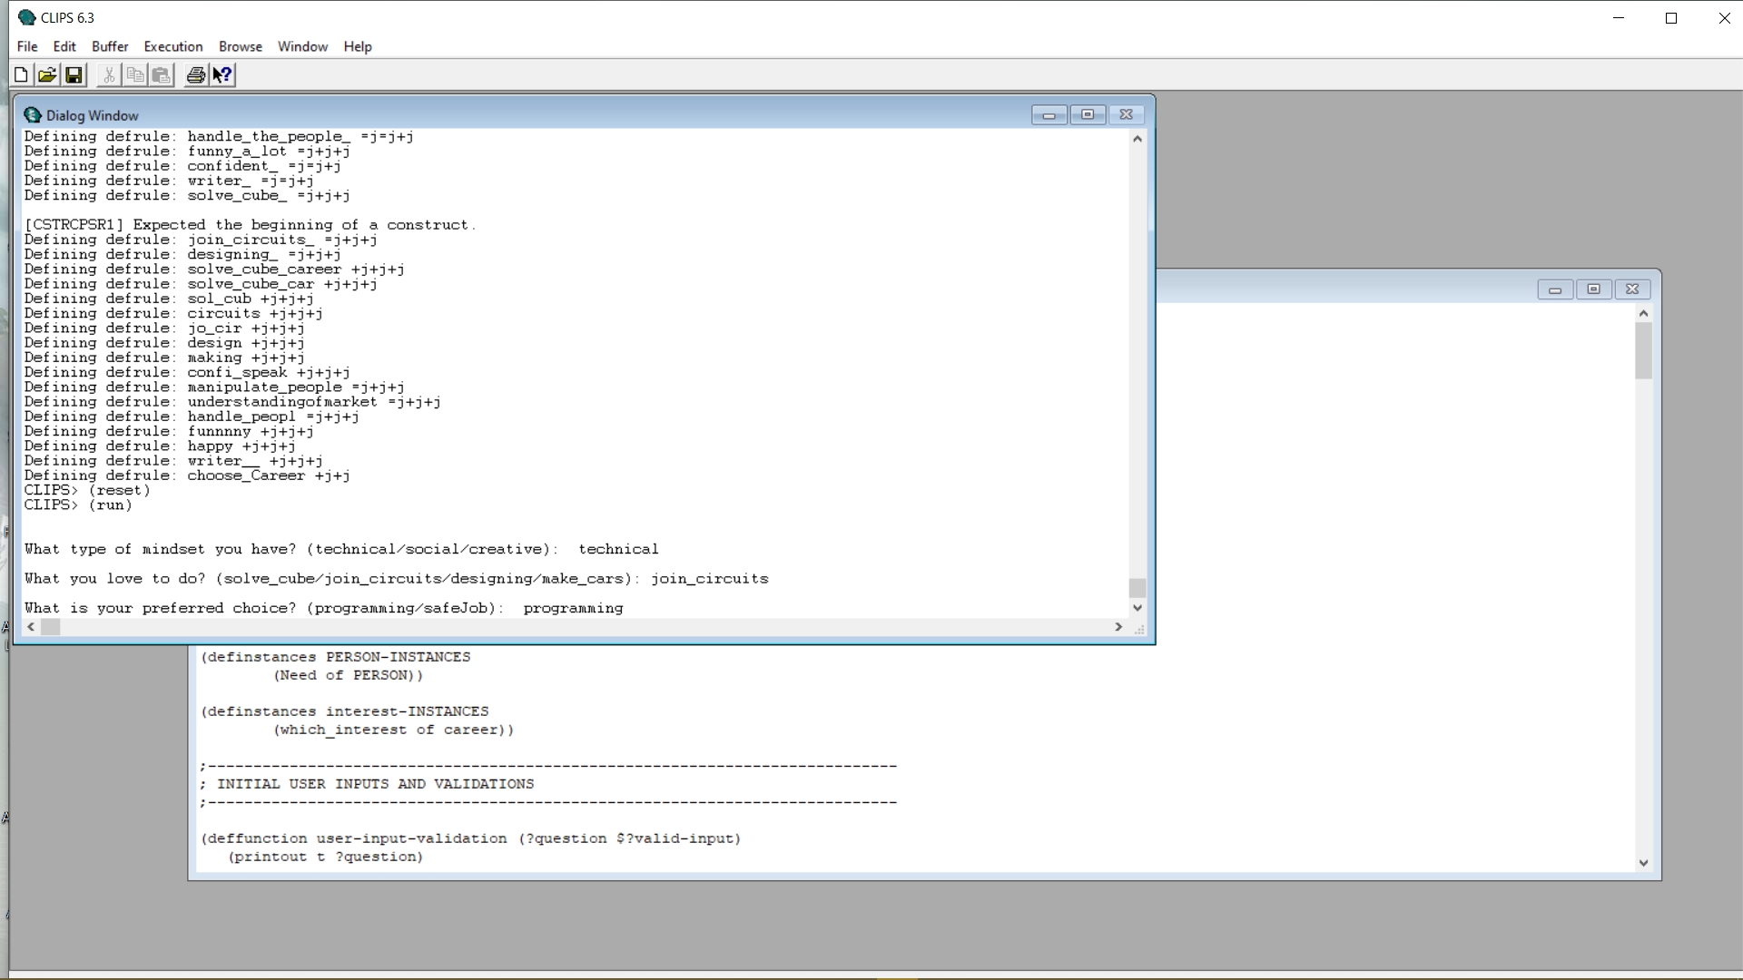

Fig 3

* **Phase-2(decision making):** Our project make decision using forward chaining algorithm.
* **Phase-3(result):** After taking all answers it will filter out the best career for you to occupy.

**8.2 Performance Requirements**

1. It will take time it needs to open ide.
2. Fast working on results.
3. Performance depend on database size.
4. Performance also depends on pc.

**8.3 Safety and Security**

1. It is totally secure.
2. The source code of program is maintained in file.
3. It is totally depend pc security.

**9. Results and Comparisons**

The career guidance expert system we made, prompts the user to input criteria, and then uses the forward chaining algorithm to gives out the recommendations as output, from the known facts and data present in database.

Table for Comparisons:

|  |  |  |
| --- | --- | --- |
|  | **This project** | **Other Systems** |
| Expert System used | Rule-Based | Knowledge based |
| Algorithm | Forward chaining | Data mining |

**10. Conclusions with Future Scope**

Our expert system is based on local data; and right now it works well, but it right now can’t use for students because of absent in GUI.

System can be improved:

1. Increasing dataset will help to make more decision.
2. Increasing rules will help to make output more precise.
3. UI make it looks good.
4. Login /Password make it more secure.

**11. References**

1. <https://www.researchgate.net/figure/Forward-chaining-algorithm-7_fig2_224863145>.
2. <https://en.wikipedia.org/wiki/Jussi_Karlgren>
3. <https://en.wikipedia.org/wiki/Recommender_system>
4. <https://piazza.com/redirect/s3?bucket=uploads&prefix=attach%2Fjyugei4f23is5%2Fjyughkincbe6q0%2Fk1qetpau2v3l%2FPaper1_Expert_SystemusingCLIPS.pdf>
5. <https://piazza.com/redirect/s3?bucket=uploads&prefix=attach%2Fjyugei4f23is5%2Fjyughkincbe6q0%2Fk1qeud6t6faj%2FPaper3_MultiLevel_ExpertSystem.pdf>
6. <https://www.ieee.org/conferences/publishing/templates.html>