Pokerth_accounting Instruction manual
(c) by Scott Carlson aka sacarlson
July 11, 2015 sacarlson_2000@yahoo.com

What is it?
Pokerth_accounting is a program module that allow people to play FREE P2P poker with real money using new uncentralized crypto currency methods. It is an add on module program written in Ruby that runs in the background to monitor events generated by the Pokerth poker game. This allows secure real money P2P poker to be played anywhere in the world. No modifications are needed to the original and popular open source pokerth game for pokerth_accounting to work.

Features:
· Local accounting of each player you play with to see how much money or chips over time you have lost to each game player on pokerth.

· Real time Stellar.org network currency transactions done at the end of each hand (can be disabled to only do local accounting above)

· Changeable currency to any Stellar.org supported or created currency, default is worthless CHP chips but also Bitcoin BTC or USD, EUR, YEN, GLD.... any crypto currency also can be transacted

· Settable issurer of currency gateway on Stellar or Ripple networks

· Auto creation of Stellar.org testnet account number and secrete number at first run that is auto credited with crypto starting cash chips of 100,000 CHP to start for FREE from http://poker.surething.biz.

· Global score keeping of of how many CHP you made or lost and to whom that the whole world can see, for all registered poker.surething.biz players. At present it's just a simple table with the Stellar CHP and STR balances of every registered player. We will make it pretty with searches for players and stuff later.

· Settable Stellar or Ripple or other currency networks you create can be selected

· Chip multiple selectable (Chip_Mult) to allow 10,000 chips to be just 1 cent or .0001 BTC or any multiple.

· Audio voice status can be enabled to hear status of Stellar transactions going in and out in real time.

· Audits transactions received on Stellar with what was seen locally in game play

· by default we use the completely free Stellar.org testnet with worthless but trackable CHP

· All transactions on Stellar.org are public and trackable so you can research who won how many chips from who at what time. This is also good to research possible players that you think might be colluding

· In Real money mode you can play for real money in any country in the world in any currency without having your assess taken away.

· Disable Future Stellar payments to selected players in present and future games.

· Basic tools are also included in package to allow for sending currency or chips you already have to other players or trading chips or currency for other chips or currencies on the Stellar network. These tools are not fully covered in this manul. At this time you will have to look inside each of the ruby *.rb files to get a better idea what is contained in each and how they work. If you have any questions feel free to ask me sacarlson at IRC #pokerth and I'll add your questions and my answers to this document for others to read.

· This package also contains files and setup to create a simple AccountServerURL including php programs and mysql database setup file and instructions. This is optional not needed by most people but here as a reference for people that want to add to it and make improvements.

How to install
To install pokerth_accounting first download the package of files that are located at http://github.com/sacarlson/pokerth_accounting . You can ether download the zipped page as seen on that page or if you prefer you can use git clone if you want to be able to upgrade over time as we make changes. The git clone method requires you have git installed on your system so I won't go into details on that here.

If you chose the zipped package method you will have to unzip or uncompress the files in any manner that you prefer. For me I just use file manager and double click on the zip file and select unzip files. It doesn't mater where you uncompress the files to they will run from any directory but you will have to remember where you put them to know that path when you want to run them.

After the files are uncompressed into a directory that we will say for this documentation are at ~/pokerth_accounting. At this point we will need to install the needed dependencies for pokerth_accounting to run. At this time we have a script that installs the needed dependencies on a Linux mint or Ubuntu or Debian like system. This script is run from the command window like this:
> cd pokerth_accounting # note this must be the directory you uncompressed your files into
>sudo install_dependencies.sh
This should install all the apt-get packages and ruby gem packages needed to run pokerth_accounting.

After the dependencies are successfully installed you can now run pokerth_accounting.rb from the command line
>./pokerth_accounting.rb

At this point pokerth_accounting will setup the new sqlite accounting files and also setup a new fully funded Stellar.org account with 100,000 CHP chips. At this point it should note that you are not running pokerth poker game so it should shutdown.

If that looks like it ran OK you are now ready to run pokerth_accounting.rb in the background with pokerth. At first you might want to run pokerth_accounting.rb in a terminal just a few seconds after you start the pokerth poker program to see if any errors are coming up in the first few games but later you can setup pokerth_accounting.rb to come up together with pokerth with a single script that was written to do this called start_set.sh. I will later go into details on how to setup start_set.sh to run from a shortcut icon on your desktop screen to allow starting both pokerth and pokerth_accouning with just a double click of an icon, just as simple or simpler than just running pokerth, but for now you will have to Google that one as I've run out of time.

Configuration and settings
pokerth_accounting is made to be user customized to allow using it to just locally account in local sqlite files or to be used for what it was meant to do, as an auto payment or score keeping system for P2P poker. By default pokerth_accounting is setup to do Stellar transactions on the Stellar testnet with the default trust settings for worthless CHP currency. All these settings and more can be changed to your custom desires with the tools provided in the packages installed. The tool we use to make configuration changes in a GUI is done with the program called sqlitebrowser that is now installed with your pokerth_accounting. The sqlitebrowser allows you to view and edit the contents of the account_log.pdb file that is originally created at the first start of pokerth_accounting.rb and filled with the defaults settings. We can open and view this file before, during play or after playing a game in pokerth. By default the account_log.pdb file is located at ~/.pokerth/accounts/account_log.pdb . You can open this file with sqlitebrowser by opening sqlitbrowser from the command line or other method then select open file from the top left standard open file location. Browse the directory until you find ~/.pokerth/accounts/account_log.pdb and open it. We will later figure out how to have this also setup as a shortcut in future edits of this documentation. When the file opens you can browse the data base to see what's in it as we will show screen shots here to see what you are expected to see. When the configuration tab is selected you will see something like this:

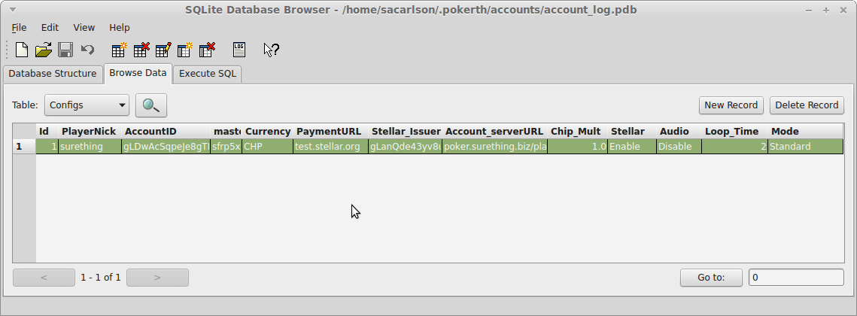
Note if you want to change any of these values in Configs you can double click the box with the value you want to change. It will then open a window to allow you to make the needed changes. After you OK the changes you will have to exit the editor before the changes are put into the data base. The value changes if the pokerth_accounting is already running at the time of editing will not take effect until the next payment on a loosing hand is detected. Most of these values should only be changed before you start pokerth_accounting. But things like Audio Disable Enable can be done while you are running pokerth_accounting. Also Loop_Time can be changed while running. Also Stellar Disable Enable can be done during running but not sure you want to try that.

Explained bellow is what is seen in each config above:

ID: just a column number of your user always 1, later we may add the ability to have more than one user with different settings.

PlayerNick: This is you user nick name that was extracted from the logs of pokerth, it is also used to link to your account number on the poker.surething.biz website. Good to note here to run pokerth at least one time to make you pokerth settings first before you start pokerth_accounting so that it has this information available from the pokerth logs.

AccountID: This is the auto generated random Stellar account number used in payment transactions. This account and the secret key bellow can also be used on the Stellar.org site if your running on the live.stellar.org mode.

Master_secret: This is the secret code number needed to send currency from you Stellar account to other players or gateway addresses or other Stellar transactions including trading currencies.

Currency: is The currency you will be playing with when a transaction in the game is made. It defaults to the worthless CHP currency that is issued by poker.surething.biz to you for free at the first start of the program.

PaymentURL: is the URL or IP address of the Stellar sever you will be using to make Stellar transactions. It defaults to using test.stellar.org to use there testnet. To play in real money you would change this to live.stellar.org or another IP node of the Stellar network that could even be a node that is running on your own local computer.

Account_serverURL: is the URL or IP address of a server that is setup to share the links between players pokerth nickname and there Stellar Account number. This address is automatically contacted each time you start pokerth_accounting. At that point you share your present settings for your pokerth nickname and present Stellar Account so that other players know how to pay you. At this point you also download the list of players and there corresponding Stellar Accounts and add them to you local list of players on the local sqlite account database file. This package also contains the files needed to setup your own Account_severURL server in the event you want to setup your own secrete group of players on some private website. We won't go into detail on this subject in this manual at this time. Look in the server subdirectory of this package for more details or ask sacarlson.

Stellar_issuer: This is the trust line selected for the currency that you have selected on the Stellar network. It defaults to a trust line that is auto added to your account at start to trust poker.surething.biz gateway issurer account so that you trust the same issuer of CHP as other players of pokerth do by default on the Stellar network.

Chip_Mult: is the multiplier of the currency to chips that you are playing with. For example if you want to play with 10,000 chips in your game but you want that number of chips to be worth $1.00 USD then you would set this number to 10000. by default we set this number to 1 as 1 CHP is worth 1 chip in the pokerth game.

Audio: This by default is set to Disable to turn off the voice speaking status of the pokerth_accounting system. When enabled you will hear every transaction being made and received on pokerth_accounting with it is running from the voice of some nice sounding ladies voice. It will also indicated when pokerth_accounting is shutting down that is done automatically when pokerth is closed. At times pokerth_accounting will also bring down the pokerth game program. This will also be indicated and explained why with voice status.

Loop_time: This is the time period of the loop that pokerth_accounting will pool the pokerth log files to analyze and decide who to send payments to after each hand of poker. This should work fine even as high as to 5 seconds or so depending on how fast you and your group play. I wasn't sure how fast people play or how much overhead is required to run the pool check so I make it changeable here. It defaults to 2 seconds to be safe as that should be more than fast enuf I would think.

Mode: defaults to Standard. This was just added for test and experimentation by me or others that might want to play in the code and add configs changes to there own stuff.

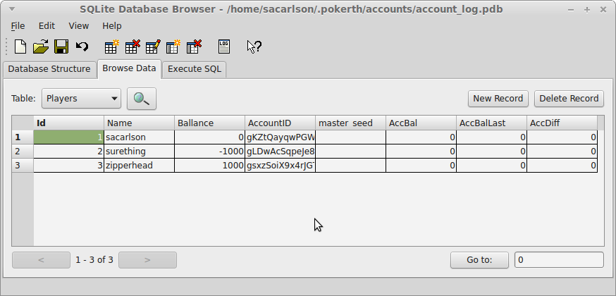
In the Player table you will see this. It contains:

ID: just a unique number index for each player that is now registered on poker.surething.biz. This list comes from the updated list that is auto downloaded every time you start pokerth_accounting.rb from poker.surething.biz website.

Name: The pokerth nick names of every player that is now registered on the poker.surething.biz website. These are the same nick names as are registered also on the pokerhero.com website so you will know who each of them are as you may have played with them before on pokerth in Internet mode.

Ballance: This is the locally recorded balance accumulated over all the time since you started the accounting system of what each of these players have ether paid you (or would owe you) when the balance is negative ,or positive when you have sent them this much more money than they have sent you in all the gaming with them to date. Note that your own nick name is also on this list and doesn't contain the same information as the other players. It only shows a reference of how much money you have won or lost to all players in all the gaming it has recorded over time. This feature of local accounting can work on pokerth_accounting weather you have Stellar transactions Enabled or not. In the example screen shot above I was sacarlson and this was my first game. I lost the pot of the game that was 1000 chips. So I (surething) show a balance of -1000. This indicates I have lost 1000 chips to all I have played with so far over all time. the player I played with was zipperhead that shows a balance of +1000 chips. As I have sent him +1000 chips more than he has sent me over all time. So at this time he should be considered the better player than me. And last sacarlson shows balance of zero as I have never played with him yet so his balance is still zero.

AccountID: This is the Stellar account numbers of each of the players in the list. This number can also be used to send CHP direct to this user if you want to loan him money or trade him something.

MasterSeed: at this time these numbers are no longer used. It was originally used it prototype testing and verification of proof of design with auto created account numbers for every player I would play with. I played many games of 10 people on pokerth Internet mode with the other players at the time never knowing I was making transactions for each of them on every hand on the Stellar network to test feasibility of the system.

AccBal: This is not setup to be used yet in the present software but it will be soon. The plan here is this will contain The Stellar CHP balance at this time. This can be useful to also check that the Stellar account is matching the amounts we would be expecting from the previous gaming.

AccBalLast: Again not setup yet but will be a number you can setup manually to take a snapshot from some point in time to compare changes from the this time to the next with the calculated difference being seen in the AccDiff column.

AccDiff: Is the calculated difference from AccBalLast – AccBal. This can be useful to audit the changes seen from local Balance and the Stellar account balances seen on the network.

What's coming soon?
· We will soon be adding uncentralized escrow that is a feature that is built into the Stellar network. To play in escrow mode you will secure a deposit at start of a game to make sure all players pay what's due at completion of game. The escrow contracts will be signed be all the players at the table. A majority vote of all that played will determine who owes who in the end in the event of a dispute. This will all be done without notice by the human players as it will be an automated internal process ran inside all the pokerth_accounting clients. Other options would be to have a 3rd party signer to help handle disputes in the case of only two players. I would imagine in big money gaming they might want this 3rd party that would also end up adding a fee to the game in that case. Also with pokerth we already have the ability to have observers. So the third party could be an automated or human agreed upon observer if desired.

· Mental Poker encrypted card shuffling to make sure no one can see the cards in play will later be added to a branch of pokerth.

· If we don't get uncentralized escrow working in time we plan to add auto Audit in play to discontinue to pay out on future hands when other players have failed to pay what due in previous hands.

· Debian package will be created to make for easy install on Linux system at least

· We plan to have this tested on windows in the near future and have it packaged with ruby2exe to make it a simple standard download install. At this time I would advise windows users to install what we have now using virtualbox to have Lubuntu running inside it where you can run pokerth and pokerth_accounting inside that. This also provides you security in not to having to worry about your windows system being compromised. And also not having your hacked windows system give away you secret numbers and your money.

What else you want?
Just ask and you will receiver. The more feedback the better. I can be contacted in realtime chat on IRC at #pokerth in public or pm me, or leave me a message on http://github.com/sacarlson. Also I am open to any help people can give. We need help now on the Stellar escrow section as there are no examples yet published. I guess we will be the first published system that uses them.

