2026
Sen, Amrita (SMS group GmbH)
SMS Group GmbH
2/10/2026
Roller Tracking System

UI / Application Design Specification

Document Control
Item | Description
System Name | Roll Shop / Caster Web Application
Document Type | UI / Application Design Specification
Version | v0.1
Status | Draft
Author | Amrita Sen
Date | 10-02-2026
Reviewed By
Related Documents | Visio Screen Flow, DB Schema

1. Purpose of This Document
This document describes the page-level behavior of the web application, including pages, navigation, data usage, user actions, and backend interaction. It enables UI and backend development before final Functional Specification approval.

2. System Overview
The system supports roller, sleeve, and axle tracking across disassembly, processing, workshop, and outgoing stages, replacing manual and Excel-based tracking.

3. Application Navigation Overview

Page ID | Page Name | Accessed From
PG0001 | Login
PG0002 | Main | PG0001

4. Page-Wise Design Specification
Repeat the following structure for each application page.

4.1 PG0001 – Login

Page Purpose:
This page gives the option to users of both workshop and the refurbishment unit to do log in the system and get corresponding functionalities to do data entry.
User Roles:
All users have access to this page.
Page Actions:
Log In.

Displayed Fields:
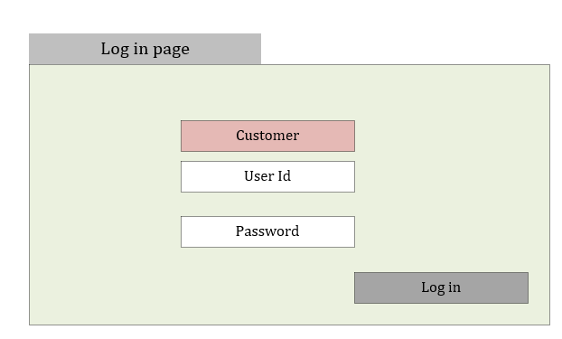
Figure 1: Login page
Field data entry description:
Field | Data type | Range | Dependency
User Id | Varchar
Password | Password

Backend Interaction:
Field/Button | Query | Dependency
Customer | SELECT  site_name  FROM roller_tracking.site  WHERE is_active = 1  ORDER BY site_name
Submit | SELECT  r.role_code,  s.site_name  FROM roller_tracking.app_user u  JOIN roller_tracking.user_role ur  ON u.user_id = ur.user_id  JOIN roller_tracking.role r  ON ur.role_id = r.role_id  JOIN roller_tracking.user_site us  ON u.user_id = us.user_id  JOIN roller_tracking.site s  ON us.site_id = s.site_id  WHERE u.username = @username  AND u.password_hash = HASHBYTES('SHA2_256',@password)  AND u.is_active = 1  AND s.site_name = @site_name  AND s.is_active = 1;

UI Behavior & Validation:

4.2 PG0002 – Main

Page Purpose:
This page gives the main navigation for the user
User Roles:
All users have access to this page. But according to their role they can see the operations they can perform.
Displayed Fields: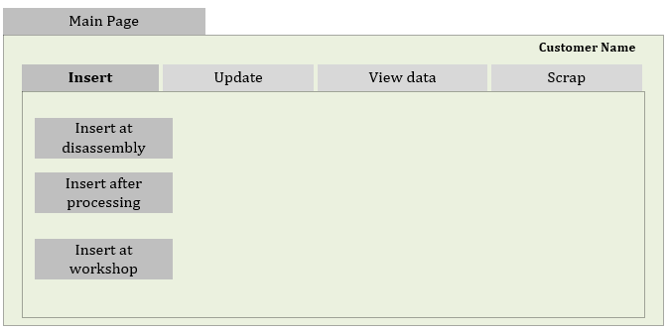
Figure 2: Main page Insert
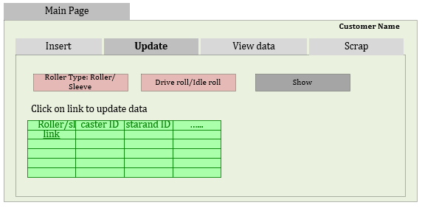
Figure 3: Main page Update
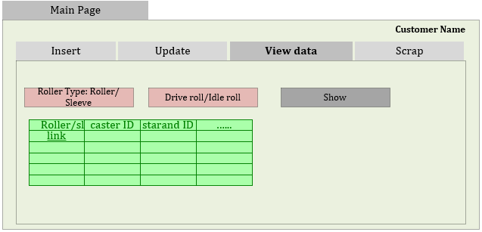
Figure 4: Main page View
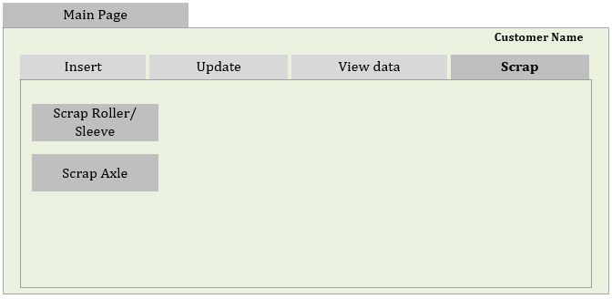
Figure 5: Main page Scrap

Page Actions:
Navigation
Backend Interaction:
Keep customer name and user role from Login page and transfer it to main page.

UI Behavior & Validation:
Figure 6: Refurbishment Area Main Page Navigation

Figure 7: Workshop Main Page Navigation

4.3 PG0003 – Insert at Disassembly

Page Purpose:
Insert Roller/Sleeve tracking data after the roller or sleeve is disassembled.

User Roles:
REF_OP, REF_ADMIN
Page Actions:
Insert data

Displayed Fields:

Depending on Roller type this page fields will be populated.

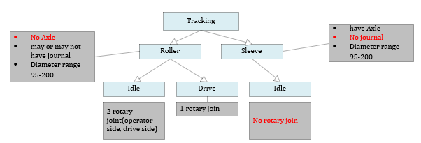
Figure 8: Roller type wise field population
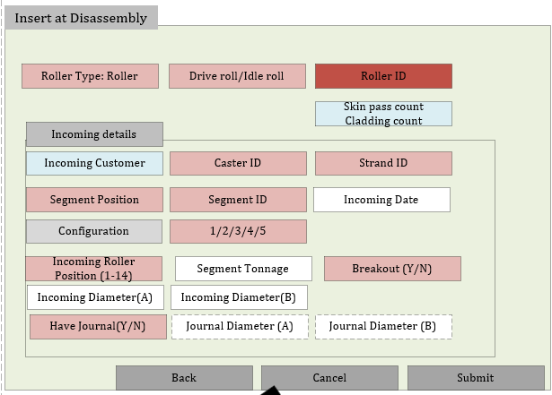
Figure 9: Insert Existing Roller at Disassembly
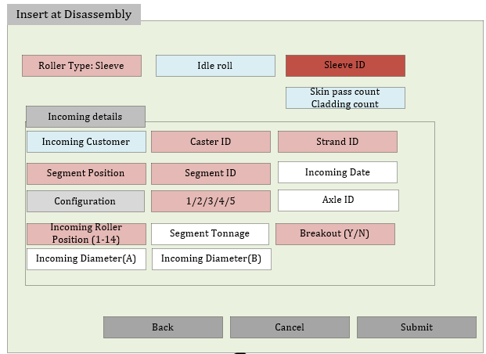
Figure 10: Insert Existing Sleeve at Disassembly
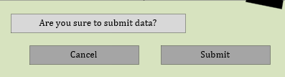
Figure 11: On Submit Check
Field data entry description:
Field | Data type | Range | Dependency
Roller type | Varchar | Selection: (Roller/ Sleeve)
Drive roll/Idle Roll | Varchar | Selection: (Idle/Drive)
Incoming date | Date
Configuration | Integer | Selection: (1/2/3/4/5)
Axle ID | Varchar
Incoming Roller Position | Integer | Selection: (1-14)
Segment Tonnage | Integer
Breakout | Varchar | Selection: (Y/N)
Incoming Diameter(A), Incoming Diameter(B) | Decimal | (95-200)
Have Journal | Varchar | Selection: (Y/N)
Journal Diameter(A), Journal Diameter(B) | Decimal |  | Have Journal (Y)

Backend Interaction:

Field | Query | Populated after field
Roller ID/ Sleeve Id | SELECT  roller_sleeve_id  FROM roller_tracking.roller_sleeve  WHERE is_scrapped = 0  ORDER BY roller_type; | Drive Roll/Idle Roll
Alert on Skinpass or cladding | SELECT  SUM(CASE WHEN is_skin_cut = 1 THEN 1 ELSE 0 END) AS skin_cut_count,  SUM(CASE WHEN is_cladded = 1 THEN 1 ELSE 0 END) AS cladded_count  FROM roller_tracking.roller_lifecycle  WHERE roller_sleeve_id = @roller_sleeve_id; | Roller ID/ Sleeve Id
Caster Name | SELECT  caster_name  FROM roller_tracking.caster  WHERE site_id = @site_id  AND is_active = 1  ORDER BY caster_name; | Roller ID/ Sleeve Id
Strand ID | SELECT  strand_id,  strand_no  FROM roller_tracking.strand  WHERE caster_id = @caster_id  ORDER BY strand_no; | Caster Name
Segment position | SELECT  position_id,  position_no  FROM roller_tracking.position  WHERE strand_id = @strand_id  ORDER BY position_no; | Strand ID
Segment ID | SELECT  s.segment_id,  s.segment_no  FROM roller_tracking.segment_position_rule spr  JOIN roller_tracking.segment s  ON s.segment_id = spr.segment_id  WHERE spr.position_id = @position_id  ORDER BY s.segment_no; | Segment position
Submit -> Ok | INSERT INTO roller_tracking.roller_lifecycle  (  roller_sleeve_id,  process_stage,  created_by_user_id,  updated_by_user_id,  from_site_id,  from_caster_id,  from_strand_id,  from_position_id,  from_segment_id,  received_at,  received_config,  from_roller_position,  tonnage,  received_axle_id,  received_diameter_a,  received_diameter_b,  breakout_flag  )  VALUES  (); - process_stage ‘RECEIVED’

4.4 PG0004 – Insert after Processing-Navigation

Page Purpose:
Insert Roller/Sleeve tracking data after the roller or sleeve is assembled. This is a intermediate page. Depending on new or existing Sleeve/Roller next page the data entry will happened.
User Roles:
REF_OP, REF_ADMIN
Page Actions:
Inset

Displayed Fields:
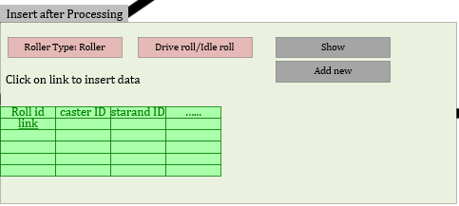
Figure 12: Insert after processing – Roller

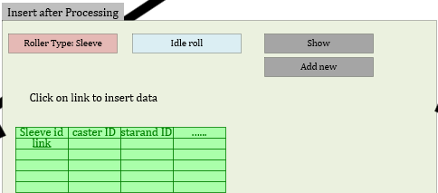
Figure 13: Insert after processing – Sleeve

Backend Interaction:

Field | Query | Populated after field
Roller type | no | Roller type =’Roller”, ‘Sleeve’
Drive roll/Idle Roll | no | Roller function Idle/Drive:
Roller ID/ Sleeve Id | SELECT  roller_sleeve_id  FROM roller_tracking.roller_sleeve  WHERE is_scrapped = 0 and roller_type= <Roller_type> and roller_function =<roller_function>  ORDER BY roller_type; | After Drive Roll/Idle Roll DB values (‘Idle’,’Drive’)
Show | SELECT  rs.roller_sleeve_id,  rs.roller_type,  rs.roller_function,  -- Incoming details (from latest lifecycle record)  rl_current.from_site_id,  rl_current.from_caster_id,  rl_current.from_strand_id,  rl_current.received_at,  -- Aggregated counts  SUM(CAST(rl_all.is_skin_cut AS INT)) AS skin_cut_count,  SUM(CAST(rl_all.is_cladded AS INT)) AS cladded_count  FROM roller_tracking.roller_sleeve rs  -- Latest lifecycle record  JOIN roller_tracking.roller_lifecycle rl_current  ON rs.roller_sleeve_id = rl_current.roller_sleeve_id  -- All lifecycle rows for counting  JOIN roller_tracking.roller_lifecycle rl_all  ON rs.roller_sleeve_id = rl_all.roller_sleeve_id  WHERE  rs.is_scrapped = 0  AND rs.roller_type = @roller_type  AND rs.roller_function = @roller_function  -- Only latest lifecycle row  AND rl_current.created_at = (  SELECT MAX(rl2.created_at)  FROM roller_tracking.roller_lifecycle rl2  WHERE rl2.roller_sleeve_id = rs.roller_sleeve_id  )  -- Currently disassembled  AND rl_current.process_stage =’ RECEIVED’  GROUP BY  rs.roller_sleeve_id,  rs.roller_type,  rs.roller_function,  rl_current.from_site_id,  rl_current.from_caster_id,  rl_current.from_strand_id,  rl_current.received_at  ORDER BY rs.roller_sleeve_id;

UI Behavior & Validation:

4.5 PG0005 – Insert after Processing-Insert new

Page Purpose:
Insert new roller data when it is 1st time going into system.

User Roles:
REF_OP, REF_ADMIN
Page Actions:
Insert data
Displayed Fields:

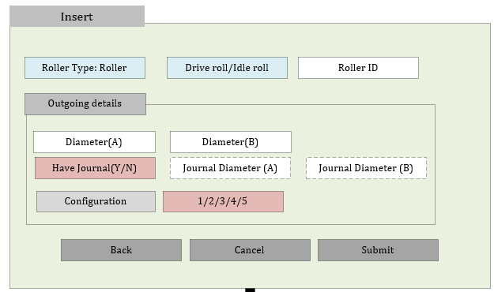
Figure 14: Add new Roller

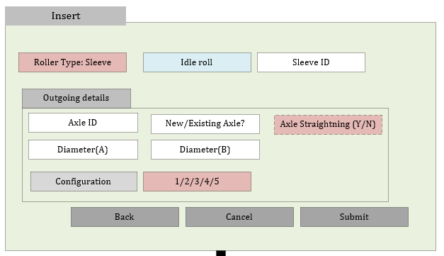
Figure 15: Add new Sleeve
Figure 16: On Submit Check

Field data entry description:
Field | Data type | Range | Dependency
Roller Type | Varchar | Sleeve/Roller | From last page
Drive roll/Idle Roll | Varchar | Idle/Drive | From last page
Roller / Sleeve ID | Varchar
Diameter(A), Diameter(B) | Decimal | (95-200)
Have Journal | Varchar | Selection: (Y/N)
Journal Diameter(A), Journal Diameter(B) | Decimal
Axle ID | Integer
New/Existing Axle | Varchar | Selection: (New/Old)
Axle Straightening | Varchar | Selection: (Y/N) | Old Axle
Configuration | Integer | Selection: (1/2/3/4/5)

Backend Interaction:
Field/Button | Query | Dependency
Submit - Submit | INSERT INTO roller_tracking.roller_sleeve  (  roller_type,  roller_function,  is_scrapped,  )  VALUES  (  @roller_type, -- 'Sleeve' or 'Roller'  @roller_function, -- 'Idle' or 'Drive'  0 -- not scrapped  );  --Roller  INSERT INTO roller_tracking.roller_lifecycle  (  roller_sleeve_id,  created_by_user_id,  updated_by_user_id,  process_stage,  received_at,  from_site_id,  from_caster_id,  from_strand_id,  roller_scrap_flag,  is_skin_cut,  is_cladded  )  VALUES  (  @roller_sleeve_id,  @user_id,  @user_id,  'PROCESSED',  SYSDATETIME(),  @from_site_id,  @from_caster_id,  @from_strand_id,  0,  0,  0  );  --Sleeve  INSERT INTO roller_tracking.roller_lifecycle  (  roller_sleeve_id,  created_by_user_id,  updated_by_user_id,  process_stage,  -- Outgoing / dispatch info  dispatched_at,  dispatched_axle_id,  dispatched_axle_straight_flag,  dispatched_config,  dispatched_diameter_a,  dispatched_diameter_b,  roller_scrap_flag,  is_skin_cut,  is_cladded  )  VALUES  (  @roller_sleeve_id,  @user_id,  @user_id,  'DISPATCHED',  SYSDATETIME(),  @axle_id,  @axle_straight_flag, -- 1 = Yes, 0 = No  @config, -- 1/2/3/4/5  @diameter_a,  @diameter_b,  0, 0, 0);

4.6 PG0006 – Insert after Processing-Insert Existing

Page Purpose:
Insert Roller/Sleeve tracking data after the roller or sleeve is processed

User Roles:
REF_OP, REF_ADMIN
Page Actions:
Update data

Displayed Fields:
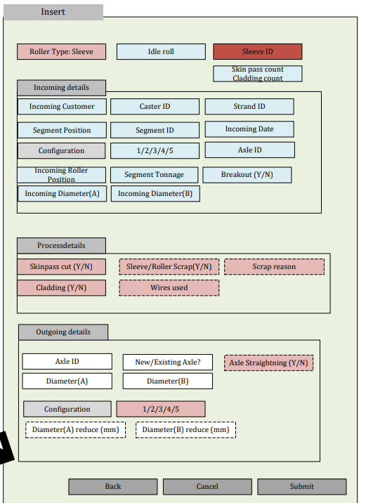
Figure 17: Sleeve Processing Data

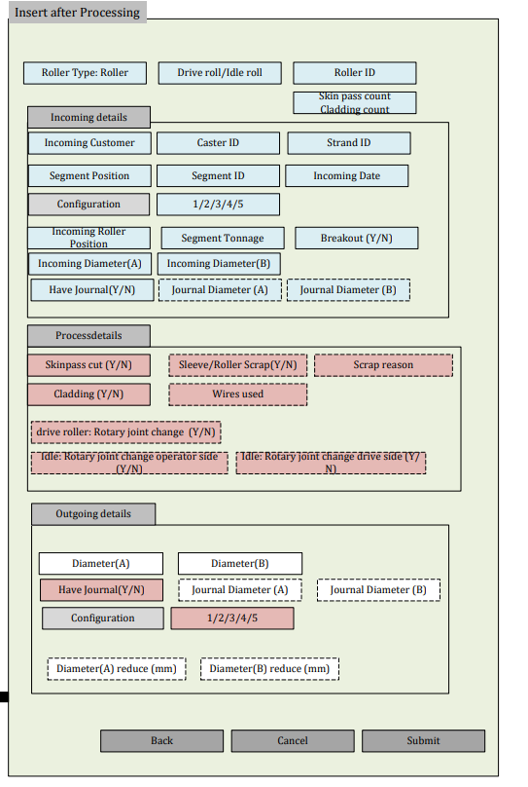
Figure 18: Roller Processing data

Figure 19: On Submit Check

Field data entry description:
All blue fields will come from previous page.
Field | Data type | Range | Dependency
Skinpass | Varchar | Y/N
Scraped | Varchar | Y/N | After skin pass, if scrap no other field will populate rather than Scrap reason
Scraped reason | Varchar |  | Scraped
Cladding | Varchar | Y/N | Skinpass N , Scrapped N
Diameter(A), Diameter(B) | Decimal | (95-200)
Have Journal | Varchar | Selection: (Y/N)
Journal Diameter(A), Journal Diameter(B) | Decimal
Axle ID | Integer
New/Existing Axle | Varchar | Selection: (New/Old)
Axle Straightening | Varchar | Selection: (Y/N) | Old Axle
Configuration | Integer | Selection: (1/2/3/4/5)

Backend Interaction:
Field/Button | Query | Dependency
Wire used
Submit | --Sleeve  WITH LatestReceived AS  (  SELECT *,  ROW_NUMBER() OVER (  PARTITION BY roller_sleeve_id  ORDER BY created_at DESC  ) AS rn  FROM roller_tracking.roller_lifecycle  WHERE roller_sleeve_id = @roller_sleeve_id  AND process_stage = 'RECEIVED'  )  UPDATE LatestReceived  SET  process_stage = 'PROCESSED',  -- Process details  is_skin_cut = @is_skin_cut,  is_cladded = @is_cladded,  cladding_wire_id = @cladding_wire_id,  roller_scrap_flag = @scrap_flag,  roller_scrap_reason = @scrap_reason,  -- Outgoing details  dispatched_axle_id = @axle_id,  dispatched_axle_straight_flag = @axle_straight_flag,  dispatched_config = @config,  dispatched_diameter_a = @diameter_a,  dispatched_diameter_b = @diameter_b,  updated_at = SYSDATETIME(),  updated_by_user_id = @user_id  WHERE rn = 1;  --Roller  WITH LatestReceived AS  (  SELECT *,  ROW_NUMBER() OVER (  PARTITION BY roller_sleeve_id  ORDER BY created_at DESC  ) AS rn  FROM roller_tracking.roller_lifecycle  WHERE roller_sleeve_id = @roller_sleeve_id  AND process_stage = 'RECEIVED'  )  UPDATE LatestReceived  SET  -- Change lifecycle stage  process_stage = 'PROCESSED',  -- ===== PROCESS DETAILS =====  is_skin_cut = @is_skin_cut,  is_cladded = @is_cladded,  cladding_wire_id = @cladding_wire_id,  roller_scrap_flag = @scrap_flag,  roller_scrap_reason = @scrap_reason,  drive_rotary_joint_change_flag = @drive_joint_change,  idle_rotary_joint_change_o_flag = @idle_operator_change,  idle_rotary_joint_change_d_flag = @idle_drive_change,  -- ===== OUTGOING DETAILS =====  dispatched_diameter_a = @diameter_a,  dispatched_diameter_b = @diameter_b,  dispatched_config = @config,  diff_diameter_a = @reduce_a,  diff_diameter_b = @reduce_b,  dispatched_journal_flag = @have_journal,  dispatched_journal_a = @journal_a,  dispatched_journal_b = @journal_b,  updated_at = SYSDATETIME(),  updated_by_user_id = @user_id  WHERE rn = 1;

4.7 PG0007 – Insert at workshop Navigation

Page Purpose:
Insert Roller/Sleeve tracking data after the roller or sleeve is in workshop and delivered to customer.

User Roles:
WS_OP, WS_ADMIN
Page Actions:
View data

Displayed Fields:

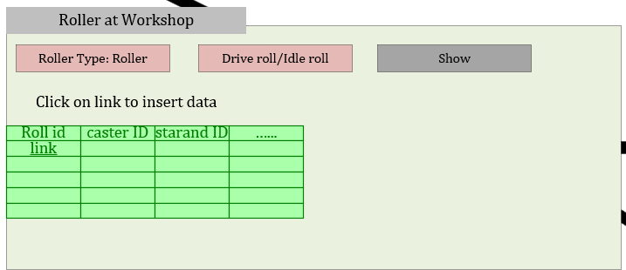
Figure 20: Roller at Workshop

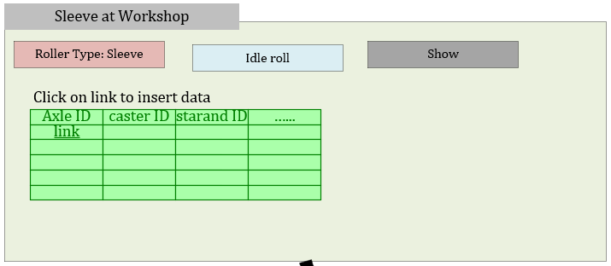
Figure 21: Sleeve at workshop
Field data entry description:
Field | Data type | Range | Dependency
Roller type | no | Roller type =’Roller”, ‘Sleeve’
Drive roll/Idle Roll | no | Roller function Idle/Drive:

Backend Interaction:
Field/Button | Query | Dependency
Show | WITH LatestLifecycle AS  (  SELECT  rl.*,  ROW_NUMBER() OVER (  PARTITION BY rl.roller_sleeve_id  ORDER BY rl.created_at DESC, rl.lifecycle_id DESC  ) AS rn  FROM roller_tracking.roller_lifecycle rl  )  SELECT  ll.dispatched_axle_id AS axle_id,  ll.from_site_id,  ll.from_caster_id,  ll.from_strand_id,  ll.from_segment_id,  ll.from_position_id,  ll.received_at  FROM LatestLifecycle ll  JOIN roller_tracking.roller_sleeve rs  ON rs.roller_sleeve_id = ll.roller_sleeve_id  WHERE ll.rn = 1  AND ll.process_stage = 'PROCESSED'  AND rs.roller_type = @roller_type  AND rs.roller_function = @roller_function  AND rs.is_scrapped = 0  ORDER BY ll.dispatched_axle_id;

UI Behavior & Validation:

4.8 PG0008 – Insert at Sleeve

Page Purpose:
Insert Roller/Sleeve tracking data after the sleeve is in workshop and delivered to customer.

User Roles:
WS_OP, WS_ADMIN
Page Actions:
Insert data

Displayed Fields:

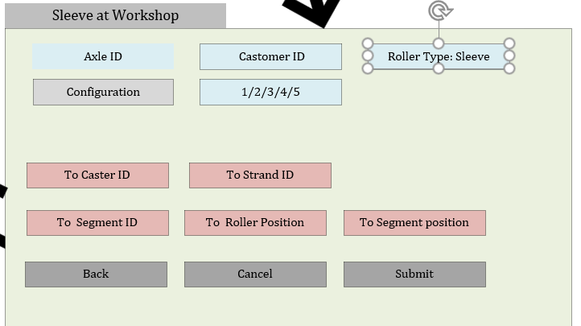
Figure 22: Insert Sleeve data in workshop

Figure 23: On Submit Check

Field data entry description:
Field | Data type | Range | Dependency

Backend Interaction:
Field/Button | Query | Dependency
Caster Name | SELECT  caster_name  FROM roller_tracking.caster  WHERE site_id = @site_id  AND is_active = 1  ORDER BY caster_name;
Strand ID | SELECT  strand_id,  strand_no  FROM roller_tracking.strand  WHERE caster_id = @caster_id  ORDER BY strand_no; | Caster Name
Segment position | SELECT  position_id,  position_no  FROM roller_tracking.position  WHERE strand_id = @strand_id  ORDER BY position_no; | Strand ID
Segment ID | SELECT  s.segment_id,  s.segment_no  FROM roller_tracking.segment_position_rule spr  JOIN roller_tracking.segment s  ON s.segment_id = spr.segment_id  WHERE spr.position_id = @position_id  ORDER BY s.segment_no; | Segment position
Submit-submit | WITH LatestPerSleeve AS  (  SELECT  rl.*,  ROW_NUMBER() OVER (  PARTITION BY rl.roller_sleeve_id  ORDER BY rl.created_at DESC, rl.lifecycle_id DESC  ) AS rn  FROM roller_tracking.roller_lifecycle rl  WHERE rl.dispatched_axle_id = @axle_id  )  UPDATE LatestPerSleeve  SET  process_stage = 'DISPATCHED',  to_site_id = @to_site_id,  to_caster_id = @to_caster_id,  to_strand_id = @to_strand_id,  to_segment_id = @to_segment_id,  to_position_id = @to_position_id, -- segment position (FK position table)  to_roller_position = @to_roller_position,  dispatched_at = SYSDATETIME(),  updated_at = SYSDATETIME(),  updated_by_user_id = @user_id  WHERE rn = 1  AND process_stage = 'PROCESSED';

4.3 PG0009 – Insert at Roller

Page Purpose:
Insert Roller tracking data after the Roller is in workshop and delivered to customer.

User Roles:
WS_OP, WS_ADMIN
Page Actions:
Insert data

Displayed Fields:

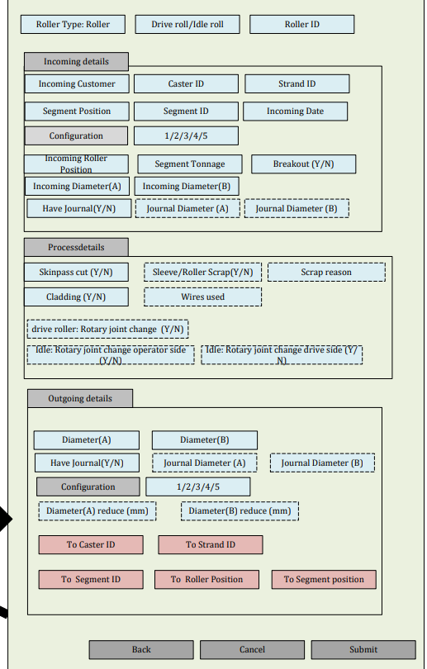
Figure 24: Roller at workshop

Figure 23: On Submit Check
Field data entry description:
Field | Data type | Range | Dependency

Backend Interaction:
Field/Button | Query | Dependency
Submit-submit | WITH LatestProcessed AS  (  SELECT *,  ROW_NUMBER() OVER (  PARTITION BY roller_sleeve_id  ORDER BY created_at DESC, lifecycle_id DESC  ) AS rn  FROM roller_tracking.roller_lifecycle  WHERE roller_sleeve_id = @roller_sleeve_id  AND process_stage = 'PROCESSED'  )  UPDATE LatestProcessed  SET  process_stage = 'DISPATCHED',  to_caster_id = @to_caster_id,  to_strand_id = @to_strand_id,  to_segment_id = @to_segment_id,  to_position_id = @to_segment_position,  to_roller_position = @to_roller_position,  dispatched_at = SYSDATETIME(),  updated_at = SYSDATETIME(),  updated_by_user_id = @user_id  WHERE rn = 1;

4.3 PG0010 – Insert at Roller/ Sleeve Scrap

Page Purpose:
Insert Roller tracking data after the Roller/sleeve is scrapped.

User Roles:
REF_OP, REF_ADMIN
Page Actions:
Insert data

Displayed Fields:

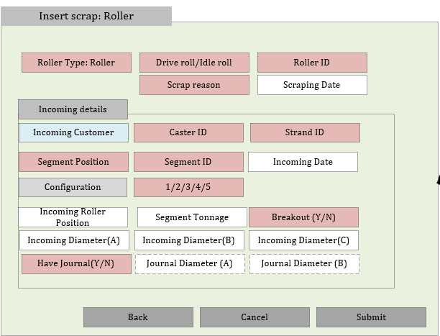
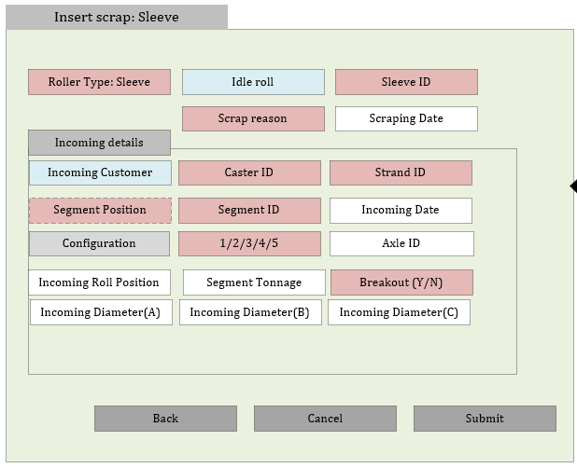
Field data entry description:
Field | Data type | Range | Dependency

Backend Interaction:
Field/Button | Query | Dependency

4.3 PG0010 – Insert at Axle Scrap

Page Purpose:
Insert Roller tracking data after the Axle is scrapped.

User Roles:
REF_OP, REF_ADMIN
Page Actions:
Insert data

Displayed Fields:

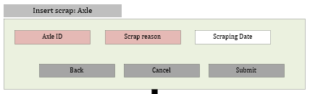

5. Error Handling
Define error scenarios and expected behavior.

6. Assumptions & Open Points
List unresolved decisions.

7. Change History
Version | Date | Description

