Lisa Bourlier

Id : 5999222005

Database AWS assignment

* Create VPC and EC2

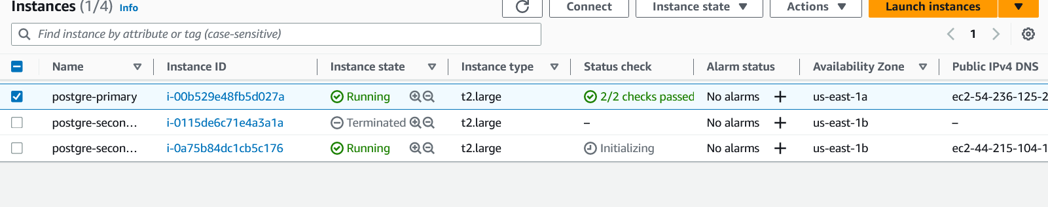

* Create the key and user

* Create the two hosts and launch them successfully

* Configure primary server

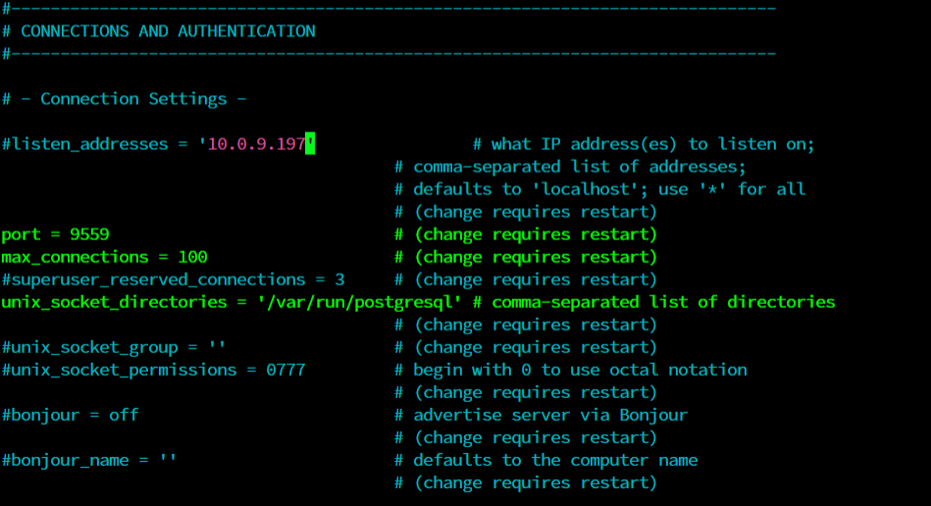

* Configure secondary server

Error when trying to do the sudo pg_basebackup -h 10.0.5.30 -U replica_user -X stream -C -S replica_1 -v  
-R -W -D /var/lib/postgresql/14/main/

