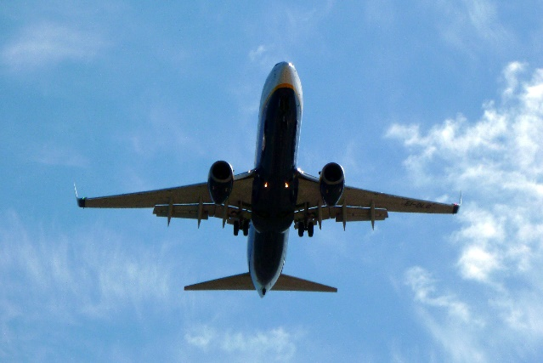**Your account statements**

Issue date: 10/11/2023

Period date: 15/11/2023 to 25/12/2023

111-234-567-890

**Bit manufacturing Limited**

HSR Layout

Bangalore, Karnataka

|  |  |  |  |  |  |
| --- | --- | --- | --- | --- | --- |
| Date | Type | Description | PaidIn | PaidOut | Balance |
| 22 Oct 2014 | Automated pay in | 650274051211-CHB |  | 190.40 | 1803.9 |
| 22 Oct 2014 | Digital banking | CALL REF. NO. 3442, FROM A/C 22222222 |  | 140.00 | 1613.5 |
| 24 Oct 2014 | Faster payment | Amazon |  | 132.0 | 1473.5 |
| 24 Oct 2014 | BACS | Tebay trading co |  | 515.22 | 1341.2 |
| 25 Oct 2014 | Faster payment | Morrisons petrol |  | 80.00 | 825.98 |
| 25 Oct 2014 | BACS | Business loan | 20000.00 |  | 745.98 |
| 26 Oct 2014 | BACS | James white media |  | 2461.55 | 20745.98 |
| 27 Oct 2014 | Faster payment | ATM high street |  | 100.00 | 18284.43 |
| 01 Nov 2014 | BACS | Acorn Advertising Studies |  | 150.00 | 18184.43 |
| 01 Nov 2014 | BACS | Marriott Hotel |  | 177.00 | 18034.43 |
| 01 Nov 2014 | Faster Payment | Abellio Scotrail Ltd |  | 122.22 | 17857.43 |
| 01 Nov 2014 | CHQ | Cheque 0000234 |  | 1,200.00 | 17735.21 |
| 01 Dec 2014 | Int. Bank | Interest Paid | 9.33 |  | 16535.21 |
| 01 Dec 2014 | DD | OVO Energy |  | 2470.00 | 16544.54 |
| 21 Dec 2014 | BACS | Various Payment |  | 10,526.40 | 14074.54 |
| 21 Dec 2014 | BACS | HMRC |  | 1,000.00 | 3548.14 |
| 21 Dec 2014 | DD | DVLA |  | 280.00 | 2548.14 |
|  |  |  |  |  |  |
|  |  |  |  |  |  |
|  |  |  |  |  |  |
|  |  |  |  |  |  |
|  |  |  |  |  |  |