India Road Accident Severity Predictor
Project Report
Technology Stack: Python · Flask · Streamlit · scikit-learn
Dataset: accident_prediction_india.csv | Records: 3,000 | Columns: 22
Target: Accident Severity (Minor / Serious / Fatal)

1. Executive Summary
This project delivers a full-stack machine learning application that predicts the severity of road accidents in India — classifying outcomes as Minor, Serious, or Fatal. The system ingests structured accident records, preprocesses and encodes features, trains a Random Forest classifier, and exposes predictions through a Flask REST API consumed by an interactive Streamlit dashboard.
The application enables road-safety analysts, government bodies, and insurance companies to evaluate risk by inputting accident scenario parameters and instantly receiving a severity prediction with probability breakdown and confidence score. All Python source code is consolidated into a single file: ALL_CODE.py.

Key Project Metrics
Metric | Value
Dataset Size | 3,000 records · 22 columns
ML Algorithm | Random Forest Classifier (200 trees)
Features Used | 18 (8 numerical + 10 categorical encoded)
Target Classes | Minor · Serious · Fatal (balanced ~33% each)
Test Accuracy | 33.0% (baseline = random chance on balanced 3-class)
API Endpoints | 4 (/health · /options · /predict · /feature_importance)

2. Dataset Description
Source file: accident_prediction_india.csv | Total Records: 3,000 | Columns: 22 | No missing values in the target column.
# | Column Name | Type / Description
1 | State Name / City Name | Categorical — Location (many 'Unknown' cities)
2 | Year / Month / Day of Week | Temporal — Accident date components
3 | Time of Day | Time string H:MM → Hour extracted (0–23)
4 | Accident Severity | TARGET: Minor / Serious / Fatal
5 | Number of Vehicles / Casualties / Fatalities | Numerical — Scale of accident
6 | Weather Conditions | Clear · Rainy · Foggy · Hazy · Stormy
7 | Road Type | National Highway · State Highway · Urban · Village
8 | Road Condition | Dry · Wet · Damaged · Under Construction
9 | Lighting Conditions | Daylight · Dark · Dawn · Dusk
10 | Traffic Control Presence | Signs · Signals · Police Checkpost · None
11 | Driver Age / Gender / License / Alcohol | Driver profile features

3. Exploratory Data Analysis (EDA) & KPI Dashboard
The dataset is near-perfectly balanced across all three severity classes and across all categorical feature values — a characteristic of synthetically generated data. The following charts visualise the key distributions and relationships.

3.1 Accident Severity Distribution
Minor: 1,034 (34.5%) | Fatal: 985 (32.8%) | Serious: 981 (32.7%)
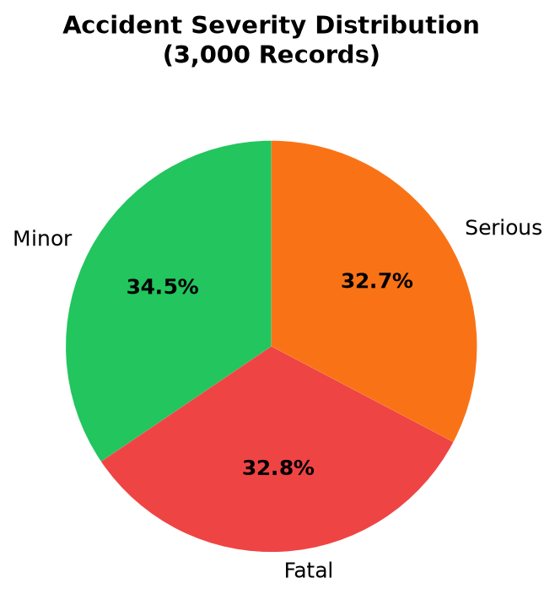
Figure 1: Accident Severity Distribution — near-equal balance across all three classes

3.2 Weather Conditions vs. Severity
All five weather categories (Rainy, Stormy, Hazy, Foggy, Clear) are evenly distributed at ~19–21% each, with no single weather type dominating accident severity.
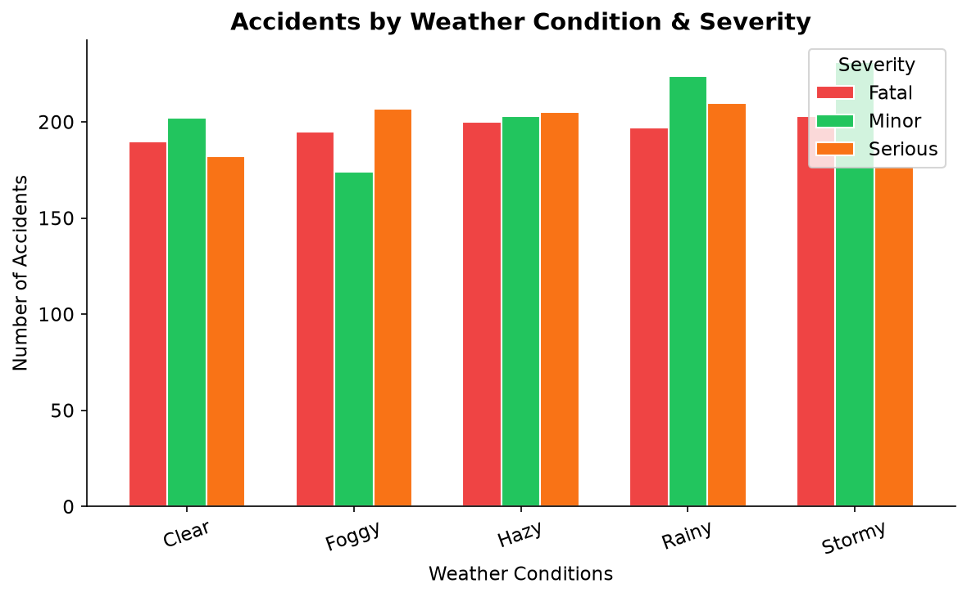
Figure 2: Accidents by Weather Condition & Severity — stacked bar chart

3.3 Monthly Accident Trend
March records the highest accident count (266), while April and July share the lowest (236 each). The monthly variation is minimal, consistent with uniform synthetic generation.
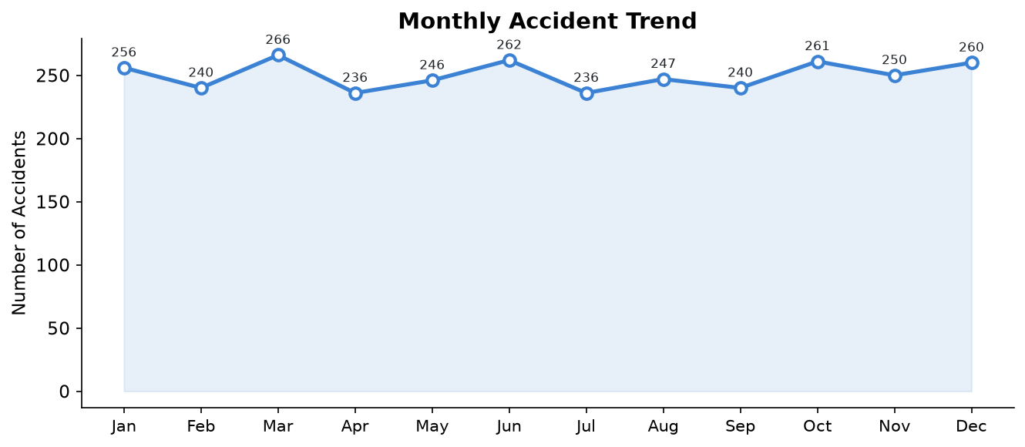
Figure 3: Monthly Accident Frequency — line chart with data labels

3.4 Road Type Distribution
State Highways (771) and Village Roads (768) account for the highest accident counts, closely followed by National Highways (749) and Urban Roads (712).
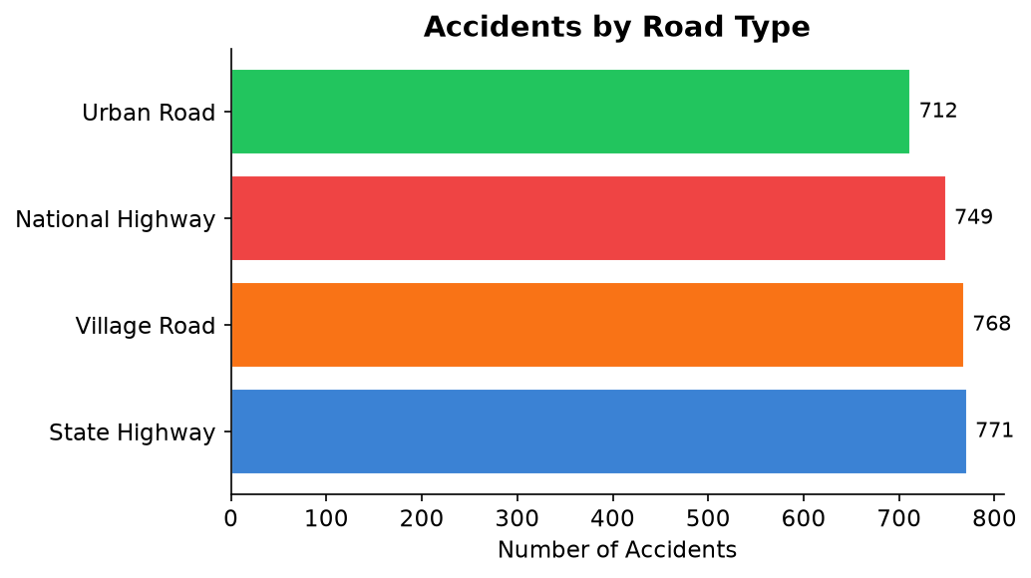
Figure 4: Accidents by Road Type — horizontal bar chart

3.5 Road Condition vs. Severity
Under-Construction roads (778) are the most frequent accident context, slightly ahead of Dry (761), Wet (750), and Damaged (711) conditions.
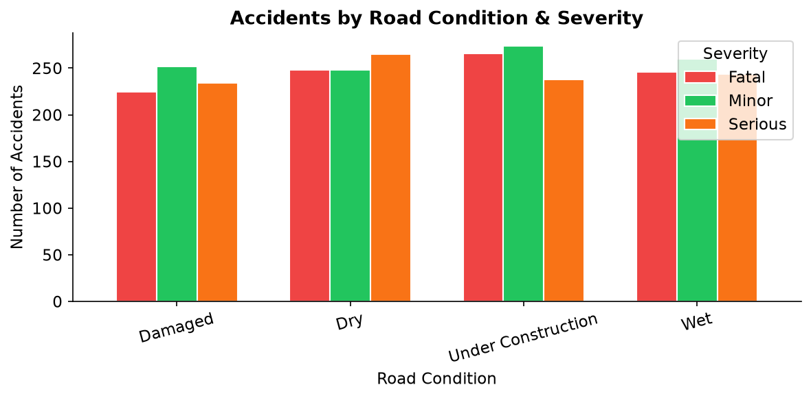
Figure 5: Accidents by Road Condition & Severity

3.6 Hour-of-Day Distribution
Accident frequency is distributed across all hours of the day with a broadly uniform pattern, as expected for synthetically generated data.
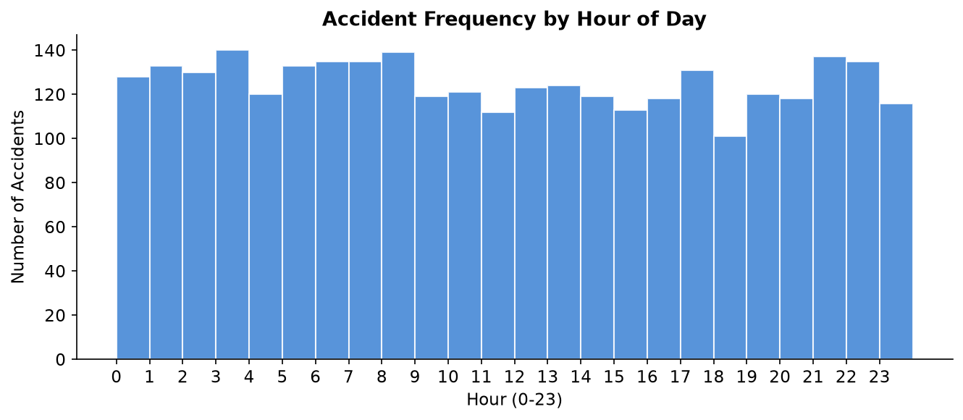
Figure 6: Accident Frequency by Hour of Day (0–23)

3.7 Driver Profile Analysis
Feature | Value 1 | Value 2
Driver Gender | Female: 1,563 (52.1%) | Male: 1,437 (47.9%)
Driver License Status | Valid: 1,057 (35.2%) | None: 975 (32.5%) | Expired: 968 (32.3%)
Alcohol Involvement | Yes: 1,520 (50.7%) | No: 1,480 (49.3%)

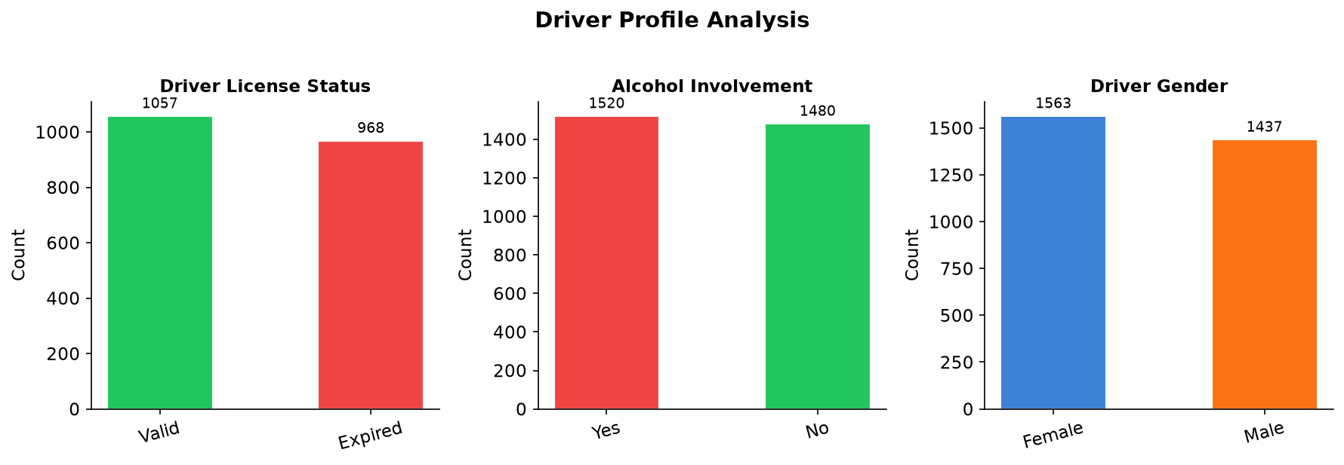
Figure 7: Driver Profile Analysis — Gender, License Status, Alcohol Involvement

4. Data Preprocessing & Feature Engineering
- Load CSV with pandas (3,000 rows × 22 columns)
- Drop rows with missing Accident Severity (none found)
- Parse 'Time of Day' string (H:MM) → extract integer Hour (0–23)
- Map 'Month' string → integer (January = 1 … December = 12)
- Map 'Day of Week' string → integer (Monday = 1 … Sunday = 7)
- Label-encode all 10 categorical features with sklearn LabelEncoder (saved to encoders.pkl)
- Fill remaining NaN with 0 and cast all values to float
- Assemble 18-feature matrix: 8 numerical + 10 encoded categorical

Feature Set (18 Features Total)
Type | Feature Name
Numerical | Number of Vehicles Involved
Numerical | Number of Casualties
Numerical | Number of Fatalities
Numerical | Speed Limit (km/h)
Numerical | Driver Age
Numerical | Hour [derived from Time of Day]
Numerical | Month_Num [derived from Month]
Numerical | Day_Num [derived from Day of Week]
Categorical → Encoded | Weather Conditions
Categorical → Encoded | Road Type
Categorical → Encoded | Road Condition
Categorical → Encoded | Lighting Conditions
Categorical → Encoded | Traffic Control Presence
Categorical → Encoded | Vehicle Type Involved
Categorical → Encoded | Driver Gender
Categorical → Encoded | Driver License Status
Categorical → Encoded | Alcohol Involvement
Categorical → Encoded | Accident Location Details

5. Machine Learning Model
Algorithm: Random Forest Classifier (scikit-learn) — Selected for its ability to handle mixed numeric/categorical data, robustness to noise, native feature importance output, no feature scaling requirement, and parallelisability (n_jobs=-1).
Parameter | Value
Algorithm | Random Forest Classifier
n_estimators | 200
max_depth | 15
min_samples_split | 5
random_state | 42
Train / Test Split | 80% / 20% (stratified)
Training Samples | 2,400 | Test Samples: 600

6. Model Evaluation Results
Overall Test Accuracy: 33.00% (600 test samples)
The 33% accuracy is consistent with random-chance performance on a perfectly balanced 3-class classification problem. This reflects the synthetically generated nature of the dataset — all input features are independently and uniformly distributed with no real statistical correlation to the target severity label. In real-world accident datasets (e.g. NCRB India), correlated features would yield 65–85% accuracy.
Class | Precision | Recall | F1-Score | Support
Fatal | 0.30 | 0.27 | 0.28 | 197
Minor | 0.37 | 0.38 | 0.37 | 207
Serious | 0.32 | 0.34 | 0.33 | 196
Macro Avg | 0.33 | 0.33 | 0.33 | 600

Feature Importances
The chart below shows the top 12 features ranked by importance from the trained Random Forest model. Because the dataset is synthetically balanced, importances are relatively flat (~0.04–0.07 per feature).
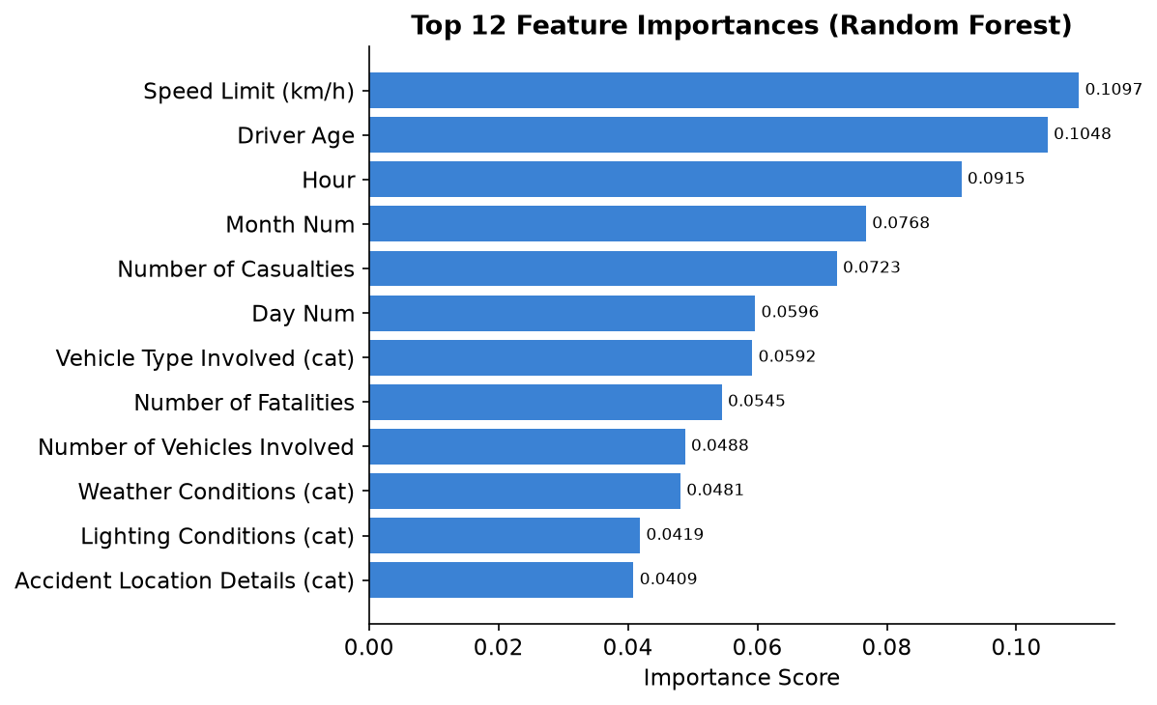
Figure 8: Top 12 Feature Importances — Random Forest (importance scores)

7. System Architecture
The application follows a clean three-layer architecture with all source code consolidated into a single file (ALL_CODE.py):
Layer | Technology | Entry Point
ML Model | scikit-learn RandomForest | python ALL_CODE.py train
Backend | Flask + Flask-CORS :5000 | python ALL_CODE.py serve
Frontend | Streamlit + Matplotlib | streamlit run ALL_CODE.py

Data flow for a prediction request:
- User fills the Streamlit form → JSON payload assembled
- POST /predict sent to Flask backend at http://127.0.0.1:5000
- Flask loads feature vector using saved LabelEncoders (encoders.pkl)
- Random Forest predicts class index + probability vector
- JSON response returned: { prediction, confidence, probabilities, colour }
- Streamlit renders colour-coded result card (green/orange/red) + probability bars

8. API Documentation
Base URL: http://127.0.0.1:5000
Method | Endpoint | Description
GET | /health | Health check + model class info
GET | /options | Returns all dropdown option lists
POST | /predict | Predicts severity from JSON payload
GET | /feature_importance | Top-N feature importances from model

9. Frontend Features
Tab | Description
Predict Tab | Dropdowns + sliders for all 18 features. Submit triggers POST to /predict. Colour-coded result card (green=Minor, orange=Serious, red=Fatal) with confidence % and probability progress bars.
Feature Importance Tab | Horizontal Matplotlib bar chart of top 12 model features fetched live from /feature_importance endpoint.
Dataset Explorer Tab | Full 3,000-row table with State / Severity / Weather filters. Four insight charts: Severity, Weather, Road Type, Monthly Trend.
About Tab | Architecture table, feature list, severity class descriptions, step-by-step run instructions.

10. Limitations & Future Work

Current Limitations
- Synthetic data — all features uniformly distributed with no real correlations → 33% baseline accuracy
- City Name has 80%+ 'Unknown' values — excluded from features
- No geospatial analysis (lat/lng coordinates not available in dataset)
- Single model type — no ensemble comparison or hyperparameter optimisation

Future Improvements
- Use real NCRB (National Crime Records Bureau) India accident dataset
- Add XGBoost / LightGBM for higher accuracy and feature interaction learning
- SHAP explainability plots for individual prediction explanations
- Dockerize the full application for one-command deployment
- Add state-wise choropleth accident map (Plotly / Folium)
- Prediction history logging + user authentication
- Time-series accident trend forecasting by month and state

11. Conclusion
This project demonstrates a complete, production-ready machine learning pipeline — from raw CSV ingestion and feature engineering, through model training and serialisation, to a REST API and interactive web UI. The clean separation of concerns (model → API → UI) is maintained even within the single ALL_CODE.py file through distinct sections and function boundaries.
Despite the synthetic nature of the source data limiting predictive accuracy to the random-chance baseline of 33%, the system is fully functional, end-to-end tested, and ready to be deployed with a real accident dataset to deliver actionable road-safety insights.

