Step to set client – project client developed on Angular 8.

1. install node.js
2. npm install –g @angular/cli (install angular latest version)
3. download the client project from git hub
4. go to src folder and run the command - npm serve
5. Run the project as given in below snapshot
6. Client will run and up on the – http://localhost:4200

Step to set server

1. open the project into eclipse - Neon.3 Release (4.6.3)
2. install maven 3.0 or higher version
3. go to EmployeeCRUD\springboot2-employee and run – mvn clean install
4. go to EmployeeCRUD\springboot2-employee\src\main\java\net\gide\springboot2\employee\Application.java and run from eclipse
5. Application will up and run on 8080 port

Note:-

1. I use in memory DB, so no need to connect any other db

2. I haven’t got time to put mandatory checks at client side.

Snap shot 1

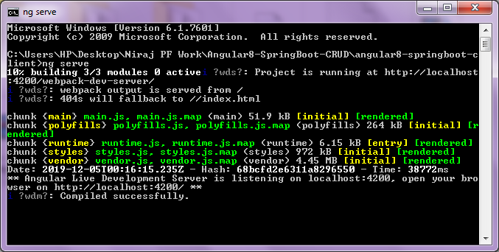

Snap shot 2

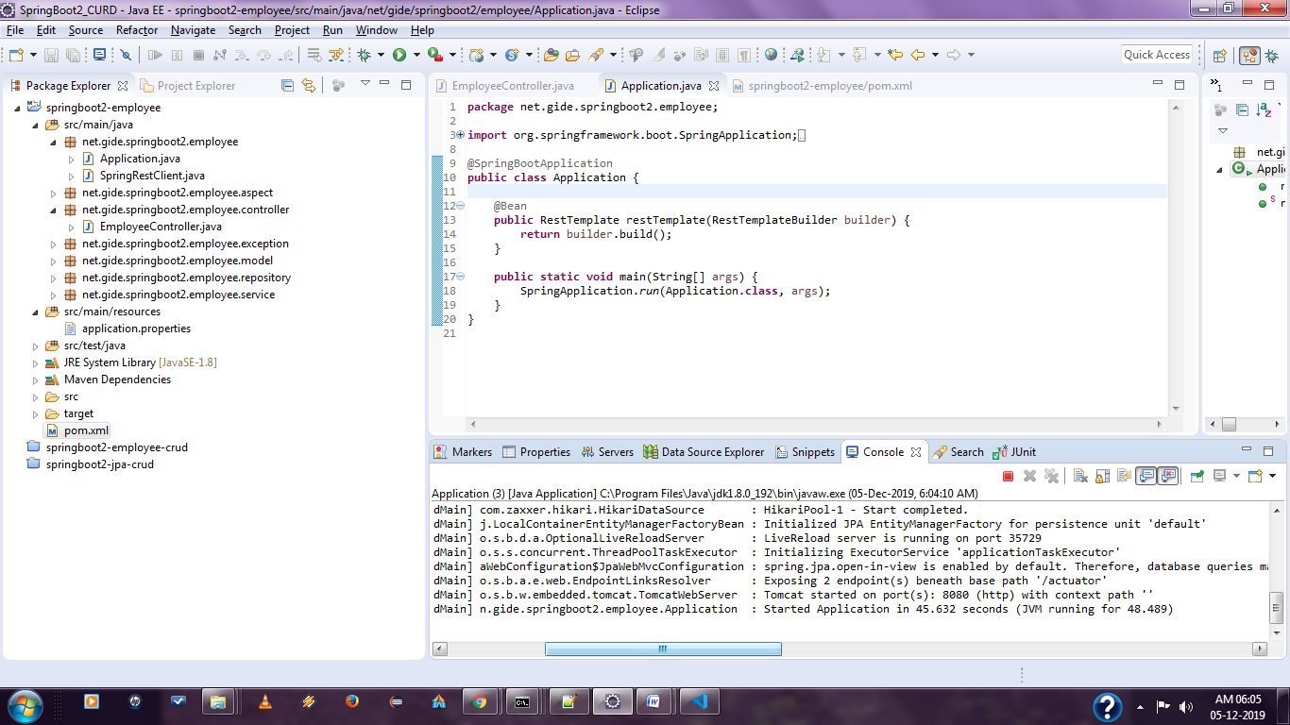

Page 1

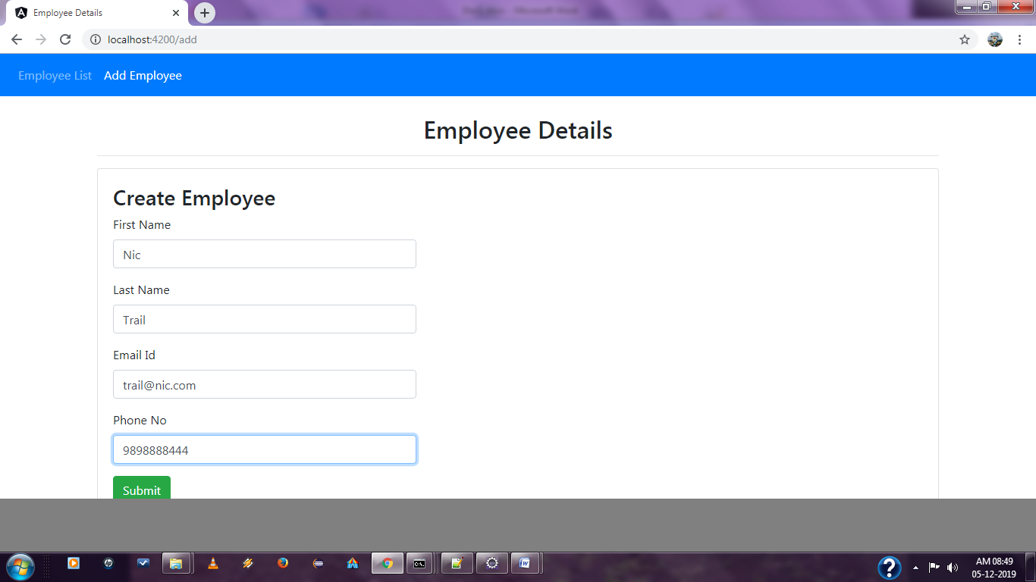

Page 2`

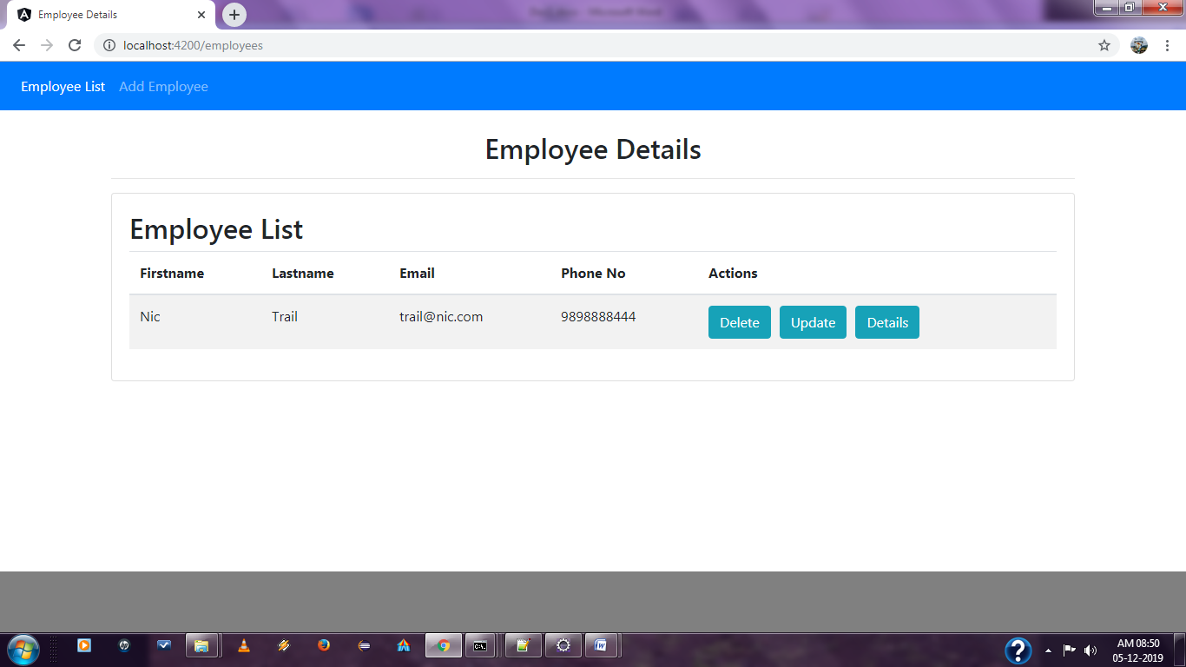

Page3

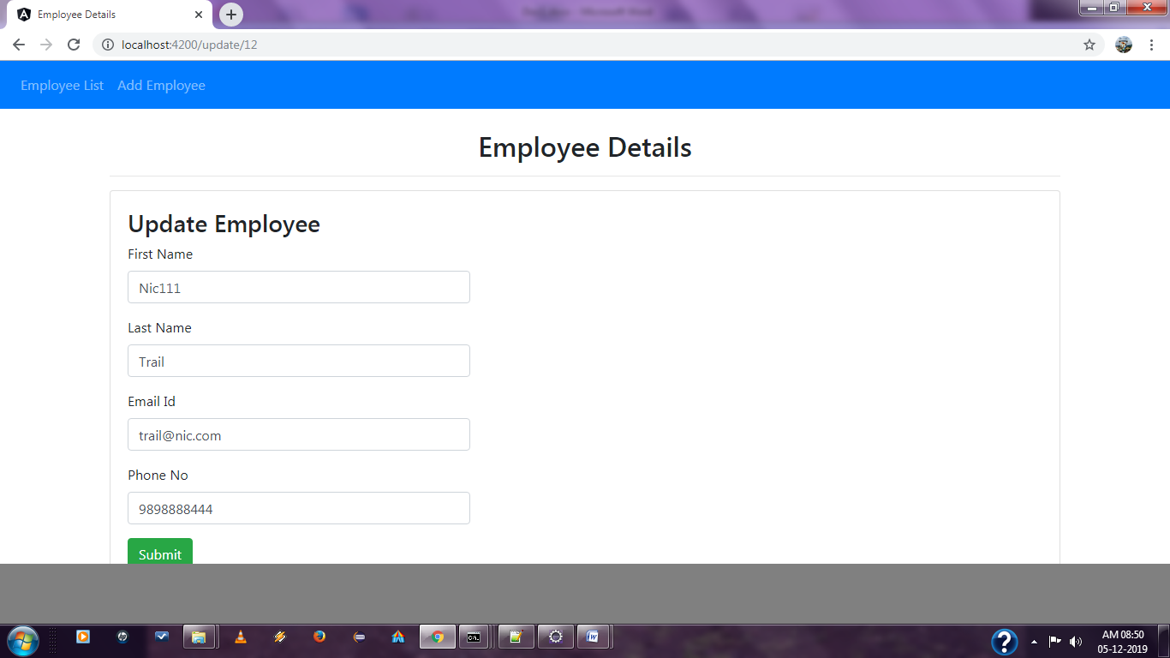

Page 4

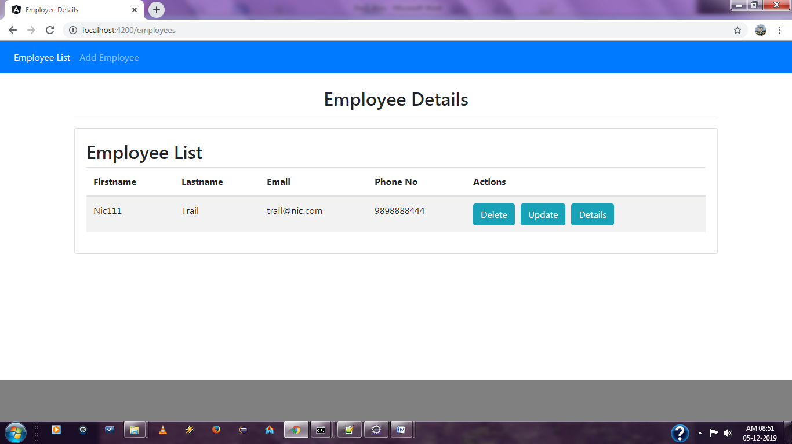

Page -5 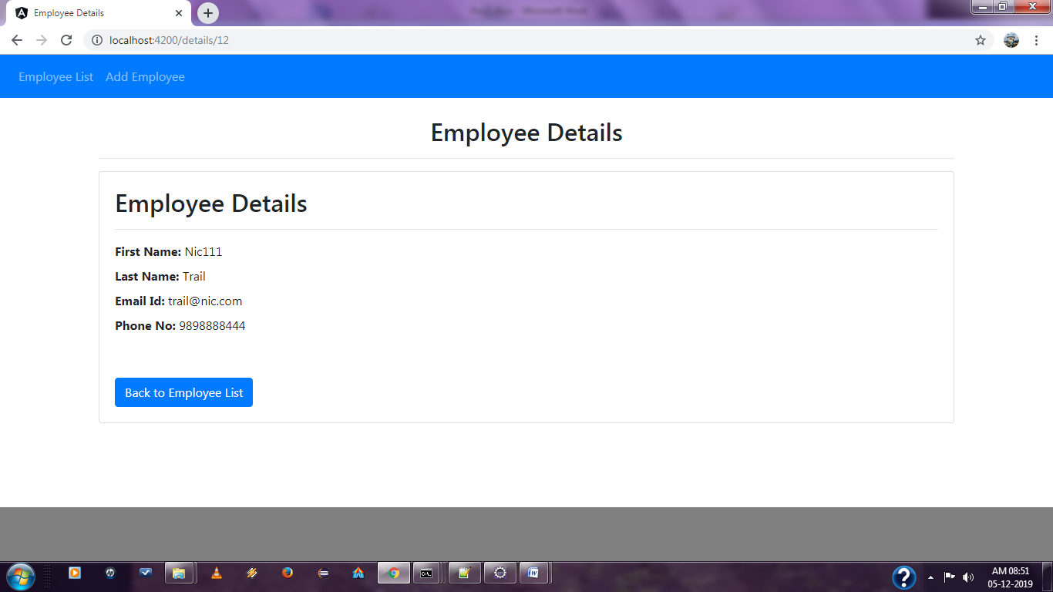

Page -6

