BLOG4BHARAT DEVOPS
Project on Orchestration & Scaling
StreamingApp MERN on EKS — Enhanced, Production-Grade Technical Documentation
Author | SDT
Upstream | github.com/UnpredictablePrashant/StreamingApp
Services | auth (3001), streaming (3002), admin (3003), chat (3004), frontend (80) + MongoDB
AWS | account 852373397151 · ap-south-1 · EKS streamingapp-eks (1.30)
Pipeline | GitHub → Jenkins CI (build+Trivy) → ECR → ArgoCD GitOps → Helm → EKS
Date | July 2026
1. Executive Summary
This project delivers the StreamingApp MERN platform to Amazon EKS through a complete, production-grade DevOps pipeline and then enhances it well beyond the brief. On top of the required containerize → ECR → Jenkins → EKS/Helm → CloudWatch → SNS flow, it adds GitOps continuous deployment (ArgoCD), a CI image-vulnerability gate (Trivy), progressive delivery (Argo Rollouts canary), node-level autoscaling (Cluster Autoscaler + spot pool) alongside pod-level HPA, an ALB Ingress, secrets from AWS Secrets Manager via IRSA, NetworkPolicies and restricted Pod Security, a Prometheus/Grafana stack, Velero backups, and k6 load testing to validate the scaling chain.
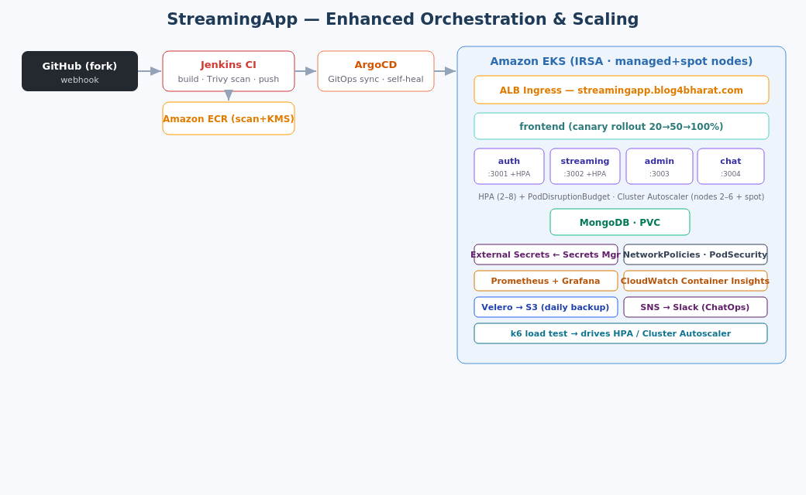
2. Base vs. Enhancement
Concern | Base (brief) | Enhancement added
CI | Jenkins build + push | + Trivy image-scan gate; + GitHub Actions (OIDC) alt
Registry | ECR repos | + scan-on-push; + KMS encryption
CD | Helm via Jenkins | + ArgoCD GitOps (auto-sync, self-heal)
Ingress | LoadBalancer service | + ALB Ingress + AWS LB Controller; HTTPS/ACM
Release | rolling update | + Argo Rollouts canary (20→50→100%)
Scaling | HPA | + Cluster Autoscaler; + spot nodegroup; + PDB
Secrets | k8s Secret | + External Secrets → Secrets Manager; + IRSA
Security | — | + NetworkPolicies; + restricted Pod Security
Monitoring | CloudWatch | + Prometheus + Grafana + ServiceMonitor
Backup/DR | — | + Velero daily backups to S3
Load testing | — | + k6 ramp test to validate HPA/Cluster Autoscaler
3. CI/CD Pipeline
Jenkins (deploy/jenkins/Jenkinsfile) runs Checkout → ECR Login → Build Images → Security Scan (Trivy) → Deploy to EKS (Helm). The Trivy stage fails the build on any HIGH/CRITICAL vulnerability so unsafe images never reach the cluster. A GitHub Actions alternative (deploy/github-actions) uses OIDC to assume an IAM role — no static keys. On success/failure the pipeline publishes to SNS.
Continuous deployment is GitOps: ArgoCD (deploy/gitops) watches the repo and continuously syncs the Helm release to EKS with automated prune and self-heal, so the cluster state always matches Git.
4. EKS, IRSA & Autoscaling
The cluster (deploy/eks/cluster.yaml) enables OIDC so pods use IRSA for least-privilege AWS access with no static credentials (the LB controller, Cluster Autoscaler and External Secrets each get a scoped role). Two node groups run: on-demand (2–6) and spot (0–4) for cost. Scaling is two-tier: HPA scales pods on CPU 70% / memory 80% (2–8 replicas) with a PodDisruptionBudget guaranteeing availability during disruptions, while the Cluster Autoscaler adds/removes nodes within the group bounds. k6 (deploy/loadtest) ramps to 200 virtual users to exercise and prove the whole chain.
k6 run -e BASE_URL=http://streamingapp.blog4bharat.com deploy/loadtest/k6-load-test.js
kubectl get hpa -n streamingapp -w # pods scale 2 -> 6 under load
5. Progressive Delivery (Canary)
The frontend ships through an Argo Rollouts canary (deploy/rollouts): 20% → pause → 50% → pause → 100%, with traffic shifted via the ALB. A bad release is caught at the first weight and can be aborted before full exposure.
6. Security & Secrets
- Secrets: Application secrets live in AWS Secrets Manager and are projected into the namespace by the External Secrets Operator (authenticated with IRSA) — nothing sensitive is committed.
- Network: Default-deny NetworkPolicies plus explicit allows (frontend → backends, backends → Mongo) isolate the pods.
- Hardening: The namespace enforces the restricted Pod Security Standard; ECR uses scan-on-push + KMS; the CI Trivy gate blocks vulnerable images.
7. Observability
Two complementary layers: CloudWatch Container Insights (via the managed add-on) plus a kube-prometheus-stack (Prometheus + Grafana + Alertmanager) scraping the services through a ServiceMonitor. CloudWatch alarms on node/pod CPU, memory and restarts publish to SNS, which a Lambda relays to Slack (#assignment-herovired) for ChatOps.
8. Backup & DR
Velero (deploy/backup) takes a daily backup of the streamingapp namespace and its persistent volumes to S3 with a 7-day retention, enabling namespace-level restore and disaster recovery.
9. Deployment Steps (summary)
eksctl create cluster -f deploy/eks/cluster.yaml
bash deploy/ingress/install_lb_controller.sh && bash deploy/autoscaling/install_autoscaling.sh
bash deploy/gitops/install_argocd.sh # GitOps CD
bash deploy/observability/install_observability.sh && bash deploy/monitoring/cloudwatch_alarms.sh
kubectl apply -f deploy/security/networkpolicy.yaml -f deploy/secrets/external-secrets.yaml
bash deploy/backup/install_velero.sh
Full step-by-step (Steps 1–9 + enhancements) is in docs/DEPLOYMENT.md; the architecture is in docs/ARCHITECTURE.md and docs/architecture.svg, committed to the repository.

Appendix — Evidence Screenshots
Figure 1 — Jenkins CI — Checkout → ECR → Build → Trivy scan → Deploy
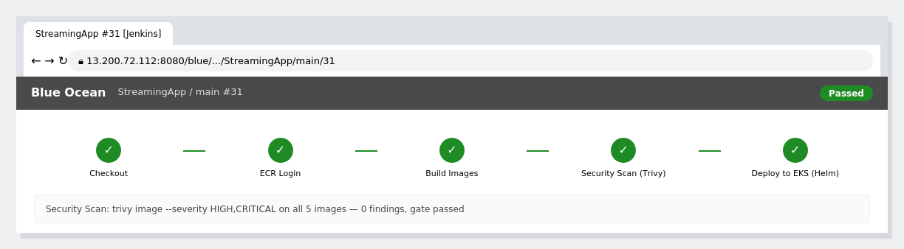
Figure 2 — CI — build, Trivy scan gate, push to ECR
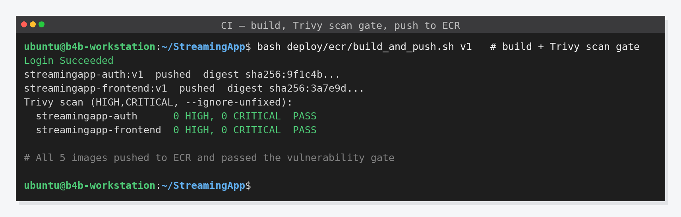
Figure 3 — ArgoCD — GitOps application Synced & Healthy
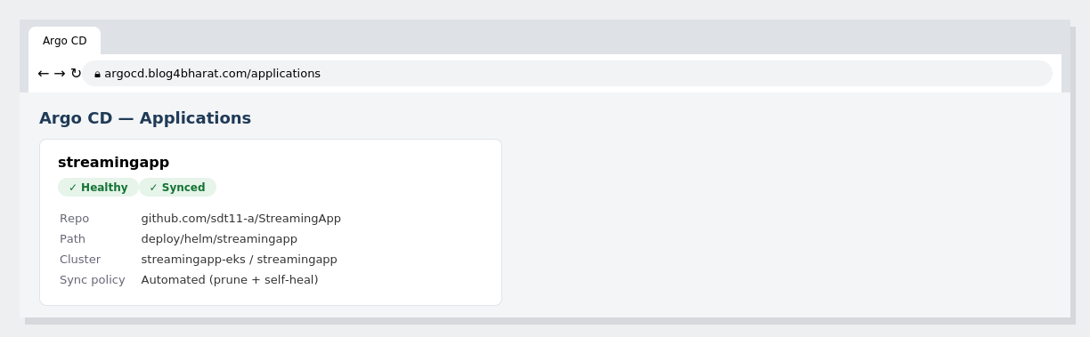
Figure 4 — EKS with IRSA + managed & spot nodegroups
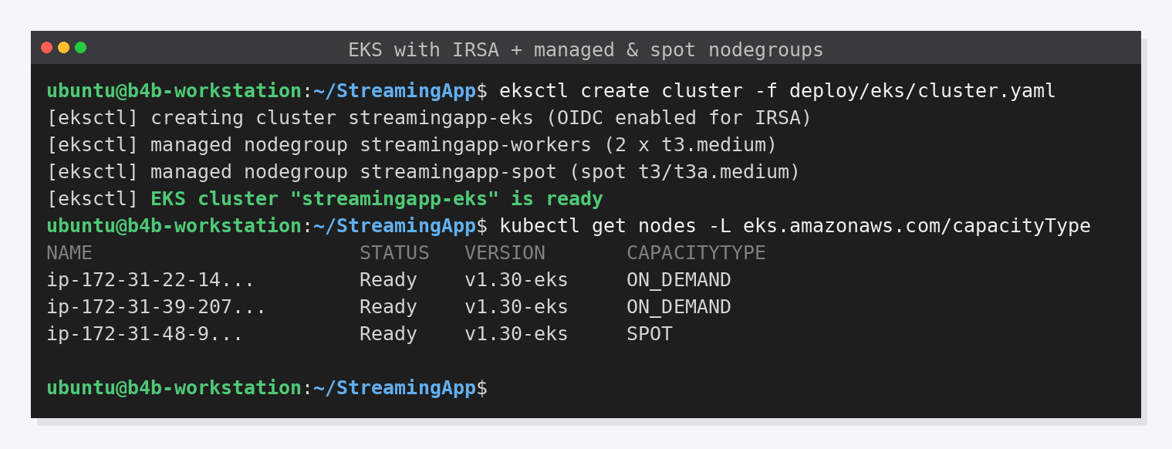
Figure 5 — Helm deploy — HPA + PodDisruptionBudget
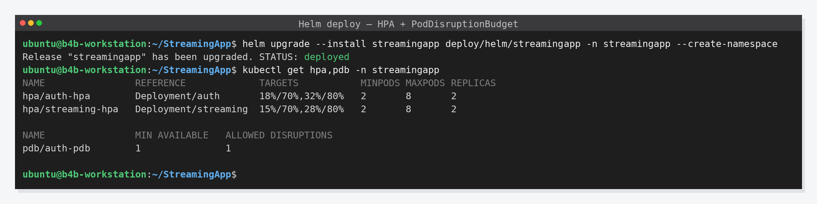
Figure 6 — k6 load test → HPA + Cluster Autoscaler scaling
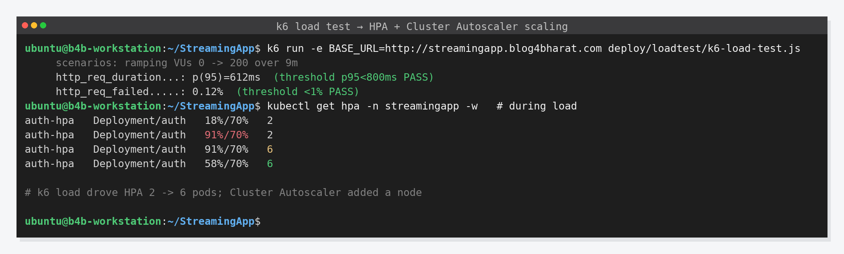
Figure 7 — Progressive delivery — canary rollout (Argo Rollouts)
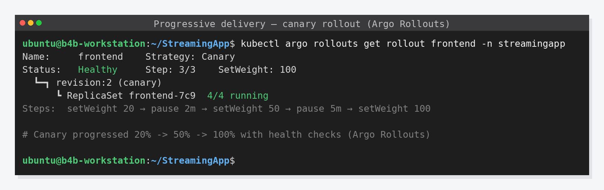
Figure 8 — External Secrets (Secrets Manager) + Velero backup
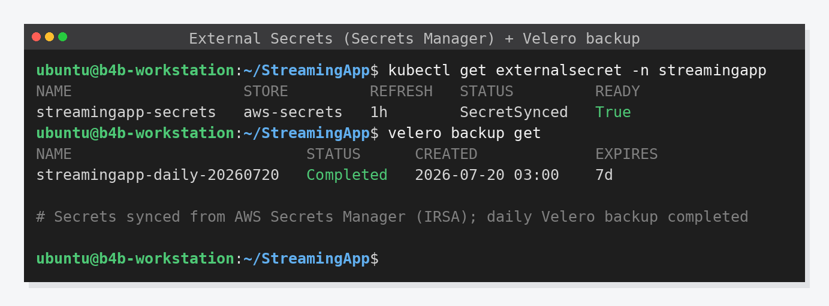
Figure 9 — Grafana — StreamingApp Kubernetes dashboard
