1. Create the database

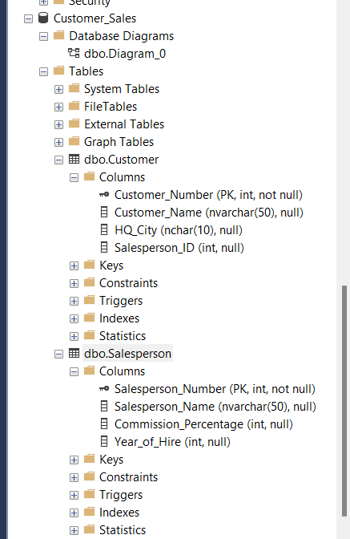

1. Create the entities

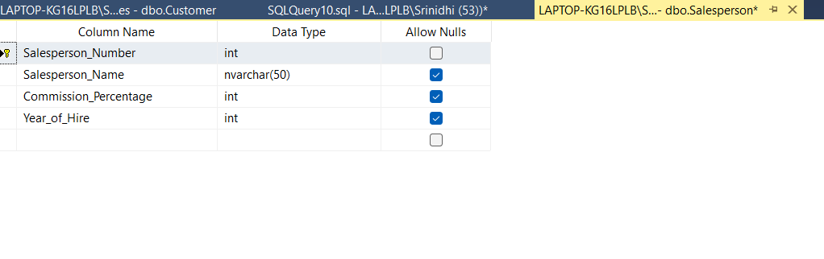

1. Foreign key and the diagram

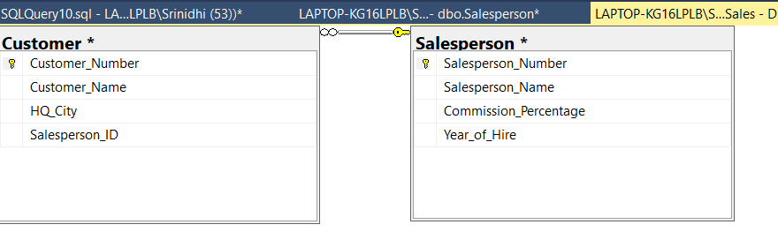

1. INSERT Values into tables results:

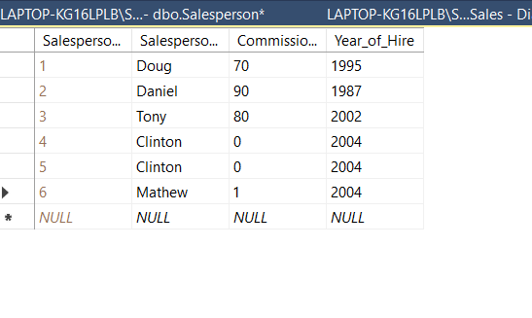

1. INSERT Values into Customer tables results

