# High Level Design (HLD)

# Parkinson’s Disease Prediction

**Version 1.0**

**Date of Revision 07 May 2022**

**Document Version Control**

**Date Issued Version Description Author**

07-05-22 1 Initial HLD – V1.0 Sachchit S. kolekar

# Contents

Document Version Control Abstract

1. Introduction
   1. Why this High-Level Design Document ?
   2. Scope
   3. Definitions
2. General Description
   1. Product Perspective
   2. Problem Statement
   3. Proposed Solution
   4. Technical Requirements
   5. Data Requirements
   6. Tools Used
   7. Constraints
   8. Assumptions
3. Design Details
   1. Application Process Flow
   2. Model Training
   3. Event Logs
   4. Error Handling
4. Performance
   1. Reusability
   2. Application Compatibility
   3. Resource Utilization
   4. Deployment 5 Conclusion

## Abstract

Many of the existing machine learning models for health care analysis are concentrating on different diseases as per analysis. In this article proposing a system which used to predict Parkinson's diseases by using Streamlit API. To implement Parkinson's disease analysis used machine learning algorithms and Steamlit API. Python pickling is used to save the model behaviour and python unpickling is used to load the pickle file whenever required. The importance of this article analysis in while analysing the diseases all the parameters which causes the disease is included so it possible to detect the maximum effects which the disease will cause. For example for diabetes analysis in many existing systems considered few parameters like age, sex, bmi, insulin, glucose, blood pressure, diabetes pedigree function, pregnancies, considered in addition to age, sex, bmi, insulin, glucose, blood pressure, diabetes pedigree function, pregnancies included serum creatinine, potassium, GlasgowComaScale, heart rate/pulse Rate, respiration rate, body temperature, low density lipoprotein (LDL), high density lipoprotein (HDL), TG (Triglycerides). Final models behaviour will be saved as python pickle file. Streamlit API is designed. When user accessing this API, the user has to send the parameters of the disease along with disease name. Streamlit API will invoke the corresponding model and returns the status of the patient. The importance of this analysis to analyse the maximum diseases, so that to monitor the patient’s condition and warn the patients in advance to decrease mortality ratio.

## Introduction

### Why this High-Level Design Document ?

The purpose of this High-Level Design (HLD) Document is to add the necessary detail to the current project description to represent a suitable model for coding. This document is also intended to help detect contradictions prior to coding, and can be used as a reference manual for how the modules interact at high level.

The HLD will:

* + - Present all of the design aspects and define them in detail
    - Describe the user interface being implemented
    - Describe the hardware and software interfaces
    - Describe the performance requirements
    - Include design features and the architecture of the project
    - List and describe the non-functional attributes like:
      * Security
      * Reliability
      * Maintainability
      * Portability
      * Reusability
      * Application compatibility
      * Resource utilization
      * Serviceability

**1.2** **Scope**

The HLD documentation presents the structure of the system, such as the database architecture, application architecture (layers), application flow (Navigation), and the technology architecture. The HLD uses non-technical to mildly-technical terms which should be understandable to the administrators of the system.

**1.3 Definitions**

|  |  |
| --- | --- |
| **Terms** | **Description** |
| AWS | Amazon web sercvice |
| IDE | Integrated Development Environment |

## General Description

### Product Perspective

The Parkinson's disease prediction System is a machine learning based system.

### Problem statement

* + - To design a Parkinson's Prediction System for medical data classification and early disease prediction by using SVM Algorithm. It might have happened so many times that you or someone need doctor’s help immediately but they are not available due to some reason. People cannot identify his symptoms and take medicines without consulting doctors. Some medicines are very much harmful to health. So user needs online consultation.

### Proposed Solution

* In multi disease model prediction, it is possible to predict more than one disease at a time. So user no need to traverse many models to predict the diseases. It will reduce time and also due to predicting multiple diseases at a time there is a chance of reducing mortality rate.

### Technical Requirements

* build a machine learning web application.
* Use uci dataset.
* Use cloud platform for deploying an application

### Data Requirements

dataset composed of a range of biomedical voice measurements.

Each column in the table is a particular voice measure, and each row corresponds one of 195 voice recording from these individuals ("name" column). The main aim of the data is to discriminate healthy people from those with PD, according to "status" column which is set to 0 for healthy and 1 for PD.

### Tools Used





********



1. **Jupyter Notebook** has been used for EDA
2. For data cleaning and preprocessing, **Pandas** and **NLTK** have been used.
3. **Python**, **Flask**, **Scikit Learn** use for building Machine Learning Web Application.
4. Front End Development is done using HTML, CSS, Javascript, JQuery.
5. **GitHub** has been used as the version control system

### Constraints

Parkinson’s Disease prediction System must be user friendly, well maintainable.

### Assumptions

The main objective of the project is to implement use cases of Parkinson’s Disease prediction, and finding improvement strategies.

### Design Details

* 1. **Application Process Flow**

For the Parkinson's Disease prediction we will use a machine learning based model. Below is the process flow diagram.

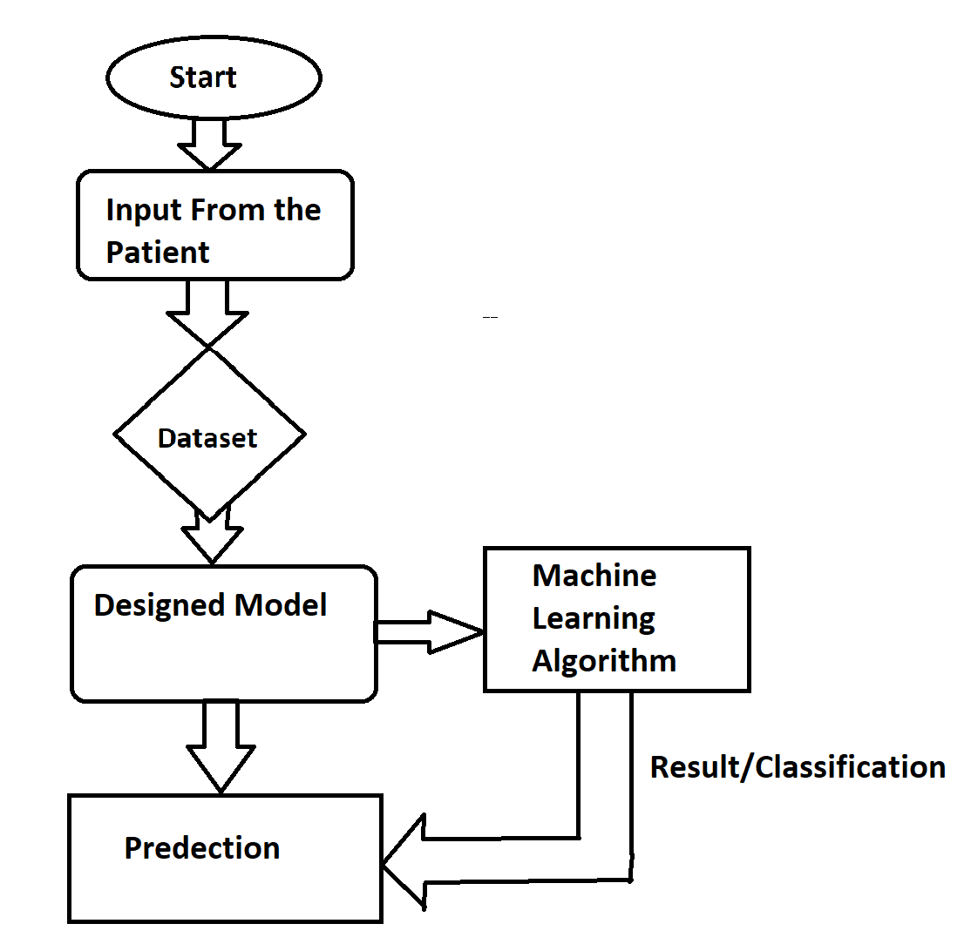

### Model Training

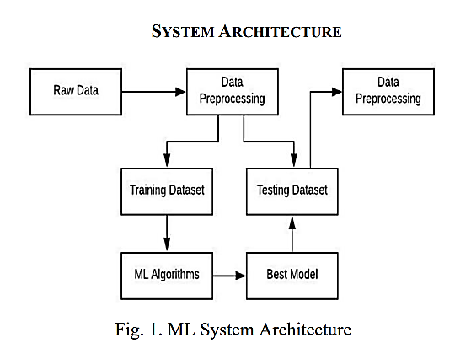

**3.1.2 Deployment process**

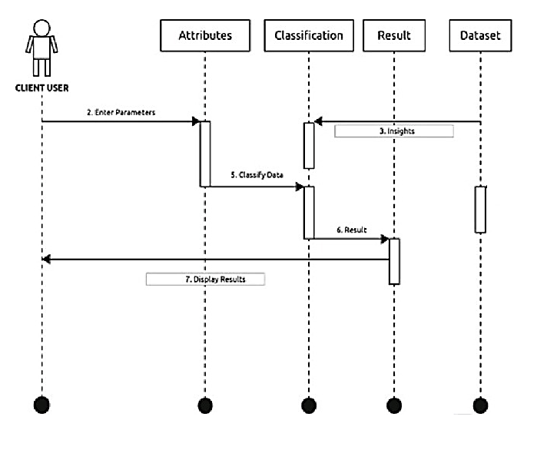

* 1. **Event Logs**

The System should log every event so that the user will know what process is running internally.

**Initial Step-By-Step Description**

* + 1. The System identifies at what step logging required
    2. The System should be able to log each and every system flow.
    3. Developers can choose logging methods. You can choose database logging/ File logging as well.
    4. System should not hang even after using so many loggings. Logging just because we can easily debug issues so logging is mandatory to do.

### Error Handling

Should errors be encountered, an explanation will be displayed as to what went wrong? An error will be defined as anything that falls outside the normal and intended usage.

### .Performance

Evaluate performance of model for Parkinson's Disease prediction.

### Reusability

The code written and the components used should have the ability to be reused with no problems.

### Application Compatibility

The different components for this project will be using Python as an interface between them. Each component will have its own task to perform, and it is the job of the Python to ensure proper transfer of information.

### Resource Utilization

When any task is performed, it will likely use all the processing power available until that function is finished.

### Deployment



1. **Conclusion**

Here based on the user input disease will be predicted. The choice will be given to user. If the user want to predict disease or if the user don’t enter any disease type then based on user entered inputs corresponding disease model will be invoked and predicted. The advantage of Parkinson’s disease prediction model in advance can predict the probability of occurrence of the disease and also can reduce mortality ratio.